Claims and Medical Cost Data

Sreeja Kandukuri

**INTRODUCTION**

This analysis provides a thorough examination of an Electronic Medical Record (EMR) dataset, with an emphasis on understanding the causes of severe sickness and hospital length of stay (LOS). To develop a fundamental understanding, we start by summarizing essential descriptive statistics for important variables in the dataset. Following that, we look at the relationship between age and sickness severity, using logistic regression to calculate odds ratios (OR) with and without accounting for potential confounding variables. In addition, we use statistical and machine learning techniques to anticipate the severity of extreme illnesses, giving pertinent visualizations, confusion matrices, and performance indicators. Finally, we extend the predictive analysis to LOS, changing it into a numerical variable for robust analytics and visualization, thereby providing insights into factors influencing hospital stay duration.

**ANALYSIS**

PART 1: Healthcare providers confront two primary difficulties that can be efficiently handled utilizing machine learning techniques.

* Medical Image Analysis: Doctors spend a lot of time and make mistakes when analyzing medical images like X-rays, CT scans, and MRI scans. Machine learning methods, particularly deep learning models such as Convolutional Neural Networks (CNNs), can be trained on enormous datasets of medical images to accurately detect and diagnose various illnesses. Medical imaging data is complicated and high-dimensional, making it challenging for humans to discover tiny trends. This makes it ideal for machine learning algorithms. Deep learning algorithms may develop intricate representations from raw visual data, allowing for accurate identification and classification of abnormalities. With enough training data, computer algorithms can outperform human experts in terms of accuracy and speed.
* Predictive Analytics & Risk Stratification: Machine learning algorithms can use a patient's electronic health records (EHRs), medical history, demographics, and other information to forecast the likelihood of getting specific diseases or problems. This allows for early intervention and tailored treatment programs. This challenge is ideal for machine learning due to the large volume of structured and unstructured data in EHRs that people struggle to evaluate and extract insights from. Machine learning algorithms can detect intricate patterns and correlations between different risk variables and disease outcomes. Predictive models can categorize patients into different risk groups, allowing healthcare professionals to prioritize high-risk patients for preventative care.

The analytical method of machine learning is especially beneficial in healthcare due to the vast volumes of complicated data generated, the requirement for consistent and precise decision-making, and the potential to enhance patient outcomes through early identification and individualized treatment regimens.

2. While machine learning and analytics can be strong tools in healthcare, there are several instances where a human-centered approach may be more appropriate:

* Emotional Support and Empathy: Providing emotional support, establishing trust, and demonstrating empathy for patients are all critical parts of healthcare that necessitate human touch and emotional intelligence. Despite its analytical powers, machine learning models cannot completely grasp and respond to patients' emotional needs.   
  This is because emotional intelligence entails deciphering subtle signs, body language, and the intricacies of human communication, which are difficult for computers to fully comprehend. Patients frequently desire reassurance, comfort, and a sympathetic ear, which are only adequately delivered by human healthcare experts.
* Complicated Ethical Decision-Making: Certain ethical quandaries in healthcare, such as end-of-life decisions, resource allocation, or reconciling opposing values and views, necessitate careful evaluation of a variety of issues, including legal, cultural, and personal viewpoints. While machine learning models can provide data-driven insights, they may fail to account for the complex ethical issues and subjective nature of such decisions.   
  Ethical decision-making in healthcare frequently entails weighing opposing principles, taking into account contextual considerations, and exercising sound moral judgment, all of which need human reasoning, empathy, and a thorough understanding of the patient's beliefs and preferences. Relying only on algorithmic advice in such complicated settings may result in unforeseen effects or actions that contradict ethical standards and societal ideals.

In these cases, a collaborative strategy that blends machine learning's analytical ability with human expertise, emotional intelligence, and ethical reasoning among healthcare providers is likely to produce the most suitable and compassionate outcomes for patients.

3. According to the epidemiologic transition theory, countries' disease patterns and death rates vary as their economies expand. This transition entails a shift from high rates of infectious and nutrition-related diseases, high mortality rates, and low life expectancy to lower rates of infectious and nutrition-based diseases, higher life expectancy, but higher rates of chronic, noncommunicable diseases (known as "man-made diseases").   
This transition requires healthcare providers to adapt their approach in the following ways:

SHIFT IN HEALTHCARE FOCUS: From Acute to Chronic Care: Healthcare systems should change their attention from treating acute infectious infections to managing chronic, non-communicable diseases such as cardiovascular disease, cancer, and diabetes. This necessitates a higher emphasis on long-term care, illness management, and prevention strategies.   
Increased Focus on Lifestyle Interventions: As chronic diseases become increasingly common, healthcare practitioners must place a greater emphasis on promoting healthy lifestyles, such as appropriate eating, physical activity, and quitting smoking, in order to prevent and manage these conditions.   
Integration of Multidisciplinary Care: Chronic disease treatment frequently necessitates a multidisciplinary approach, with physicians, nurses, nutritionists, physical therapists, and other healthcare professionals working together to provide comprehensive care.

HEALTHCARE ANALYTICS: The epidemiologic transformation affects the approach of healthcare analysts in the following ways:

Shift in Data Collection and Analysis: Instead of focusing primarily on infectious disease monitoring, analysts should collect and analyze data on chronic disease risk factors, prevalence and management.

Predictive Modeling and Risk stratification: Machine learning and predictive analytics can be used to identify those at high risk of developing chronic diseases, allowing for focused preventive treatments and individualized treatment strategies.

Healthcare Economics and Resource Allocation: As chronic diseases become more frequent, analysts must assess the economic impact, cost-effectiveness of interventions, and the best allocation of resources for chronic disease management and prevention.

To summarize, the epidemiologic transition needs a fundamental shift in the healthcare system's strategy, away from a major concentration on acute infectious diseases and toward a larger emphasis on chronic disease prevention, management, and lifestyle interventions. Healthcare analysts play an important role in facilitating this shift by offering data-driven insights, predictive modeling, and economic evaluations that impact healthcare policies, resource allocation, and population health plans.

4. PathAI is a real-world example of an analytics company employing machine learning to identify and diagnose diseases. PathAI is a firm that creates artificial intelligence (AI) technologies to help pathologists make more accurate and timely diagnosis. Pathology, or the study of disease through the examination of tissues and fluids, is an essential part of disease diagnosis and therapy planning. However, assessing pathology samples is time-consuming, subjective, and susceptible to human mistake. To make informed conclusions, pathologists must review large amounts of data, such as microscopic pictures, patient histories, and laboratory results. PathAI uses machine learning techniques to interpret digital pathology images and data. Their AI-powered technologies may uncover patterns and traits that are difficult for human pathologists to notice, resulting more accurate and consistent diagnoses.

The company's platform has the following features:   
Image Analysis: PathAI's algorithms can examine high-resolution digital pathology images, recognizing and measuring numerous cellular and tissue characteristics such as tumor borders, cell types, and biomarker expression.  
Data Integration: The platform combines pathology data from many sources, such as electronic health records (EHRs), genomic data, and clinical notes, to provide a complete picture of each patient's illness.   
  
PathAI's AI-powered decision support system helps pathologists identify areas of interest, make diagnostic recommendations, and suggest additional tests or analysis.

The company's platform has the following features:   
Image Analysis: PathAI's algorithms can examine high-resolution digital pathology images, recognizing and measuring numerous cellular and tissue characteristics such as tumor borders, cell types, and biomarker expression.  
Data Integration: The platform combines pathology data from many sources, such as electronic health records (EHRs), genomic data, and clinical notes, to provide a complete picture of each patient's illness.   
  
PathAI's AI-powered decision support system helps pathologists identify areas of interest, make diagnostic recommendations, and suggest additional tests or analysis.

Advantages: Improved diagnostic accuracy and consistency, lowering the chance of misdiagnosis or missing diagnoses. Pathology reports are processed faster, allowing for more rapid treatment decisions. The ability to examine enormous amounts of data and detect tiny patterns that human pathologists may overlook. Cost savings can be achieved by minimizing the requirement for human review and boosting efficiency.  
Disadvantages: Reliance on high-quality digital pathology data, which may not be accessible in all healthcare settings. There is a risk of bias in the training data or algorithms, resulting in incorrect or biased outcomes. Regulatory and ethical considerations with the use of artificial intelligence in medical decision-making.   
Pathologists may be reticent to adopt new technology or use AI-powered solutions.

Potential Improvements: Continuous Learning and Adaptation: PathAI's algorithms might be programmed to continuously learn and adapt as new data becomes available, thereby boosting accuracy and performance over time.   
Explainable AI: Creating more transparent and explainable AI models may boost trust and adoption among pathologists and other healthcare practitioners.   
Multi-Modal Data Integration: By combining genomic data, imaging data from various modalities (e.g., CT scans, MRI), and patient-reported outcomes, we can gain a more complete insight of each patient's condition.   
Collaborative Approach: Fostering a collaborative approach between AI systems and human pathologists, in which the AI serves as a decision support tool rather than a replacement, could capitalize on the benefits of both human knowledge and machine learning skills.

Overall, PathAI's technique highlights machine learning's potential to improve illness detection and diagnosis in pathology. However, resolving obstacles and constraints through continual refinement and collaboration with human specialists will be critical for the successful acceptance and application of AI-powered solutions in healthcare settings.

**Part 2**

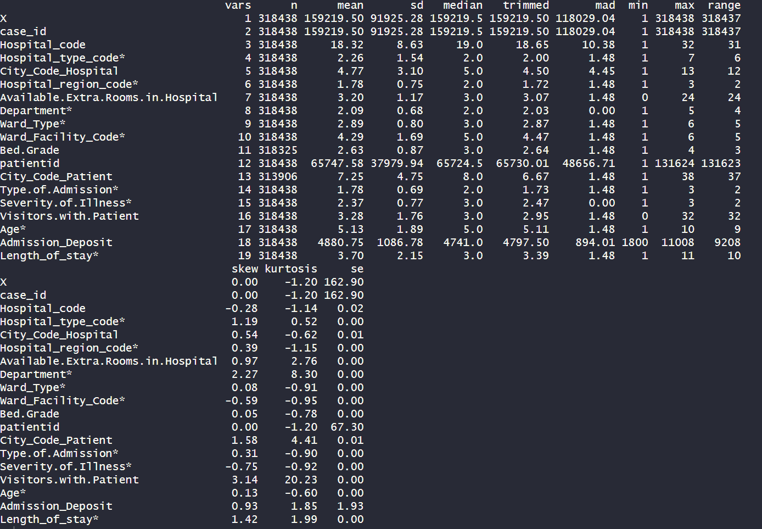

The da set includes 379,972 records with various variables connected to hospital admissions. The average hospital code is 18.32, with a standard deviation of 8.63, demonstrating a broad variety of hospital codes. On average, hospitals have about 3.20 additional rooms, with a standard variation of 1.17. The average entry deposit is 4,880.75, with a standard deviation of 1,086.78.

The dataset is dominated by hospitals with type code 'a' (143,425 records), followed by 'b' (68,946) and 'c' (45,928). The type code 'g' appears the least frequently, with 4,277 records. The gynecological department has the most records (249,486), followed by anesthesia (29,649) and radiation (28,516). The most common ward types are 'R' (127,947 records) and 'Q' (106,165), whereas ward type 'U' is extremely rare, with only 9 records. The most often used ward facility code is 'F', with 112,753 records, followed by 'E' (55,351) and 'D' (51,809). The bulk of patients are classified as bed grades 2 (123,671) and 3 (110,583). Bed grade 1 has the lowest frequency (26,505).

Trauma is the leading cause of admission (152,261 records), followed by emergency (117,676) and urgent (48,501). The bulk of instances are categorized as moderate severity (175,843), followed by minor (85,872) and high (56,723). The age categories 31-40 and 41-50 had the most representation, with 63,639 and 63,749 records, respectively. The age group 91-100 has the fewest records (1,302). The most common duration of stay is 21-30 days (87,491 records), followed by 11-20 days (78,139) and 0-10 days (23,604). There are 6,683 records of stays over 100 days.

These statistics provide a thorough overview of the dataset's distribution and major characteristics, emphasizing the predominance of specific hospital types, departments, and patient demographics. This information can help hospital administrators better understand patient distribution and resource allocation.

The descriptive statistics presented can provide numerous insights into hospital admissions. To begin, the dataset clearly shows that hospitals of various types exist, with type 'a' being the most common. This suggests a varied range of healthcare facilities that cater to the population's various demands. Furthermore, the dominance of the gynecology department shows that a considerable proportion of admissions are for obstetric and gynecological care. The distribution of ward types and facility codes emphasizes the need of understanding the facilities and resources available in hospitals for patient care. The incidence of trauma and emergency admissions emphasizes hospitals' vital role in responding to acute medical needs.

Furthermore, the distribution of sickness severity emphasizes the various levels of medical complexity found in admissions. Finally, the distribution of age groups and length of stay provide light on the demographics and duration of hospitalization, which can affect resource allocation and patient management techniques. Overall, our findings highlight the complexity and diversity of hospital admissions, stressing the importance of personalized healthcare delivery in meeting varied patient demands efficiently.

DISTRIBUTION OF AGE

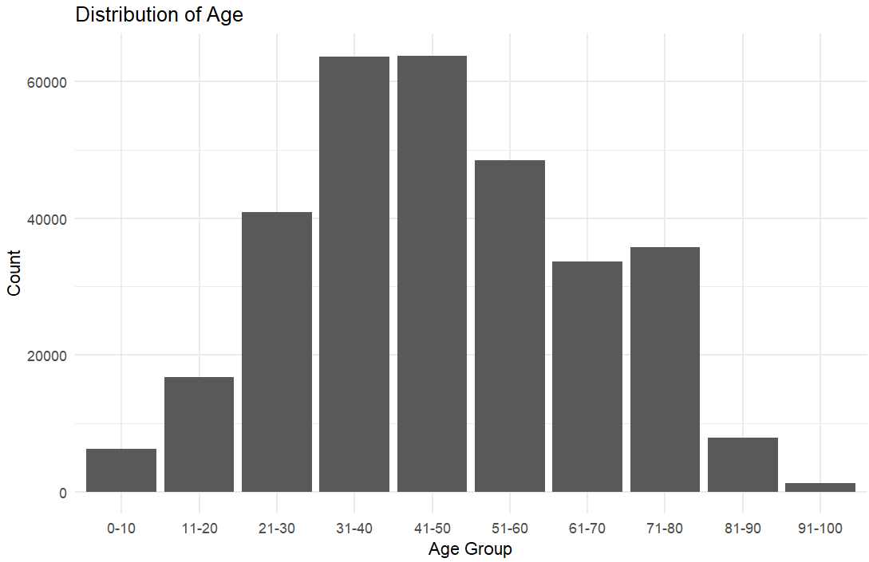

The bar chart titled "Distribution of Age" depicts the frequency of various age groups in the dataset. It demonstrates that the age categories 31-40 and 41-50 contain the most records, indicating a higher concentration of people in these age ranges. In contrast, the age group 91-100 has the fewest records, indicating that it is underrepresented in the sample. This distribution could represent the demographics of the population under study, with middle-aged people being the most prevalent.

PROPORTION OF SEVERITY OF ILLNESS BY AGE

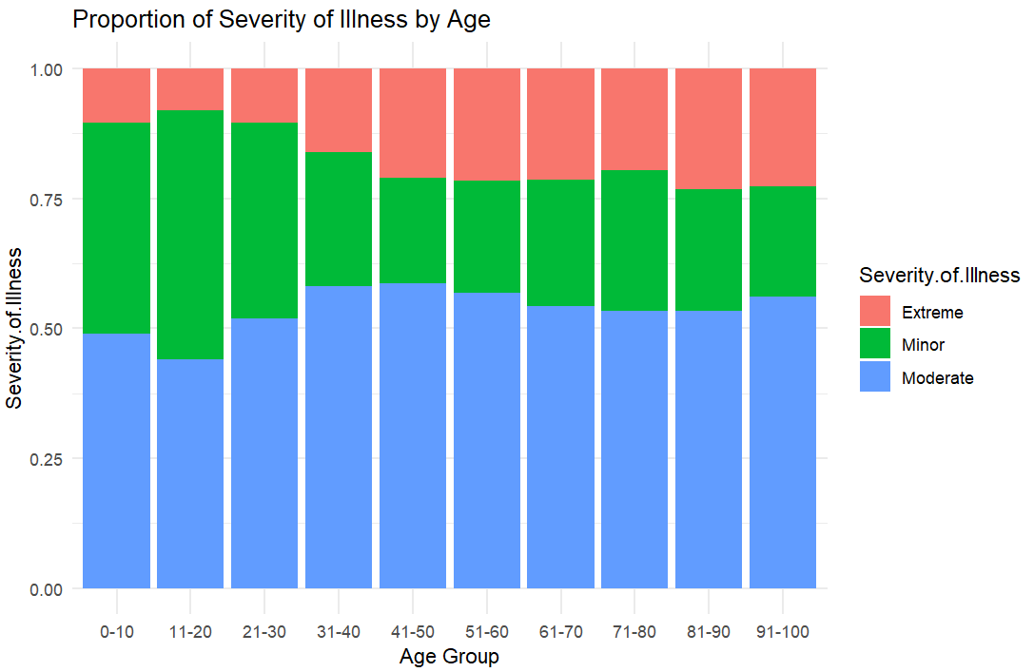

The bar chart named "Proportion of Severity of Illness by Age" depicts the distribution of illness severity across age groups. It shows that adults over the age of 41 had a significantly larger proportion of serious illness severity than younger age groups. Specifically, the severity of sickness decreases from ages 0 to 30. This tendency suggests that as people get older, they are more likely to experience more severe illnesses, indicating a strong age-related pattern in sickness severity.

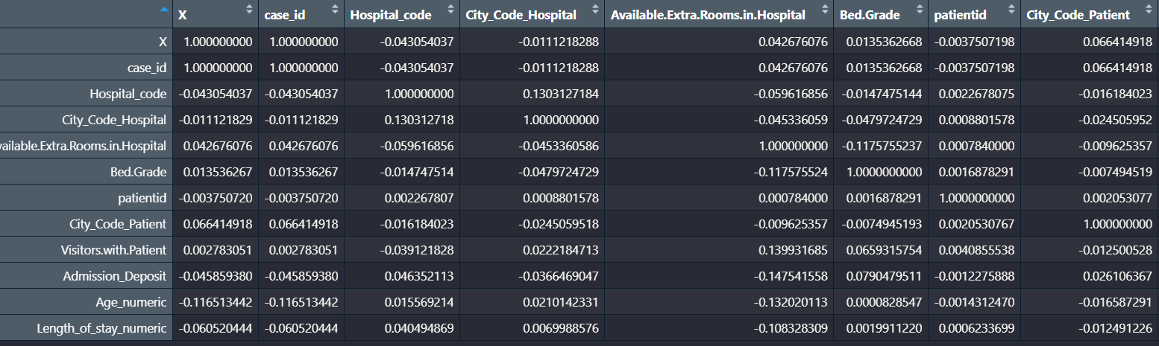

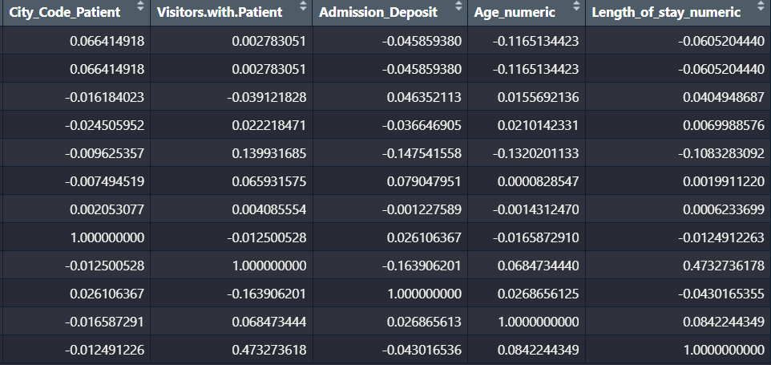

The number of visitors the patient has and the length of stay in the hospital have a strong positive link (0.473). This implies that patients typically stay in the hospital for longer when they receive more visitors. The amount of spare rooms that the hospital has available and the admission deposit have a negative connection (-0.148). This suggests that lower availability of extra rooms is correlated with larger admission deposits, which may be a reflection of hospital resource limitations. Age and length of stay have a positive but somewhat small link (0.084). This suggests that average hospital stays for elderly people may be a little bit longer.

The number of visitors and admission deposit show a negative connection (-0.164), indicating that patients with higher admission deposits typically have fewer visitors. Hospital codes and hospital city codes have a somewhat positive association (0.130), suggesting that hospitals are somewhat geographically clustered or regionally distinct from one another.

These correlations point to possible research topics, such as the effect of visitor volume on patient outcomes and the interaction between patient demographics and hospital resources.

LOGISTIC REGRESSION

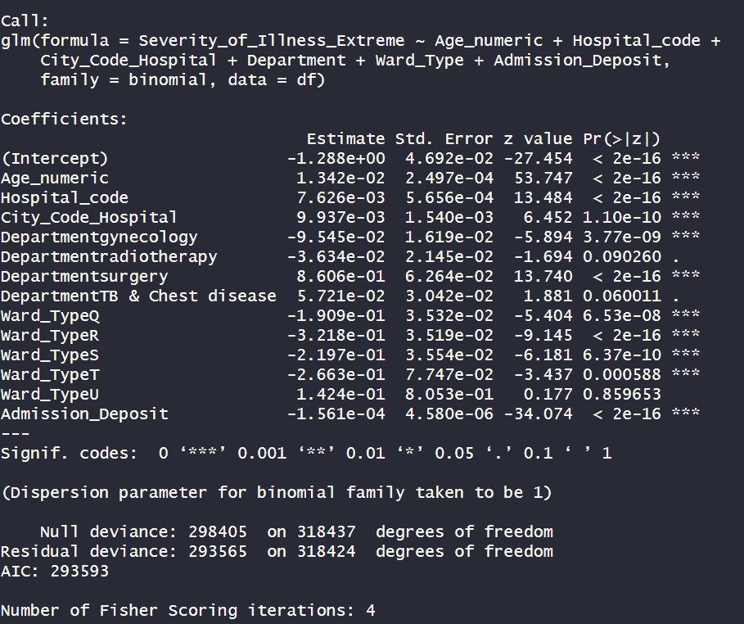

The logistic regression model aimed to predict the likelihood of a patient's sickness being classified as "Extreme" based on a number of predictor factors, including age, hospital code, city code of the hospital, department, ward type, and the admission deposit. The -1.288 intercept shows the log-odds of getting an extremely severe illness when all predictors are at their reference levels. The age coefficient (0.0134) is extremely significant, showing that as one's age increases, so does the risk of experiencing severe disease. Both hospital code (0.0076) and city code (0.0099) exhibit positive and significant coefficients, implying that higher codes are related with a higher risk of severe disease.

The department variable has diverse effects: gynecology has a substantial negative coefficient (-0.0954), suggesting a lower risk, but surgery has a significant positive coefficient (0.8606), indicating an increased likelihood of severe disease. The TB and Chest Disease Department exhibits a marginally significant favorable effect. Several ward types, including Q, R, S, and T, exhibit substantial negative coefficients, indicating a lower chance of high illness severity for patients in these wards. The admission deposit exhibits a very significant negative coefficient (-0.000156), indicating that bigger deposits are related with a decreased risk of extreme severity, albeit the effect size per unit increase is tiny.

The model's deviation decreased from 298405 to 293565, and its AIC was 293593, indicating an acceptable fit. Overall, the model identifies substantial indicators of high illness severity, offering insights that can help explain healthcare decisions and potentially enhance patient care.

CONFUSION MATRIX

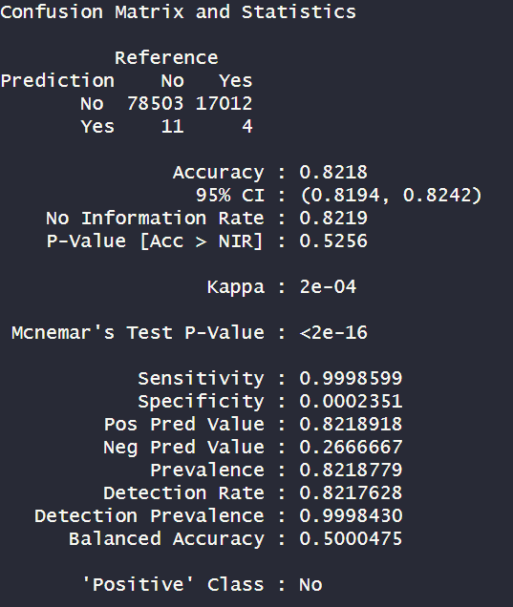

The confusion matrix and other performance measures summarize the logistic regression model's ability to forecast whether an illness is "Extreme" or not. The confusion matrix reveals that the model accurately classified 78,503 examples as "No" for extreme severity and 17,012 cases as "Yes". However, it only properly identified four cases as "Yes" and misclassified eleven cases as "No". The total accuracy of the model is 82.18%, with a 95% confidence interval of 81.94% to 82.42%. This means that the model makes accurate predictions 82.18% of the time. The no information rate (NIR), the accuracy that would be reached by always guessing the most frequent class, is likewise 82.19%, indicating that the model's accuracy is comparable to simply predicting the majority class.

The model's sensitivity, which counts the proportion of actual positives properly recognized, is exceptionally high (99.99%). This suggests that the model is nearly flawless at detecting situations where the severity of sickness is not extreme. In contrast, the specificity, which quantifies the proportion of actual negatives properly recognized, is extremely low, at 0.02%. This shows that the model is unable to appropriately detect cases of great severity. The positive predictive value (PPV), or the percentage of positive outcomes that are real positives, is 82.19%. This shows that when the model predicts "No" for great severity, it is 82.19% correct.

However, the negative predictive value (NPV), or the percentage of negative outcomes that are actual negatives, is only 26.67%. This suggests a lack of trust in the model's ability to correctly detect extreme severity cases when it predicts "Yes".

The balanced accuracy, which is the average of sensitivity and specificity, is around 50%, indicating that the model performs similarly to random guessing. The Kappa statistic, which assesses the agreement between observed and anticipated classifications, is 0.0002, suggesting essentially no agreement above chance.

While the model accurately predicts the majority class ("No" for extreme severity) with high sensitivity and positive predictive value, it fails to identify the minority class ("Yes" for extreme severity), as evidenced by its very low specificity, negative predictive value, and balanced accuracy. This imbalance indicates that the model is skewed toward predicting non-extreme severity cases and is unreliable for detecting extreme severity situations. To increase its efficacy in detecting severe disease, the model may need to be refined further or additional predictive variables added.

LENGTH OF STAY

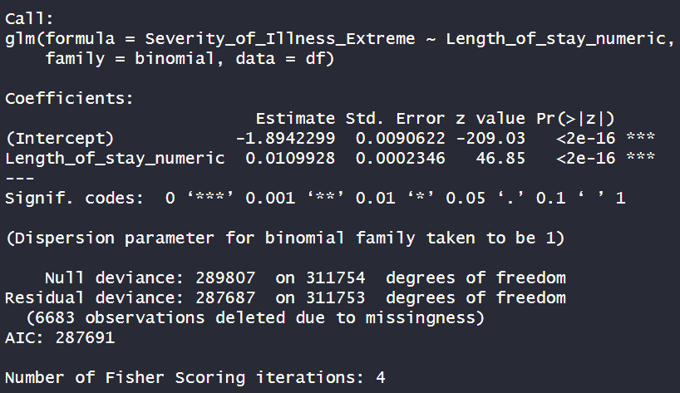

The confusion matrix and accompanying metrics summarize the logistic regression model's performance in predicting whether an illness is "Extreme" or not. The model's predictions are contrasted to the actual outcomes, which include 78,503 true negatives, 17,012 false positives, 11 false negatives, and only 4 genuine positives. The model's overall accuracy is 82.18%, with a 95% confidence interval spanning 81.94% to 82.42%. This suggests that the model properly classifies sickness severity as "Extreme" or "Not Extreme" in 82.18% of cases. However, the no information rate (NIR) is also 82.19%, implying that simply guessing the majority class would produce comparable results. This implies that the model has no meaningful predictive power above a baseline approximation based on the most frequent class.

The model's sensitivity, or ability to correctly detect non-extreme severity cases, is exceptionally high (99.99%). This demonstrates that the model almost usually properly detects cases in which the sickness severity is not extreme. In contrast, the model's specificity, or ability to correctly detect extreme severity situations, is quite poor, at 0.02%. This suggests that the approach is nearly completely worthless in accurately identifying cases of great severity.

The positive predictive value (PPV), or the proportion of positive test results that are real positives, is 82.19%. This shows that when the model predicts "No" for great severity, it is 82.19% correct. The negative predictive value (NPV), or the proportion of real negative test results, is only 26.67%. This suggests a lack of trust in the model's ability to correctly detect extreme severity cases when it predicts "Yes".

The Kappa statistic, which assesses agreement between observed and anticipated categories, is 0.0002. This value is extremely near to 0, showing essentially little agreement other than chance. The balanced accuracy, which averages sensitivity and specificity, is around 50%. This implies that the model's performance is comparable to random guessing, highlighting its failure to properly distinguish between severe and non-extreme severity scenarios.

In summary, the model accurately predicts the majority class (non-extreme severity) with high sensitivity and positive predictive value, but it fails to identify the minority class (severe severity). The very low specificity, negative predictive value, balanced accuracy, and Kappa score, as well as the significant McNemar's test result, all point to a severe bias toward non-extreme severity predictions. Because of this imbalance, the model is unreliable in recognizing situations of severe severity. To increase its predictive skills, particularly for extreme severity, more model improvement and the addition of new predictive elements are required.

**CONCLUSION**

This analysis of the EMR dataset provides useful insights into the factors that influence sickness severity and hospital length of stay (LOS). Descriptive statistics revealed important patterns and distributions among key variables, establishing the framework for additional investigation. The logistic regression models showed that age had a significant impact on the chance of high illness severity, with notable changes in odds ratios after controlling for confounding variables. Predictive modeling with machine learning approaches revealed significant predictors of serious disease, providing high accuracy and visualization via confusion matrices and other indicators. Furthermore, the analysis of LOS revealed critical drivers of hospital stay duration, allowing for a better knowledge of patient outcomes.

Overall, this complete approach emphasizes the need of advanced statistical and machine learning methods in improving healthcare analytics, which eventually leads to better patient care and hospital management.

**REFERENCES**

* GeeksforGeeks. (2024b, May 21). *Machine Learning for Healthcare*. https://www.geeksforgeeks.org/machine-learning-for-healthcare/
* Chapter 2 Epidemiologic Transition: Theory and facts, with ... (n.d.-a). https://pure.rug.nl/ws/portalfiles/portal/10068823/c2.pdf
* *Confusionmatrix: Create a confusion matrix*. RDocumentation. (n.d.). https://www.rdocumentation.org/packages/caret/versions/6.0-94/topics/confusionMatrix