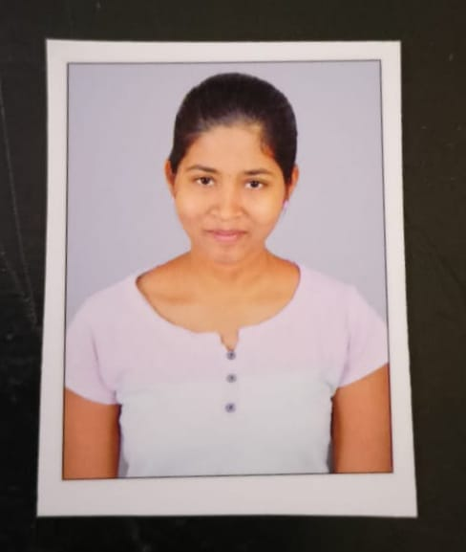

PHOTO

# NAME : Kuppireddy Nikitha

**H.No** : **9-1/143, Bhavani Nagar colony,**

**dammaiguda , nagaram.**

**Phone : 9652083981**

**E-mail : nikithakuppi@gmail.com**

# CAREER OBJECTIVE

To obtain a challenging position as a Software Engineer in a leading multi-national organization where I can use my qualifications and skills to prove my abilities to lead the team as team leader.

# EDUCATIONAL QUALIFICATIONS

|  |  |  |  |  |  |  |  |
| --- | --- | --- | --- | --- | --- | --- | --- |
| **S.**  **No.** | **Examination Passed** | **Name**  **of Institute/ University** | **Discipline/ Subject** | **Month & Year of Passing** | **Percen- tage of Marks** | **Division** |  |
| 1. | B. Tech | Ace Engineering College | Computer Science Engineering -AIML. | 2025 | 8.5 | First |  |
| 2. | Intermediate | Narayana junior college-ECIL | Maths, Physics, Chemistry. | March  2019-21 | 89 | First |  |
| 3. | S.S.C | Board of Secondary Education, TS., Hyderabad. | Maths , Science, Social Studies | March 1  2019 | 9.3 | First |  |

**TECHNICAL PROFILE**

* Languages : C, PYTHON

# ACHIEVEMENT:

# BEC certification

# Cisco PCAP - Programming Essentials in Python

# Cisco CLA - Programming Essentials in C

# Salesforce Developer virtual intership

# Uipath Automation Explorer for Students

# STRENGTHS

* Patience
* Determination
* Positivity

# WEAKNESSES

# Hesitating to say No

# HOBBIES

* Dancing
* Listening to music

**PERSONAL PROFILE**

* Date of Birth : 30th October 2003
* Languages known : English ,Telugu, Hindi.
* Father's Name : Mr. Kuppireddy Ashokreddy
* Mother’s Name : Mrs. Kuppireddy Chandrakala

# DECLARATION :

It is hereby acknowledged that the information furnished above is true to my knowledge.

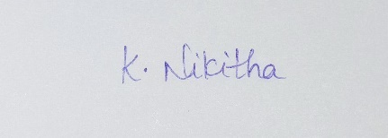

Place : Hyderabad **Signature**

Date : 11/11/2023

* * *