**Exercise 1: Setting Up JUnit**

**Scenario:**

You need to set up JUnit in your Java project to start writing unit tests

**Source code:**

**Calculator.java**

package com.example;

public class Calculator {

public int add(int a, int b) {

return a + b;

}

public int sub(int a, int b) {

return a - b;

}

public int mul(int a, int b) {

return a * b;

}

public int div(int a, int b) {

if (b == 0) {

throw new ArithmeticException("Cannot divide by zero");

}

return a / b;

}

public int mod(int a, int b) {

if (b == 0) {

throw new ArithmeticException("Cannot mod by zero");

}

return a % b;

}

public boolean isEven(int number) {

return number % 2 == 0;

}

public boolean isPositive(int number) {

return number > 0;

}

}

**Test code:**

**CalculatorTest.java**

**package** com.example;

**import** org.junit.Test;

**public** **class** CalculatorTest {

**private** **final** Calculator calc = **new** Calculator();

@Test

**public** **void** testAdd() {

**int** result = calc.add(4, 3);

System.***out***.println("add(4, 3) = " + result);

}

@Test

**public** **void** testSub() {

**int** result = calc.sub(10, 6);

System.***out***.println("sub(10, 6) = " + result);

}

@Test

**public** **void** testMul() {

**int** result = calc.mul(3, 5);

System.***out***.println("mul(3, 5) = " + result);

}

@Test

**public** **void** testDiv() {

**int** result = calc.div(20, 5);

System.***out***.println("div(20, 5) = " + result);

}

@Test

**public** **void** testMod() {

**int** result = calc.mod(10, 3);

System.***out***.println("mod(10, 3) = " + result);

}

@Test

**public** **void** testIsEven() {

**boolean** res = calc.isEven(8);

System.***out***.println("isEven(8) = " + res);

}

@Test

**public** **void** testIsPositive() {

**boolean** res = calc.isPositive(-5);

System.***out***.println("isPositive(-5) = " + res);

}

}

**Pom.xml**

<?xml version="1.0" encoding="UTF-8"?>  
<project xmlns="http://maven.apache.org/POM/4.0.0"  
 xmlns:xsi="http://www.w3.org/2001/XMLSchema-instance"  
 xsi:schemaLocation="http://maven.apache.org/POM/4.0.0 http://maven.apache.org/xsd/maven-4.0.0.xsd">  
 <modelVersion>4.0.0</modelVersion>  
  
 <groupId>org.example</groupId>  
 <artifactId>calculatorapp</artifactId>  
 <version>1.0-SNAPSHOT</version>  
  
 <properties>  
 <maven.compiler.source>24</maven.compiler.source>  
 <maven.compiler.target>24</maven.compiler.target>  
 <project.build.sourceEncoding>UTF-8</project.build.sourceEncoding>  
 </properties>  
 <dependencies>  
 <dependency>  
 <groupId>junit</groupId>  
 <artifactId>junit</artifactId>  
 <version>4.13.2</version>  
 <scope>test</scope>  
 </dependency>  
 <dependency>  
 <groupId>junit</groupId>  
 <artifactId>junit</artifactId>  
 <version>4.13.2</version>  
 <scope>test</scope>  
 </dependency>  
 </dependencies>  
  
</project>

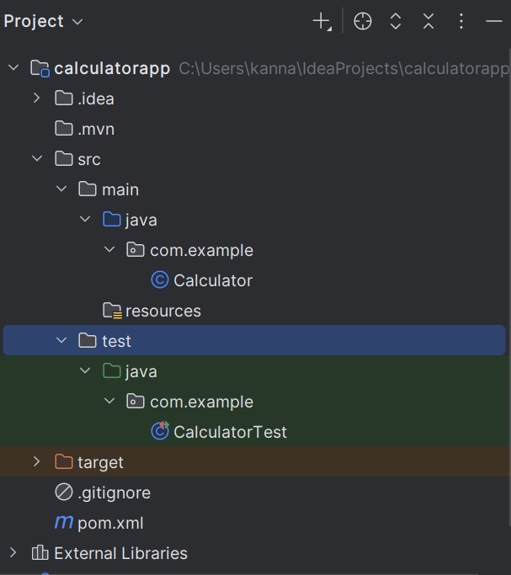

**Output:**

