**Exercise 3: Assertions in JUnit**

**Scenario:**

You need to use different assertions in JUnit to validate your test results

**Source code:**

**AssertionsTest.java**

package com.example;

import org.junit.Test;

import static org.junit.Assert.*;

import static org.hamcrest.CoreMatchers.*;

public class AssertionsTest {

@Test

public void basicAssertions() {

assertEquals(5, 2 + 3);

assertTrue(10 > 1);

assertFalse(2 > 10);

assertNull(null);

assertNotNull("Hi");

System.out.println("basicAssertions passed");

}

@Test

public void arrayAssertions() {

assertArrayEquals(new int[]{1, 2, 3}, new int[]{1, 2, 3});

System.out.println("arrayAssertions passed");

}

@Test

public void identityAssertions() {

String a = "x";

String b = a;

String c = new String("x");

assertSame(a, b);

assertNotSame(a, c);

System.out.println("identityAssertions passed");

}

@Test

public void matcherAssertions() {

assertThat("calculator", containsString("calc"));

System.out.println("matcherAssertions passed");

}

@Test

public void exceptionAssertions() {

assertThrows(ArithmeticException.class, () -> { int x = 1 / 0; });

System.out.println("exceptionAssertions passed");

}

}

**Pom.xml**

<?xml version="1.0" encoding="UTF-8"?>

<project xmlns="http://maven.apache.org/POM/4.0.0"

xmlns:xsi="http://www.w3.org/2001/XMLSchema-instance"

xsi:schemaLocation="http://maven.apache.org/POM/4.0.0 http://maven.apache.org/xsd/maven-4.0.0.xsd">

<modelVersion>4.0.0</modelVersion>

<groupId>org.example</groupId>

<artifactId>assertion-demo</artifactId>

<version>1.0-SNAPSHOT</version>

<properties>

<maven.compiler.source>24</maven.compiler.source>

<maven.compiler.target>24</maven.compiler.target>

<project.build.sourceEncoding>UTF-8</project.build.sourceEncoding>

</properties>

<dependencies>

<dependency>

<groupId>junit</groupId>

<artifactId>junit</artifactId>

<version>4.13.2</version>

<scope>test</scope>

</dependency>

</dependencies>

</project>

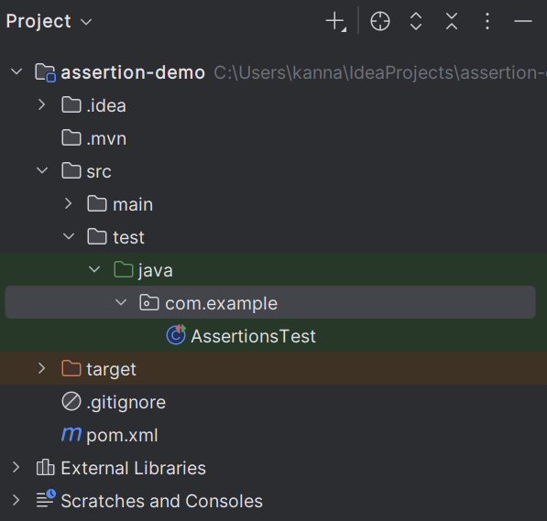

**Output:**

