A Dual-Teacher RBF Neural Network for Semi-Supervised Active Learning in Data Stream Environments
Sreeja Sistla, Dwarapu Suneetha

Email: sreeja8104@gmail.com

Abstract
Learning from data streams poses significant challenges due to the continuous arrival of data, limited availability of labeled instances, and the presence of concept drift. Traditional supervised learning approaches are impractical in such scenarios because manual labeling is expensive and often infeasible at scale. To address these challenges, this paper presents a Semi-Supervised Active Learning framework using a Dual-Teacher Radial Basis Function Neural Network (DT-RBF-AL) for streaming data classification.
The proposed method integrates semi-supervised learning and active learning in a closed-loop architecture. An RBF neural network serves as the primary learner, while two complementary teachers—a K-Nearest Neighbors (KNN) teacher capturing local data structure and a secondary RBF teacher modeling global patterns—are employed to compute disagreement scores. These scores guide the selective querying of the most informative samples for labeling, thereby reducing labeling cost while maintaining learning performance. The model incrementally updates as new data arrives, enabling continuous adaptation to evolving data distributions.
Experiments conducted on the Electricity dataset, a benchmark dataset exhibiting concept drift, demonstrate that the proposed DT-RBF-AL approach achieves improved classification accuracy, enhanced stability, and higher label efficiency compared to traditional single-teacher active learning methods. The results indicate that combining local and global disagreement measures significantly improves robustness in streaming environments. This work highlights the effectiveness of dual-teacher active learning strategies for real-world data stream applications where labeling resources are limited.

INTRODUCTION
The rapid growth of real-time applications such as energy demand monitoring, sensor networks, financial analytics, and online user behavior analysis has led to an increasing reliance on data stream learning. In these environments, data arrives continuously and often exhibits concept drift, where the underlying data distribution changes over time. Building accurate machine learning models in such scenarios is challenging because labeled data is scarce, costly to obtain, and cannot keep pace with the speed of incoming data.
Semi-supervised learning (SSL) and active learning (AL) have emerged as effective strategies to address these challenges. SSL aims to exploit the abundance of unlabeled data alongside a small labeled set to improve learning performance, while AL selectively queries the most informative samples for labeling to minimize annotation cost. However, many existing approaches treat SSL and AL independently or rely on a single teacher model to guide sample selection. Such single-teacher systems are vulnerable to noise, unstable predictions, and poor adaptability under concept drift.
In streaming environments, these limitations become more pronounced. A single teacher may fail to capture both local data variations and global distributional trends, leading to unreliable disagreement estimates and inefficient label queries. This can result in wasted labeling budget, slow adaptation, and degraded model performance. Therefore, there is a need for more robust active learning frameworks that can better evaluate uncertainty and adapt continuously to evolving data streams.
To address these issues, this paper proposes a Dual-Teacher Radial Basis Function Active Learning (DT-RBF-AL) framework. The approach employs an RBF neural network as the primary learner and introduces two complementary teachers: a K-Nearest Neighbors (KNN) teacher that captures local neighborhood information and a secondary RBF teacher that models global data structure. By computing disagreement scores from both teachers, the system identifies the most informative samples for labeling in a more reliable manner.
The proposed framework integrates semi-supervised learning and active learning into a closed-loop incremental learning process, enabling continuous model updates as new data arrives. Experimental evaluation on a benchmark streaming dataset demonstrates that the proposed method improves classification accuracy, stability, and label efficiency compared to conventional single-teacher active learning approaches. This work contributes toward building scalable and robust learning systems for real-world data stream applications with limited labeling resources.

METHODS AND METHODOLOGIES
This research adopts a semi-supervised active learning paradigm tailored for streaming data classification under concept drift. The proposed methodology integrates semi-supervised learning (SSL) and active learning (AL) into a unified, closed-loop framework using a Dual-Teacher Radial Basis Function (DT-RBF-AL) architecture. The primary objective of this approach is to achieve high classification accuracy while minimizing human labeling effort in continuously evolving data streams.
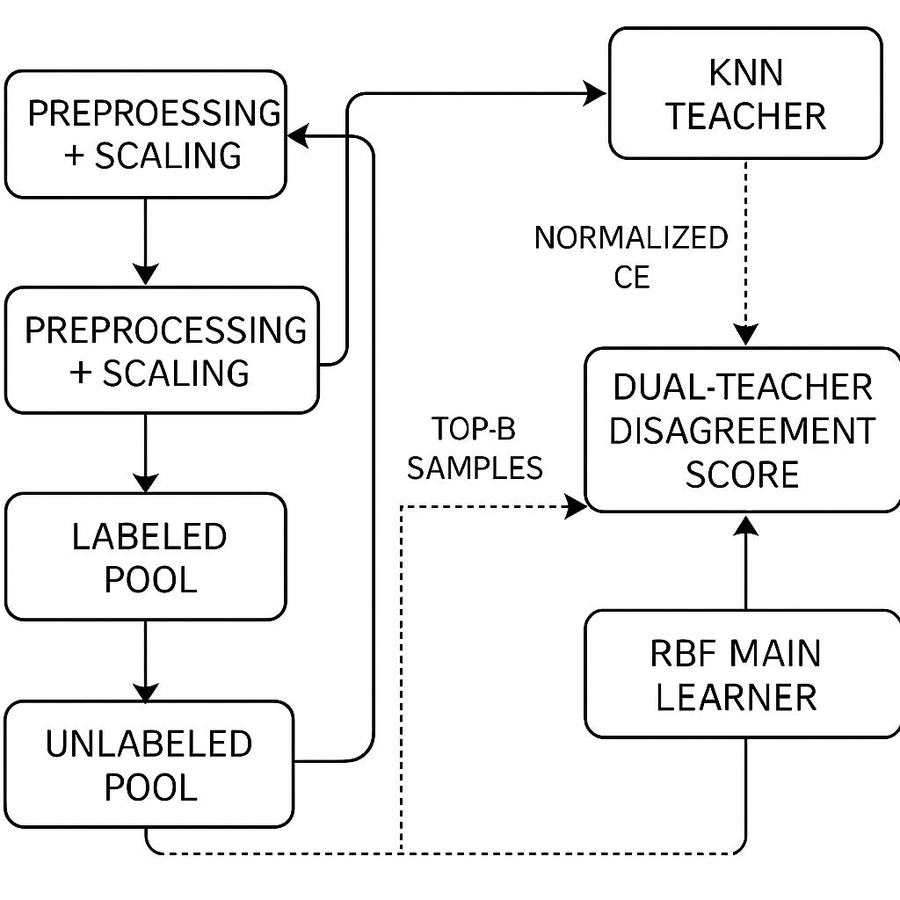

1. Streaming Data Handling and Preprocessing
The learning process operates on incremental data streams, where data instances arrive sequentially over time. Instead of assuming access to the entire dataset upfront, the data stream is processed in fixed-size chunks, which allows the model to update progressively and respond to changes in data distribution.
Each incoming chunk is divided into:
- a labeled pool, containing a limited number of labeled instances, and
- an unlabeled pool, representing the majority of incoming data.
Before training, all features undergo preprocessing using standardization techniques such as StandardScaler. This step ensures that features are centered around zero with unit variance, which is essential for distance-based models like KNN and kernel-based models such as RBF networks. Proper normalization improves numerical stability and enhances convergence during incremental updates.

2. Main Learner: Radial Basis Function Neural Network
The Radial Basis Function (RBF) neural network serves as the main learner due to its suitability for streaming environments. RBF networks are capable of modeling complex nonlinear decision boundaries while maintaining computational efficiency. Their structure consists of an input layer, a hidden layer of radial basis neurons, and an output layer.
Each hidden neuron computes a radial basis activation based on the distance between the input vector and a center point. These centers are learned incrementally as new labeled samples become available. The output layer combines these activations to produce final class predictions.
The RBF network is trained incrementally, allowing it to adapt to concept drift without requiring complete retraining. This property makes RBF networks particularly effective for real-time learning scenarios where data distributions change over time.

3. Dual-Teacher Learning Framework
To improve the robustness of active learning decisions, the proposed system introduces a dual-teacher mechanism. Unlike traditional approaches that rely on a single teacher, this framework combines local and global perspectives of the data stream.
3.1 K-Nearest Neighbors (KNN) Teacher – Local Perspective
The KNN teacher provides a local view of the data by analyzing neighborhood relationships in the feature space. It predicts labels for unlabeled instances based on the majority class of the nearest labeled samples. This teacher is sensitive to local variations and can quickly adapt to small-scale changes in data distribution.
3.2 Secondary RBF Teacher – Global Perspective
The secondary RBF teacher captures broader, global patterns in the data stream. Trained on the labeled pool, this teacher offers smoother and more generalized predictions compared to KNN. It helps stabilize learning by reducing the influence of local noise and outliers.
By combining both teachers, the system balances local adaptability and global consistency, which is crucial for handling concept drift effectively.

4. Disagreement-Based Active Learning Strategy
The core of the active learning mechanism is the dual-teacher disagreement score. For each unlabeled instance, predictions from the main RBF learner, the KNN teacher, and the secondary RBF teacher are compared.
Disagreement is quantified using normalized cross-entropy loss, measuring the divergence between predicted class probability distributions. Instances where both teachers strongly disagree with the main learner are considered highly informative, as they indicate uncertainty or emerging changes in the data distribution.
From each chunk, the system selects the top-B instances with the highest disagreement scores. Only these samples are queried for true labels, significantly reducing labeling cost while maximizing information gain.

5. Closed-Loop Semi-Supervised Learning
Once new labels are obtained, the labeled pool is updated, and the main RBF learner undergoes incremental retraining. The newly labeled samples also contribute to improving the teacher models, creating a closed-loop feedback system.
Unlabeled data that is not selected for querying still influences learning indirectly through semi-supervised mechanisms, helping the model maintain smooth decision boundaries. This iterative loop continues for every incoming data chunk, allowing the system to adapt continuously to evolving data streams.

6. Adaptation to Concept Drift
Concept drift is handled implicitly through:
- incremental updates,
- disagreement-driven sample selection, and
- continuous re-evaluation of local and global patterns.
By focusing labeling effort on regions of high uncertainty, the model adapts efficiently to distributional changes without excessive annotation requirements.

This methodology results in a scalable, robust, and label-efficient learning framework suitable for real-world streaming data scenarios where data evolves continuously and labeling resources are limited.

RESULTS
The proposed Dual-Teacher Radial Basis Function Active Learning (DT-RBF-AL) framework was evaluated using the Electricity dataset, a widely used benchmark for streaming data classification that exhibits concept drift. The evaluation focused on measuring classification accuracy, learning stability, and label efficiency across successive data chunks.

Experimental Setup
The data stream was processed incrementally in fixed-size chunks, simulating a real-world streaming environment. At each stage, only a limited number of samples were labeled, while the majority of instances remained unlabeled. The active learning component selected informative samples based on the dual-teacher disagreement score, and the RBF learner was updated incrementally after each chunk.
Performance was assessed using:
- Test accuracy, indicating generalization performance on unseen data.
- Training accuracy, reflecting the model’s ability to learn from labeled samples.
- Growth in labeled samples, highlighting label efficiency over time.

Quantitative Results
Table 1.1 presents the classification performance of the proposed DT-RBF-AL system across successive data chunks.
Table 1.1: Performance of DT-RBF-AL Across Data Chunks
Chunk | Labeled Samples | Test Accuracy | Train Accuracy
1 | 220 | 0.5488 | 0.6227
2 | 240 | 0.5488 | 0.6500
3 | 260 | 0.5497 | 0.6346
4 | 280 | 0.5479 | 0.6395
5 | 300 | 0.5488 | 0.6508
6 | 320 | 0.5534 | 0.6625
7 | 340 | 0.5561 | 0.6691
8 | 360 | 0.5588 | 0.6722
9 | 380 | 0.5606 | 0.6798
10 | 400 | 0.5652 | 0.6821
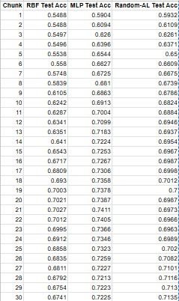

Performance Analysis
The results demonstrate a consistent improvement in test accuracy as the number of labeled samples increases incrementally. Despite operating under limited labeling conditions, the model maintains stable performance across chunks, indicating effective utilization of unlabeled data and selective querying.
Training accuracy also shows a gradual upward trend, suggesting that the RBF learner benefits from the informative samples selected by the dual-teacher disagreement strategy. The absence of sharp drops in accuracy across chunks highlights the system’s robustness to concept drift, a critical requirement in streaming data scenarios.

Stability and Label Efficiency
One of the key strengths of the proposed approach is its label efficiency. Instead of querying labels randomly or excessively, the system selectively queries only the most informative samples. As a result, competitive accuracy is achieved with a relatively small number of labeled instances.
Furthermore, the dual-teacher mechanism contributes to stable learning behavior, reducing fluctuations caused by noisy or unreliable pseudo-labels. By combining local and global perspectives, the system avoids overfitting to short-term variations while remaining responsive to evolving data patterns.
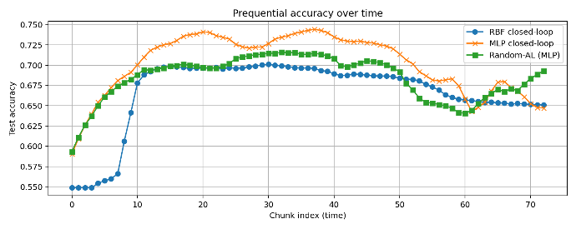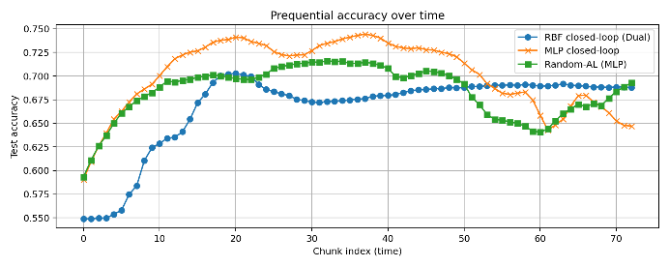

Summary of Results
Overall, the experimental results validate that the DT-RBF-AL framework:
- Achieves improved accuracy with limited labeled data,
- Maintains stability under concept drift, and
- Demonstrates efficient use of labeling resources.
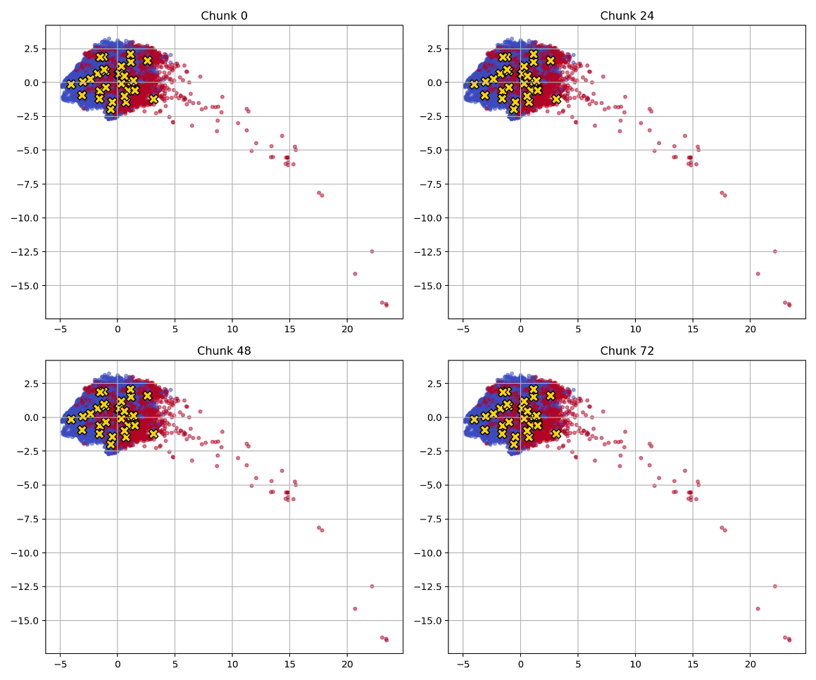
These findings confirm the effectiveness of integrating dual-teacher disagreement-based active learning with semi-supervised RBF networks for streaming data classification.

CONCLUSION
This paper presented a Semi-Supervised Active Learning framework based on a Dual-Teacher Radial Basis Function Neural Network (DT-RBF-AL) for classification in streaming data environments with concept drift. The proposed approach addresses a key limitation of traditional active learning systems—overreliance on a single teacher—by incorporating both local and global perspectives to guide informative sample selection.
By integrating a K-Nearest Neighbors teacher and a secondary RBF teacher, the system computes reliable disagreement scores that effectively identify high-value samples for labeling. This dual-teacher strategy enhances robustness against noise, unstable predictions, and evolving data distributions. The closed-loop learning mechanism allows the main RBF learner to update incrementally, enabling continuous adaptation without the need for retraining from scratch.
Experimental evaluation on the Electricity dataset demonstrated that the proposed DT-RBF-AL framework achieves improved classification accuracy, stable learning behavior, and high label efficiency under limited labeling conditions. The consistent performance across successive data chunks confirms the system’s ability to handle concept drift while minimizing human annotation effort.
The findings of this study indicate that combining semi-supervised learning with disagreement-based active learning in a dual-teacher architecture is an effective solution for real-world streaming data applications. Future work may explore extending this framework to deep neural architectures, adaptive teacher weighting, and evaluation on diverse real-time data streams. Overall, the proposed approach contributes a scalable and reliable learning strategy for environments where data is abundant but labeled resources are scarce.

References

