ASSIGNMENT-14.4

Task 1: Responsive Homepage Layout for a Startup Website
Scenario: You are designing a basic homepage for a startup company that needs to look good on desktops, tablets, and mobile devices.
Prompt:
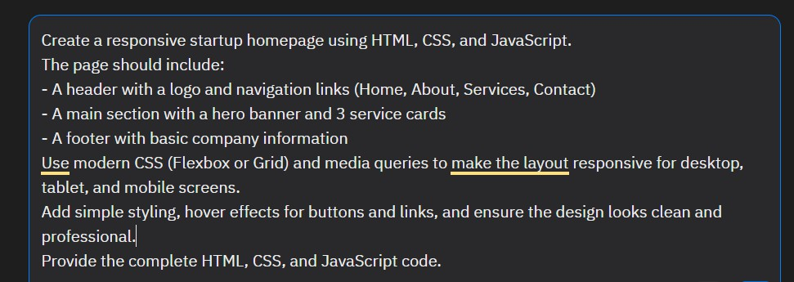
Output:

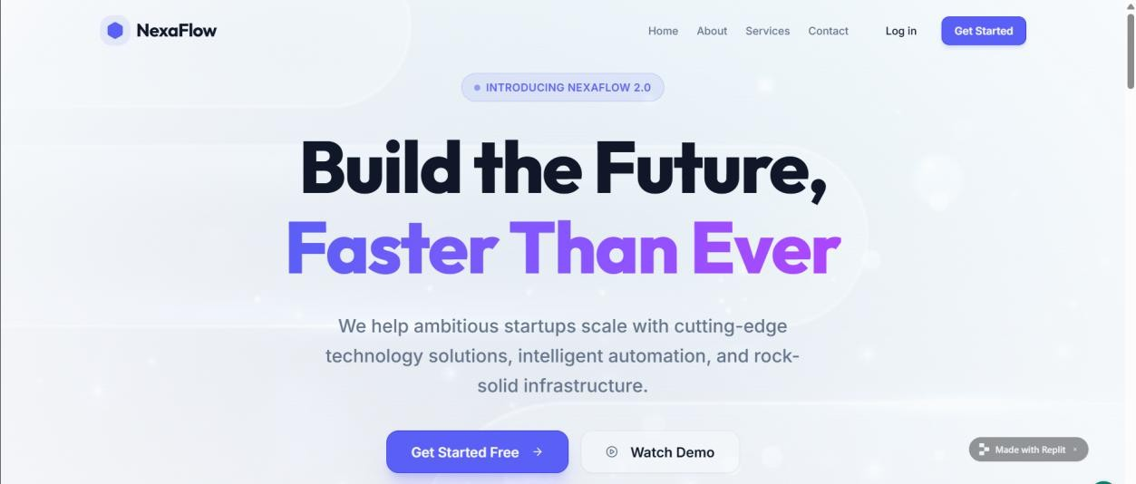

Task 2: Interactive Call-to-Action Button

Scenario: A marketing page requires a call-to-action button that responds when users interact with it.
Prompt:
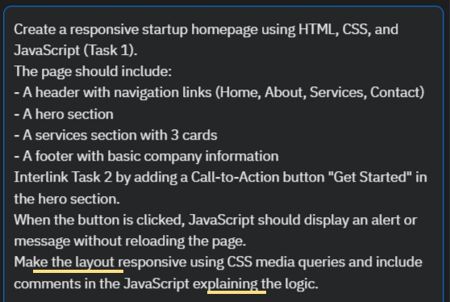
Output:
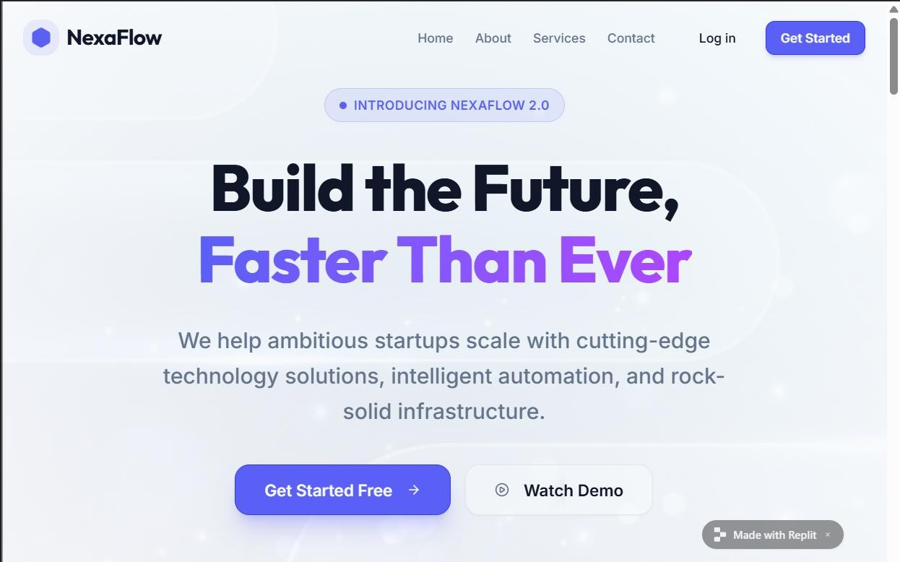

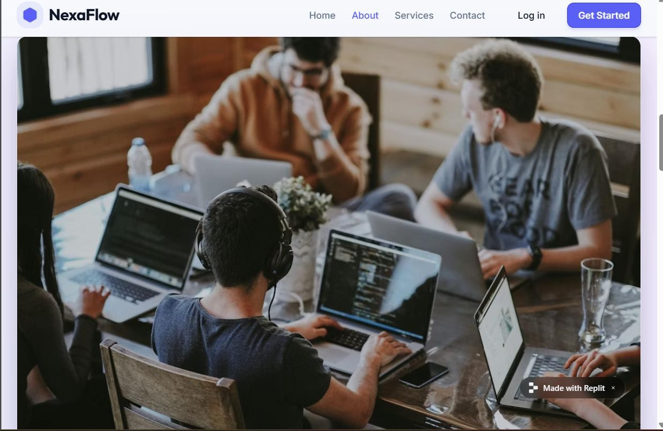

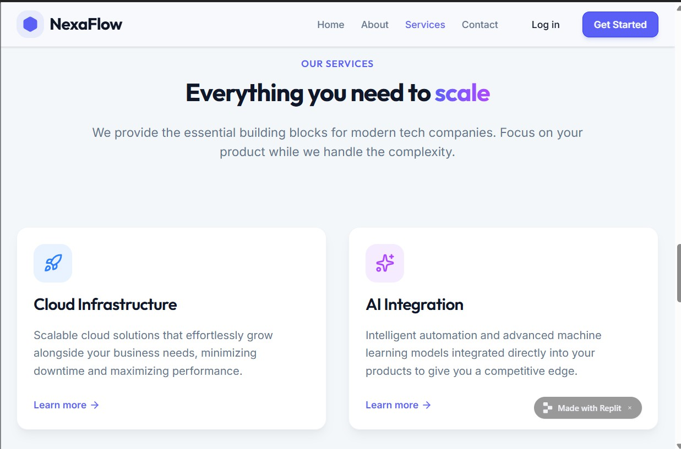

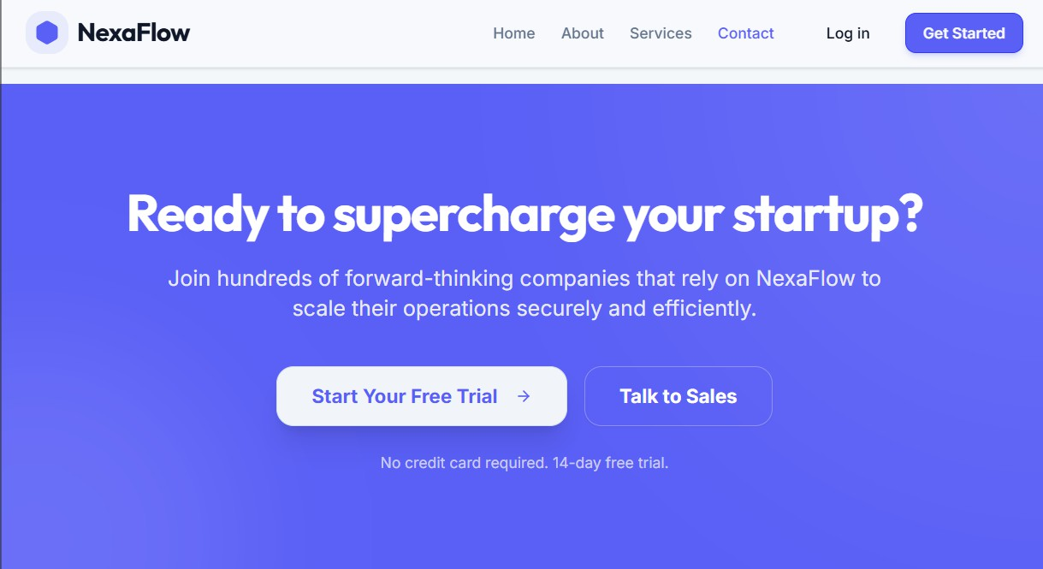
Task 3: Contact Form with Client-Side Validation
Scenario: You are developing a contact form for a company website to collect user queries safely and correctly.
Prompt:
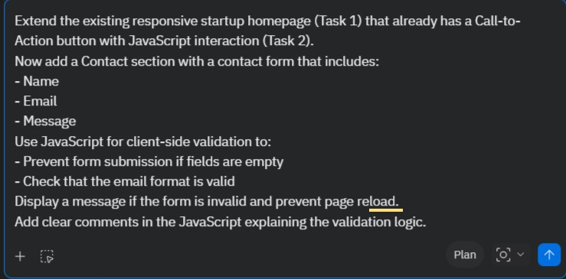
Output:

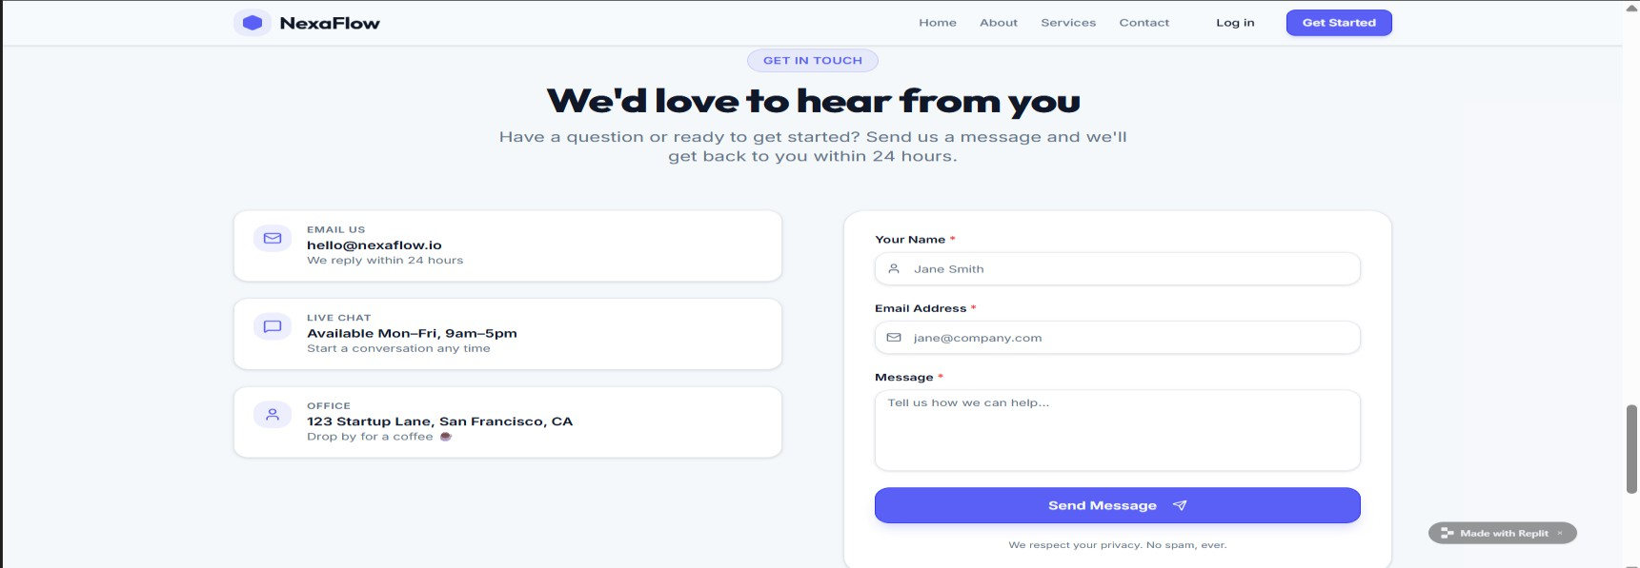
Task 4: Dynamic List Management for a Product Page
Scenario: A product listing page needs to add or remove items dynamically without refreshing the page.
Prompt:
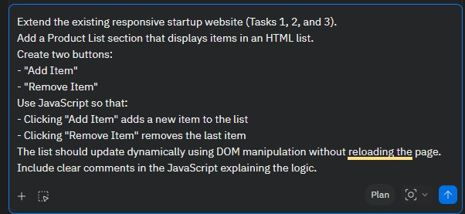
Output:

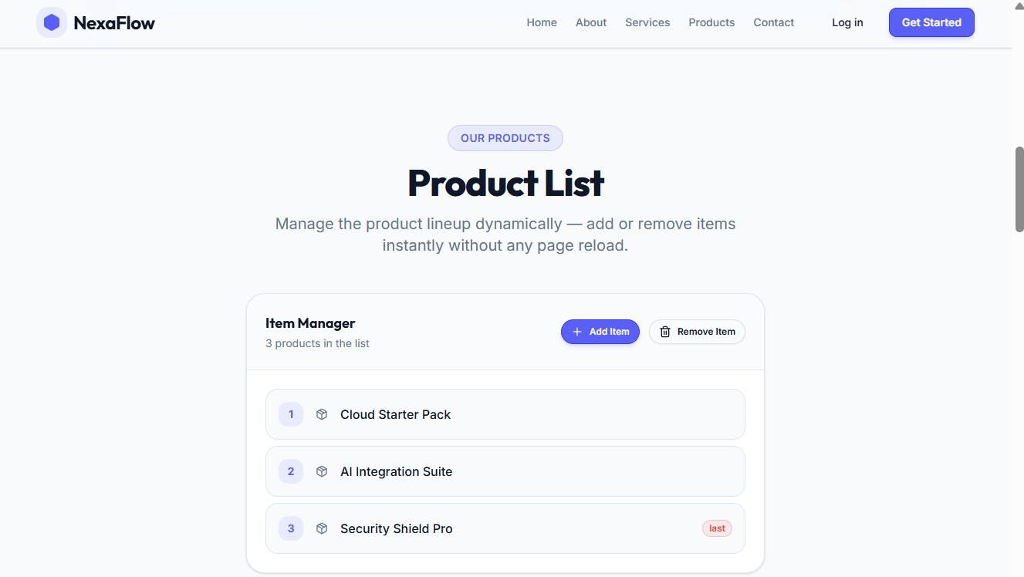
Task 5: Modal Popup for User Notifications
Scenario:You are building a user notification popup for announcements or alerts on a website.
Prompt:
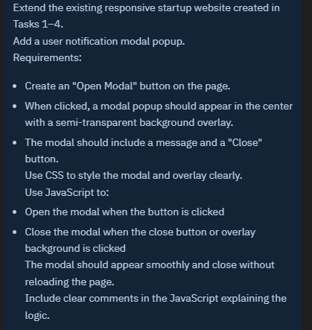
Output:

