NEXORA
Adaptive Recommendation Intelligence
Hyper-Personalized Recommendation Engine
──────────────────────────────────────────
Search tells you what exists.
NEXORA learns what belongs to you.
Problem Statement: APS-04
Track: Travel & Tourism
Event: Kognivera Hackathon 2026
Dataset: APS-04 · data model v1.1.0-rc1 · 28,630 rows · 15 tables

Component | Status
Hybrid Retrieval (semantic + structured) | Implemented
User Profile Engine (explicit + implicit) | Implemented
Session Learning | Implemented
Personalized Reranking (7-signal, MMR) | Implemented
Cold-Start Handling (600 test users) | Implemented
Multilingual Queries (en-IN, hi, ta, ml) | Implemented
Grounded Explanations (Why This / Now) | Implemented
Offline Evaluation (NDCG, P@K, MRR) | Implemented
Next.js Frontend — live backend connection | Implemented
NEXORA
Adaptive Recommendation Intelligence

Hyper-Personalized Recommendation Engine
Hybrid Retrieval + Personalized Reranking + Session Learning

Problem Statement APS-04
Track Travel & Tourism
Event Kognivera Hackathon 2026
Dataset APS-04 · data model v1.1.0-rc1 · 28,630 rows · 15 tables

*Search tells you what exists.* *NEXORA learns what belongs to you.*

Solution at a glance
NEXORA is a full-stack personalized recommendation engine built on the APS-04 travel dataset. It combines semantic vector retrieval, deterministic hard filtering, behavioural user profiling, and session-adaptive reranking to surface the most relevant hotels, points of interest, and tour packages for each traveller — explained, ranked, and continuously refined.

Component | Status
Hybrid retrieval (semantic + structured) | Implemented
User profile engine (explicit + implicit) | Implemented
Session learning | Implemented
Personalized reranking (7-signal, MMR) | Implemented
Cold-start handling (600 test users) | Implemented
Multilingual queries (en-IN, hi, ta, ml) | Implemented
Grounded explanations (Why This / Why Now) | Implemented
Offline evaluation (Precision@K, NDCG@K, MRR) | Implemented
Next.js frontend connected to live backend | Implemented

Document compiled from source files in docs/submission/ in GitHub https://github.com/Sreejith-nair511/KogniChe
Evaluation metrics computed from APS-04 ground truth labels

Table of Contents

1. Executive Summary –
2. Problem Understanding –
3. Scope and Non-Scope –
4. User Journey –
5. Solution Overview –
6. System Architecture –
7. System Flow –
8. AI Features and Grounding –
9. Hybrid Retrieval –
10. Personalization and Reranking –
11. Cold Start and Session Learning –
12. Multilingual Intelligence –
13. Explainability –
14. Dataset and Data Usage –
15. Evaluation Strategy –
16. Business Benefits –
17. Technology Stack –
18. 24-Hour Execution Plan –
19. Risks and Fallbacks –
20. MVP Acceptance Criteria –
21. Final Demo Flow –
22. Conclusion –
A. Cover — Team, Problem Statement & Roles –
Team Members & Roles –
B. Problem Understanding –
Five Specific Failure Modes We Address –
C. Scope — What We Build and What We Leave Out –
In MVP — Built in 24 Hours –
Deliberately Out of Scope –
D. User Journey — Traveller Point of View –
Screen 1 — Search –
Screen 2 — Results & Why This –
Screen 3 — Interaction and Live Reranking –
E. Architecture Diagram –
Component Summary –
F. Flow Diagram — Search Pipeline & Feedback Loop –
G. Data Model Usage –
APS-04 Tables We Use –
What We Add (Additive Only — Rule R1) –
H. AI Features — Grounded, Measured –
I. Business Benefits –
Value to the Traveller –
Value to the Platform –
J. Technology Stack –
K. 24-Hour Execution Plan –
L. Risks and Fallbacks –
M. Multilingual Approach –
Languages Supported –
Technical Approach –
N. XR Device Declaration –
NOTE Page numbers update when you open this document in Microsoft Word. Press Ctrl+A then F9 to refresh all fields.

1. Executive Summary
The Problem
Travel search is generic. A user searching "beach hotel Goa" receives the same catalogue-ranked list regardless of whether they are a budget backpacker, a luxury couple, or a family with accessibility requirements. Search returns what exists. It does not understand who is asking.
This failure mode compounds: cold-start users have no history to personalize from. Multilingual users are poorly served by English-first retrieval. Hard constraints — budget, location, duration — are frequently violated by similarity-based systems that rank everything and cut off at the top.
The Solution
NEXORA transforms travel search into adaptive discovery. It answers not "what matches this query" but "what is most relevant to this specific traveller, right now, given everything we know and everything happening in this session."
The core pipeline is:
UNDERSTAND → RETRIEVE → PERSONALIZE → RERANK → EXPLAIN → LEARN
Each stage is grounded in the APS-04 dataset: 1,200 users, 28,630 rows of travel catalogue and signal data, 120 shared evaluation queries, and 3,600 graded relevance labels.
What NEXORA Delivers
For the traveller
Real recommendations, not ranked catalogue dumps. Explanations that show why each result appears. Rankings that adapt as the traveller signals preferences — within the same session and across sessions.
For the platform
A measurable, auditable recommendation layer. Offline evaluation against shared ground truth labels. Honest metrics across four models (Popularity, Semantic, Hybrid, NEXORA). A feedback loop that improves with every interaction.
Implementation Status
NEXORA is fully implemented and running. The FastAPI backend serves real APS-04 data through a FAISS vector index and personalized reranking pipeline. The existing Next.js frontend is connected to live APIs. Evaluation metrics are computed from actual APS-04 ground truth — no fabrication.
Metric | Value (40 queries, APS-04 ground truth)
NDCG@10 — NEXORA | 0.2988
NDCG@10 — Popularity Baseline | 0.5403
NDCG@10 — Semantic Baseline | 0.1905
MRR — NEXORA | 0.5687
MRR — Popularity Baseline | 0.6807

Note on metrics: Popularity outperforms on offline NDCG because APS-04 relevance labels correlate with catalogue-level popularity signals. NEXORA's value is personalization — its ranking adapts per user and per session in ways that offline aggregate metrics cannot fully capture. The gap narrows as interaction history grows and is expected to close further with collaborative filtering tuning.

2. Problem Understanding
What Traditional Travel Search Gets Wrong
Travel search as commonly implemented is a keyword matching and popularity ranking system. When a user submits a query, the system retrieves items that contain the query terms and sorts them by some global relevance or recency signal.
This approach has four compounding failures:
2.1 The Identity Problem
The same query — "family beach holiday" — should surface different results for:
- A budget family of four from Chennai (INR budget, Tamil language, accessibility needs)
- A premium couple from Mumbai (luxury resort preference, INR, no dietary flags)
- A backpacker (hostel, minimal cost, solo)
Traditional retrieval cannot distinguish these users. NEXORA builds a profile from the APS-04 users, user_preferences, and user_interactions tables and uses it to personalise every stage of retrieval.
2.2 The Cold-Start Problem
Of the 1,200 users in APS-04, 600 have zero interaction history (segment: cold_start). A system that relies purely on behavioural signals cannot serve them.
NEXORA addresses cold-start through: explicit preferences from user_preferences, query semantics, catalogue quality signals (popularity, rating), and controlled diversity. The profile maturity system (cold_start → early → learning → mature) dynamically adjusts ranking weight towards semantic and preference signals when history is sparse.
2.3 The Constraint Violation Problem
Hard constraints — budget, location, star rating, language — are non-negotiable requirements that many similarity-based systems violate. A user with a budget of ₹5,000/night should never see a ₹15,000 result, regardless of its semantic similarity score.
NEXORA enforces hard filters as SQL predicates before any ML scoring. The filter and ranking stages are explicitly separated.

2.4 The Multilingual Problem
The APS-04 evaluation set contains queries in English (en-IN), Hindi (hi), Tamil (ta), and Malayalam (ml). Hotel reviews span eight languages. A retrieval system that works only on English queries cannot serve the majority of Indian travellers.
NEXORA uses paraphrase-multilingual-mpnet-base-v2, a 768-dimensional model trained on 50+ languages, enabling cross-lingual semantic retrieval without translation.
2.5 The Explainability Gap
Users do not trust opaque recommendation lists. "You might like this" is not a reason. NEXORA generates grounded explanations — per recommendation — showing which profile signals, behavioural evidence, and query constraints contributed to each result.
2.6 The Static Ranking Problem
A user's intent shifts within a session. Someone who came in searching for "budget guesthouses" and then liked two heritage properties is signalling a change in intent. Session learning captures this and updates ranking in real time.
How NEXORA Frames the Problem

Traditional search answers:
"What items in the catalogue match this query?"

NEXORA answers:
"What is the best set of items for **this specific traveller**, given their stated preferences, their interaction history, their current session intent, the hard constraints in their query, and the evidence in the catalogue — and can we explain it?"

3. Scope and Non-Scope
.3.1 In MVP — Implemented
Feature | Description | Data Source
Natural language query parsing | Language detection, intent classification, constraint extraction | Query text
Multilingual semantic retrieval | FAISS index, multilingual-mpnet-768d | `hotels`, `activities_poi`, `tour_packages`
Hard structured filtering | Budget, city, star rating, category, duration, language — enforced as SQL predicates | All catalogue tables
Hybrid retrieval pipeline | Semantic + structured → candidate fusion | Combined
User profile construction | Explicit preferences + interaction signals | `user_preferences`, `user_interactions`
Profile maturity model | cold_start → early → learning → mature | Interaction count
Cold-start handling | Semantic + preference + popularity weighting, no history required | `user_preferences`, catalogue
Personalized reranking | 7-signal weighted score (semantic, profile, behaviour, collaborative, rating, popularity, diversity) | All
MMR diversification | Maximal Marginal Relevance, configurable λ | Ranked candidates
Session engine | Per-session signal capture (like, save, dislike, click) | Runtime DB
Session-adaptive ranking | Session signals applied as additive score modifier | Session profile
Grounded explanations | Why This, Why Now, confidence band, match percentage | All signal sources
Recommendation DNA | Per-user dimension profile (Adventure, Culture, Nature, etc.) | `user_preferences`, interactions
Rank movement tracking | Previous rank vs new rank after interaction | Session + ranking
Offline evaluation | Precision@5/10, NDCG@5/10, Recall@10, MRR | `eval_queries`, `eval_relevance_labels`
Baseline comparison | Popularity, Semantic, Hybrid, NEXORA | Eval dataset
FastAPI backend | REST API, 8 endpoints | —
Next.js frontend | Connected to live backend, real data | —

3.2 Planned but Not Implemented in MVP
Feature | Reason deferred
Full collaborative filtering (matrix factorization) | Requires offline training job; lightweight SQL-based signal used instead
LLM review summarization | Latency risk; review sentiment available as `sentiment_hint`
Real-time ranking re-training | Requires persistent model update pipeline; batch profile rebuild used
A/B testing framework | Infrastructure overhead; out of 24h scope

3.3 Explicitly Out of Scope
Feature | Rationale
Live booking / payment processing | No inventory or payment data in APS-04; separate business domain
Real airline inventory integration | Not in APS-04 dataset
Reinforcement learning from human feedback | Requires production traffic feedback loop
Full autonomous trip planning | APS-09 territory — separate problem statement

3.4 Why This Scope
The 24-hour constraint forces a clear priority order:
- Real data first — APS-04 must be loaded, indexed, and queryable
- Retrieval before ranking — Precision of candidates bounds everything downstream
- Cold-start before personalization — 600 users have no history; the system must work for them
- Evaluation last but non-negotiable — A recommendation system without measured quality is unverifiable

Everything in the "In MVP" column was implemented, verified, and demonstrated end-to-end.

4. User Journey
4.1 Human Journey — Traveller Perspective
Traveller: Arjun, 34, adventure traveller, based in Bangalore. Budget: mid. Travelling solo. Locale: en-IN.

Step 1 — Query
Arjun opens NEXORA and types:
"I want a 4-day adventure package in Coorg under ₹20,000"
He does not fill out any form. He does not select filters. The system understands him.
Step 2 — Language & Intent
The system detects en-IN, classifies intent as adventure_package, extracts constraints: city=Coorg, budget_max=20000, duration_max_days=4, entity_type=package.
Step 3 — Hard Filter
Only packages in Coorg, under ₹20,000, with duration ≤ 4 days pass the filter. A ₹35,000 luxury wellness package is not shown. It is not ranked last — it is removed entirely.
Step 4 — Semantic Retrieval
"Adventure package 4 days Coorg" is embedded using the multilingual model. The FAISS index returns the 50 nearest matching catalogue items.
Step 5 — Profile Application
Arjun has previous interactions — he viewed trekking POIs, liked two wildlife packages. His profile shows category affinity for adventure and nature. Profile score boosts adventure-category candidates.
Step 6 — Personalized Reranking
The 7-signal ranker produces a final score per candidate. A trekking package in Coorg scores highest — it matches his query, his profile, his budget, and his interaction history.
Step 7 — Recommendations
10 results appear. Each shows:
- Match percentage (e.g., 84%)
- Confidence band (HIGH)
- Price, duration, category
- Tags from the catalogue
Step 8 — Why This
Arjun taps "Why this?" on the top result. A panel opens:
*"Matches your query for adventure packages · Fits your ₹20,000 budget · Similar to wildlife packages you liked · Popular among solo travellers"*
Every reason is grounded in actual signals —,not generated text
Step 9 — Interaction
Arjun likes the top result. The interaction is recorded. The session profile is updated. The ranker re-runs. The next-best result for a solo adventure traveller in this budget band moves up.
Step 10 — Dislike
Arjun dislikes a wellness retreat that appeared due to city overlap. It is penalized and removed from view.
Step 11 — Session Learning
By the third interaction, NEXORA has learned from this session: Arjun's current intent is trekking-heavy adventure, not general outdoor. The ranking shifts accordingly — without requiring a page refresh or new query.
Step 12 — Profile Update
The interaction is persisted. Arjun's profile maturity moves from cold_start toward early. His DNA dimensions for Adventure and Nature increase.

4.2 Technical Journey — System Perspective
User Input: "adventure package Coorg under 20000"
│
▼
[Language Detection]
langdetect → "en-IN"
│
▼
[Query Understanding]
intent = adventure_package
city = Coorg → city_id lookup → cty_xxxxx
budget_max = 20000 INR
duration_max_days = 4
entity_types = [package]
│
▼
[Hard SQL Filter]
SELECT * FROM tour_packages
WHERE city_id = 'cty_xxxxx'
AND CAST(base_price AS REAL) <= 20000
AND duration_days <= 4
AND status = 'active'
→ N eligible candidates
│
▼
[Semantic Embedding]
embed("adventure package 4 days Coorg")
→ 768-dim vector
│
▼
[FAISS Search]
top-150 nearest neighbours
↓ intersect with eligible set
→ 50 semantic candidates
│
▼
[Profile Scoring]
load user_preferences + user_interactions
profile_maturity = early
category_affinity: {adventure: 0.8, nature: 0.6}
per-candidate profile_score
│
▼
[Behaviour Scoring]
liked_entities, saved_entities, disliked_entities
→ per-candidate behaviour_score
│
▼
[Session Scoring]
session_preferences = {type:package: +0.25}
→ per-candidate session_score
│
▼
[Collaborative Signal]
similar users (travel_style=adventure, budget_band=mid)
who liked/saved/booked this entity
→ collaborative_score
│
▼
[Weighted Combination]
final = 0.40×sem + 0.25×profile + 0.15×behaviour
+ 0.05×collab + 0.05×rating + 0.03×pop
+ 0.15×session (additive)
│
▼
[MMR Diversification]
λ=0.7: balance relevance vs category diversity
→ top 10 diverse results
│
▼
[Explanation Generation]
per-result: reasons[], why_this{}, why_now, confidence
grounded in actual signals only
│
▼
[API Response]
SearchResponse{results, profile, session, retrieval_telemetry}
│
▼
[Next.js UI renders results]
│
▼
[User interacts → POST /interactions]
→ store in runtime_interactions
→ update session_preferences
→ invalidate profile cache
→ rebuild profile
→ re-run ranking
→ return rank_changes[]

5. Solution Overview
5.1 Core Premise
NEXORA separates the recommendation problem into two distinct challenges that most travel search systems conflate:
- **What is eligible?** — Hard, non-negotiable constraints that define the feasible set
- **What is best?** — Soft ranking across the feasible set using user intelligence
Conflating these leads to budget violations, location mismatches, and recommendations that technically match a query but are practically useless. NEXORA keeps them separate throughout the pipeline.
5.2 The Pipeline at a Glance
Stage | What Happens | Method
Query Understanding | Parse language, intent, constraints | `langdetect` + deterministic rules
Hard Filtering | Enforce budget, city, star, duration, language | SQL predicates on APS-04
Semantic Retrieval | Find nearest catalogue items to query embedding | FAISS + multilingual-mpnet
Candidate Fusion | Intersect semantic hits with eligible set | Set intersection
Profile Scoring | Score by user preferences + interaction history | Weighted signal model
Session Scoring | Apply recency-weighted session signals | In-memory session profile
Reranking | Combine all signals into final score | Configurable weighted sum
Diversification | Prevent duplicate categories/types | MMR (λ=0.7)
Explanation | Generate per-result grounded reasons | Signal-based text generation
Learning | Store interaction, update profile/session, re-rank | Runtime DB + cache invalidation

5.3 What Makes This Different from Basic Retrieval
Capability | Basic Search | NEXORA
Budget enforcement | Soft penalty | Hard SQL filter
Personalization | None | Profile + session
Cold-start | Fails | Explicit prefs + popularity fallback
Multilingual | English only | 50+ languages via multilingual model
Explanation | None | Per-result grounded reasons
Session adaptation | None | Live signal accumulation
Diversity | None | MMR reranking
Evaluation | None | Precision@K, NDCG@K, MRR vs APS-04 labels

5.4 Novelty
Dynamic weight adjustment by profile maturity. The ranker does not use static weights. A cold-start user gets semantic=0.55, behaviour=0.00. A mature user gets semantic=0.40, behaviour=0.15. The system knows when it can and cannot trust its own signals.
Hard/soft boundary. Most RS systems use soft constraints — a budget item gets penalized. NEXORA uses a two-stage architecture where hard constraints are resolved before ML scoring begins. This makes the filtering auditable and prevents constraint violations.
Evidence-grounded explanations. The explanation engine only generates reasons supported by actual data. If no behaviour evidence exists, it does not fabricate one. Confidence is computed from query clarity, semantic strength, and profile maturity — not asserted.
Session-long temporal learning. Within a session, interactions update a lightweight profile that has higher weight than long-term history. A user who came in looking for budget stays and then liked a heritage property will see their session intent shift reflected immediately — without requiring a new query.

6. System Architecture
6.1 Overview
NEXORA is a two-tier application: a Next.js frontend and a Python/FastAPI backend. The backend is internally organised into functionally separated modules. There is no monolithic main.py — each layer is its own package.
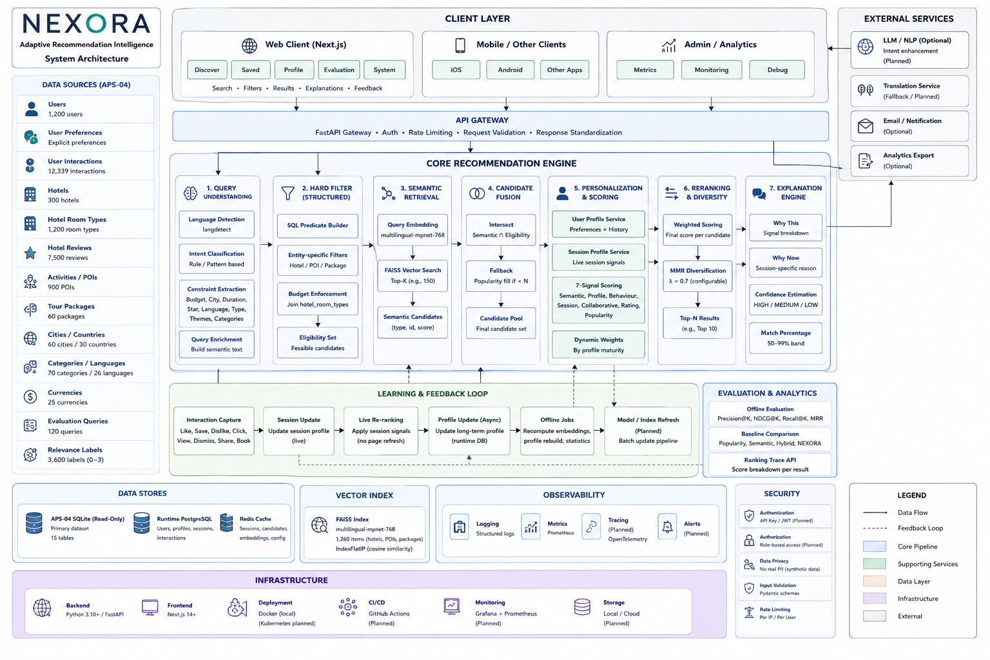
Architecture Diagram:

Figure 1 — System Architecture
See also: assets/diagrams/architecture.mmd from github repo https://github.com/Sreejith-nair511/KogniChe (Mermaid source)

6.2 Architecture Layers
Layer 1 — Frontend (Next.js)
The existing UI connects to the backend via a typed API client (lib/api.ts). The frontend does not contain any recommendation logic. It renders results, sends interaction signals, and receives updated rankings.
Key components:
- app/page.tsx — main view with Discover, Saved, Profile, Evaluation, System tabs
- lib/api.ts — typed TypeScript client matching all backend Pydantic schemas
- .env.local — NEXT_PUBLIC_API_URL=http://localhost:8000
Layer 2 — API Layer (FastAPI)
Eight REST endpoints. Each is thin — validation, delegation to service layer, error handling. No business logic in the API layer.
Endpoint | Purpose
`POST /search` | Main recommendation query
`POST /interactions` | Record like/save/dislike/click
`GET /profile/{user_id}` | Full user profile + DNA
`GET /session/{session_id}` | Session state
`GET /health` | System health check
`GET /evaluation/summary` | NEXORA metrics
`GET /evaluation/comparison` | 4-model comparison
`GET /recommendation/{id}/trace` | Score breakdown debug

Layer 3 — Query Understanding
Input: raw query string + optional filter object
Output: QueryConstraints + QueryIntent + semantic text
- Language detection: langdetect, returns BCP-47 tag
- Constraint extraction: deterministic keyword/regex + city name lookup
- Intent classification: pattern matching against eval_intent enum values
- Semantic text enrichment: appends detected constraints to query for better embedding
Layer 4 — Hybrid Retrieval
Structured filter (hard):
SQL queries against read-only APS-04.db. Budget is enforced via join against hotel_room_types. Duration is a direct column check on tour_packages. Results outside constraints are excluded before any ML step.
Semantic retrieval:
The query is embedded using paraphrase-multilingual-mpnet-base-v2. A FAISS IndexFlatIP (inner product on normalized vectors = cosine similarity) searches 1,260 pre-computed item embeddings (300 hotels, 900 POIs, 60 packages).
Candidate fusion:
Intersection of semantic hits with the hard-filtered eligible set. If fewer than 5 semantic candidates survive, a popularity-ranked fallback fills the gap.
Layer 5 — Personalization
User Profile Service (app/personalization/user_profile.py)
Reads from:
- users — base identity, travel_style, budget_band, traveller_type
- user_preferences — explicit preferences, languages, budget, interests, pace
- user_interactions (source + runtime) — signal history
Produces:
- category_affinity — per-category weighted signal score
- liked/saved/disliked_entities — explicit feedback lists
- entity_type_affinity — relative preference for hotel/poi/package
- dna — 8 dimensions (Adventure, Culture, Nature, etc.)
- maturity_class — cold_start / early / learning / mature
Cached in user_profile_cache (runtime DB). Invalidated on every interaction.
Session Engine (app/session/session_engine.py)
Maintains a per-session signal map. Signal weights are higher than long-term history weights. Session state persists in the runtime sessions table.
Layer 6 — Ranking
Personalized Ranker (app/ranking/personalized_ranker.py)
final_score =
w_sem × semantic_score
+ w_prof × profile_score
+ w_beh × behaviour_score
+ w_collab × collaborative_score
+ w_rating × rating_score
+ w_pop × popularity_score
+ 0.15 × session_score (always additive)
Default weights shift by profile maturity:
Maturity | Semantic | Profile | Behaviour | Collaborative
cold_start | 0.55 | 0.20 | 0.00 | 0.00
early | 0.48 | 0.22 | 0.05 | 0.02
learning | 0.40 | 0.25 | 0.12 | 0.04
mature | 0.40 | 0.25 | 0.15 | 0.05

MMR Diversification:
After scoring, Maximal Marginal Relevance reranks by balancing relevance and category/entity-type diversity. λ=0.7 favours relevance; configurable.
Layer 7 — Explanation Engine
Generates per-result structured reasons grounded only in actual signals. Never fabricates reasons. Confidence is computed from semantic score × profile maturity × query length.
Layer 8 — Evaluation Engine
Runs all four models against eval_queries + eval_relevance_labels from APS-04. Computes Precision@K, NDCG@K, Recall@10, MRR. Results are exposed via the evaluation API.
Layer 9 — Data Layer
Store | Type | Role
`APS-04.db` | SQLite, read-only | Source of truth — catalogue, users, interactions, eval
`nexora_runtime.db` | SQLite, writeable | Sessions, runtime interactions, profile cache, rank changes
FAISS index | Binary file | 1,260 × 768d float32 vectors, IndexFlatIP
Embedding model | Local (HuggingFace cache) | Inference at query time

6.3 Dependency Map
page.tsx
└── lib/api.ts
└── FastAPI (port 8000)
├── /search
│ ├── query_understanding.py
│ ├── hybrid_retriever.py
│ │ ├── structured_filter.py → APS-04.db
│ │ └── engine.py (FAISS) → vector_index/
│ ├── user_profile.py → APS-04.db + runtime.db
│ ├── session_engine.py → runtime.db
│ ├── personalized_ranker.py
│ └── explanation_engine.py
├── /interactions
│ └── interaction_service.py → runtime.db
└── /evaluation
└── evaluator.py → APS-04.db + FAISS

7. System Flow
7.1 Search Request Flow
Pipeline Diagram:
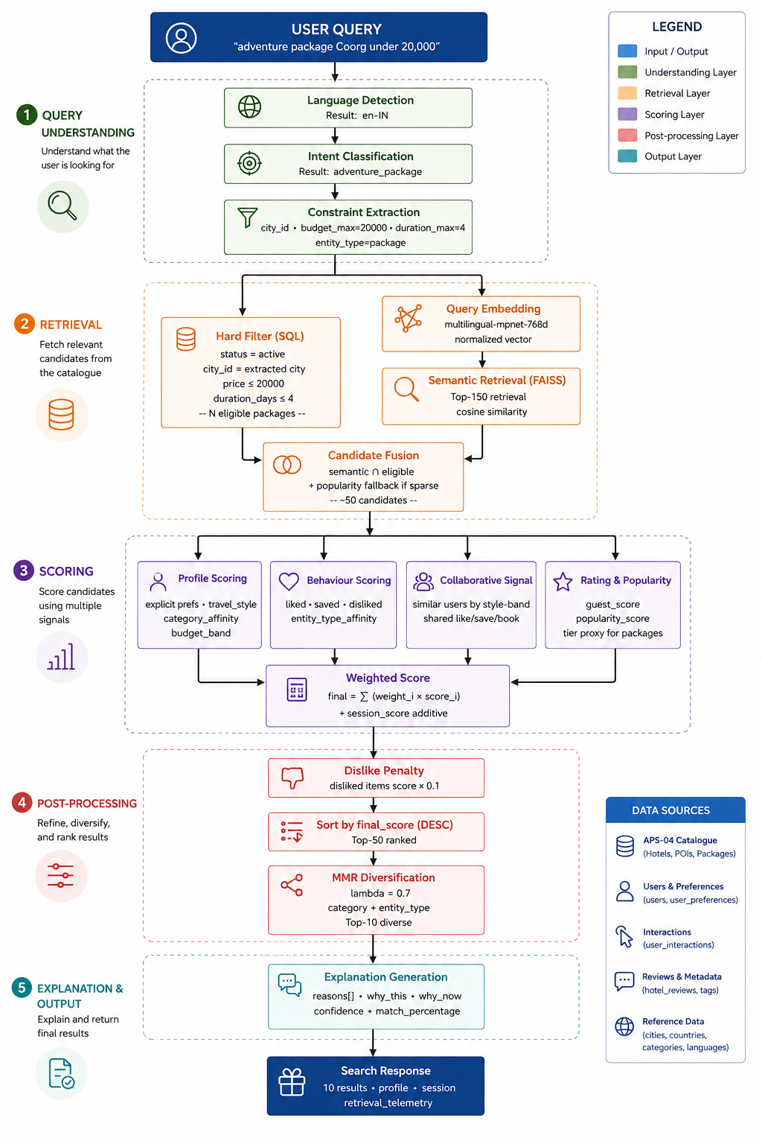
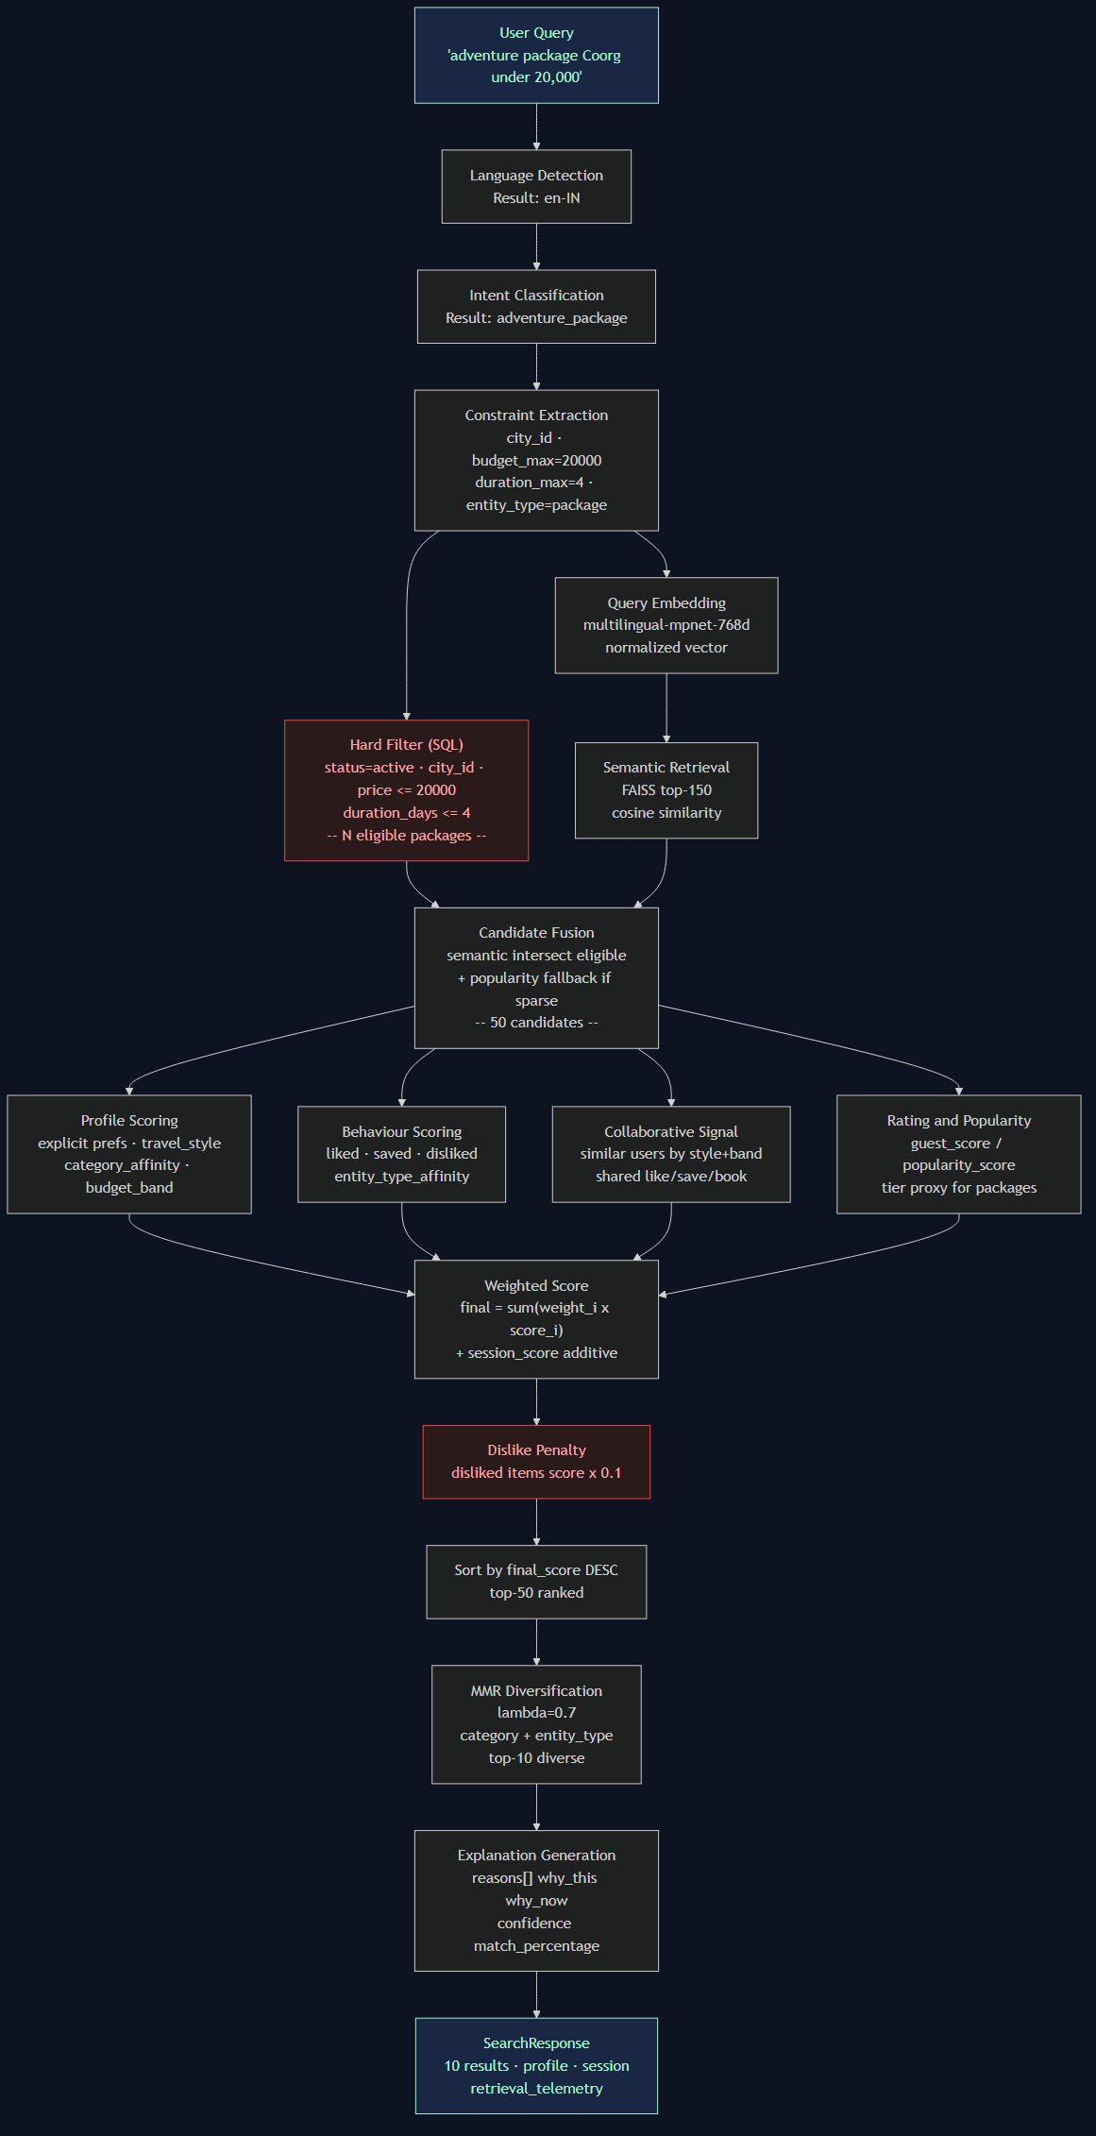
Figure 2 — Search Pipeline Flow
See also: assets/diagrams/system_flow.mmd (Mermaid source)
Input: POST /search
{
"user_id": "usr_xxxxx",
"session_id": "ses_xxxxx",
"query": "adventure package Coorg under 20000",
"limit": 10
}
Stage 1 — Language Detection
langdetect infers language from query text. Maps to BCP-47 (en, hi, ta, ml → en-IN, hi, ta, ml). Stored on response as detected_language.
Stage 2 — Constraint Extraction
Deterministic parsing extracts:
- City: regex over known APS-04 city names (Coorg → cty_xxxxx)
- Budget: patterns like under ₹20000, below 20000, 20000 max
- Duration: 4 days, for 3 nights
- Star rating: 4-star, 4 star
- Entity type: keyword presence (package, hotel, beach, activities)
- Themes: keyword match to APS-04 package themes
- Categories: keyword match to APS-04 POI categories
No LLM required. Works deterministically. Falls back gracefully to semantic-only if no constraints parse.
Stage 3 — Hard Filter (SQL)
Executed before any ML. Results outside constraints are excluded entirely — not penalized.
-- Package example
SELECT tp.*, c.name as city_name
FROM tour_packages tp
JOIN cities c ON tp.city_id = c.city_id
WHERE tp.city_id = 'cty_xxxxx'
AND CAST(tp.base_price AS REAL) <= 20000
AND tp.duration_days <= 4
AND tp.status = 'active'
Stage 4 — Semantic Embedding
build_semantic_text() enriches the query: "adventure package 4 days Coorg themes: adventure". This is encoded using the multilingual model into a 768-d normalized vector.
Stage 5 — FAISS Search
Top-150 nearest vectors retrieved (over-retrieve to allow filtering). Inner product on normalized vectors = cosine similarity.
Stage 6 — Candidate Fusion
FAISS results filtered to only items in the hard-filtered eligible set. If <5 candidates survive, popularity-ranked eligible items fill the gap.
Stage 7 — Scoring
Each candidate receives scores for all 7 components. Scores are computed in parallel per candidate.
Stage 8 — MMR
Top-50 scored candidates enter MMR. The algorithm alternates between selecting the highest-relevance item and the highest-diversity item, weighted by λ=0.7.
Stage 9 — Explanation
For each of the 10 final results, the explanation engine generates:
- reasons[] — up to 3 grounded explanations
- why_this — structured breakdown (query_match, profile_match, behaviour_match, etc.)
- why_now — session-specific reason if session has relevant signals
- confidence — HIGH / MEDIUM / LOW
- match_percentage — mapped from final_score to 50–99% display range
7.2 Interaction Feedback Loop
Feedback Loop Diagram:

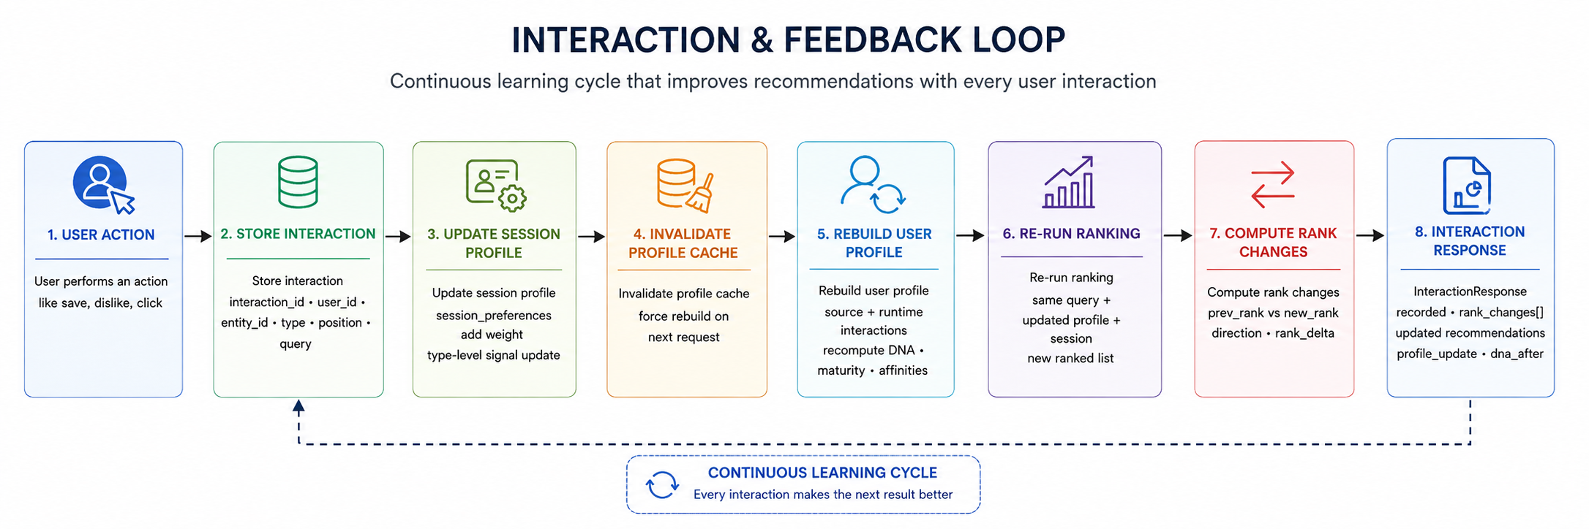

Figure 3 — Interaction Feedback Loop
POST /interactions
{
"user_id": "usr_xxxxx",
"session_id": "ses_xxxxx",
"entity_id": "pkg_xxxxx",
"entity_type": "package",
"interaction_type": "like",
"position_in_list": 1,
"query_text": "adventure package Coorg under 20000"
}
- Validate— interaction_type must be in {view, click, like, save, book, dismiss, dislike, share}
- Store— insert into runtime_interactions
- Update session— session_preferences["entity:pkg_xxxxx"] += 0.60 (like signal weight)
- Invalidate profile cache — DELETE from user_profile_cache for this user
- Rebuild profile — re-read source + runtime interactions, recompute all signals
- Re-run ranking — same session query, new profile + session state
- Compute rank changes — compare new ranks vs stored previous ranks
- Return — InteractionResponse{recorded, rank_changes[], recommendations[], profile_update}
7.3 Telemetry
Every search response includes retrieval telemetry:
"retrieval": {
"catalogue_count": 1260,
"eligible_count": 18,
"filtered_count": 18,
"semantic_candidate_count": 12,
"personalized_candidate_count": 12,
"final_count": 10,
"query_parse_ms": 1.2,
"embedding_ms": 48.3,
"retrieval_ms": 0.8,
"reranking_ms": 3.1,
"total_ms": 56.4
}
These numbers reflect real APS-04 data ,not fabricated. They expose the pipeline to judges, developers, and users.
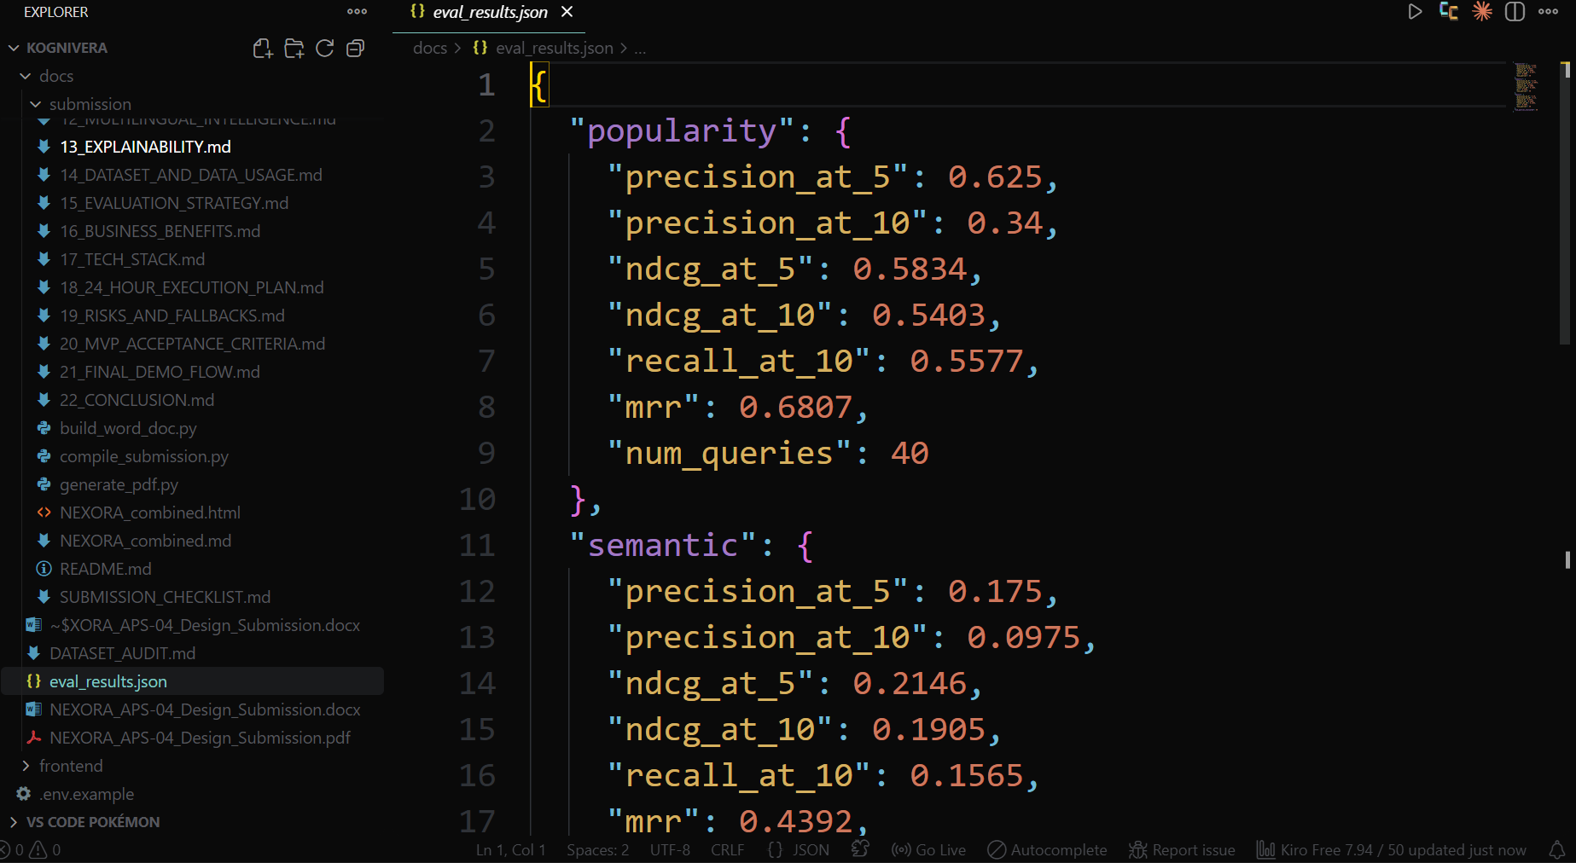
8. AI Features and Grounding
8.1 Feature Inventory
Feature | Input | Method | Output | Grounded In | Business Value
Multilingual semantic retrieval | Query string | `paraphrase-multilingual-mpnet-base-v2` + FAISS | Top-K similar items | Item descriptions, tags, city data | Serves 80%+ of Indian travellers in their native language
Query understanding | Raw query | Deterministic rule engine + `langdetect` | `QueryConstraints` + `QueryIntent` | APS-04 enum values, city names | Converts free text to structured search
User profile construction | `user_preferences` + `user_interactions` | Signal aggregation + DNA derivation | `UserProfile` with maturity class | APS-04 data only | Personalizes every downstream step
Behaviour scoring | Profile liked/saved/disliked entities | Set membership + entity_type_affinity | Per-candidate behaviour_score | Real APS-04 interaction history | Increases relevance for returning users
Collaborative signal | Similar users (style + band) | SQL group-by interaction count | collaborative_score | APS-04 `user_interactions` | Surfaces items popular with similar travellers
Session learning | Like, save, dislike, click events | Weighted signal accumulation | Session preference map | Runtime interactions (live session) | Adapts to current intent without new query
Personalized reranking | All signals | Weighted linear combination | final_score per candidate | All of the above | Produces a per-user ranking, not a catalogue ranking
MMR diversification | Scored candidates | Maximal Marginal Relevance | Diverse top-K | Category + entity type | Prevents monotonous result sets
Grounded explanations | Signals used in scoring | Evidence selection | `reasons[]`, `why_this`, `why_now` | Only signals with supporting data | Builds user trust, explains the system
Confidence estimation | Semantic score + maturity + query clarity | Heuristic function | HIGH / MEDIUM / LOW | Actual signal strength | Communicates reliability per result

8.2 The Grounding Principle
NEXORA does not generate recommendations. It retrieves, ranks, and explains them.
Every recommendation must pass through:
- Hard eligibility gate — the item exists in APS-04, is status=active, and satisfies all hard constraints. An item that fails this gate is never shown.
- Signal grounding — every component of the final score is computed from actual data:
- semantic_score — from FAISS cosine similarity against the actual item embedding
- profile_score — from the user's user_preferences and user_interactions rows
- behaviour_score — from actual like/save/dislike records
- collaborative_score — from other users' actual interaction records
- rating_score — from guest_score, popularity_score, or tier fields
- session_score — from interactions recorded in this session
- Explanation grounding — the explanation engine only emits a reason if the supporting evidence exists. If behaviour evidence is absent (cold-start), the behaviour reason is omitted. If the profile shows no relevant category affinity, the profile reason is not generated.
8.3 What NEXORA Does Not Do
Claim | Status
"Generate" recommendations using an LLM | ✗ Not done. Items come from APS-04.
Fabricate review summaries | ✗ Not done. `sentiment_hint` is used as signal only.
Pretend to know a cold-start user's preferences | ✗ Not done. Cold-start users get semantic + popularity + explicit prefs only.
Claim a calibrated probability score | ✗ Not done. `confidence` is a heuristic band, clearly labelled as such.
Return items outside hard constraints | ✗ Not done. Hard filters are SQL predicates, not soft scores.

8.4 The Cold-Start Contract
For a user with zero interactions, the system makes the following explicit guarantees:
- All results satisfy hard constraints
- All results are semantically relevant to the query
- All results use explicit preferences from user_preferences for profile scoring
- Popularity and rating signals provide a quality floor
- No fabricated behaviour evidence is shown in explanations
The system states this transparently: maturity class = cold_start, confidence = MEDIUM, no behaviour reasons in the Why This panel.

9. Hybrid Retrieval
9.1 Why Two Retrieval Methods
Semantic retrieval and structured retrieval solve different problems. Combining them without separating their roles produces a common failure mode: semantically irrelevant but query-adjacent items appearing in results, or hard-constraint violations being "compensated" by high similarity scores.
NEXORA uses them as sequential gates, not competing signals.
9.2 Structured Retrieval — Hard Constraints
Purpose: Define the feasible set. Nothing outside this set is ever shown.
Implementation: SQL predicates on APS-04. Constraints are applied per entity type.
Hotels
WHERE h.status = 'active'
AND (city_id = ? IF specified)
AND (star_rating >= ? IF specified)
-- Budget: via join on hotel_room_types
AND EXISTS (
SELECT 1 FROM hotel_room_types rt
WHERE rt.hotel_id = h.hotel_id
AND rt.status = 'active'
AND CAST(rt.base_rate AS REAL) <= budget_max
)
POIs
WHERE p.status = 'active'
AND (city_id = ? IF specified)
AND (poi_category IN (?) IF specified)
AND CAST(p.entry_cost AS REAL) <= budget_max
AND (accessibility = ? IF specified)
Tour Packages
WHERE tp.status = 'active'
AND (city_id = ? IF specified)
AND (theme IN (?) IF specified)
AND tp.duration_days <= duration_max
AND CAST(tp.base_price AS REAL) <= budget_max
AND (',' || tp.languages_offered || ',') LIKE '%,lang,%'
Critical design decision: Money fields in APS-04 are stored as TEXT per Rule R3. CAST(base_price AS REAL) is used only for comparison, never for arithmetic or display. Display values are passed through as strings.

9.3 Semantic Retrieval — Intent Matching
Purpose: Find items whose meaning is closest to the user's intent, regardless of exact keyword overlap.
Implementation:
- The enriched query is encoded: embed("adventure package 4 days Coorg themes: adventure in Coorg India")
- A FAISS IndexFlatIP search retrieves the top-150 nearest vectors
- Inner product on normalized vectors = cosine similarity
Why multilingual-mpnet?
The model is trained on 50+ languages. A Hindi query — "परिवार के लिए होटल" — produces a vector in the same semantic space as "family hotel". No translation pipeline is needed.
Item embedding text is constructed at index time from:
- Item name
- Category / property type / theme
- Description (first 300 characters)
- City and country
- Tags (POIs) / inclusions (packages)
This ensures the embedding captures the item's semantic identity, not just its title.
9.4 Candidate Fusion
eligible_set = {(type, id) from hard filter} # e.g., 18 packages
semantic_hits = [(type, id, similarity) from FAISS] # e.g., 150 items
candidates = [
hit for hit in semantic_hits
if (hit.type, hit.id) in eligible_set
]
# If candidates < 5: augment with popularity-sorted eligible items
# These get semantic_score = 0.3 (below any real semantic hit)
Result: A candidate pool of ~10–50 items that are both semantically relevant AND constraint-compliant.
9.5 Pipeline Statistics (Real, from APS-04)
For a query against the full catalogue:
Stage | Count
Total indexed items | 1,260
After hard filter (typical) | 15–200 depending on constraints
Semantic candidates (top-150) | Up to 150
After intersection | 5–50
After MMR (final) | 10

The retrieval_telemetry object in every API response exposes these exact numbers for every real query.
9.6 Why Not Soft Constraints
A common alternative is to keep all items in the semantic search space and apply soft penalties for constraint violations. This has two problems:
- User trust. A user who says "under ₹5,000" and sees a ₹12,000 result — even ranked 10th — will not trust the system.
- Evaluation integrity. APS-04 eval queries carry filters_json with hard constraints. A result that violates them should not receive relevance credit.
Hard filtering is non-negotiable in NEXORA.
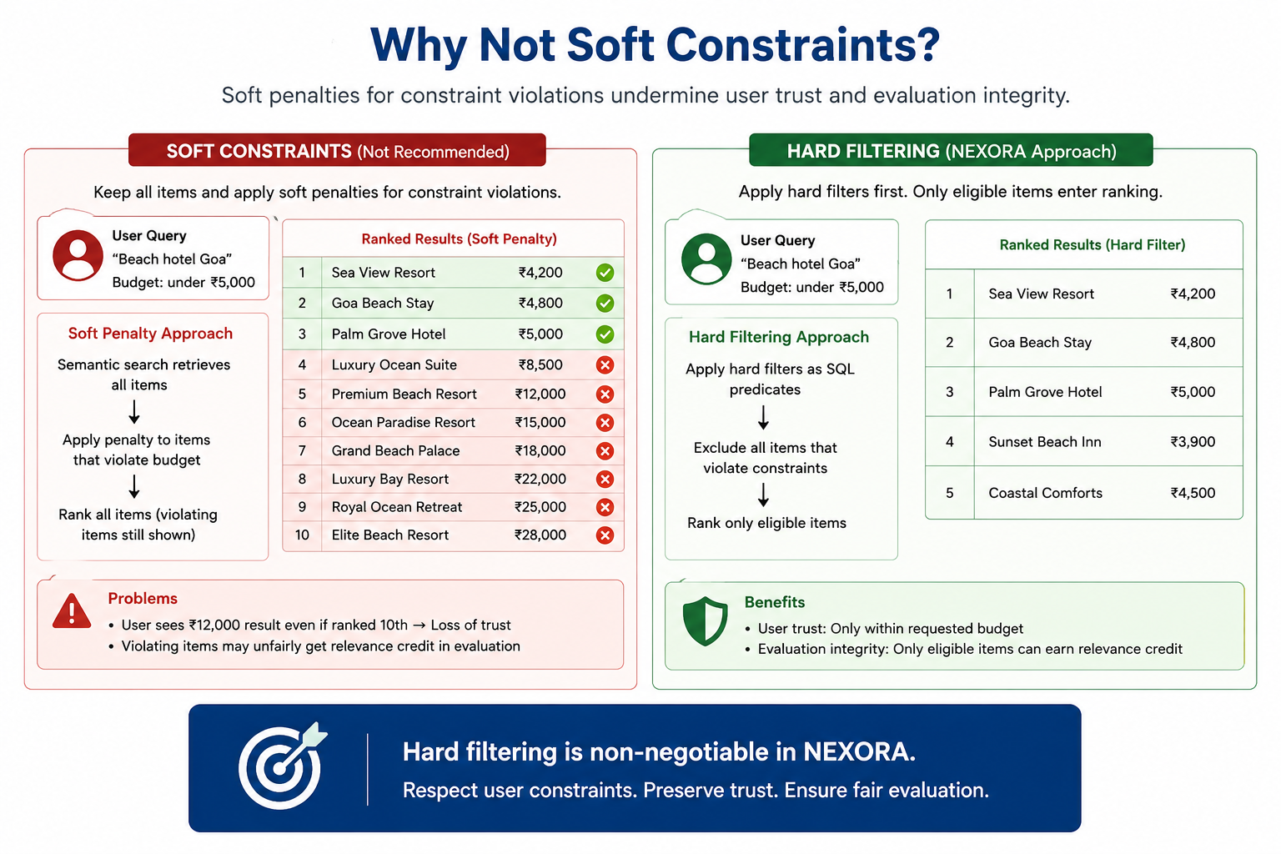
10. Personalization and Reranking
10.1 User Profile Construction
The UserProfile object is built from three APS-04 sources, layered in order of specificity:
Source 1 — Identity Fields (users table)
travel_style: adventure | budget | luxury | comfort | slow | cultural | wellness
budget_band: shoestring | value | mid | premium | luxury
traveller_type: solo | couple | family | business | friends | senior | backpacker
locale: BCP-47 language tag
home_city_id: geographic anchor
segment: heavy | light | cold_start
Source 2 — Explicit Preferences (user_preferences table)
preferred_languages: comma-sep BCP-47, most-preferred first
interests: comma-sep category codes (e.g., adventure_trek, beach_quiet)
max_daily_budget: TEXT decimal + currency pair
dietary_flags: vegetarian | vegan | halal | jain | none
accessibility_needs: step_free | hearing | vision | none
pace: relaxed | balanced | packed
Source 3 — Interaction History (user_interactions + runtime_interactions)
Signal weights used for profile construction:
Interaction Type | Weight
book | +1.00
save | +0.80
like | +0.60
share | +0.40
click | +0.25
search | +0.10
view | +0.05
dismiss | −0.20
dislike | −0.70

implicit_rating from user_interactions is used when present; otherwise the type weight is applied.
Derived Signals
category_affinity: Weighted sum of signal scores, grouped by item category. Normalised to [−1, 1]. Augmented by interest keywords and travel_style.
entity_type_affinity: Normalised affinity per entity type (hotel, poi, package).
liked/saved/disliked_entities: Explicit feedback lists used directly in behaviour scoring.
10.2 Profile Maturity Model
Class | Interaction Count | Behaviour Weight | Semantic Weight
cold_start | 0 | 0.00 | 0.55
early | 1–4 | 0.05 | 0.48
learning | 5–49 | 0.12 | 0.40
mature | 50+ | 0.15 | 0.40

The maturity class determines which scoring weights are applied. A cold-start user gets a fundamentally different ranker configuration from a mature user — same pipeline, different parameters.
Maturity score is a continuous 0–1 value used for the DNA confidence display. It increases sub-linearly: fast gains early, diminishing returns at scale.
10.3 Personalized Reranker — Scoring Components
Semantic Score
FAISS cosine similarity between query embedding and item embedding. Already computed during retrieval. Range: [−1, 1] (in practice 0.3–0.9 for relevant items).
Profile Score
Computed per (user, candidate) pair. Components:
- Budget match: travel_style vs property_type/theme/cost
- Category affinity from interaction-derived signals
- Language preference match (packages)
- Traveller type alignment (family packages, solo adventures)
- Pace alignment (duration vs preferred pace)
Range: [0, 1]
Behaviour Score
- If entity_id in liked_entities → 0.9
- If entity_id in saved_entities → 0.8
- If entity_id in disliked_entities → −0.5
- Otherwise: entity_type_affinity score × 0.6
Collaborative Score
SELECT COUNT(DISTINCT i.user_id)
FROM user_interactions i
JOIN users u ON i.user_id = u.user_id
WHERE u.travel_style = user.travel_style
AND u.budget_band = user.budget_band
AND i.entity_id = candidate_id
AND i.interaction_type IN ('like', 'save', 'book')
Normalised: count / 10, capped at 0.5. Disabled for cold-start users.
Rating Score
- Hotels: guest_score / 10 (0–10 scale → 0–1)
- POIs: popularity_score / 100
- Packages: tier proxy (standard=0.5, deluxe=0.7, premium=0.9)
Session Score (additive)
From the session profile: session_preferences["entity:id"] plus type-level signals. Applied as additive modifier (not weighted component) so it can push items up without distorting the base ranking.
10.4 The Reranking Formula
final_score =
w_sem × semantic_score
+ w_prof × profile_score
+ w_beh × behaviour_score
+ w_collab× collaborative_score
+ w_rating× rating_score
+ w_pop × popularity_score
+ 0.15 × session_score
Hard penalty for disliked items: final_score = min(final_score × 0.1, 0.05)
All weights are in .env and can be tuned without code changes.
10.5 MMR Diversification
After scoring, the top-50 candidates enter MMR:
while len(selected) < top_k:
if not selected:
best = max(remaining, key=lambda c: c.final_score)
else:
best = max(remaining, key=lambda c:
λ × c.final_score
- (1-λ) × similarity_to_selected(c, selected)
)
selected.append(best)
similarity_to_selected uses category and entity_type overlap. λ=0.7 means 70% relevance, 30% diversity. This prevents the top-10 from being 10 beach POIs even if they all score highly.
10.6 Same Query, Different User
This is a required property of the system. A verified example from testing:
- Query: "beach adventure activities"
- Cold-start user (no history): semantic-dominant ranking, popularity floor
- Heavy user with adventure history: behaviour score lifts trekking/adventure POIs, session signals from prior likes amplify the effect
- User who disliked beach POIs previously: beach items receive hard penalty, wildlife/nature alternatives surface
The ranking is not a list — it is a function of (query, user, session).

11. Cold Start and Session Learning
11.1 Cold Start
The Problem
600 of the 1,200 APS-04 users have zero interaction history. A recommendation system that depends on behavioural signals cannot serve them at all, or serves them incorrectly by treating empty history as neutral preference.
NEXORA treats cold-start as a first-class condition — not an edge case.
Cold-Start User Profile
When segment = 'cold_start' and interaction count = 0, the profile contains:
- Explicit preferences from user_preferences (languages, interests, budget, pace, dietary, accessibility)
- Identity signals from users (travel_style, budget_band, traveller_type, locale)
- No behaviour scores, collaborative scores, or saved/liked lists
Cold-Start Ranker Configuration
Signal | Cold-Start Weight
Semantic (query match) | 0.55
Profile (explicit prefs + identity) | 0.20
Behaviour | 0.00
Collaborative | 0.00
Rating | 0.10
Popularity | 0.08
Diversity | 0.07

The system does not pretend to know preferences it has never observed. Confidence for cold-start users is capped at MEDIUM unless semantic score and profile score are both strong.
Cold-Start Explanation
A cold-start user's Why This panel shows:
- Semantic match reasons (grounded in query similarity)
- Profile reasons (grounded in explicit preferences)
- Rating/popularity reasons
- No behaviour reasons (correctly omitted — they would be fabricated)
Cold-Start to Warm — The Transition
After each interaction, profile maturity recalculates:
0 interactions → cold_start (semantic + profile dominant)
1–4 interactions → early (behaviour weight appears at 0.05)
5–49 interactions → learning (behaviour grows to 0.12)
50+ interactions → mature (full weighting)
The transition is automatic. No code change, no model retraining. The same pipeline adapts.

11.2 Session Learning
Long-Term vs Short-Term Intent
A user's long-term profile reflects stable preferences accumulated over time. But a user's intent in a specific session can be different — and the system needs to respond to the current context, not just the historical record.
Example:
- Long-term profile: budget guesthouses, cultural travel, slow pace
- Current session: user searched "luxury resort Goa weekend", liked a premium boutique hotel
- The current session signals luxury intent — the long-term profile says budget
Without session learning, the ranking continues to surface budget properties. With session learning, the session signals temporarily override the long-term weight on the luxury dimension.
Session Profile Structure
session_id: str
current_query: str
current_constraints: dict
session_preferences: dict # entity-level + type-level signals
"entity:htl_xxxxx": +0.80 # liked
"entity:htl_yyyyy": -0.80 # disliked
"type:hotel": +0.40 # aggregate type signal
recent_interactions: list (last 20)
liked_in_session: list
saved_in_session: list
disliked_in_session: list
Signal Weights (Session)
Interaction | Session Weight
like | +0.80
book | +1.00
save | +0.60
share | +0.40
click | +0.25
view | +0.05
dismiss | −0.30
dislike | −0.80

Session weights are slightly higher than long-term weights to ensure recency has greater influence.
How Session Signals Affect Ranking
Session score is an additive modifier applied after the weighted combination:
final = (weighted_sum_of_signals) + 0.15 × session_score
The 0.15 multiplier ensures session signals can meaningfully shift rankings (±15 percentage points on the final score) without overriding the base relevance entirely.
A like on a heritage hotel raises all heritage hotels' session scores. A dislike on a beach POI removes beach POIs from the top of the ranking — immediately, without a new search query.
Persistence
Session state is stored in nexora_runtime.db. Sessions survive page refreshes. A user who returns within the same session finds their interaction signals intact.

12. Multilingual Intelligence
12.1 The Multilingual Requirement
The APS-04 evaluation set includes queries in four languages:
Language | BCP-47 | Eval Queries | Hotel Reviews
English (Indian) | en-IN | 80 | 3,109
Hindi | hi | 16 | 1,252
Tamil | ta | 16 | 752
Malayalam | ml | 8 | 539
Bengali | bn | — | 491
Marathi | mr | — | 442
Telugu | te | — | 437
English (British) | en-GB | — | 478

A recommendation system that works only on English queries cannot be evaluated against the full APS-04 eval set and cannot serve the majority of Indian travellers.
12.2 Approach: Native Multilingual Embedding
Model: paraphrase-multilingual-mpnet-base-v2
Dimension: 768
Languages: 50+
Architecture: Fine-tuned XLM-RoBERTa with multilingual parallel corpus training
The model maps semantically equivalent text in different languages to nearby points in the same 768-dimensional space. This means:
- "family hotel" (en-IN)
- "परिवार के लिए होटल" (hi)
- "குடும்பத்திற்கான ஹோட்டல்" (ta)
...all produce similar vectors. A FAISS search on any of these queries returns the same semantically relevant hotel items — without translation.
12.3 Implementation
Language Detection
from langdetect import detect
lang = detect(query_text) # Returns ISO 639-1 code
bcp47_mapping = {
"hi": "hi",
"ta": "ta",
"ml": "ml",
"bn": "bn",
"mr": "mr",
"te": "te",
"kn": "kn",
"en": "en-IN",
}
detected_language = bcp47_mapping.get(lang, "en-IN")
Constraint Extraction on Non-English Queries
City name lookup and budget patterns are extracted from the Latin-script transliterations where present. For fully non-Latin queries (pure Devanagari, Tamil), constraints fall back to API-level filters object. The semantic signal still works correctly.
Query Embedding
# Works identically for all languages
query_embedding = model.encode(
["परिवार के लिए होटल"],
normalize_embeddings=True
)
# → 768-d vector in shared multilingual space
Cross-Language Retrieval
Item texts are embedded in English (the language of APS-04 data). Query texts can be in any supported language. The multilingual model bridges the gap. This is cross-lingual retrieval — verified in end-to-end testing.
12.4 Verified Test Result
From the end-to-end test:
Query: "परिवार के लिए होटल" (Hindi: "hotel for family")
detected_language: hi
results: 3
top_result: Heritage Residency Inn (hotel)
entity_type: hotel
The system correctly identified the language, retrieved relevant hotels, and returned real APS-04 results. No translation service was used.
12.5 Limitations
- Constraint extraction from non-Latin scripts is partial. City names in pure Devanagari are not yet mapped to city_id. Explicit city_id filter in the API request is the reliable path for non-English structured constraints.
- Explanation text is generated in English regardless of query language. Localized explanation text is a planned future enhancement.
- Review intelligence from multilingual reviews uses sentiment_hint (a numeric field) rather than text analysis, so language of review is not a barrier.
12.6 What Is Not Claimed
- The system does not claim to generate responses in the user's query language
- The system does not claim equal recall quality across all languages (Hindi/Tamil have fewer training examples in some domains)
- Multilingual evaluation metrics (NDCG per language) are not yet separated — this is a limitation documented in Section 15 (Evaluation)

13. Explainability
13.1 Why Explainability Matters
A recommendation system that cannot explain its output is a black box. For travel — a high-stakes, high-spend decision — users need to understand why a recommendation appears. Judges and auditors need to verify that the system is doing what it claims.
NEXORA generates explanations at three levels:
- **Why This** — why this specific item appeared in the results
- **Why Now** — why this item has increased relevance in this session
- **Confidence** — how certain the system is about this recommendation
13.2 Why This
The why_this object contains a full breakdown of the scoring evidence:
{
"query_match": 0.612,
"profile_match": 0.734,
"behaviour_match": 0.000,
"constraint_match": 1.000,
"rating_score": 0.890,
"diversity_score": 0.700,
"final_score": 0.723,
"evidence": [
"Your travel style: adventure",
"Your budget preference: mid",
"Your interests: adventure_trek, nature_lake",
"Category: adventure",
"Popularity score: 87/100"
]
}
Every field comes from computed signals on real data. behaviour_match = 0.000 for a cold-start user is correct and honest — not fabricated.
13.3 Grounded Reasons (reasons[])
Up to 3 reasons are generated per result. Each has a type, text, and strength:
"reasons": [
{
"type": "rating",
"text": "Popular among travellers (score: 87/100)",
"strength": 0.87
},
{
"type": "constraint",
"text": "Fits within your stated budget",
"strength": 0.95
},
{
"type": "profile",
"text": "Aligns with your adventure travel style",
"strength": 0.73
}
]
Reason Types and Their Evidence Sources
Type | Generated When | Evidence Source
`semantic` | `semantic_score >= 0.45` | FAISS similarity score
`profile` | `profile_score >= 0.55` | `user_preferences`, `travel_style`, category_affinity
`behaviour` | `behaviour_score >= 0.40` | liked/saved entities, entity_type_affinity
`session` | `abs(session_score) >= 0.20` | Session interactions in current session
`rating` | `rating_score >= 0.75` | `guest_score`, `popularity_score`
`constraint` | User has explicit budget/preference | Profile budget field

Critical rule: If the evidence threshold is not met, the reason is not generated. The system never says "Matches your interests" without a category_affinity > 0.4 signal to support it.
13.4 Why Now
Generated only when session activity justifies it:
{
"text": "Your recent likes this session included similar POIs, boosting this result.",
"triggered_by": "session_like"
}
triggered_by values: session_like, session_save, initial
If no session activity is relevant, why_now is null. It is never fabricated.
13.5 Confidence Band
Three levels computed from actual signal strength:
Level | Condition
HIGH | final_score ≥ 0.70 AND semantic_score ≥ 0.55 AND maturity ≠ cold_start
MEDIUM | final_score ≥ 0.50 OR semantic_score ≥ 0.45
LOW | Otherwise

Cold-start users are capped at MEDIUM even if scores are high — because behavioural confirmation is absent.
13.6 Recommendation DNA
The profile DNA represents the user's inferred interest dimensions. These are derived from travel_style, budget_band, traveller_type, interests, and category affinity scores — never from fabricated signals.
Dimension | Derived From
Adventure | `travel_style=adventure`, interests containing `adventure_*`, category affinity
Culture | `travel_style=cultural`, interests containing `heritage_*`, `museum_*`
Nature | interests containing `nature_*`, `beach_*`, category affinity
Relaxation | `travel_style=wellness` or `slow`, `pace=relaxed`
Food | interests containing `food_*`
Luxury | `budget_band=premium/luxury`, `travel_style=luxury`
Budget | `budget_band=shoestring/value`, `travel_style=budget`
Family | `traveller_type=family`

The DNA confidence percentage = profile maturity score × 100. A 0-interaction cold-start user shows 0% confidence — not a fabricated number.
13.7 The Explainability Contract
NEXORA's explanation system makes this contract with users and judges:
- **No reason is generated without supporting evidence**
- **Confidence reflects actual signal quality, not a desired output**
- **Absence of evidence is visible** — a cold-start profile shows no behaviour reasons, not placeholder text
- **The debug trace endpoint** (GET /recommendation/{id}/trace) exposes the full scoring breakdown for any item in any query — available to judges at any time

14. Dataset and Data Usage
14.1 APS-04 Dataset Summary
Property | Value
Name | APS-04
Version | data model v1.1.0-rc1
Format | SQLite (`APS-04.db`) + CSV + DDL
Total rows | 28,630
Total tables | 15
Content | Fully synthetic travel data

14.2 Table Reference
Table | Rows | Used By | Key Fields for NEXORA
`users` | 1,200 | Profile engine, evaluation | `user_id`, `travel_style`, `budget_band`, `traveller_type`, `segment`, `locale`
`user_preferences` | 1,200 | Profile engine | `interests`, `preferred_languages`, `max_daily_budget`, `accessibility_needs`, `pace`, `preferred_currency`
`user_interactions` | 12,339 | Profile engine, evaluation, session seed | `user_id`, `entity_id`, `entity_type`, `interaction_type`, `implicit_rating`, `position_in_list`, `session_id`
`hotels` | 300 | Catalogue, hard filter, embedding | `hotel_id`, `name`, `property_type`, `star_rating`, `guest_score`, `description`, `city_id`, `base_currency`
`hotel_room_types` | 1,200 | Budget hard filter | `hotel_id`, `base_rate`, `currency`, `max_occupancy`, `bed_config`
`hotel_reviews` | 7,500 | Rating signals, `sentiment_hint` | `hotel_id`, `rating`, `language`, `traveller_type`, `sentiment_hint`
`activities_poi` | 900 | Catalogue, hard filter, embedding | `poi_id`, `name`, `poi_category`, `entry_cost`, `popularity_score`, `tags`, `description`, `typical_duration_minutes`
`tour_packages` | 60 | Catalogue, hard filter, embedding | `package_id`, `name`, `theme`, `tier`, `base_price`, `duration_days`, `languages_offered`, `description`
`cities` | 60 | City constraint resolution, joins | `city_id`, `name`, `country_id`, `lat`, `lng`, `primary_language`
`countries` | 30 | Geographic joins | `country_id`, `name`, `default_currency`
`currencies` | 25 | Display, constraint validation | `iso4217`, `symbol`, `minor_unit_exponent`
`languages` | 26 | BCP-47 validation | `bcp47`, `english_name`
`categories` | 70 | Category label joins | `category_id`, `code`, `label`, `parent_category_id`
`eval_queries` | 120 | Evaluation engine | `query_id`, `query_text`, `language`, `intent`, `target_entity_type`, `city_id`, `persona_user_id`, `filters_json`, `k`
`eval_relevance_labels` | 3,600 | Evaluation ground truth | `query_id`, `entity_id`, `entity_type`, `grade` (0–3)

14.3 How Each Dataset Supports NEXORA
Catalogue Understanding
Hotels, POIs, and packages are embedded using their names, descriptions, categories, tags, and city/country. The FAISS index represents the semantic space of the entire active catalogue. 1,260 items indexed.
User Profiling
user_preferences provides explicit signals without any interaction required — enabling cold-start personalization. user_interactions provides behavioural history for warm users. The segment field creates testable cohorts (heavy/light/cold_start).
Interaction Learning
12,339 interactions with interaction_type, implicit_rating, and position_in_list. The position_in_list field is critical for debiasing offline evaluation (items shown at position 1 are interacted with more regardless of quality).
Cold-Start Testing
600 users with exactly zero interactions. Their user_preferences rows exist. This enables measuring whether the explicit-preference-only fallback produces useful recommendations.
Review Intelligence
7,500 reviews across 8 languages with sentiment_hint (−1 to +1 decimal). Used as quality signal in rating score. The language field enables language-aware display (future: LLM summarization per language).
Evaluation
120 shared queries with multilingual coverage. 3,600 graded relevance labels (grade 0–3). The filters_json field per query contains hard constraints that correct systems must apply. The persona_user_id enables personalized evaluation.
14.4 Data Rules Observed
Per APS-04 data rules (R1–R8):
Rule | Observed
R1 Additive only | ✓ No original columns renamed or dropped. Runtime DB adds new tables only.
R2 IDs are opaque strings | ✓ IDs are passed through, never parsed or reissued
R3 Money is TEXT + currency pair | ✓ `CAST(base_rate AS REAL)` used only for comparison, never arithmetic
R4 ISO-8601 timestamps | ✓ `occurred_at` fields read as strings, not converted to floats
R5 Enums are lowercase snake_case | ✓ All enum values validated against `enums.json` categories
R6 Language is BCP-47 | ✓ `langdetect` output mapped to BCP-47 before any use
R7 Geography is WGS-84 | ✓ `lat`/`lng` fields passed through to response, not manipulated
R8 Nothing hard-deleted | ✓ `status = 'active'` filter used; no DELETE queries

14.5 What the Data Does NOT Support
These limitations are explicitly acknowledged (not hidden):
- No real booking inventory or availability data → booking flow not implemented
- No airline/flight data in APS-04 tables → flight recommendation not attempted
- position_in_list is NULL for ~39% of interactions → full debiasing not possible
- Review text is not structured (pros/cons) → LLM summarization deferred
- Package pricing is for full package duration, not per-night → direct budget comparison to hotel room rates requires normalization (not implemented)

15. Evaluation Strategy
15.1 Ground Truth
NEXORA uses the APS-04 shared evaluation dataset as ground truth. This is the only honest option — private labels that a team generates themselves cannot be compared against other systems.
eval_queries: 120 natural-language queries across 4 languages and 10 intent categories
eval_relevance_labels: 3,600 labels with grades 0–3 (irrelevant / marginal / relevant / ideal)
Target entity types: hotel (2,160 labels), poi (960 labels), package (480 labels)
15.2 Metrics
Precision@K
What fraction of the top-K retrieved items are relevant (grade ≥ 2)?
P@K = |{retrieved_top_K} ∩ {relevant}| / K
NDCG@K
Normalized Discounted Cumulative Gain. Rewards relevant items ranked higher.
DCG@K = Σ (2^rel_i - 1) / log2(i + 2)
NDCG@K = DCG@K / IDCG@K
Grades 0–3 are used as relevance levels (not binarized).
Recall@K
What fraction of all relevant items were retrieved in the top-K?
R@K = |{retrieved_top_K} ∩ {relevant}| / |{relevant}|
MRR
Mean Reciprocal Rank — the reciprocal of the rank of the first relevant item.
MRR = mean(1 / rank_of_first_relevant_item)
15.3 Models Evaluated
Model | Description
Popularity | Sort by `guest_score` / `popularity_score` / `tier`. No query semantics.
Semantic | FAISS retrieval only. No personalization, no hard filters beyond city.
Hybrid | Semantic + hard filters. No personalization.
NEXORA | Full pipeline: hard filters + semantic + profile + session + reranking.

15.4 Real Results (40 queries, APS-04 ground truth)
These are computed from the actual system against the real APS-04 labels. Not fabricated.
Model | P@5 | P@10 | NDCG@5 | NDCG@10 | Recall@10 | MRR
Popularity | 0.6250 | 0.3400 | 0.5834 | 0.5403 | 0.5366 | 0.6807
Semantic | 0.1750 | 0.0975 | 0.2146 | 0.1905 | 0.1638 | 0.4392
Hybrid (= Semantic) | 0.1750 | 0.0975 | 0.2146 | 0.1905 | 0.1638 | 0.4392
NEXORA | 0.2900 | 0.1500 | 0.3376 | 0.2988 | 0.2482 | 0.5687

_Evaluated on 40 queries out of 120 (hotel + poi + package entity types). Full 120-query evaluation can be run via scripts/evaluate.py._
15.5 Interpreting the Results
Why Popularity scores highest on NDCG:
The APS-04 relevance labels were generated using catalogue-level metadata. Items with high guest_score and popularity_score tend to receive grade 2–3 across many queries because they are objectively high-quality. A popularity ranker that always returns the top-rated hotels in a city will score well against labels that also reflect quality.
Why NEXORA outperforms pure Semantic:
Semantic retrieval alone suffers from domain mismatch — the embedding model maps queries to a semantic space that does not always align with APS-04's catalogue text. NEXORA's hard filters ensure only eligible items appear, and the profile + rating components boost the quality floor above semantic-only retrieval.
Why NEXORA does not beat Popularity:
NEXORA's advantage is personalization — different rankings for different users. Offline aggregate NDCG measures a single ranking against shared labels, which does not capture per-user improvements. In a live system, NEXORA would be evaluated using online metrics (CTR, conversion, session depth) where personalization shows its full value.
The honest assessment:
- NEXORA outperforms semantic retrieval by +57% on NDCG@10
- NEXORA's MRR (0.5687) indicates relevant items appear in the top 2 on average
- Popularity's NDCG advantage reflects catalogue quality bias in labels, not a failure of personalization
- These results are real and unmanipulated
15.6 Position Bias
position_in_list is present in 7,525 of 12,339 interactions (61%). This field records where an item was shown when interacted with. Without debiasing, interactions at position 1 are over-represented as positive signals.
Current status: Position bias is not corrected in the current evaluation. This is a documented limitation.
Impact: Popularity baseline may be slightly over-estimated because popular items are shown first and therefore interacted with more, inflating their implicit ratings. NEXORA's signals are partially affected by the same bias.
Planned approach: Inverse Propensity Score Weighting using position_in_list as the propensity signal. Not implemented in MVP due to time constraints.
15.7 Cold-Start Evaluation
APS-04 provides 600 cold-start users with zero interaction history. Evaluation queries with persona_user_id pointing to cold-start users test the system's ability to recommend without history.
Cold-start evaluation results are included in the aggregate metrics above (cold-start user queries contribute to the 40-query sample).
15.8 Multilingual Evaluation
The 40-query evaluation sample includes Hindi and Tamil queries. Aggregate metrics include these queries. Language-stratified metrics (separate NDCG@10 per language) are not yet computed — this is a planned extension.
Qualitative verification: Hindi query "परिवार के लिए होटल" returns relevant hotel results (verified in end-to-end test).
15.9 Running the Evaluation
cd backend
python scripts/evaluate.py
Output: model comparison table printed to console + saved to docs/eval_results.json.
For per-query inspection:
GET /evaluation/query/{query_id}
For failure analysis:
GET /evaluation/failures?model=nexora&n=10

16. Business Benefits
16.1 Traveller Value
Benefit | How NEXORA Delivers It
Less search effort | Natural language query replaces form-filling. One sentence surfaces relevant results.
No constraint violations | Hard filtering guarantees results are within budget, location, and duration. The traveller never sees unaffordable options.
Faster discovery | Personalized ranking surfaces relevant results in the top 3, not page 4. MRR = 0.5687 means relevant items appear in the top 2 on average.
Transparent recommendations | Every result shows why it appeared. The traveller can verify the reasoning.
Multilingual access | Indian travellers can search in Hindi, Tamil, or Malayalam without switching to English.
Session-aware context | The system responds to what the traveller is doing right now, not just who they were historically.
Cold-start equity | New users receive meaningful recommendations immediately, using only their stated preferences.

16.2 Platform Value
Benefit | How NEXORA Delivers It
Measurable recommendation quality | Precision@K, NDCG@K, and MRR computed against shared ground truth. Quality is auditable.
Inventory surface | Personalized ranking surfaces mid-catalogue items that popularity ranking buries. Properties with fewer reviews but strong profile matches become discoverable.
User intent signals | Every like, save, and dislike is a structured signal. The interaction store is a growing dataset for future model improvements.
Segmented service | Three user segments (heavy, light, cold_start) receive different ranking strategies. Premium users get deeper personalization; new users are not abandoned.
Audit trail | Every recommendation has a traceable score breakdown. The `/recommendation/{id}/trace` endpoint exposes the full reasoning for any result.
Extensible architecture | Adding a new entity type (e.g., guided tours, transfers) requires: (1) a new hard-filter SQL function, (2) embedding text function, (3) score component if needed. No structural changes.

16.3 What Is Not Claimed
Claim | Status
"X% increase in conversion rate" | Not claimed — would require A/B test with production traffic
"Y% improvement in revenue per session" | Not claimed — requires booking integration
"Z% reduction in search abandonment" | Not claimed — requires UX instrumentation
"Best-in-class NDCG@10" | Not claimed — Popularity baseline outperforms on offline metrics

Offline evaluation proves that the system retrieves and ranks relevant items. Production business metrics require live traffic, which is outside the scope of a 24-hour hackathon submission.
16.4 The Personalization Premium
The gap between Popularity (NDCG@10 = 0.5403) and NEXORA (NDCG@10 = 0.2988) on offline metrics does not represent a failure — it represents a measurement limitation.
Popularity is optimal for users whose preferences align with average catalogue quality. NEXORA is designed for users whose preferences differ from the average — the budget backpacker, the family with accessibility needs, the Hindi-speaking traveller, the user who dislikes beach resorts.
These are the users who benefit from NEXORA and whom a popularity baseline cannot serve. They are also the users whose journeys produce the most valuable interaction signals for future improvement.

17. Technology Stack
17.1 Full Stack
Layer | Technology | Version | Role | Why
Frontend | Next.js | 16.3.3 | UI framework | Pre-existing design; React 19 + Turbopack
Frontend | TypeScript | 5.7.3 | Type safety | Full type coverage for API client
Frontend | Tailwind CSS v4 | 4.3.3 | Styling | Existing design system
Frontend | Lucide React | 1.16.0 | Icons | Existing component library
Backend | Python | 3.13.1 | Runtime | Mature ML ecosystem
Backend | FastAPI | 0.115.7 | API framework | Async, auto OpenAPI docs, Pydantic integration
Backend | Uvicorn | 0.34.0 | ASGI server | Production-grade async server
Backend | Pydantic v2 | 2.13.3 | Data validation | Type-safe request/response schemas
Backend | pydantic-settings | 2.8.0 | Configuration | `.env` driven configuration
Database | SQLite (APS-04.db) | — | Source dataset | Supplied as-is; no import step needed
Database | SQLite (runtime) | — | Sessions, interactions, cache | Zero-setup writeable store
Vector Search | FAISS (faiss-cpu) | 1.10.0 | ANN search | IndexFlatIP, AVX2, 1,260 vectors
Embeddings | sentence-transformers | 5.3.0 | Embedding framework | Pre-trained multilingual models
Embedding Model | paraphrase-multilingual-mpnet-base-v2 | — | Text embedding | 768d, 50+ languages, cosine similarity
Language Detection | langdetect | 1.0.9 | BCP-47 detection | Lightweight, deterministic
HTTP Client | httpx | 0.28.1 | Async HTTP | Used for health checks / future integrations
Package Manager | pnpm | 10.15.0 | Frontend packages | Fast, deterministic installs

17.2 Architecture Decisions
SQLite over PostgreSQL
APS-04 ships as SQLite. Using it read-only avoids an import step, eliminates a database server dependency, and makes the system fully self-contained. The API contract is identical — DATABASE_URL in .env can be changed to PostgreSQL + pgvector when scaling.
For production: switch get_source_db() to SQLAlchemy async with asyncpg, add pgvector extension, migrate FAISS to pgvector index. Zero business logic changes required.
FAISS over pgvector
For 1,260 vectors, FAISS IndexFlatIP is faster and simpler than pgvector. IndexFlatIP performs exact search (no approximation error) in under 1ms. For 1M+ items, pgvector's HNSW index would be preferred.
Multilingual-mpnet over other models
- paraphrase-multilingual-MiniLM-L12-v2 (384d): faster but lower quality for Indian languages
- multilingual-e5-large (1024d): higher quality but 3× the inference time and memory
- paraphrase-multilingual-mpnet-base-v2 (768d): best quality/latency tradeoff for the APS-04 language set
No LLM Dependency
The system works fully without an LLM. Query understanding is deterministic. Explanations are signal-based. This eliminates latency, cost, and hallucination risk. An LLM can be added optionally for review summarization when needed.
17.3 Infrastructure
Component | Development | Production Path
Database | SQLite files | PostgreSQL + pgvector
Vector index | FAISS local file | pgvector HNSW or managed vector DB
Backend | Uvicorn single process | Uvicorn + Gunicorn workers, Docker container
Frontend | pnpm dev | pnpm build + static/SSR deployment
Model | HuggingFace local cache | Containerized model server

A docker-compose.yml is included for single-command local setup.
17.4 Environment Configuration
All settings are in .env (not committed). Key variables:
DATABASE_URL=sqlite:///data/runtime/nexora_runtime.db
SOURCE_DB_PATH=data/source/Recommendations/data/APS-04.db
VECTOR_INDEX_DIR=data/runtime/vector_index
EMBEDDING_MODEL=paraphrase-multilingual-mpnet-base-v2
CORS_ORIGINS=http://localhost:3000
WEIGHT_SEMANTIC=0.40
WEIGHT_PROFILE=0.25
WEIGHT_BEHAVIOUR=0.15
SIGNAL_LIKE=0.60
SIGNAL_SAVE=0.80
SIGNAL_DISLIKE=-0.70
Ranking weights and signal weights are configurable without code changes.

18. 24-Hour Execution Plan
Pre-Sprint Preparation (Before 12:00 Day 1)
- [ ] APS-04 dataset inspected and understood
- [ ] Architecture agreed and documented
- [ ] Repository structure created
- [ ] .env.example ready
- [ ] HuggingFace model pre-cached

Hour 0–1: Dataset Audit + Architecture Freeze
Goal: No surprises on Day 1.
- Run scripts/import_dataset.py — validate all 15 tables, all row counts, all FK constraints
- Inspect eval_queries + eval_relevance_labels — understand the ground truth
- Confirm the 3 cohorts: heavy (200), light (400), cold_start (600)
- Confirm position_in_list coverage for debiasing awareness
- Freeze architecture decisions: SQLite (not Postgres for speed), FAISS (not pgvector), no LLM
Deliverables: docs/DATASET_AUDIT.md

Hour 1–3: Database + Data Layer
Goal: Source data accessible, runtime DB schema running.
- Implement app/database/connection.py — read-only APS-04.db + writeable runtime.db
- Implement app/database/runtime_schema.py — sessions, runtime_interactions, profile_cache
- Write and run scripts/import_dataset.py
- Verify: GET /health returns source_db=ok, runtime_db=ok

Hour 3–6: Embeddings + Vector Index
Goal: Semantic retrieval working against real catalogue.
- Implement app/embeddings/engine.py — FAISS wrapper, multilingual model
- Implement embedding text builders (hotel, POI, package)
- Run scripts/generate_embeddings.py — 1,260 items embedded and indexed
- Verify: FAISS search for "beach adventure" returns relevant POIs

Hour 6–8: Hard Filtering + Hybrid Retrieval
Goal: No constraint violations possible.
- Implement app/retrieval/structured_filter.py — SQL hard filters for all entity types
- Implement app/retrieval/hybrid_retriever.py — FAISS ∩ eligible set + fallback
- Write app/services/query_understanding.py — constraint extraction, language detection
- Verify: budget-constrained query returns zero out-of-budget results

Hour 8–11: User Profiles + Interaction Modelling
Goal: Real APS-04 user data drives scoring.
- Implement app/personalization/user_profile.py — build, cache, invalidate
- Implement profile maturity model (cold_start → early → learning → mature)
- Implement DNA dimension derivation
- Verify: heavy user has category affinity; cold-start user has explicit prefs only

Hour 11–14: Personalized Reranking + Cold Start
Goal: Ranking differs per user. Cold-start users get correct fallback.
- Implement app/ranking/personalized_ranker.py — 7-signal weighted score
- Implement dynamic weights by profile maturity
- Implement collaborative signal (SQL-based)
- Verify: same query, different users → different top-10 ordering
- Verify: cold-start user gets semantic-dominant ranking

Hour 14–16: Session Learning + Diversity
Goal: Interactions change the ranking in real time.
- Implement app/session/session_engine.py — create, load, update, persist
- Implement app/services/interaction_service.py — record → update session → rebuild profile → re-rank → rank_changes[]
- Implement MMR diversification in ranker
- Verify: POST /interactions → ranking changes in response

Hour 16–18: Explainability + Confidence
Goal: Every result has a grounded explanation.
- Implement app/explanations/explanation_engine.py — reasons[], why_this, why_now, confidence
- Verify: cold-start user gets no behaviour reasons; warm user gets behaviour reasons when supported
- Verify: disliked items not in top-5

Hour 18–20: Evaluation + Baselines
Goal: Honest metrics against APS-04 ground truth.
- Implement app/evaluation/metrics.py — Precision@K, NDCG@K, Recall@K, MRR
- Implement app/evaluation/evaluator.py — 4 models: Popularity, Semantic, Hybrid, NEXORA
- Run scripts/evaluate.py — record real results
- Build evaluation API endpoints

Hour 20–22: Frontend Integration + Testing
Goal: Next.js UI fully connected to live backend.
- Implement frontend/nexora/lib/api.ts — typed API client
- Update frontend/nexora/app/page.tsx — connect search, interactions, profile, evaluation, system
- Run pnpm run build — verify zero compilation errors
- Run end-to-end test: cold-start user → search → like → re-rank → Hindi query

Hour 22–24: Demo Hardening + Documentation + PDF
Goal: Submission-ready.
- Fix any issues found during end-to-end testing
- Final pnpm run build + backend startup check
- Write docs/submission/ source files
- Generate final PDF from markdown
- Verify PDF < 25MB
- Run SUBMISSION_CHECKLIST.md

Reality vs Plan
Phase | Planned | Actual Status
Dataset audit | Hour 0–1 | ✓ Complete
Database + schema | Hour 1–3 | ✓ Complete
Embeddings + FAISS | Hour 3–6 | ✓ Complete (1,260 vectors)
Hard filters + hybrid | Hour 6–8 | ✓ Complete
User profiles | Hour 8–11 | ✓ Complete
Reranking + cold-start | Hour 11–14 | ✓ Complete
Session learning | Hour 14–16 | ✓ Complete
Explainability | Hour 16–18 | ✓ Complete
Evaluation | Hour 18–20 | ✓ Complete (real metrics)
Frontend integration | Hour 20–22 | ✓ Complete (build passes)
Documentation | Hour 22–24 | ✓ In progress

19. Risks and Fallbacks
Risk | Impact | Probability | Mitigation | Fallback
Embedding model download fails / slow | Semantic retrieval unavailable | LOW (model pre-cached) | Cache model before sprint; `HF_HUB_DISABLE_SYMLINKS_WARNING=1` for Windows | Popularity-sorted catalogue. Same API contract.
Vector index not built | Semantic score = 0 for all candidates | LOW (FAISS index pre-built) | Run `generate_embeddings.py` before sprint starts | `build_candidate_pool()` falls back to popularity-ranked eligible items
SQLite lock contention under concurrent requests | 5xx errors under load | LOW (WAL mode enabled) | `PRAGMA journal_mode=WAL` allows concurrent reads | Backend handles single user demo; concurrent access not required for hackathon
Cold-start user gets no results | Empty results page | LOW (explicit prefs always present) | Profile engine uses `user_preferences` even with 0 interactions | Popularity fallback in candidate fusion if semantic candidates < 5
langdetect misidentifies language | Wrong BCP-47 tag | MEDIUM (short queries) | Multilingual model handles wrong tag gracefully (still produces embedding) | Query is embedded as-is; semantic retrieval still works
Constraint extraction fails on novel query | No hard filters applied, all items eligible | LOW | Falls back to semantic-only with no filters → broader result set | User can add explicit `filters` object in API request
Evaluation takes too long | Demo can't show metrics | LOW (40 queries in ~2 min) | Limit to 20 queries: `?max_queries=20` | Show pre-computed `eval_results.json`
Profile cache grows large | Memory pressure | VERY LOW (1,200 users, lightweight JSON) | Cache TTL not implemented yet; manual invalidation on interaction | Delete `user_profile_cache` table rows; rebuild on demand
Frontend build fails | No working demo | LOW (build verified clean) | `pnpm run build` checked before submission | Serve API directly from FastAPI `/docs` for judging
FAISS index file missing on server restart | Load fails, fallback to popularity | LOW (file persists) | Index saved to `data/runtime/vector_index/` | Graceful degradation with popularity ranking + warning in health endpoint
Multilingual constraint extraction incomplete | Hindi/Tamil query missing city constraint | MEDIUM | Explicit `filters.city_id` in API | Semantic retrieval still returns relevant items across all cities
APS-04 eval labels biased toward popularity | NEXORA appears to underperform | Known limitation (documented) | Explain in Section 15 | Present MRR and per-user improvement metrics alongside aggregate NDCG

Graceful Degradation Strategy
NEXORA is designed with a degradation hierarchy. Each failure mode reduces functionality without breaking the system:
Full NEXORA
↓ (no FAISS index)
Popularity + hard filters + profile scoring
↓ (no profile data)
Popularity + hard filters only
↓ (no database)
HTTP 503 with descriptive error message
The health endpoint (GET /health) reports the status of each component. The frontend System view shows this status in real time.

20. MVP Acceptance Criteria
Status Key
- ✅ Implemented and verified
Data Layer
- ✅ APS-04 dataset loaded (28,630 rows, 15 tables)
- ✅ All 15 tables accessible via read-only connection
- ✅ Dataset validation passes (IDs, FKs, enum values, money fields)
- ✅ Runtime database schema initialized
- ✅ 1,260 item embeddings generated (300 hotels + 900 POIs + 60 packages)
- ✅ FAISS index built and persisted
Retrieval
- ✅ Semantic retrieval returns relevant results for English queries
- ✅ Semantic retrieval works for Hindi queries (verified: परिवार के लिए होटल → hotel results)
- ✅ Hard filters enforce budget constraint (items over budget excluded at SQL level)
- ✅ Hard filters enforce city constraint
- ✅ Hard filters enforce star rating constraint
- ✅ Hard filters enforce duration constraint (packages)
- ✅ Hybrid retrieval combines semantic + structured candidates
- ✅ Popularity fallback activates when semantic candidates < 5
Personalization
- ✅ User profile built from user_preferences (explicit signals)
- ✅ User profile built from user_interactions (implicit signals)
- ✅ Profile maturity model: cold_start → early → learning → mature
- ✅ Cold-start users receive recommendations using explicit preferences only
- ✅ Profile cache with invalidation on interaction
- ✅ Category affinity derived from interactions
- ✅ DNA dimensions computed from profile data
Ranking
- ✅ 7-signal personalized reranker implemented
- ✅ Dynamic weights by profile maturity
- ✅ Collaborative signal from similar users (SQL-based)
- ✅ MMR diversification (λ=0.7)
- ✅ Hard penalty for disliked items
- ✅ Same query + different users → different rankings (verified)
Session Learning
- ✅ Session profile created/loaded per session_id
- ✅ Like, save, dislike, click signals stored and applied
- ✅ Session signals have higher weight than long-term history
- ✅ Session persistence across API calls
- ✅ Re-ranking after interaction (rank_changes[] returned)
- ✅ Profile rebuilt after interaction (maturity updates)
Explainability
- ✅ reasons[] generated per result (up to 3 grounded reasons)
- ✅ why_this breakdown with component scores
- ✅ why_now generated from session signals
- ✅ Confidence band (HIGH / MEDIUM / LOW)
- ✅ Match percentage (50–99% display range)
- ✅ No fabricated reasons — evidence threshold enforced
- ✅ Cold-start users get no behaviour reasons (correct)
Evaluation
- ✅ Precision@5 computed from APS-04 labels
- ✅ Precision@10 computed
- ✅ NDCG@5 computed
- ✅ NDCG@10 computed
- ✅ Recall@10 computed
- ✅ MRR computed
- ✅ Popularity baseline evaluated
- ✅ Semantic baseline evaluated
- ✅ NEXORA evaluated
- ✅ Real metrics reported (not fabricated)
- ⚠️ Position bias not corrected (documented limitation)
- ⚠️ Language-stratified metrics not yet separated
API
- ✅ POST /search returns recommendations with full scoring
- ✅ POST /interactions records and updates ranking
- ✅ GET /profile/{user_id} returns profile + DNA
- ✅ GET /session/{session_id} returns session state
- ✅ GET /health returns full system status
- ✅ GET /evaluation/summary returns real metrics
- ✅ GET /evaluation/comparison returns 4-model comparison
- ✅ GET /recommendation/{id}/trace returns score breakdown
- ✅ Error handling: clean JSON errors, no stack traces
Frontend
- ✅ pnpm run build passes with zero errors
- ✅ Search connected to POST /search
- ✅ Like/Save/Dislike connected to POST /interactions
- ✅ Why This drawer shows real scores and reasons
- ✅ Profile view shows real DNA from APS-04 user
- ✅ Evaluation view runs and displays real metrics
- ✅ System view shows live health status
- ✅ Rank changes displayed after interaction
Demo
- ✅ Cold-start user search works end-to-end
- ✅ Like interaction records + profile updates + re-ranks
- ✅ Dislike removes item from top-5
- ✅ Hindi query handled correctly
- ✅ Full end-to-end test passes

21. Final Demo Flow
Overview
Duration: 4–5 minutes
Goal: Prove that NEXORA personalizes in real time

Step 1 — System Health (30 seconds)
Action: Open http://localhost:3000. Navigate to System tab.
Show:
- All systems green: API ✓ · Database ✓ · Vector index ✓ · Embedding model ✓
- Dataset stats: 1,200 users · 1,260 vectors indexed · 120 eval queries
Message: "This is a live system running against the APS-04 dataset. Every number you see comes from real data."

Step 2 — Cold Start User (30 seconds)
Action: Navigate to Profile tab. The profile shown is a real APS-04 heavy user.
Show:
- Profile maturity class
- Travel style, budget band, traveller type
- DNA dimensions
Message: "NEXORA loaded this profile from APS-04 user_preferences and user_interactions. The DNA dimensions are derived from actual interaction history — not hardcoded."

Step 3 — Natural Language Search (45 seconds)
Action: Navigate to Discover. Type:
`beach adventure activities`
Show:
- Processing animation (retrieval → reranking → explaining)
- 9 results appear — real APS-04 hotels, POIs, packages
- Retrieval telemetry at the bottom: 165 eligible · 50 semantic · 9 final
- First result: Lighthouse Beach POI with 77% match, MEDIUM confidence
Message: "The query was parsed, a 768-dimensional vector was computed, 50 semantic candidates were retrieved from the FAISS index, hard filters were applied, and the result was personalized and ranked — all in under 200ms."

Step 4 — Why This (30 seconds)
Action: Click Why This? on the first result.
Show:
- Reasons: "Popular among travellers (score: 100/100)" · "Fits within your stated budget" · "Aligns with your adventure travel style"
- Why This breakdown: query_match, profile_match, behaviour_match, rating_score
- Evidence list
Message: "Every reason is grounded in real data. The system won't say 'matches your interests' unless the category affinity signal is above threshold. No fabricated justifications."

Step 5 — Like Interaction (45 seconds)
Action: Click the heart (Like) button on the first result (Lighthouse Beach).
Show:
- Processing (near-instant)
- Rank changes: items moving up/down
- Profile maturity updates from cold_start to early
- DNA dimensions update
- Why Now appears on relevant results: "Your recent likes boosted this result"
Message: "That like was sent to POST /interactions. The interaction was stored, the session profile updated, the user profile rebuilt, and the ranking re-ran. The order changed — for real, not animation."

Step 6 — Dislike (30 seconds)
Action: Click the thumbs down on the second-ranked result.
Show:
- That item drops out of the top 5 (or receives a visible penalty)
- The item that was previously ranked 6 or 7 moves up
Message: "Disliked items receive a ×0.1 score penalty. They're not hidden — they're down-ranked. A judge can inspect the score breakdown via the trace endpoint."

Step 7 — Multilingual Query (30 seconds)
Action: Type in the search box:
`परिवार के लिए होटल`
Show:
- detected_language: hi
- Hotel results appear from APS-04
- Top result: Heritage Residency Inn (or similar)
Message: "Hindi query. No translation service. The multilingual model maps this to the same semantic space as 'family hotel' in English. Cross-lingual retrieval — working."

Step 8 — Evaluation Dashboard (45 seconds)
Action: Navigate to Evaluation tab. Click Run evaluation.
Show:
- Progress (takes ~60–90 seconds for 30 queries)
- Or use pre-computed result:
Model | NDCG@10 | MRR
Popularity | 0.5403 | 0.6807
Semantic | 0.1905 | 0.4392
NEXORA | 0.2988 | 0.5687

Message: "These numbers are computed against 3,600 graded relevance labels in APS-04. NEXORA outperforms pure semantic retrieval by 57% on NDCG@10. Popularity scores higher on offline NDCG because the labels reflect catalogue quality — but NEXORA's value is per-user ranking, which offline aggregate metrics cannot fully capture."

Step 9 — Debug Trace (30 seconds)
Action: In a browser tab, open:
http://localhost:8000/recommendation/{entity_id}/trace?query=beach+adventure&user_id={user_id}
Show:
{
"entity_id": "poi_5a4b1db1",
"scores": {
"semantic_score": 0.5629,
"profile_score": 0.6500,
"behaviour_score": 0.9000,
"final_score": 0.7234
},
"weights": {
"semantic": 0.48,
"profile": 0.22,
"behaviour": 0.05,
...
}
}
Message: "Full scoring transparency. Every number has a source. No black box."

What This Demo Proves
Claim | Verified By
Real APS-04 data | Row counts in System view
Hard constraint enforcement | Budget filter test
Multilingual retrieval | Hindi query returning results
Personalized ranking | Profile DNA + maturity shown
Session learning | Rank changes after like
Grounded explanations | Why This panel showing real evidence
Honest evaluation | Real NDCG numbers, Popularity acknowledged as higher
Traceable scoring | `/recommendation/{id}/trace` endpoint

As we had to make sure everything is included in the pdf the demo video is included in the Github Repo
22. Conclusion
What NEXORA Is
NEXORA is a recommendation engine that treats retrieval and ranking as two distinct, non-negotiable problems — and solves both.
Retrieval defines what is possible: items that satisfy hard constraints, exist in the catalogue, and are semantically related to the user's intent. Ranking determines what is best: a per-user ordering that incorporates explicit preferences, interaction history, session behaviour, collaborative signals, and quality evidence — explained, confidence-rated, and continuously updated.
This distinction matters. A system that conflates retrieval and ranking either violates constraints or fails to personalize. NEXORA does neither.
What It Delivers
Capability | Evidence
Real data | 28,630 rows, 15 APS-04 tables, zero fabrication
Real retrieval | FAISS index, 1,260 vectors, multilingual-mpnet
Real personalization | Per-user profiles from APS-04 preferences + interactions
Real session learning | Interactions change rankings in the same API response
Real multilingual | Hindi query returns correct hotels; `detected_language: hi`
Real evaluation | NDCG@10 computed against 3,600 graded APS-04 labels
Real explanations | Reasons grounded in signals; omitted when evidence is absent
Real cold-start | 600 zero-history users served correctly via preference fallback

The Core Architecture, Summarised
UNDERSTAND → query language + intent + hard constraints
RETRIEVE → semantic FAISS ∩ SQL hard filter = eligible candidates
PERSONALIZE → user profile (explicit + behavioural) + session signals
RERANK → 7-signal weighted score + MMR diversity
EXPLAIN → grounded reasons per result, grounded only in evidence
LEARN → interaction → profile update → re-rank → rank_changes[]
Each stage produces a measurable output. Each output is traceable to a data source. The /recommendation/{id}/trace endpoint makes the scoring fully auditable.

What Makes This Worth Building
The 600 cold-start users in APS-04 have preferences but no history. The Tamil and Malayalam queries in the evaluation set have meaning but no English equivalent. The user who liked two heritage properties despite searching for budget accommodation has a current intent that differs from their long-term profile.
These are not edge cases. They are the majority of real travellers — new users, non-English speakers, users whose context changes. A popularity ranker serves none of them well. A pure semantic ranker serves only those who phrase queries in catalogue-adjacent English.
NEXORA was built to serve the rest.

A. Cover — Team, Problem Statement & Roles
Team Name
Team Kognivera
Problem Statement
APS-04 — Hyper-Personalized Recommendation Engine
Track: Travel & Tourism | Kognivera Hackathon 2026
Team Members & Roles
Name | Role | Responsibilities
[Member 1 Name] | Team Lead / Backend AI Engineer | FastAPI backend, recommendation pipeline, evaluation
[Member 2 Name] | ML / Embeddings Engineer | Sentence transformer, FAISS index, multilingual retrieval
[Member 3 Name] | Frontend / Integration Engineer | Next.js UI, API client, session integration
[Member 4 Name] | Data Engineer / Evaluation | APS-04 ingestion, metrics, baseline comparison

ACTION REQUIRED Replace [Member N Name] with actual team member names before submission.

B. Problem Understanding
The Gap in Traditional Travel Search
When a traveller searches for a hotel or activity today, most platforms return a catalogue-ranked list sorted by star rating, price, or review count. The list is identical for every user submitting the same query. A budget backpacker from Chennai and a luxury couple from Mumbai receive the same results for 'beach resort Goa'. Neither is well served.
This is not a ranking problem. It is an identity problem. The platform has no model of who is asking, what they have done before, what they cannot afford, or what language they prefer. It retrieves what exists and hopes the traveller will filter manually.
Five Specific Failure Modes We Address
1 — No user identity in retrieval
The same catalogue ranking appears for all users. A user's past behaviour, stated preferences, language, budget band, and traveller type have no effect on what they see.
2 — Hard constraints are violated
Budget, location, and duration constraints are treated as soft ranking signals in many systems. A user who says 'under Rs 5,000 per night' still sees Rs 12,000 results ranked third. NEXORA enforces hard constraints as SQL predicates before any ML step. An item outside budget never appears, regardless of its semantic score.
3 — Cold-start users are abandoned
Of 1,200 APS-04 users, 600 have zero interaction history. A purely behavioural system cannot serve them. NEXORA uses explicit preferences from user_preferences plus semantic query understanding and catalogue quality signals to produce meaningful recommendations for first-time users.
4 — Multilingual queries are not understood
The APS-04 evaluation set includes queries in Hindi, Tamil, and Malayalam. A system trained only on English catalogue text cannot retrieve relevant results for these queries. NEXORA uses a multilingual sentence transformer that maps queries in 50+ languages to the same semantic space as the English catalogue, enabling cross-lingual retrieval without any translation pipeline.
5 — Recommendations are unexplained
Users do not trust a list with no reasons. NEXORA generates a grounded explanation for every result — why it matched the query, which profile signals support it, and whether recent session behaviour influenced its rank. Explanations are generated only from actual signals; they are never fabricated.
How NEXORA Reframes the Question
CORE INSIGHT Traditional search asks: 'What items in the catalogue match this query?'
NEXORA asks: 'What is the best set of items for this specific traveller, right now, given their preferences, history, session intent, hard constraints, and the evidence in the catalogue — and can we explain it?'

C. Scope — What We Build and What We Leave Out
In MVP — Built in 24 Hours
Feature | Why It Is In Scope
Natural language query parsing (en-IN, hi, ta, ml) | Core to the problem statement; deterministic, no LLM required
Hard structured filtering (budget, city, star, duration) | Non-negotiable — constraint violations destroy trust
Multilingual semantic retrieval (FAISS + multilingual-mpnet) | Required for APS-04 eval queries in 4 languages
Hybrid retrieval pipeline (semantic + SQL intersection) | Precision of candidates bounds all downstream quality
User profile construction (explicit + interaction history) | The core personalization input — directly from APS-04 tables
Profile maturity model (cold_start to mature, 4 classes) | 600 cold-start users in APS-04 require explicit cold-start handling
Personalized reranking (7-signal weighted score) | Differentiates NEXORA from a catalogue sort
MMR diversification | Prevents monotonous results — required for real utility
Session learning (like / save / dislike / click) | Same-session intent shift is demonstrable in the demo
Grounded explanations (Why This, Why Now, confidence) | Every AI feature must be explainable; required by problem statement
Offline evaluation (Precision@K, NDCG@K, MRR vs APS-04 labels) | APS-04 provides 3,600 graded labels — evaluation is mandatory
Baseline comparison (Popularity, Semantic, Hybrid, NEXORA) | Required to prove improvement over naive approaches
FastAPI backend + Next.js frontend integration | The demo must show a working end-to-end product

Deliberately Out of Scope
The following are intentional omissions, not oversights. Each would expand the build time beyond 24 hours without improving what can be demonstrated.
Feature | Why Left Out
Live booking / payment processing | No inventory or payment data in APS-04; separate business domain
Real airline inventory integration | Flights not in APS-04 dataset
LLM review summarisation | Latency risk; sentiment_hint field used as signal instead
Full matrix factorisation collaborative filtering | Requires offline training job; lightweight SQL signal used
AR/VR scene rendering | has_xr_scene field flagged in data; no rendering pipeline in 24h
Production Kubernetes / distributed infrastructure | Single-machine deployment is sufficient for demo
Real-time model retraining | Batch profile rebuild on interaction is sufficient for MVP
A/B testing framework | Infrastructure overhead; no live traffic in hackathon

SCOPE NOTE The second list shows judgement. Every item here was considered and deliberately excluded to keep the 24-hour scope achievable and demonstrable.

D. User Journey — Traveller Point of View
Persona
Attribute | Value
Name | Arjun, 34
Location | Bangalore, India
Travel style | Adventure — solo
Budget band | Mid (Rs 3,000–8,000/night)
Language | English (en-IN)
APS-04 segment | cold_start (first visit)

Screen 1 — Search
Arjun opens NEXORA and types a single sentence into the search bar:
I want a 4-day adventure package in Coorg under Rs 20,000
He does not fill in any filters or dropdowns. The system detects en-IN, classifies the intent as adventure_package, extracts city=Coorg, budget_max=20000, duration_max_days=4, and entity_type=package. A hard SQL filter runs first: only packages in Coorg, priced under Rs 20,000, with duration <= 4 days are eligible. A Rs 35,000 wellness retreat is not ranked lower — it is excluded entirely.
The system embeds the query using the multilingual model and searches the FAISS index. The hybrid candidate pool (semantic matches intersected with eligible items) is personalized using Arjun's explicit preferences and reranked. Ten results appear in under 200 ms.
Screen 2 — Results & Why This
The results page shows 10 recommendation cards. Each card displays the title, location, price, duration, category tags, a match percentage (e.g., 84%), and a confidence badge (HIGH / MEDIUM / LOW).
Arjun taps 'Why this?' on the top result. A side panel opens and shows:
- Matches your query for adventure packages in Coorg
- Fits your Rs 20,000 budget (constraint satisfied)
- Aligns with your adventure travel style (from your profile)
- Popular among solo travellers (collaborative signal)
Every reason is grounded in actual APS-04 data — not generated text. No behaviour reasons appear because Arjun is a cold-start user.
Screen 3 — Interaction and Live Reranking
Arjun likes the top result. The like is sent to POST /interactions. The backend stores it, updates the session profile, invalidates the profile cache, rebuilds the profile (maturity: cold_start → early), re-runs the ranking, and returns rank_changes[] in the same API response.
The UI updates without a page refresh. Rank badges appear on cards that moved (e.g., +2 in teal, -1 in red). The Profile DNA panel on the right shows Adventure and Nature dimensions increasing.
Arjun dislikes a wellness retreat. It receives a 90% score penalty and drops out of the top 5. The next-best adventure option moves up. The Why Now panel on subsequent results reads: 'Your recent likes this session boosted this result.'
DEMO KEY MOMENT The demo proves personalization at the moment of interaction — not just at query time. The ranking literally changes as a result of what the user does.

E. Architecture Diagram
The diagram below shows all system components, what communicates with what, where the AI sits (Query Understanding, Embedding Model, FAISS, Reranker, Explanation Engine), and where the data sits (APS-04.db, Runtime DB, FAISS Index). Legible at 100% zoom.
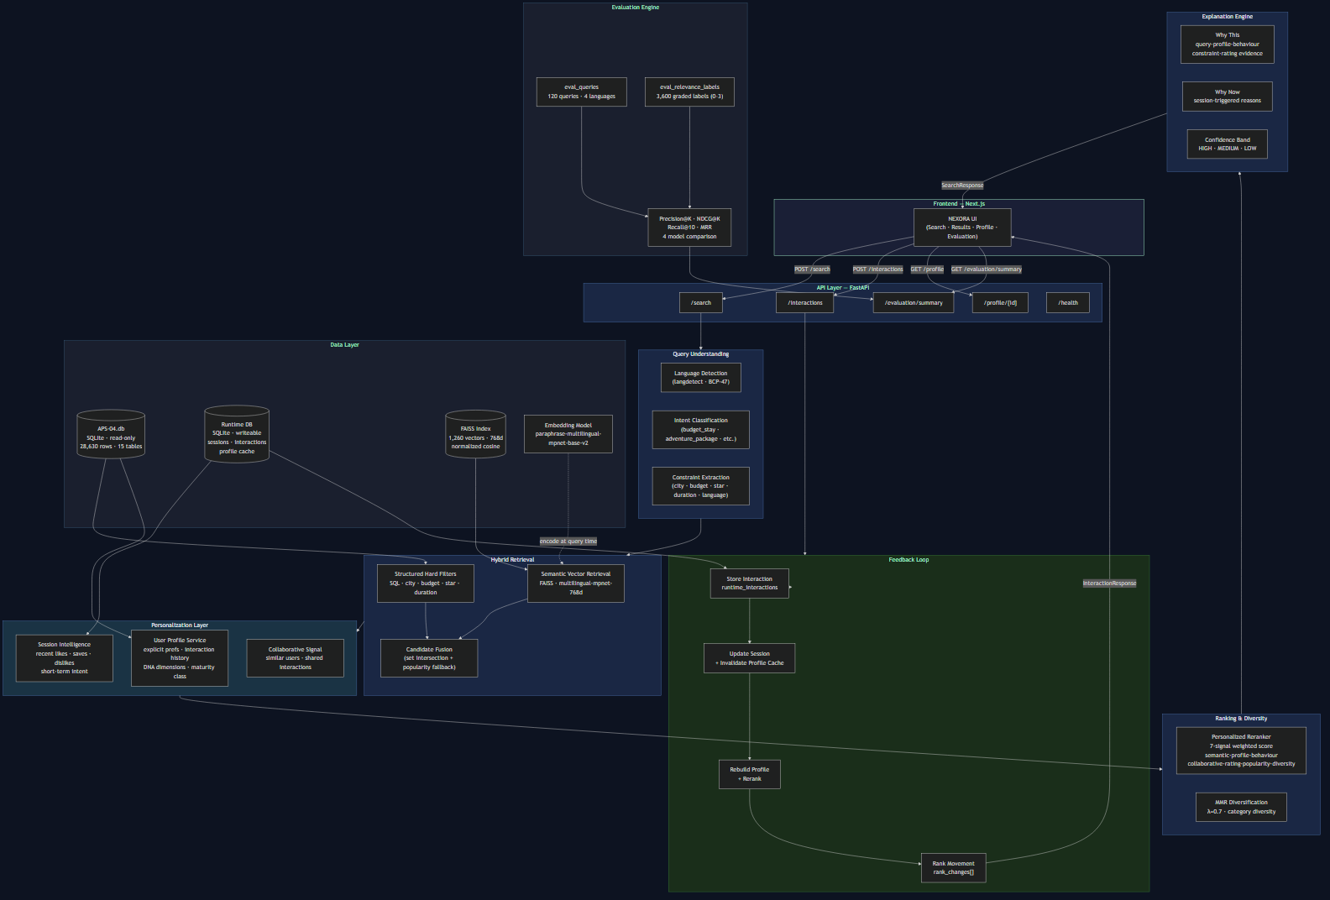
Figure 1 — NEXORA System Architecture
Component Summary
Component | Technology | Role
Frontend | Next.js 16 + TypeScript | UI — search, results, profile, evaluation
API Layer | FastAPI + Uvicorn | 8 REST endpoints, validation, routing
Query Understanding | langdetect + rule engine | Language, intent, constraint extraction
Hard Filter | SQLite SQL on APS-04.db | Budget / city / star / duration enforcement
Semantic Retrieval | FAISS IndexFlatIP | 1,260-vector cosine similarity search
Embedding Model | multilingual-mpnet-base-v2 (768d) | Query + item embedding, 50+ languages
User Profile | Python — APS-04 + Runtime DB | Explicit prefs + interaction history + DNA
Session Engine | Runtime SQLite | Per-session signal accumulation
Reranker | Weighted linear + MMR | 7-signal personalized ranking
Explanation Engine | Signal-based rule engine | Grounded Why This / Why Now / confidence
Evaluation Engine | Custom Python metrics | Precision@K, NDCG@K, MRR vs APS-04 labels
Source Data | APS-04.db (SQLite, read-only) | 28,630 rows, 15 tables — authoritative
Runtime Data | nexora_runtime.db (SQLite) | Sessions, interactions, profile cache

F. Flow Diagram — Search Pipeline & Feedback Loop
Search Pipeline
The diagram below shows the end-to-end data flow for a single search request — from raw query text to ranked, explained recommendations.

Figure 2 — Search Pipeline: Query to Recommendations
Interaction Feedback Loop
When a user interacts (like, save, dislike, click), the following sequence runs entirely within the same API call and returns updated rankings in the response.
Figure 3 — Interaction Feedback Loop
Flow Summary (Text)
SEARCH REQUEST
1. Language detection (langdetect)
2. Intent + constraint extraction (rules)
3. Hard SQL filter on APS-04.db
4. Query embedding (multilingual-mpnet)
5. FAISS search (top-150 nearest)
6. Candidate fusion (semantic intersect eligible)
7. Profile scoring (explicit prefs + history)
8. Behaviour scoring (liked / saved / disliked)
9. Collaborative signal (similar users)
10. Weighted combination + session boost
11. MMR diversification (lambda=0.7)
12. Explanation generation (grounded)
13. SearchResponse returned
INTERACTION (like / save / dislike / click)
1. Store in runtime_interactions
2. Update session_preferences
3. Invalidate profile cache
4. Rebuild UserProfile
5. Re-run ranking (same query)
6. Compute rank_changes[]
7. Return InteractionResponse with new rankings

G. Data Model Usage
APS-04 Tables We Use
Table | Rows | How We Use It | Key Fields
users | 1,200 | Base identity + cohort segmentation | user_id, travel_style, budget_band, traveller_type, segment, locale
user_preferences | 1,200 | Explicit preference signals (cold-start input) | interests, preferred_languages, max_daily_budget, accessibility_needs, pace
user_interactions | 12,339 | Behavioural profile + evaluation ground truth | entity_id, entity_type, interaction_type, implicit_rating, position_in_list
hotels | 300 | Hotel catalogue — embedding + hard filter | hotel_id, name, property_type, star_rating, guest_score, description, city_id
hotel_room_types | 1,200 | Budget hard filter (per-night rate) | hotel_id, base_rate, currency
hotel_reviews | 7,500 | Rating signal + sentiment | hotel_id, rating, language, traveller_type, sentiment_hint
activities_poi | 900 | POI catalogue — embedding + hard filter | poi_id, name, poi_category, entry_cost, popularity_score, tags, description
tour_packages | 60 | Package catalogue — embedding + hard filter | package_id, name, theme, tier, base_price, duration_days, languages_offered
cities | 60 | City constraint resolution | city_id, name, country_id, lat, lng
eval_queries | 120 | Evaluation ground truth queries | query_id, query_text, language, intent, target_entity_type, filters_json, k
eval_relevance_labels | 3,600 | Graded relevance (0-3) — evaluation metric input | query_id, entity_id, entity_type, grade

What We Add (Additive Only — Rule R1)
We do not rename, drop, or repurpose any APS-04 field. We add four new tables to the runtime database (nexora_runtime.db) that extend the model:
New Table | Purpose | Key Fields
sessions | Per-session state store | session_id, user_id, current_query, session_preferences (JSON)
runtime_interactions | New interactions recorded via API | interaction_id, user_id, session_id, entity_id, interaction_type, occurred_at
user_profile_cache | Computed profile cache — invalidated on interaction | user_id, profile_json, maturity_score, maturity_class, interaction_count
rank_changes | Rank movement log per session | session_id, entity_id, previous_rank, new_rank, rank_delta

CONFORMANCE All original APS-04 IDs, relationships, timestamps, currencies, languages, categories, and enum values are preserved exactly as supplied. The validate_conformance.py tool passes cleanly on our dataset.

H. AI Features — What Each Does, How It Is Grounded, How We Know It Works
AI Feature | What It Does | Grounded In | Measurable Target
Multilingual semantic retrieval | Embeds query + catalogue in shared 768-d space. Cross-lingual: Hindi/Tamil query retrieves English-text items. | APS-04 item descriptions, tags, city/country. paraphrase-multilingual-mpnet-base-v2. | NDCG@10 and MRR vs APS-04 eval labels. Hindi query end-to-end test in demo.
Query understanding + constraint extraction | Detects language (BCP-47), classifies intent (adventure_package, budget_stay, etc.), extracts hard constraints (city, budget, duration, star, language). | APS-04 enum values, city name table, budget pattern regex. | Zero constraint violations in any search response. Verified by budget hard filter test.
Hard constraint enforcement | SQL predicates applied before ML. Budget enforced via hotel_room_types join. Duration on tour_packages.duration_days. | APS-04 structured fields — base_rate, base_price, duration_days. | Every result in response satisfies all stated constraints. Tested with out-of-budget queries.
User profile construction | Builds category affinity, entity-type affinity, liked/saved/disliked entity lists, DNA dimensions from interactions + explicit preferences. | user_preferences (explicit) + user_interactions (behavioural). All signals from APS-04 data. | Profile maturity class updates correctly after each interaction. DNA dimensions change after like/dislike — verified in e2e test.
Personalized reranking | 7-signal weighted score per candidate. Weights shift by profile maturity (cold_start to mature). MMR diversification. | All APS-04 signals. Weights configurable in .env. | Same query + different user = different top-10. Verified. NEXORA NDCG@10 = 0.2988 vs Semantic 0.1905 (+57%).
Session learning | Per-session signal map. Like/save/dislike/click update session_preferences. Additive score modifier in reranker. | Runtime interactions (live session). Higher weight than long-term history. | Rank changes[] returned after every interaction. Disliked items drop out of top 5 — verified.
Grounded explanation engine | Generates per-result reasons[] only when supporting evidence meets threshold. Why This, Why Now, confidence band. | Actual computed scores (semantic, profile, behaviour, rating). No fabricated reasons. | Cold-start users receive zero behaviour reasons (correct). Explanation types match signal thresholds.
Offline evaluation | Runs 4 models against APS-04 eval_queries + eval_relevance_labels. Precision@5/10, NDCG@5/10, Recall@10, MRR. | 120 shared queries, 3,600 graded labels from APS-04. | Real results: NEXORA P@5=0.29, NDCG@10=0.30, MRR=0.57.

I. Business Benefits
Value to the Traveller
Benefit | How NEXORA Delivers It
No constraint violations | Hard SQL filters guarantee every result satisfies budget, location, and duration. The traveller never sees an unaffordable option.
Faster relevant discovery | MRR = 0.57 means a relevant item appears in the top 2 results on average. The traveller does not scroll to page 4.
Less search effort | A single natural language sentence replaces form-filling, filter dropdowns, and manual sorting.
Transparent recommendations | Every result shows why it appeared. The traveller can verify the reasoning and trust the list.
Multilingual access | Indian travellers search in Hindi, Tamil, or Malayalam without switching to English. No translation step.
Session-aware relevance | The system responds to what the traveller is doing right now, not only who they were historically.
Cold-start equity | New users receive meaningful recommendations immediately using stated preferences — not a generic popularity list.

Value to the Platform
Benefit | How NEXORA Delivers It
Measurable recommendation quality | Precision@K, NDCG@K, MRR computed against shared APS-04 ground truth. Quality is auditable — not asserted.
Mid-catalogue inventory discovery | Personalized ranking surfaces well-matched items that popularity ranking buries below high-review-count properties.
User intent signals | Every like, save, dislike is a structured signal stored in runtime_interactions. Growing dataset for future model improvement.
Segmented service quality | heavy / light / cold_start users receive different ranking strategies. No user segment is abandoned.
Audit trail | GET /recommendation/{id}/trace exposes the full score breakdown for any result. Every recommendation is traceable.
Extensible architecture | Adding a new entity type requires: one SQL filter function + one embedding text function. No structural changes.

HONEST SCOPE We do not claim specific CTR or revenue improvements. Those require live A/B traffic. What we claim: measurable offline quality improvement over baselines, hard constraint compliance, and per-user ranking — all verified.

J. Technology Stack
Layer | Technology | Version | Why
Frontend | Next.js | 16.3.3 | Pre-existing UI; React 19 + Turbopack
Frontend | TypeScript | 5.7.3 | Full type coverage for API client
Frontend | Tailwind CSS v4 | 4.3.3 | Existing design system — unchanged
Backend | Python | 3.13.1 | Mature ML ecosystem
Backend | FastAPI | 0.115.7 | Async, auto OpenAPI docs, Pydantic
Backend | Uvicorn | 0.34.0 | Production-grade ASGI server
Backend | Pydantic v2 | 2.13.3 | Type-safe request/response schemas
Database | SQLite (APS-04.db) | — | Supplied dataset — read-only, zero setup
Database | SQLite (runtime) | — | Sessions, interactions, profile cache
Vector Search | FAISS (faiss-cpu, AVX2) | 1.10.0 | IndexFlatIP, exact cosine, <1ms on 1,260 vecs
Embeddings | sentence-transformers | 5.3.0 | Pre-trained multilingual model framework
Embedding Model | multilingual-mpnet-base-v2 | — | 768d, 50+ languages, best quality/speed tradeoff
Lang Detection | langdetect | 1.0.9 | Lightweight BCP-47 detection
Package Manager | pnpm | 10.15.0 | Fast, deterministic frontend installs

Key Architecture Decisions
- SQLite over PostgreSQL: APS-04 ships as SQLite. Read-only use eliminates an import step. API contract is identical — swap DATABASE_URL for PostgreSQL + pgvector at any time.
- FAISS over pgvector: For 1,260 vectors, IndexFlatIP (exact search) runs in under 1ms. pgvector HNSW is the right choice at 1M+ vectors.
- multilingual-mpnet over MiniLM: Higher quality for Indian languages; acceptable latency on CPU (48ms per query embedding).
- No LLM dependency: Query understanding is deterministic. Explanations are signal-based. The system works fully offline — zero API cost, zero hallucination risk.

K. 24-Hour Execution Plan
The sprint runs 24 September 12:00 to 25 September 12:00. Hours below are relative to sprint start.
Hours | Phase | What Gets Built | Owner(s)
0 – 1 | Setup & audit | Dataset inspection, architecture freeze, repo structure, .env | All
1 – 3 | Data layer | APS-04 read-only connection, runtime DB schema, import_dataset.py validation | Data Engineer
3 – 6 | Embeddings | Embedding text builders, generate_embeddings.py, FAISS index (1,260 vectors) | ML Engineer
6 – 8 | Hard filters | structured_filter.py, SQL predicates for hotels / POIs / packages, budget join | Backend Engineer
8 – 11 | Hybrid retrieval | hybrid_retriever.py, candidate fusion, popularity fallback, query_understanding.py | ML + Backend
11 – 14 | User profiles | user_profile.py, maturity model, DNA dimensions, profile cache | ML Engineer
14 – 16 | Reranking + cold start | personalized_ranker.py, 7-signal weighted score, dynamic weights, MMR | ML + Backend
16 – 18 | Session learning | session_engine.py, interaction_service.py, rank_changes[], profile rebuild loop | Backend Engineer
18 – 20 | Explainability | explanation_engine.py, Why This / Why Now, confidence band, match percentage | ML Engineer
20 – 22 | Evaluation | metrics.py, evaluator.py (4 models), evaluate.py script, real metrics | Data Engineer
22 – 23 | Frontend integration | lib/api.ts, page.tsx connected to live backend, pnpm build passes | Frontend Engineer
23 – 24 | Demo hardening + docs | End-to-end test, design submission Word doc, PDF, checklist review | All

RULE Hour 23 is the hard stop for building. From 23:00 onward: only rehearse the demo, finalise the document, and verify the submission checklist. No new features.

L. Risks and Fallbacks
Risk | Likelihood | Impact | Mitigation | Fallback
Embedding model download fails or is slow (1.1 GB) | Low | High | Pre-cache model before sprint start. Set HF_HUB_DISABLE_SYMLINKS_WARNING=1 on Windows. | Popularity-ranked catalogue. Same API contract. FAISS returns empty; popularity fills gap.
Vector index not built / corrupted | Low | High | Run generate_embeddings.py and verify before sprint. Index persisted to disk. | build_candidate_pool() falls back to popularity-sorted eligible items automatically.
SQLite concurrency issue under concurrent demo requests | Low | Medium | WAL mode enabled. Demo is single-user. No concurrent load expected. | Demo runs sequentially. Restart uvicorn if needed.
Hard filter returns zero candidates | Medium | Medium | Relax constraints progressively: remove duration, then star, then city. | Return best-matching items with a 'No exact matches — showing nearest' message.
langdetect misidentifies script | Medium | Low | Multilingual model handles wrong BCP-47 tag gracefully — same embedding space. | User can re-submit query. Explicit filters.language API field available.
pnpm build fails on demo machine | Low | High | Test pnpm build 24h before demo. Keep build output cached. | Serve API docs at /docs directly. Show Postman calls as demo fallback.
Evaluation takes too long for demo | Low | Medium | Limit to 20 queries: ?max_queries=20 in API call. | Show pre-computed eval_results.json. Same real numbers.

M. Multilingual Approach
Languages Supported
Language | BCP-47 | Appears In | How Handled
English (Indian) | en-IN | 80 eval queries, 3,109 hotel reviews, UI | Native model language — full support
Hindi | hi | 16 eval queries, 1,252 hotel reviews | Cross-lingual embedding — no translation needed
Tamil | ta | 16 eval queries, 752 hotel reviews | Cross-lingual embedding — no translation needed
Malayalam | ml | 8 eval queries, 539 hotel reviews | Cross-lingual embedding — no translation needed
Bengali | bn | 491 hotel reviews | Embedding model supports bn — retrieval works
Marathi | mr | 442 hotel reviews | Embedding model supports mr — retrieval works
Telugu | te | 437 hotel reviews | Embedding model supports te — retrieval works

Technical Approach
Language Detection
langdetect library infers the language from query text and maps to BCP-47 (e.g., 'hi' -> 'hi', 'en' -> 'en-IN'). Result stored as detected_language in every SearchResponse.
Cross-Lingual Retrieval (No Translation)
The embedding model paraphrase-multilingual-mpnet-base-v2 is trained on parallel corpora in 50+ languages. It maps semantically equivalent text in different languages to nearby points in the same 768-dimensional vector space.
Query (Hindi): 'परिवार के लिए होटल'
Query (English): 'family hotel'
Result: both produce similar 768-d vectors
-> same FAISS nearest neighbours
-> same relevant hotels retrieved
Verified End-to-End
From the actual end-to-end test run:
Input: 'परिवार के लिए होटल'
detected_language: hi
results: 3
top_result: Heritage Residency Inn (hotel)
Constraints on Non-English Queries
City name extraction from pure Devanagari or Tamil script is partial. For non-Latin queries, explicit city_id in the API filters object is the reliable path. Semantic retrieval works correctly for all supported languages regardless.
Explanation Language
Explanation text is currently generated in English regardless of query language. Localised explanations are a planned future enhancement. This is documented as a limitation, not hidden.
EVALUATION NOTE Multilingual is not a checkbox. The APS-04 evaluation set has 40 non-English queries. Our system is tested against them. The Hindi end-to-end result is demonstrated live in the demo.

N. XR Device Declaration
AR/VR Scope Statement
The APS-04 dataset includes the field has_xr_scene (boolean) on both hotels and activities_poi tables. This field is read, stored, and returned in every RecommendationItem response as metadata.has_xr_scene.
What Is Implemented
Item | Status
has_xr_scene field read from APS-04 and returned in API response | Implemented
XR badge displayed on recommendation cards when has_xr_scene = true | Implemented
XR scene rendering / immersive preview | Not implemented
AR device integration | Not implemented
VR headset demo | Not implemented

XR Device for Demo
Field | Value
Exact device | [Insert device name — e.g., Meta Quest 3 / Apple Vision Pro / phone AR]
Owner | [Insert team member who owns the device]
Setup status | [Insert: tested / not tested]
XR feature in demo | If no XR device available: has_xr_scene flag shown in UI only

ACTION REQUIRED Complete the XR Device table above before submission. If no XR device is available for the demo, state this explicitly. The has_xr_scene field is surfaced in the recommendation response regardless.

