Sreejith UnniKrishnan

C-0644881

Finance Management

Java Project

Table of Contents

1. Introduction 2

2. OverView 2

3. Flow Diagram 3

4. Critical Path Analysis Flow Diagram 4

5. Project Timeline 5

6. Database Diagram 5

7. End-User Frequently Asked Questions 6

**Introduction**

The Project will be a web application for managing the finance of user with the help of Income, Expense and Reports modules.

**Overview**

The Web based application will help the users to manage their finance. The application will be based on MVC model.

The Application will allow user to add their income and expense details to pre-defined categories or can create their own category and add the details. The application will track the income and expenses for each category monthly/yearly as user requested.

With the help of this application user can track all his expenses and incomes, which will help user to manage and plan his finance more effectively.

The modules included in the application are Login, Income, Expense and Budgeting:

* Login: In this module new user registration can be done and for registered user the links to other modules like Income budgeting, expense budgeting and reports are shown.
* Income: User can add his incomes to the available income categories or user can add new category. The details will be saved into the database. User can give Budget amount, so that the application will show if user have achieved the budgeted income for a particular month.
* Expense: User can add his expenses to the available expense category or user can add new category. The details entered will be saved to the database. User can give Budget amount, so that the application will show if user have crossed the budgeted expense for a particular month.
* Reports: Based on the user incomes and expenses, the budgeting is done and details like total expense, total income, which category contributed largest in expenses category so that user can control on the expenses and start saving.

**Flow Diagram**

Login Page

Registered User

New User

Reports

Expense Details

Income Details

Add/Edit Expense

Add/Edit Income

**Critical Path Analysis Flow Diagram**

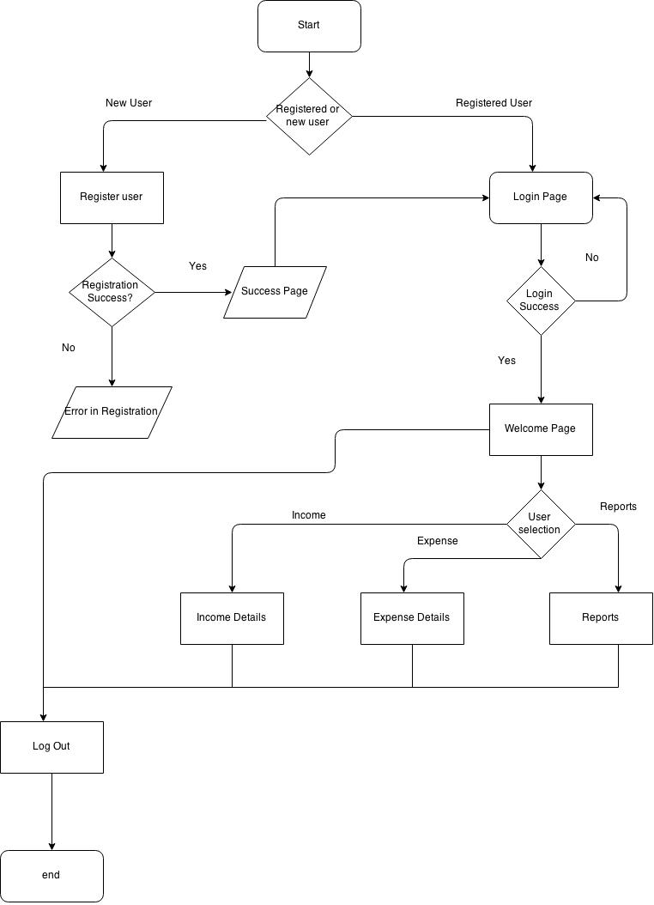

**Project Timeline**

|  |  |  |  |  |  |
| --- | --- | --- | --- | --- | --- |
| Modules/Time | Week1 | Week2 | Week3 | Week4 | Week5 |
| Setup database |  |  |  |  |  |
| create base project |  |  |  |  |  |
| login module |  |  |  |  |  |
| Registration |  |  |  |  |  |
| Income budgeting |  |  |  |  |  |
| Expense Budgeting |  |  |  |  |  |
| Reports |  |  |  |  |  |
| Integrating Chart |  |  |  |  |  |
| Web page design |  |  |  |  |  |
| Test application |  |  |  |  |  |

**Database Diagram**

|  |  |
| --- | --- |
| Expense | |
| id | INTEGER |
| name | VARCHAR2(20) |
| amount | INTEGER |
| date | DATE |
| budget | INTEGER |

|  |  |
| --- | --- |
| Income | |
| id | INTEGER |
| name | VARCHAR2(20) |
| amount | INTEGER |
| date | DATE |
| budget | INTEGER |

|  |  |
| --- | --- |
| Categories | |
| id | INTEGER |
| name | VARCHAR2(20) |
| Type | VARCHAR2(20) |

|  |  |
| --- | --- |
| Users | |
| id | INTEGER |
| name | Varchar2(20) |
| password | Varchar2(20) |
| Security_question | Varchar2(30) |
| Security_answer | Varchar2(20) |

**End-User Frequently Asked Questions (FAQs) or Help Documents**

**Q)** What if user can’t find the Income/Expense Category:

**A)** User can add an income category from the available income category list or can create a new category and assign the budget

**Q)** How to login if user forgets password

A) User can login using the security answer set during registering