House Price Prediction
Full-Stack Machine Learning Application

Project Report

Backend | Frontend | ML Model
Flask 3.0 (Python) | Streamlit 1.36 | Linear Regression  scikit-learn 1.9

1. Project Overview
This project is a full-stack machine learning application that predicts house prices based on two input features: area (in square feet) and number of rooms. The application follows a client-server architecture where a Flask REST API serves predictions from a trained scikit-learn model, and a Streamlit frontend provides an interactive, browser-based user interface.

1.1 Objectives
- Train a Linear Regression model on the house_price.csv dataset.
- Expose predictions via a RESTful API using Flask.
- Build an interactive frontend using Streamlit with charts and analytics.
- Provide dataset exploration and model insight visualisations.

1.2 Technology Stack
Layer | Technology | Purpose
ML Training | scikit-learn, numpy, pandas | Model training, scaling, data handling
Model Persistence | joblib | Save and load model + scaler
Backend API | Flask 3.0 | REST endpoints for predictions
Frontend UI | Streamlit 1.36 | Interactive Python-native web app
Visualisation | Plotly, matplotlib | Charts in UI and diagnostics plot
HTTP Client | requests | Frontend calls backend API

2. Project Structure
File / Folder | Description
house_price_project/ | Project root
data/house_price.csv | 47 training samples: area, rooms, price
model/model.pkl | Trained LinearRegression artefact
model/scaler.pkl | StandardScaler fitted on training data
model/diagnostics.png | Actual vs Predicted + Residual plots
backend/app.py | Flask REST API (port 5000)
frontend/ui.py | Streamlit frontend (port 8501)
train_model.py | Training script - runs model pipeline
requirements.txt | All Python dependencies
README.md | Run instructions

3. Dataset
The dataset (house_price.csv) contains 47 records of residential house sales with three columns: area (square footage), rooms (count), and price (USD).

3.1 Dataset Statistics
Statistic | area | rooms | price
count | 47.00 | 47.00 | 47.00
mean | 2,000.68 | 3.17 | 340,412.66
std | 794.70 | 0.76 | 125,039.90
min | 852.00 | 1.00 | 169,900.00
25% | 1,432.00 | 3.00 | 249,900.00
50% | 1,888.00 | 3.00 | 299,900.00
75% | 2,269.00 | 4.00 | 384,450.00
max | 4,478.00 | 5.00 | 699,900.00

3.2 Sample Records
Area (sq ft) | Rooms | Price ($)
2,104 | 3 | $399,900
1,600 | 3 | $329,900
2,400 | 3 | $369,000
1,416 | 2 | $232,000
3,000 | 4 | $539,900
1,985 | 4 | $299,900
1,534 | 3 | $314,900
1,427 | 3 | $198,999

4. Machine Learning Model
A Linear Regression model was trained using scikit-learn. Features were normalised using StandardScaler (fit only on training data) before model fitting. An 80/20 train-test split was used with random_state=42 for reproducibility.

4.1 Model Pipeline
- Load CSV -> pandas DataFrame
- Feature selection: area, rooms -> X; price -> y
- Train/test split: 80% train / 20% test (random_state=42)
- Feature scaling: StandardScaler.fit_transform(X_train), .transform(X_test)
- Model fitting: LinearRegression().fit(X_train_scaled, y_train)
- Evaluation: MAE, RMSE, R2 on test set
- Persistence: joblib.dump(model, scaler)

4.2 Model Equation
Price = 323,170.16 + 107176.2626 * area_scaled + -10956.1333 * rooms_scaled

4.3 Evaluation Metrics
Metric | Value | Interpretation
R2 Score | 0.5149 | Proportion of variance explained (0-1, higher is better)
MAE | $72,334.75 | Average absolute prediction error in USD
RMSE | $92,792.37 | Root mean squared error, penalises large errors
Note: The R2 of 0.51 is moderate, which is expected given the small dataset (47 samples).

5. Backend API (Flask)
The Flask backend runs on port 5000 and exposes four REST endpoints. The frontend communicates with these endpoints using HTTP requests.
Method | Endpoint | Description
GET | /health | Health check - confirms API is live
POST | /predict | Predict house price from area + rooms JSON body
GET | /dataset | Return full training dataset as JSON array
GET | /model_info | Return model coefficients, intercept, and metrics

5.1 Sample API Call - /predict
Request (POST /predict):
{ "area": 2000, "rooms": 3 }
Response:
{
"area": 2000.0,
"rooms": 3.0,
"predicted_price": 330,662.99,
"currency": "USD"
}

6. Frontend UI Output (Streamlit)
The Streamlit frontend runs on port 8501 and consists of three navigable pages, all communicating with the Flask backend API in real time.

6.1 Page 1 - Predict Price
The Predict Price page accepts area and rooms as inputs, sends a POST request to /predict, and displays the predicted price along with a gauge chart. A quick-reference table shows pre-computed predictions for common house sizes.
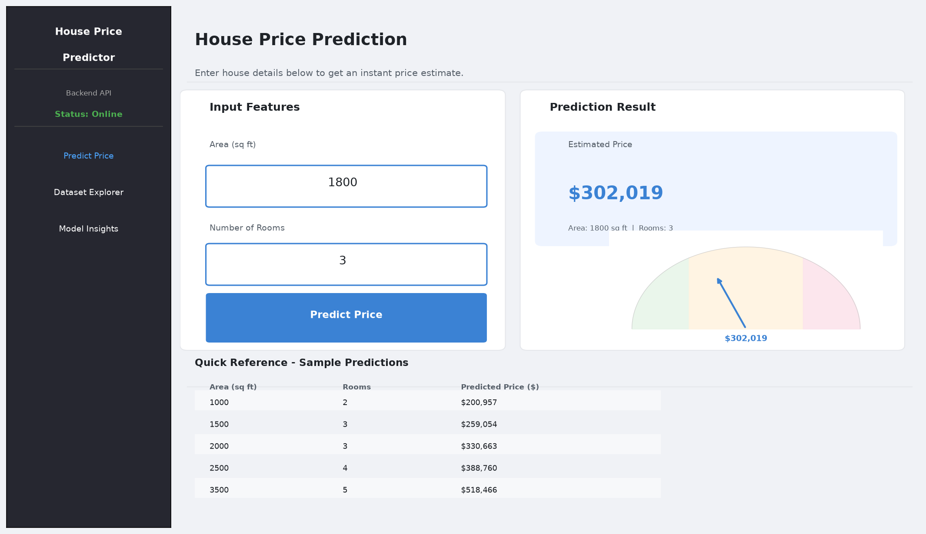

6.2 Page 2 - Dataset Explorer
The Dataset Explorer page fetches all records from the /dataset endpoint and displays them as interactive charts: scatter plot (area vs price), price histogram, box plots by room count, and a correlation heatmap. Summary metric cards show key statistics at a glance.
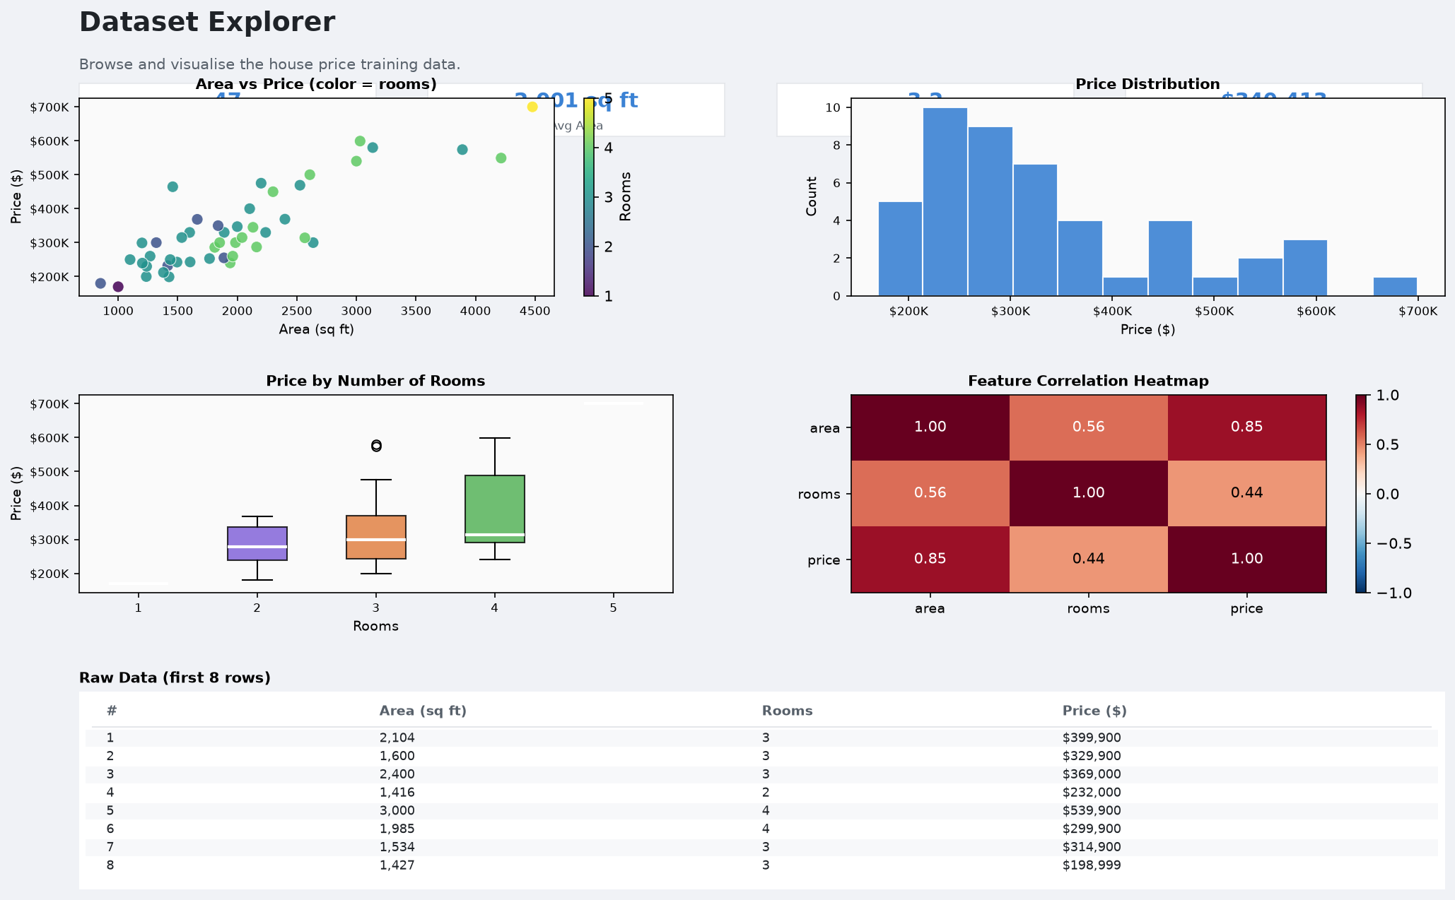

6.3 Page 3 - Model Insights
The Model Insights page fetches /model_info and displays R2, MAE, and RMSE metric cards, the full model equation, a feature coefficients bar chart, an actual vs predicted scatter plot, and an OLS regression trendline over the full dataset.
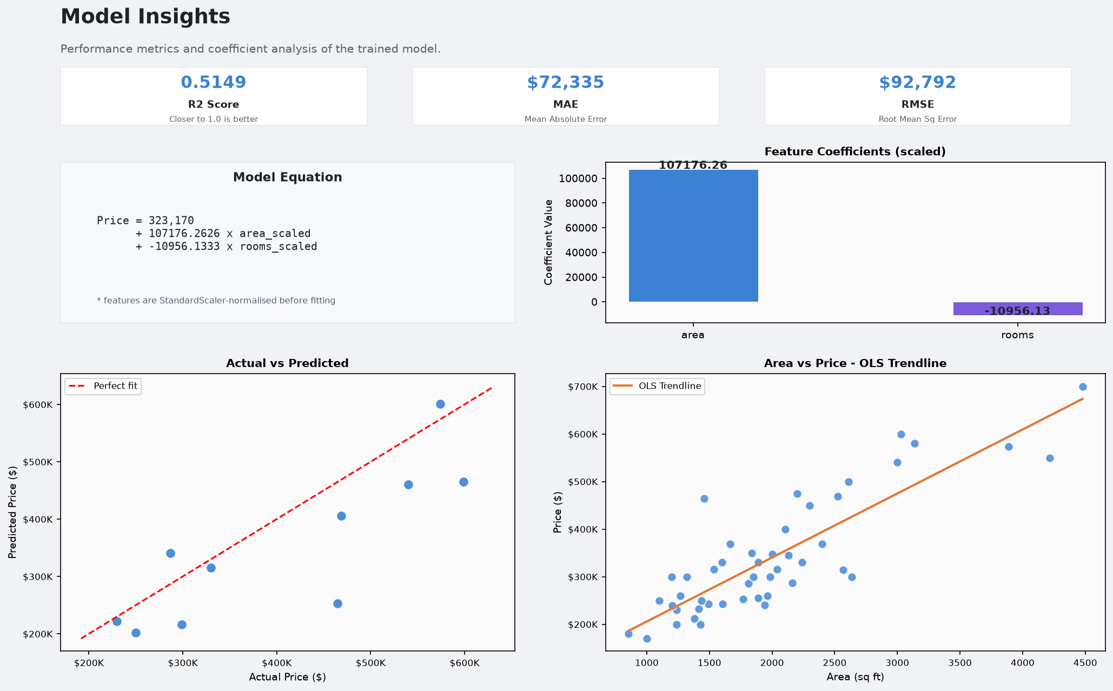

7. Sample Prediction Results
The following table shows model predictions for a range of house configurations:
Area (sq ft) | Rooms | Predicted Price (USD)
852 | 2 | $179,760.68
1,000 | 1 | $214,469.59
1,268 | 3 | $225,827.03
1,500 | 3 | $259,053.73
1,800 | 3 | $302,019.29
2,000 | 3 | $330,662.99
2,500 | 4 | $388,759.69
3,000 | 4 | $460,368.96
3,500 | 5 | $518,465.66
4,478 | 5 | $658,533.39

8. How to Run the Project
Step 1: Install Dependencies
pip install -r requirements.txt
Step 2: Train the Model
python train_model.py
Step 3: Start Flask Backend (Terminal 1)
python backend/app.py # runs on http://localhost:5000
Step 4: Launch Streamlit Frontend (Terminal 2)
streamlit run frontend/ui.py # opens http://localhost:8501

