BROKEN GARAGE DOOR SPRING REPAIR
CALL JOSEPH TODAY M-S 630AM TO 10PM SUNDAY 7AM TO 6PM AFTER HOURS LEAVE A MESSAGE
323.270.5387 310.734.0910 818.351.3118
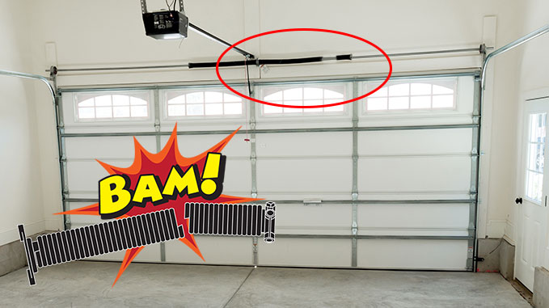

47 YEARS IN BUSINESS SHOWS WE REPAIR GARAGE DOORS RIGHT

That’s why we need to work a larger area. If you’re repairing garage door properly, you’ll see your customer every 6 to 12 years. Their needs will range from replacing a garage door or broken springs to repairing or installing a new door opener such as a Genie, Chamberlain or Liftmaster opener unit. No matter what your repair issue are or how far away from us you live. Understand we appreciate your business, as much as you appreciate our 47 years of customer satisfaction.

NEW GARAGE DOOR SPRINGS CALL TODAY 323.270.5387

GARAGE DOOR SPRINGS REPAIR BROKEN SPRING REPAIR NEW TORSION SPRINGS NEW SPRINGS GARAGE DOOR SPRING REPLACEMENT ROLL UP GARAGE DOOR SPRINGS

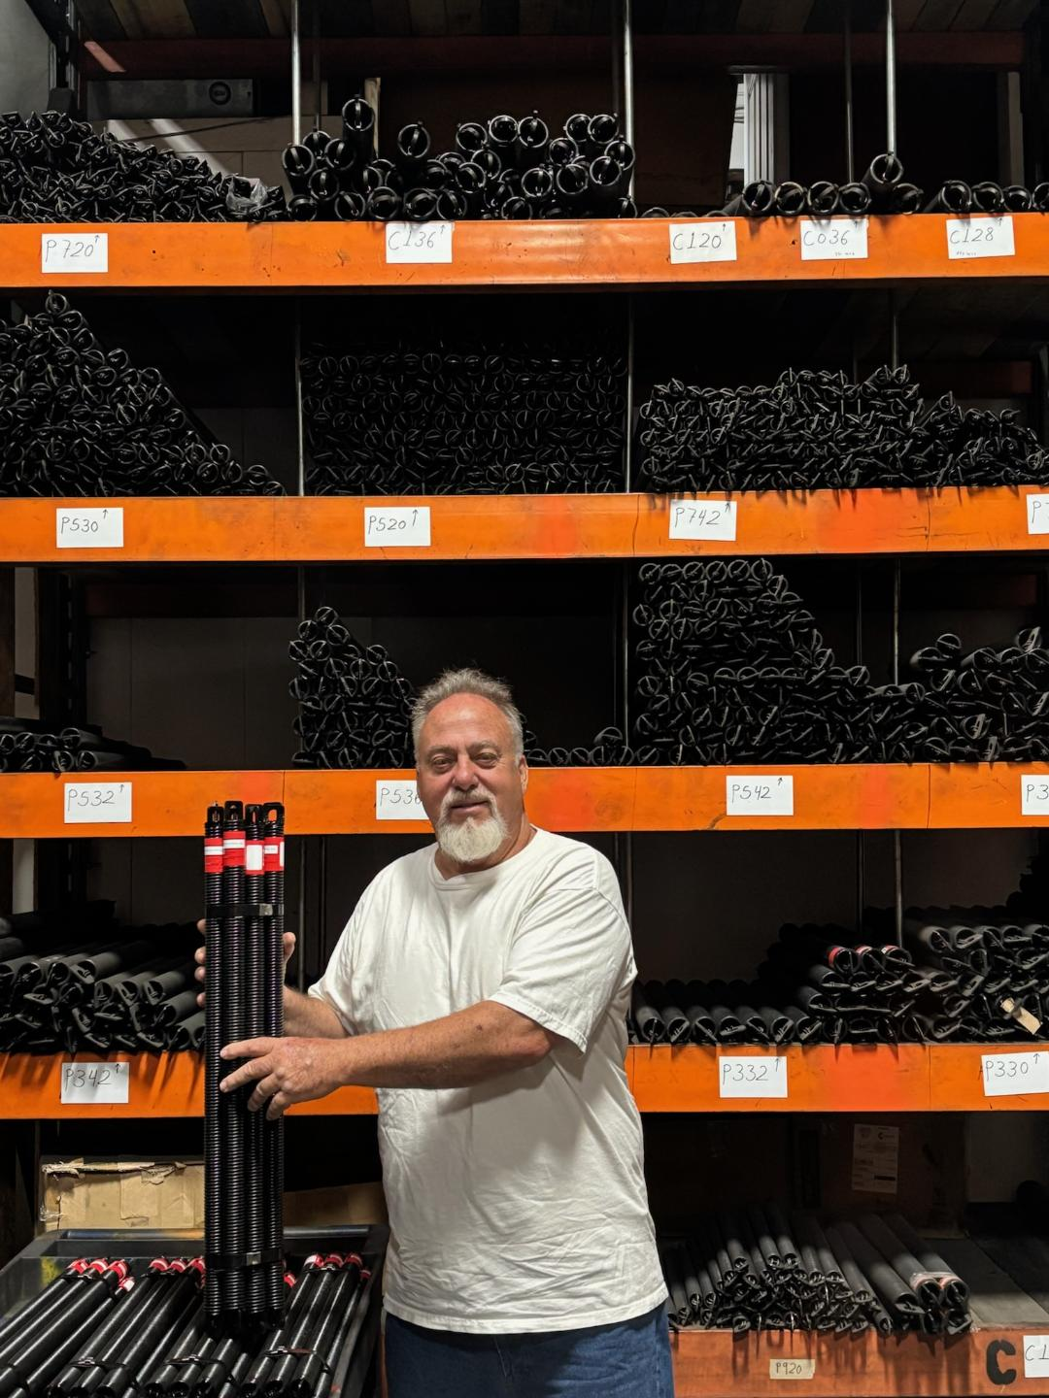

We use garage door springs manufactured by American Garage Door Spring MFG. These are high quality springs manufactured right here in the Los Angeles, California.
I’ve been buying American springs for over 30 years. They also manufacture HIGH CYCLE SPRINGS. Most garage door manufactures give 10,000 to 12,000 cycle springs with their garage doors. Those garage door torsion springs will normally last on average 6 to 10 years. HIGH CYCLE SPRINGS can double to triple that amount of time. That’s to say you don’t mind paying extra for your garage door springs.

CALL JOSEPH 323.270.5387 818.351.3118

If you notice the following symptoms, contact Joseph right away:
- The garage door won’t open or close – It’s possible that there’s something wrong with the main drive gear if it’s a Liftmaster or Chamberlain garage door opener. If you have a Genie garage door opener it could be the trolley that’s stripped out.
- If you need a gear kit or trolley replacement, it’s best that you leave the installation to professionals because it could be that those parts wore out due to the garage door not being properly balanced or your limits could be out of adjustment.
- The garage door is jammed, stuck, or uneven – Faulty cables, worn pulleys, or bent tracks can cause this problem.
- The garage door is noisy – The reason maybe a lack of lubrication on the wheels, hinges or bearings. Beside this issue If you hear popping sounds, your cables could be rubbing the garage door end caps. Frayed cables could produce a scraping sound.
- Meanwhile, the bearings or rollers should be lubrication at least 3 to 4 time a year. if there are squeaking noises.
We repair all makes and models of
garage doors and garage door openers

Most of the openers we sell are Genie and Chamberlian-Liftmaster models in chain drive, belt drive, and screw drive configurations. We still carry many Genie models, so if you want a Genie chain drive, belt drive, or screw drive opener, we have it in stock.
- New Chamberlain ½ HP Chain Drive Opener: $770.00 (including tax and installation, with two remote controls)
- New chamberlain ½ HP Belt Drive Opener: $740.00 (including tax and installation, with two remote controls)
- New Genie 1/2 HP Belt Drive Opener: $660.00 (including tax and installation, with two remote controls)
- New Genie 1 1/4 HP Belt Drive Opener: $770.00 (including tax and installation, with two remote controls)

Garage Door Spring Repair Service Areas for 2025
New garage door springs in Agoura Hills | New garage door springs in Alhambra | New garage door springs in Arcadia | New garage door springs in Artesia | New garage door springs in Azusa | New garage door springs in Baldwin Park | New garage door springs in Bell | New garage door springs in Bell Gardens | New garage door springs in Bellflower | New garage door springs in Beverly Hills | New garage door springs in Bradbury | New garage door springs in Burbank | New garage door springs in Calabasas | New garage door springs in Los Angeles County | New garage door springs in Orange County | New garage door springs in Cerritos | New garage door springs in Compton | New garage door springs in Covina | New garage door springs in Cudahy | New garage door springs in Culver City | New garage door springs in Diamond Bar | New garage door springs in Downey | New garage door springs in Duarte | New garage door springs in El Monte | New garage door springs in El Segundo | New garage door springs in Gardena | New garage door springs in Glendale | New garage door springs in Glendora | New garage door springs in Hawaiian Gardens | New garage door springs in Hawthorne | New garage door springs in Hermosa Beach | New garage door springs in Hidden Hills | New garage door springs in Huntington Park | New garage door springs in Industry | New garage door springs in Inglewood | New garage door springs in Irwin dale | New garage door springs in La Cañada Flintridge | New garage door springs in La Habra Heights | New garage door springs in La Mirada | New garage door springs in La Puente | New garage door springs in La Verne | New garage door springs in Lakewood | New garage door springs in Lawndale | New garage door springs in Lomita | New garage door springs in Long Beach | New garage door springs in Los Angeles | North Long Beach | New garage door springs in Lynwood | New garage door springs in Malibu | New garage door springs in Manhattan Beach | New garage door springs in Maywood | New garage door springs in Monrovia | New garage door springs in Montebello | New garage door springs in New garage door springs in Monterey Park | New garage door springs in Norwalk | New garage door springs in Palos Verdes Estates | New garage door springs in Paramount | New garage door springs in Pasadena | New garage door springs in Pico Rivera | New garage door springs in Pomona | New garage door springs in Rancho Palos Verdes | New garage door springs in Redondo Beach | New garage door springs in Rolling Hills | New garage door springs in Rolling Hills Estates | New garage door springs in Rosemead | New garage door springs in San Fernando | New garage door springs in San Gabriel | New garage door springs in San Marino | New garage door springs in Santa Clarita | New garage door springs in Santa Fe Springs | New garage door springs in Santa Monica | New garage door springs in Sierra Madre | New garage door springs in Signal Hill | New garage door springs in South El Monte | New garage door springs in South Gate | New garage door springs in South Pasadena | New garage door springs in Temple City | New garage door springs in Torrance | New garage door springs in Vernon | New garage door springs in Walnut | New garage door springs in West Covina | New garage door springs in Hollywood Hills | New garage door springs in Westlake Village | New garage door springs in Whittier |
New garage door springs in Anaheim | New garage door springs in Brea | New garage door springs in Buena Park | New garage door springs in Costa Mesa | New garage door springs in Cypress | New garage door springs in Fountain Valley | New garage door springs in Fullerton | New garage door springs in Garden Grove | New garage door springs in Huntington Beach | New garage door springs in La Habra | New garage door springs in La Palma | New garage door springs in Los Alamitos | New garage door springs in Orange | New garage door springs in Placentia | New garage door springs in Santa Ana | New garage door springs in Seal Beach | New garage door springs in Stanton | New garage door springs in Tustin | New garage door springs in Villa Park | New garage door springs in Westminster | New garage door springs in Yorba Linda.

© 2025 www.brokengaragedoorsprings.com All rights reserved.

