* Pursuing Post-Graduation in *Artificial Intelligence & Machine Learning /Analytics* from ***Scaler Neovarsity.***
* Post-graduated in Computer Networking *Melbourne Institute of Technology*,2021.
* Academic Project: *Virtual Doctor*
* A platform for virtual consultations between patients and doctors. The application enables patients to schedule appointments and manage their records, while giving doctors quick access to patient information.
* As the team lead, I gained hands-on experience in team management, research, and documentation. These skills helped me to effectively manage the project and ensure its success.
* I was responsible for organizing tasks and coordinating with other team members to connect the front-end and back-end modules. My role was critical in ensuring the seamless functioning of the platform.
* This project was part of my master’s degree program and provided a platform to apply my academic knowledge to real-world problems. It also helped me develop my technical skills and prepare for future opportunities in the field.
* Graduated in Computer Science & Engineering *JNTUH*,2018.

*Tools*

*Education*

|  |  |
| --- | --- |
| *Technology* | Description |
| *Python* | Experienced in using Python for data analysis and visualization, including proficiency in Pandas and Jupyter Notebook. |
| *Power BI* | Proficient in using Power BI for data visualization and dashboard creation, with experience in data modelling and report creation. |
| *SQL* | Strong experience in SQL, including proficiency in Big Query, Azure Data Studio, PostgreSQL, and MySQL. |
| *Excel* | Proficient in using Excel for data analysis, including Pivot Tables, VLOOKUPs, and macros. |
| *Git* | Experience in using Git for version control and collaboration, with a good understanding of Git workflows and commands. |

*Project 1: Data Analysis for Brazilian E-commerce*

* The company was struggling to gain a comprehensive understanding of online sales trends.
* Our team utilized SQL and Power BI to perform in-depth data exploration and created interactive dashboards to effectively communicate insights to stakeholders. Our analysis of the Brazilian E-commerce data provided a thorough understanding of customer behaviour and preferences.
* The insights we delivered enabled the company to make data-driven decisions, improving their performance. Our solution to the challenge of limited understanding of online sales trends provided a competitive advantage for the business.
* *For more information:* [*GitHub*](https://github.com/Sreekanth-Vasireddy/SreeGitHub)

*Project 2: Product Sales Analysis for Bike Store*

* The bike store needed to gain a better understanding of their product performance, including the top 10 and bottom 10 products in terms of sales and profits.
* We conducted a data analysis using SQL to identify product sales trends and customer behaviour and preferences. Our insights were then communicated to the decision-makers, enabling them to make informed decisions about product offerings.
* Our solution helped the bike store overcome the challenge of limited understanding of product performance. By using SQL to gain insights, we drove improvements in product sales and provided a competitive advantage for the store. Our approach allowed the decision-makers to make informed decisions, leading to improved product offerings and overall success for the business.
* *For more information:* [*GitHub*](https://github.com/Sreekanth-Vasireddy/SreeGitHub)

*Experience*

Highly analytical and detail-oriented data analyst with a strong background in data analysis, statistics, and programming. Proficient in using Python, Excel, Power BI, and SQL to extract, process and analyse complex data sets. Seeking a challenging role as a data analyst to leverage my skills in uncovering valuable insights and driving informed business decisions. Continuously striving to enhance my expertise, as demonstrated by my current pursuit of a Post-Graduation in AI & ML/Analytics.

*Profile*

* *IT Systems Engineer: Pushpak Technologies. (Jul,2018-Dec,2018)*
* Provided technical troubleshooting to employees, resolving hardware and software issues.
* Assisted in the implementation of databases, ensuring data accuracy and integrity.
* Contributed to the development and maintenance of database management systems.
* Conducted research and recommended new technologies to improve the IT infrastructure. Collaborated with IT team members to resolve technical issues and maintain high levels of customer satisfaction.

*Internships*

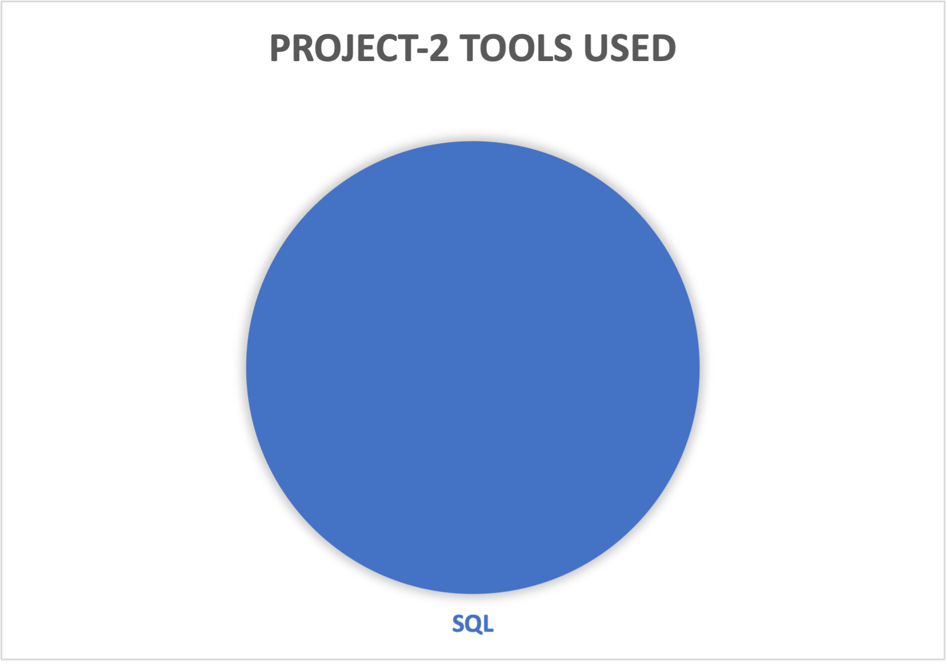

*Tools Used for Projects*

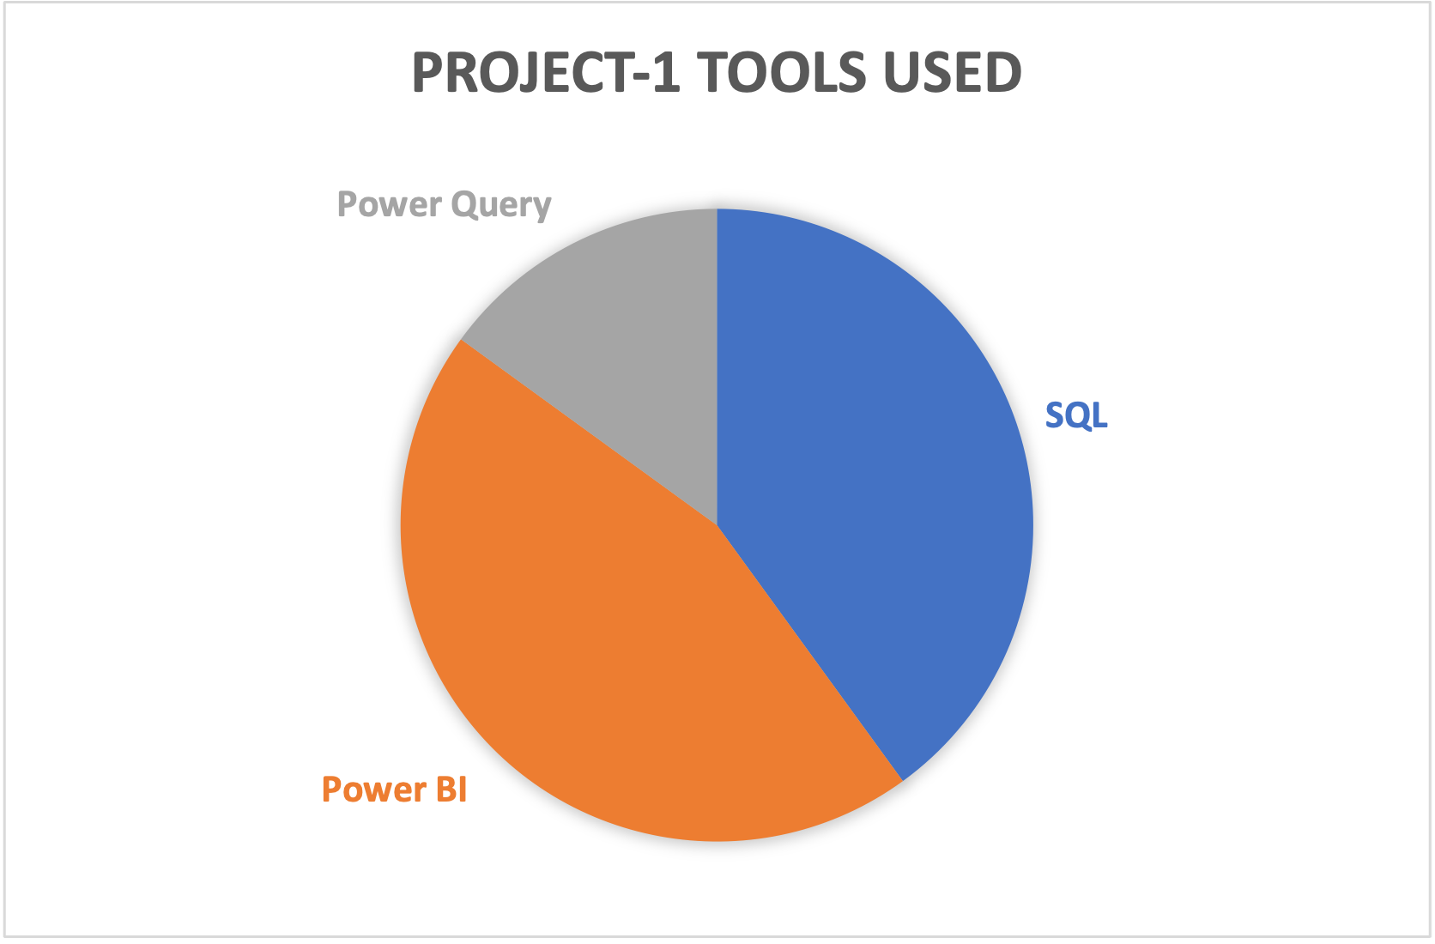

 Data Visualization

Data Wrangling

*Skills*

 +61 410 933 935

 Sreekanthau.1@gmail.com

 Melbourne, Australia

* *Microsoft Azure Data Fundamentals (DP-900):* Achieved certification in recognition of expertise in the fundamentals of Microsoft Azure data services, including storage, processing, and analysis.

*Certifications*

*Details*

Sreekanth V

Data Analyst

](https://github.com/Sreekanth-Vasireddy/SreeGitHub)