**Challenge 4**

**C#-FSD-DB**

**Submitted By:**

**Sreekanth G C**

**Emp ID:51503**

**DataBase Assignment**

**Create Table with the following fields**

**1. tblcourse - Courseid(P.K,A.I), Coursename, Courseshortname,Coursetype**

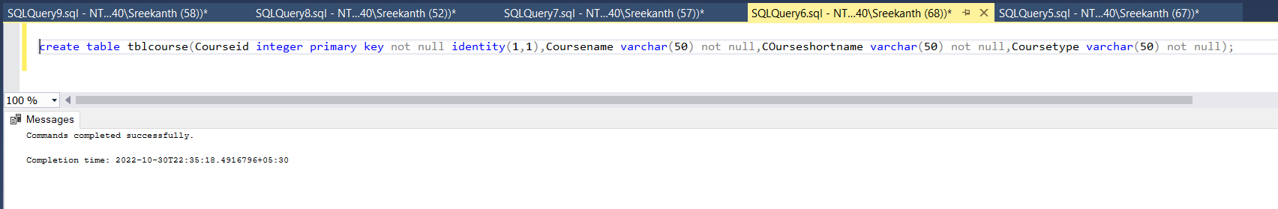

**2. tblbatch - BatchId(P.K,A.I), BatchName**

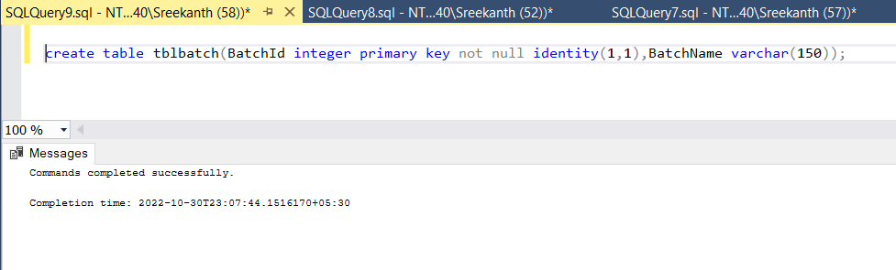

**3. tblstudent – Studentid(P.K,A.I), Student_Name, Student_Gender, Student_DOB, Student_Email, Courseid, BatchId, Student_Mark**

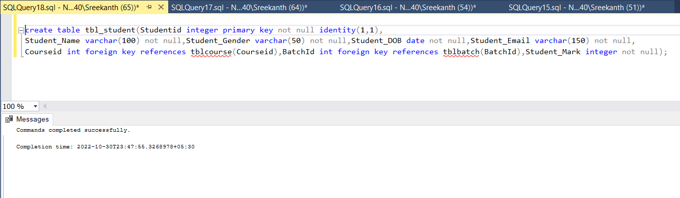

1. **Select all the details courses**

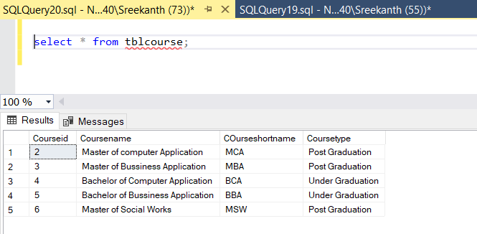

1. **Select the name of UG Courses**

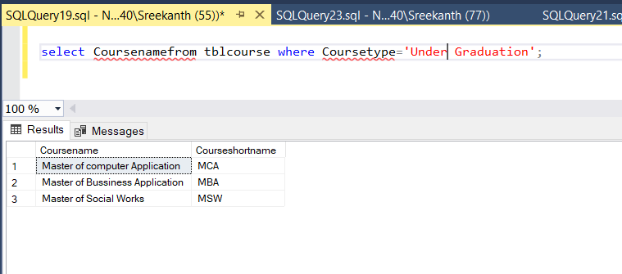

1. **Select the name and short name of PG Courses**

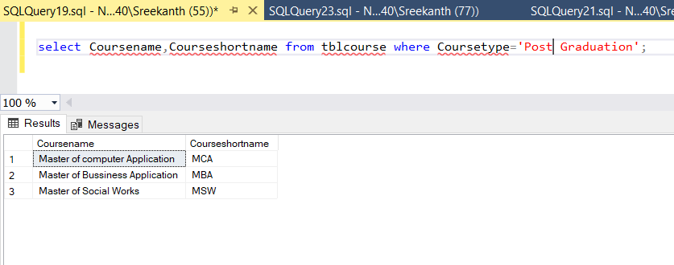

1. **Select the details of batches**

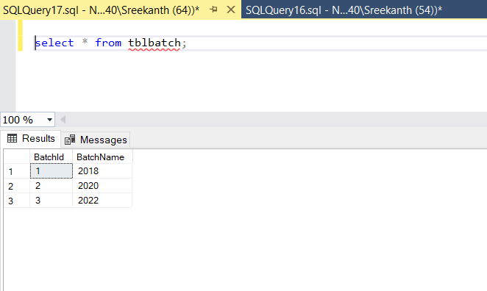

1. **Select the details of students**

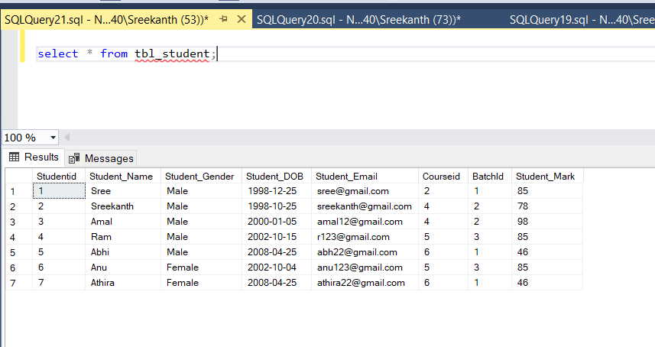

1. **Insert 3 students details whose course is MCA or BCA**

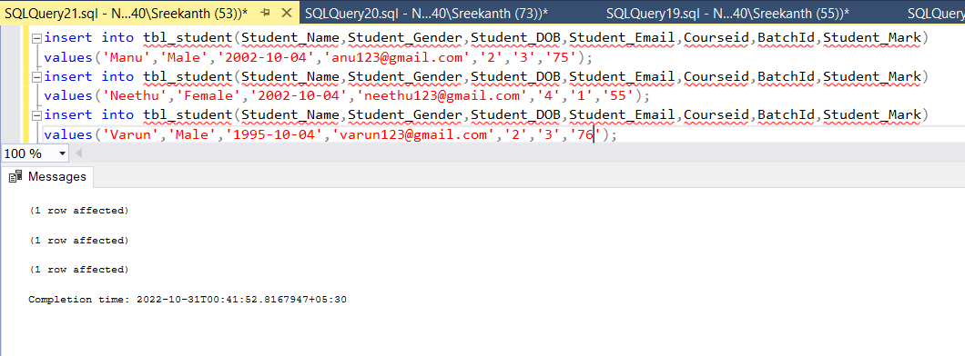

**7.Select the count of male and Female Students(use if case Statement)**

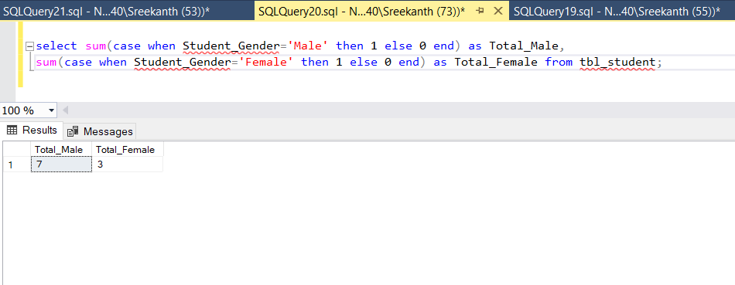

**8. Select the details of Female Students**

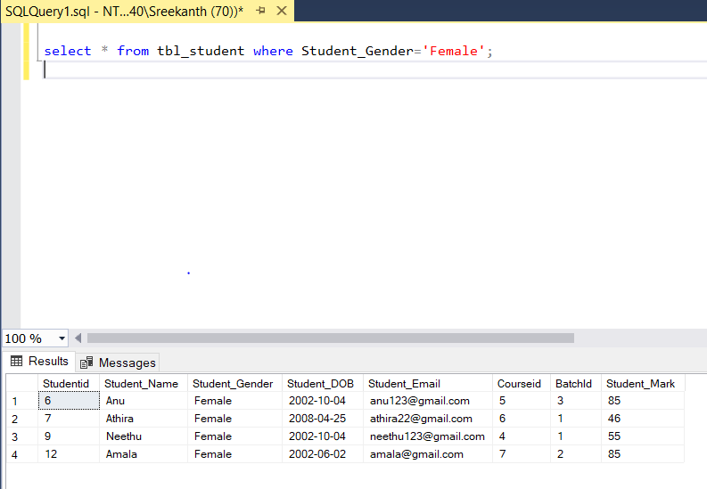

**9. Select the details Males students whose course is MCA**

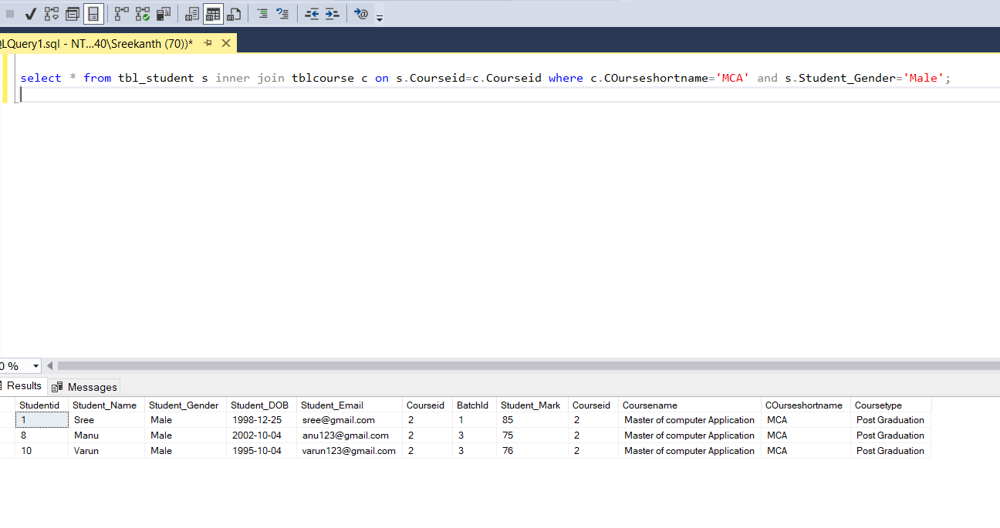

**10. Select the details BAA Students.**

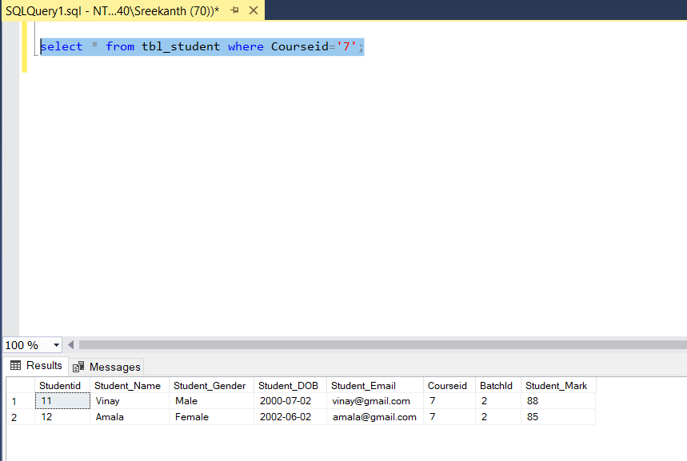

**11. Select the details of BAA students whose batch is 2017-2022**

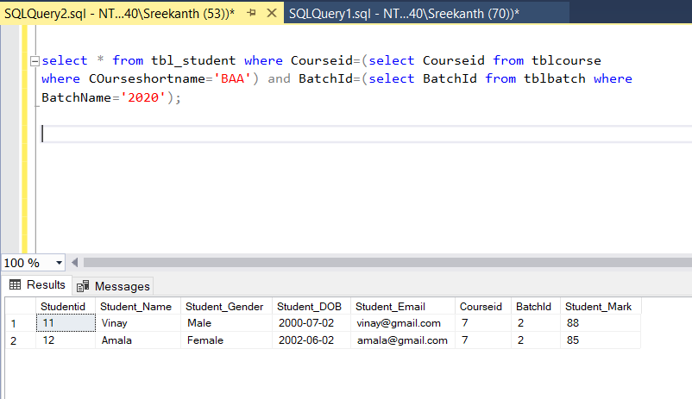

**12. Select all the course short name and total number of students .**

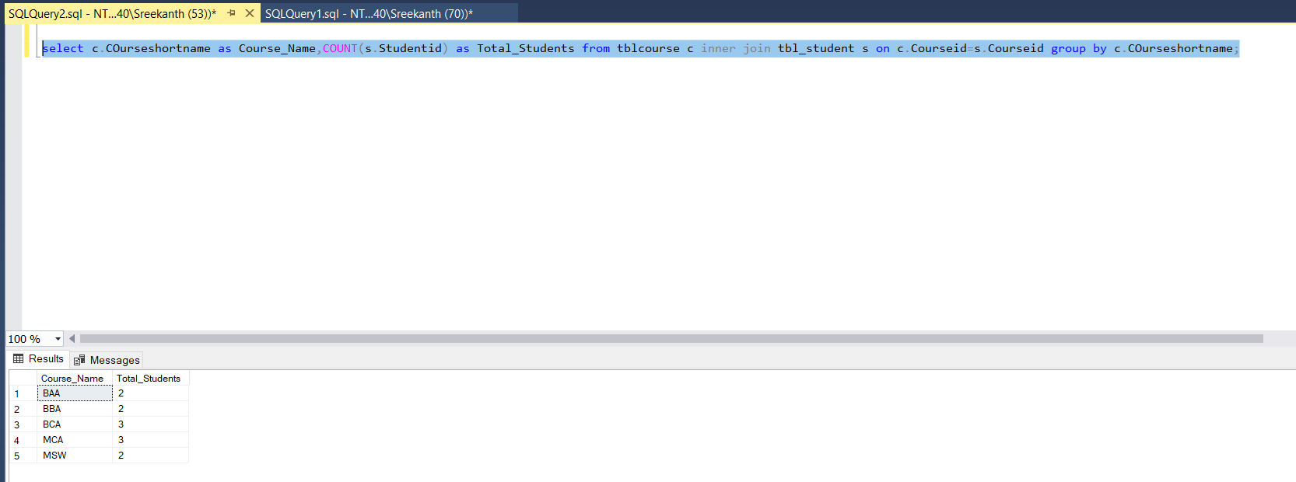

**13. Select the details UG Students**

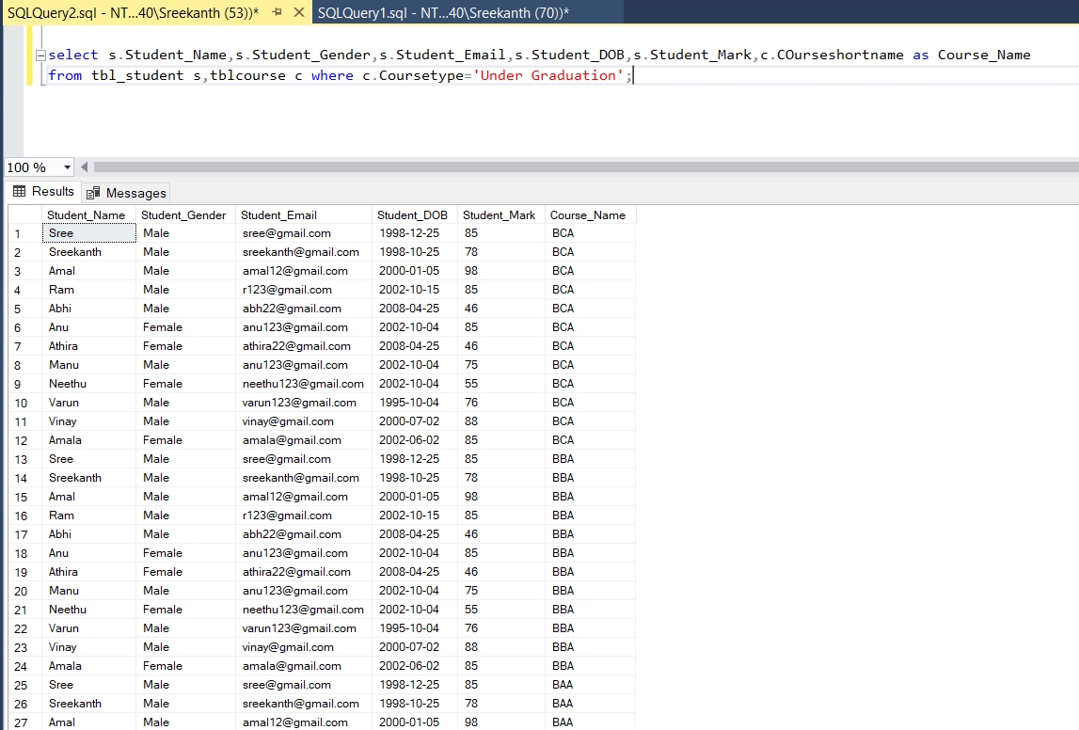

**14. Select the details of PG Students**

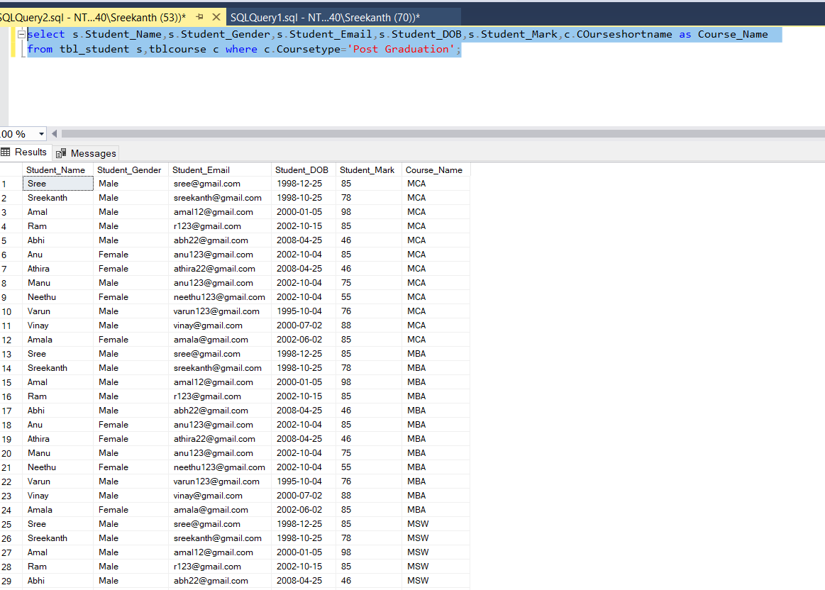

**15. Select the details of MCA Students whose batch is 2019-2021 .**

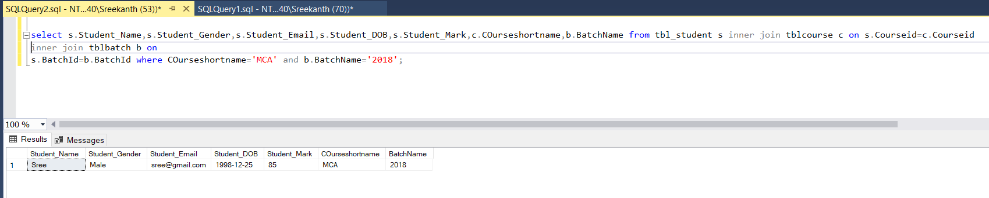

**16. Select the email and DOB of BCA Students**

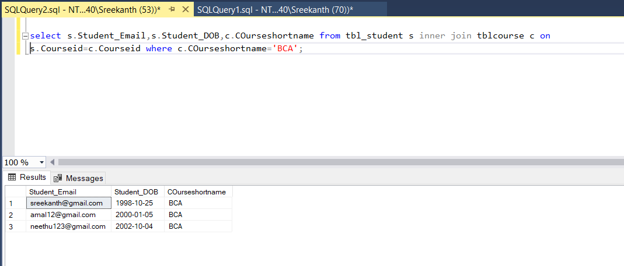

**17. Select the students details with their course name and batch name .**

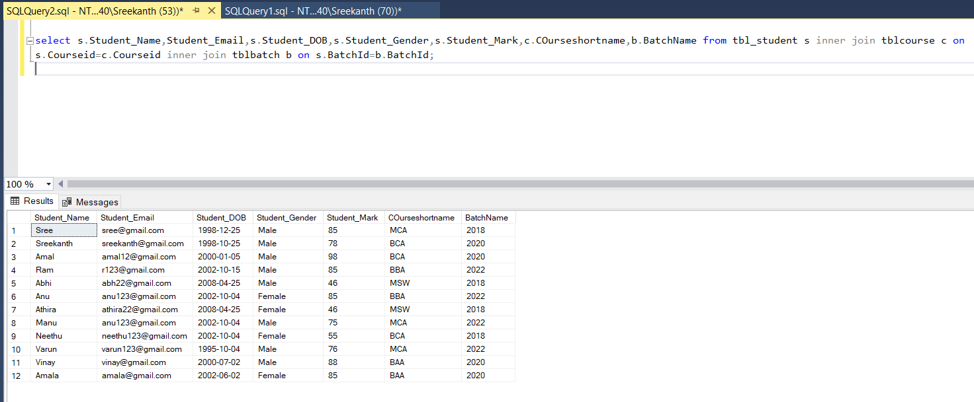

**18. Select Batch name and number of students**

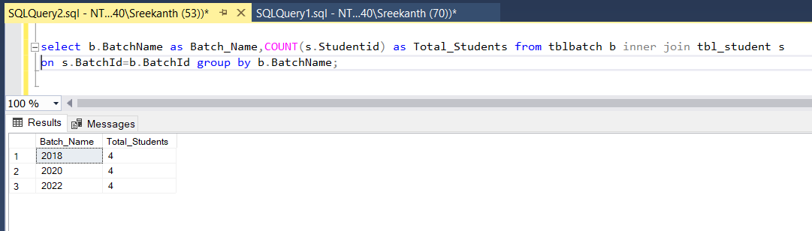

**19. Select the students name, course name and students email**

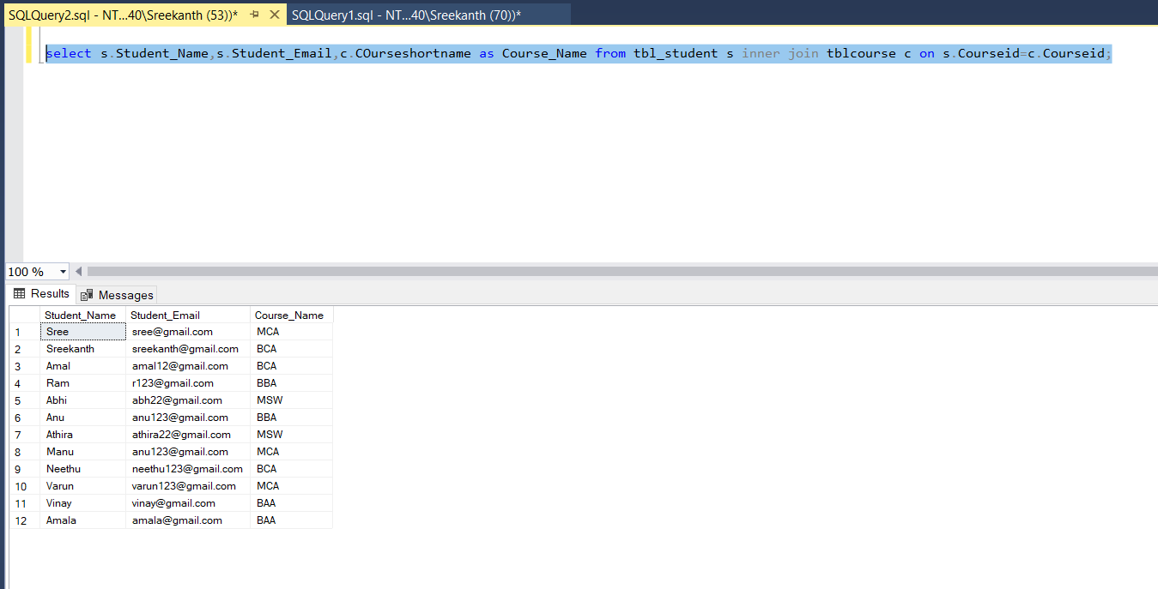

**2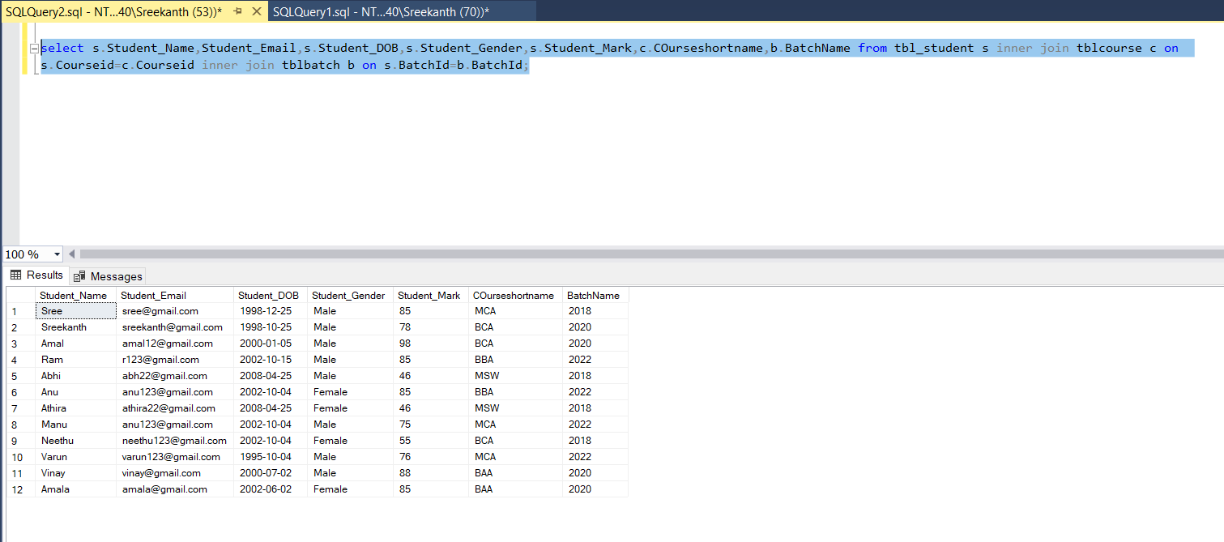0. Select the Students details and their Batch name also .**

**21. Select the count of male and female students in batch wise**

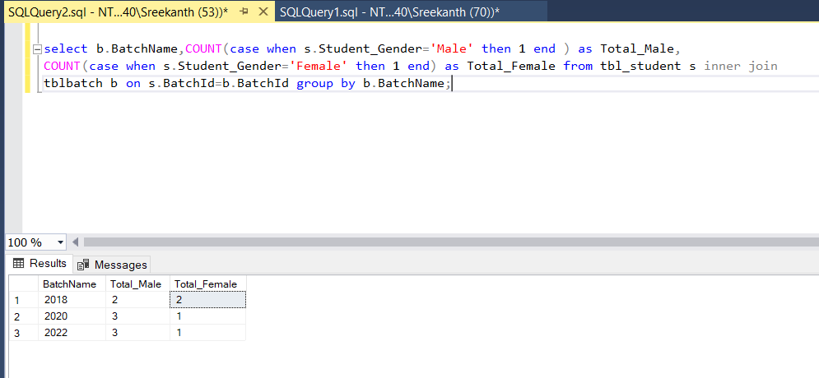

**22. Select the name of the BCA Student who have Maximum Mark.**

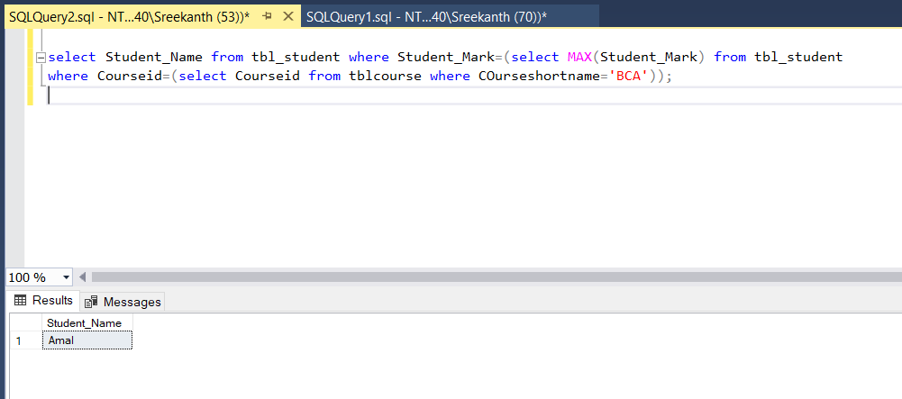

**23. Select the Male MCA Student who have Minimum Mark**

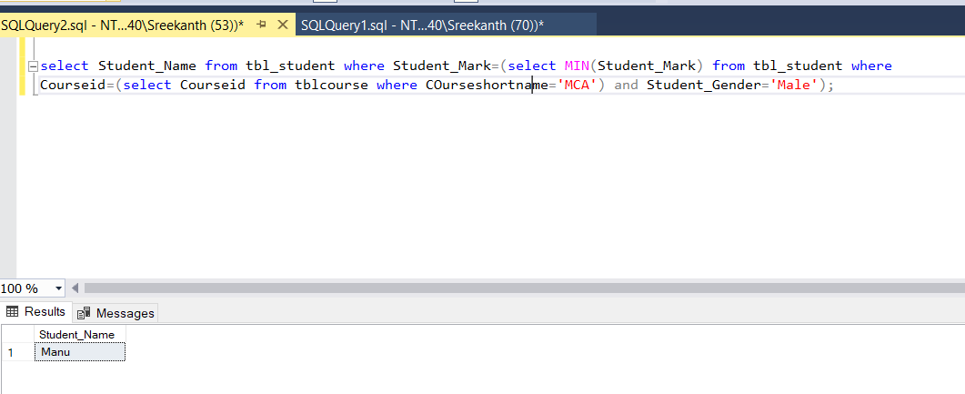

**24. Select the students details of UG Students who have greater than the average mark**

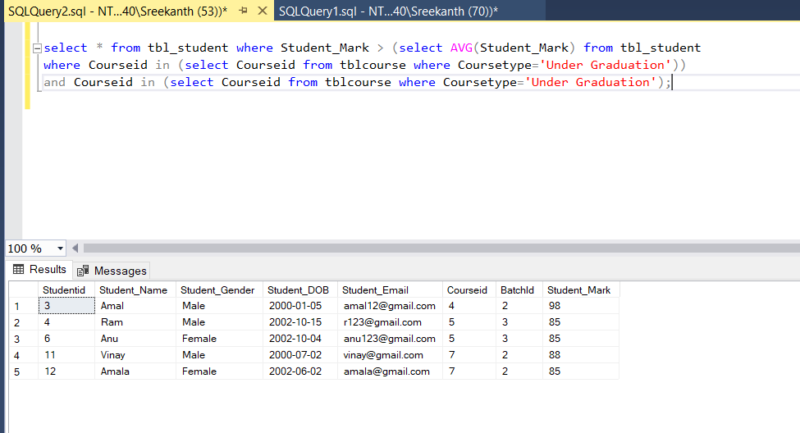

**25. Select the BCA student details who have Max Mark**

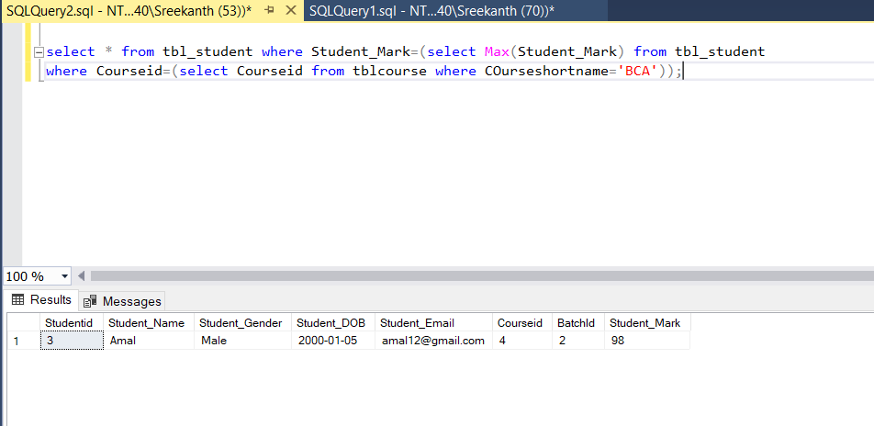

**26.Select Name and Email of the students who have second highest mark**

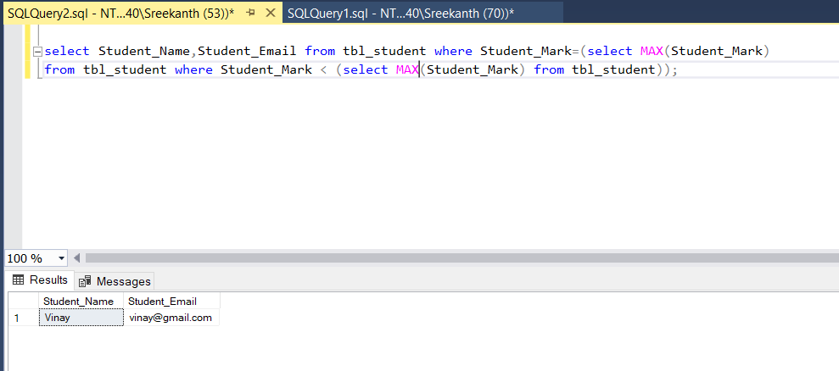

**27. Select the Dob and Current Age of All students**

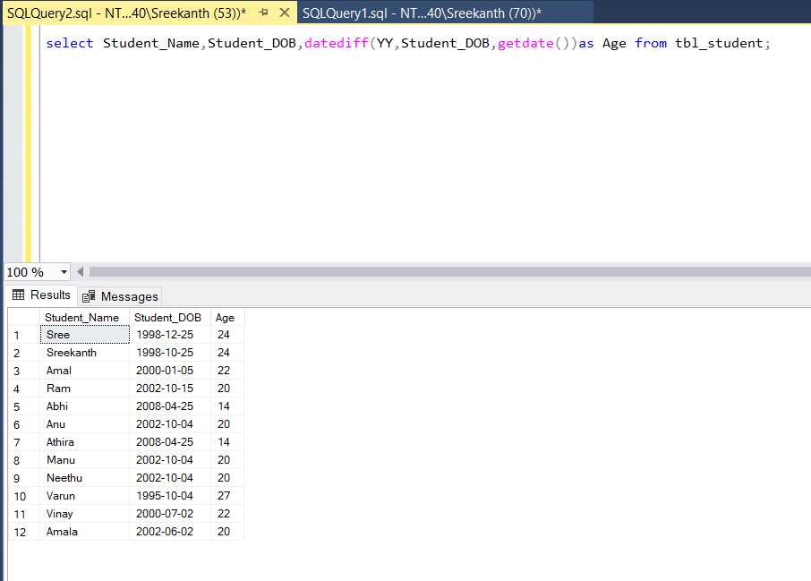

**28. Select the Student name , Month name of birth and year of birth for all the students**

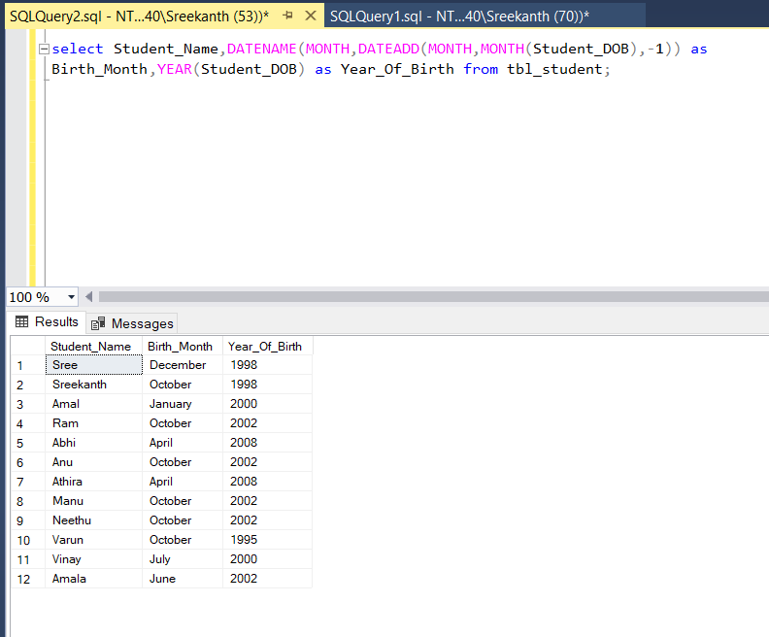

**29. Select the Email and Student DOB of MCA Female Student**

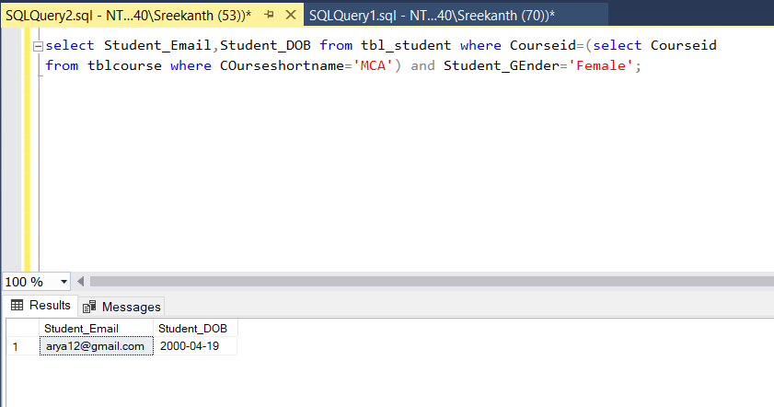

**30. Select the name of all the students who have maximum mark in course wise**

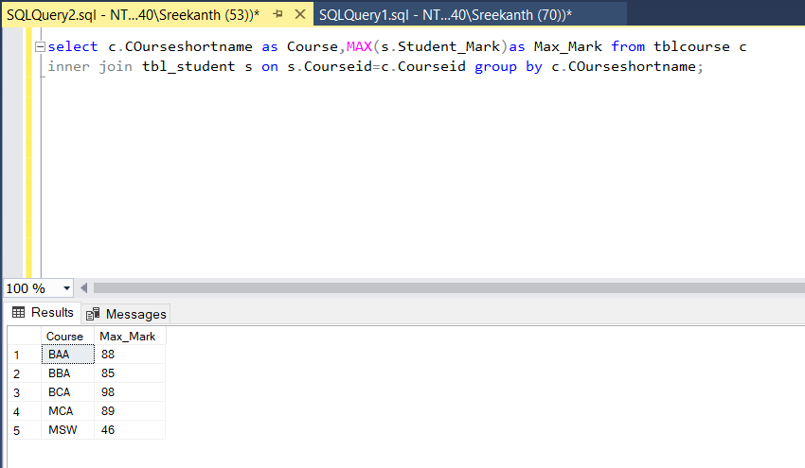

**31. Select the Details students whose year of birth less than 1995**

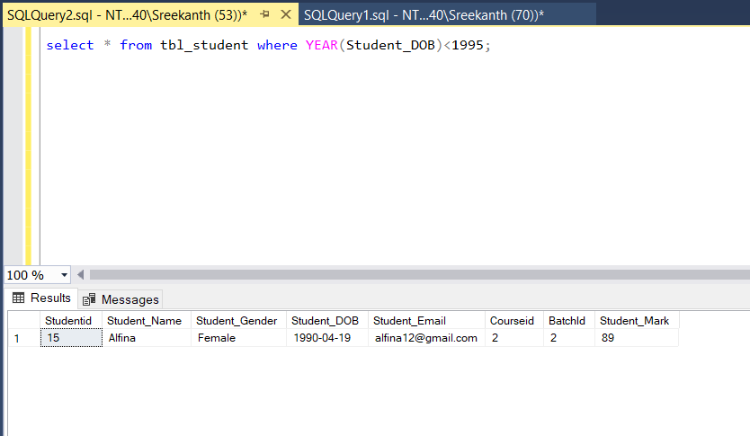

**33. Select details of BCA Students whose year of birth between 1992 and 1996**

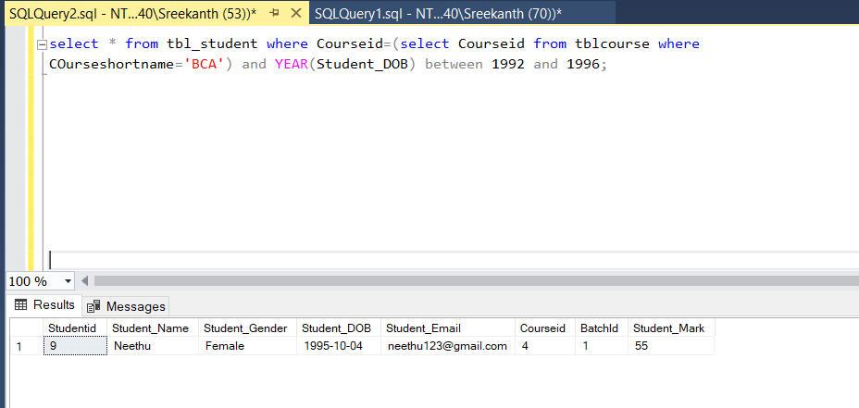

**34. Select the details of Male PG Students**

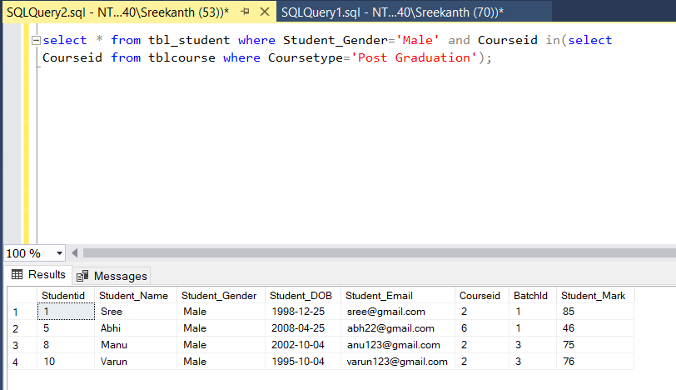

**35. Select the details of BCA Students who have greater than average mark**

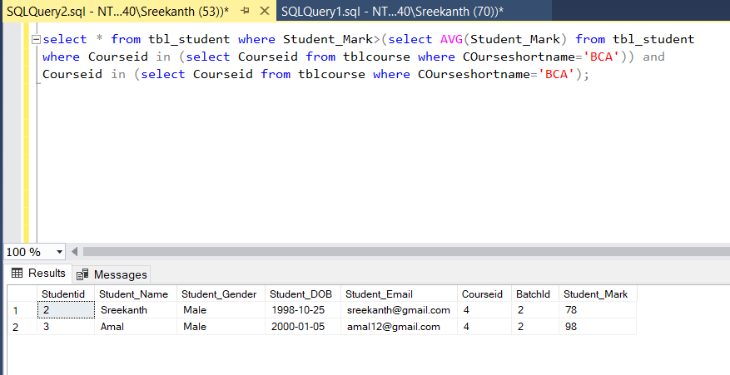

**35. Select the details BA – 2019-2020 Batch Students**

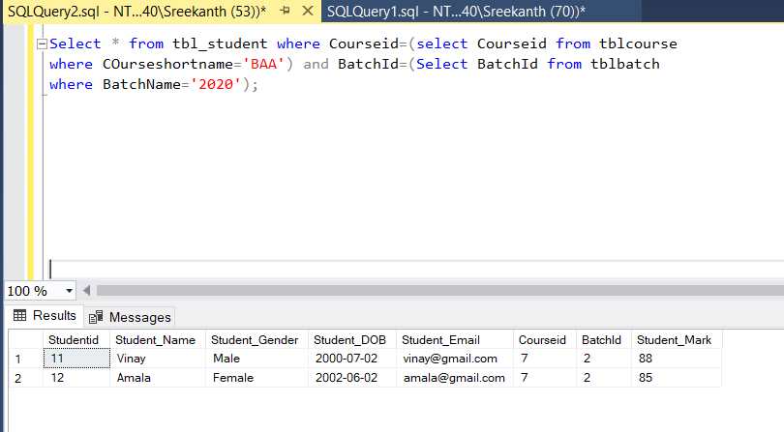

**36. Select the name of student having maximum age?**

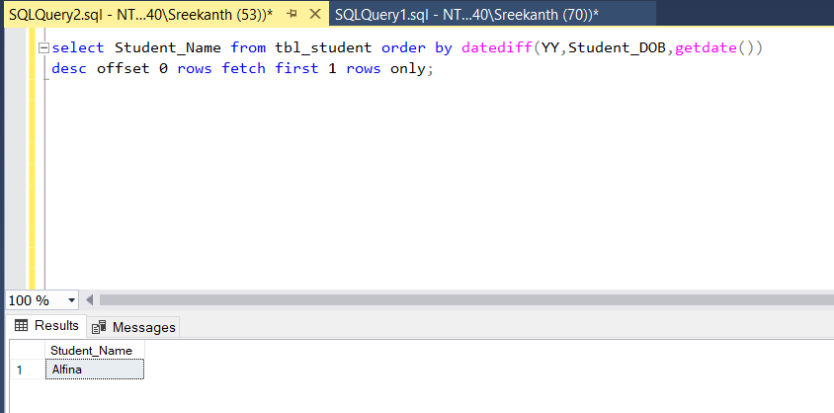

**37. Select the name and email of the BCA Students whose have Minimum age**

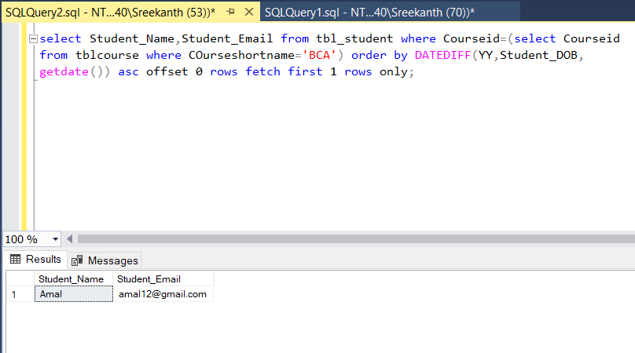

**38. Select the details of the students in descending order of their DOB**

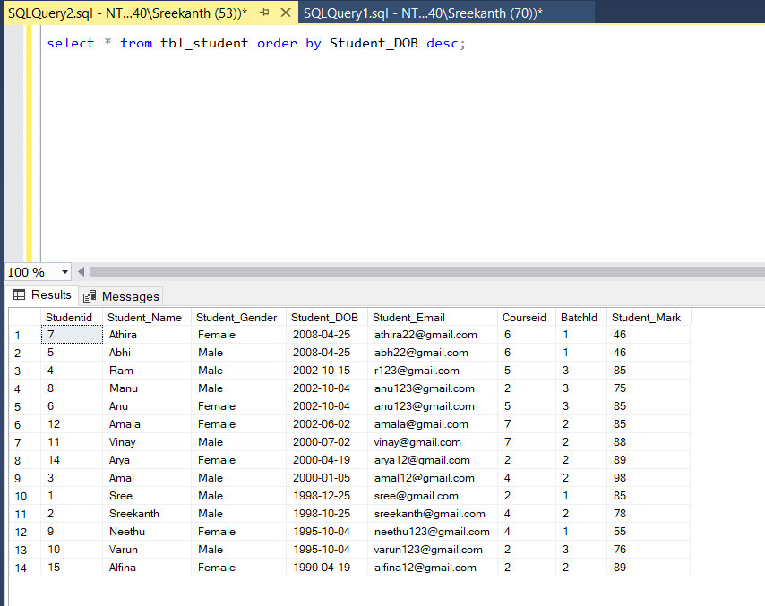

**39. Select the details of the students have mark between 65 and 91**

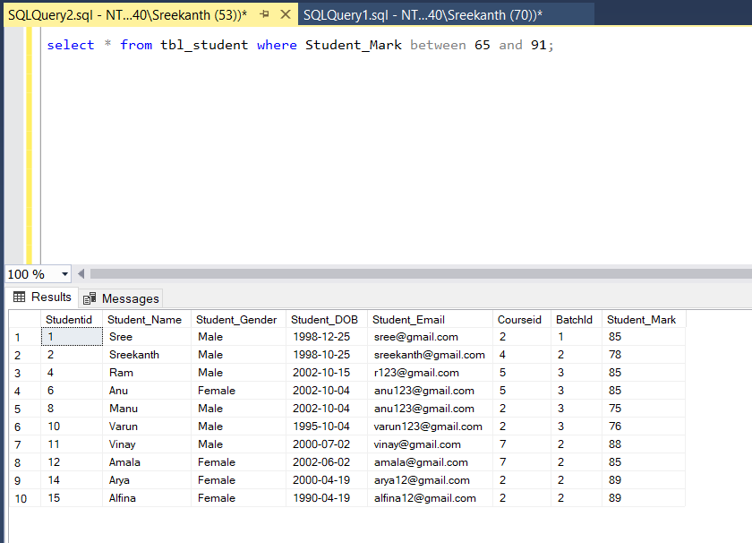

**40. Select the details of BCA Students in their mark wise**

