***Mysterious Cube***

**Introduction**

*Mysterious Cube is the mind-storming game which can test all your brains with all numbers, alphabets, characters and exciting puzzles. The game has been built by C Borland Graphics and Opengl in cube designing. The game can drag u to different type of puzzles which can amaze u and excite u to answer quickly.*

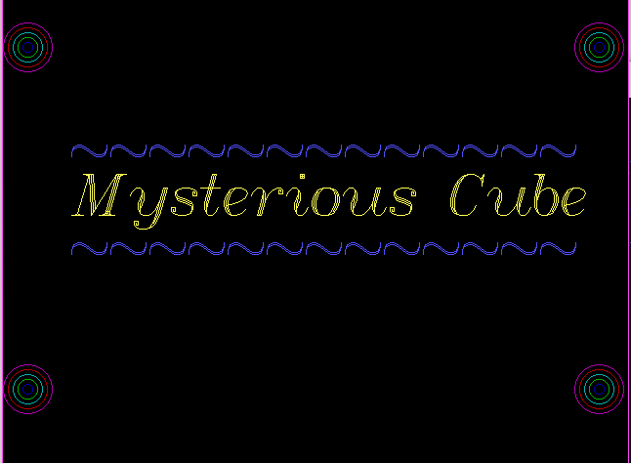

**Game Description**

*Mysterious Cube is the game of cube which has six faces and twenty-five squares of 5X5 in each face. The Game has four levels to fill the empty squares in each face. The Four Levels of cube are as follows: -*

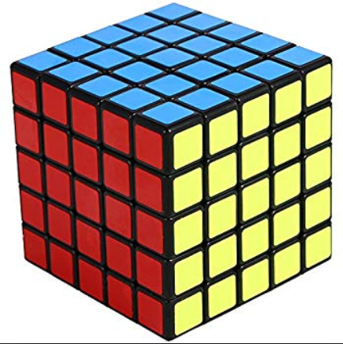

* **Number Pattern Making:-**

*Number Pattern Making* *(****Level 1****) is the decoding of alphabetical pattern to numerical pattern. If a is an alphabet which is equivalent to 1. Easy Pattern is displayed which should be decoded and placed in one face of a cube..*

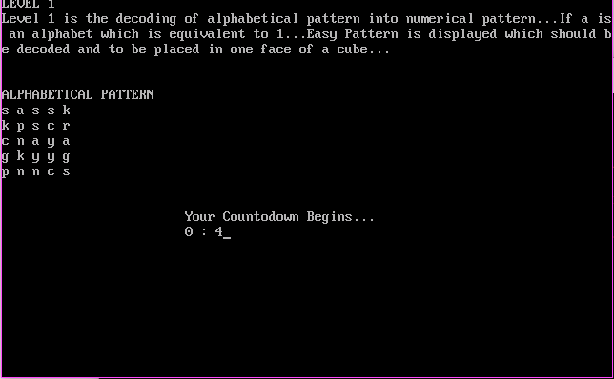

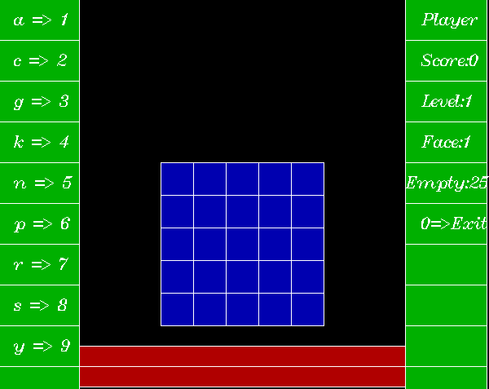

* **Character Pattern Making**

*Character Pattern Making (****Level 2****) is the decoding of Numerical Pattern into alphabetical pattern**. If 1 is a number which is equivalent to a or @. Easy Pattern is displayed which should be decoded and placed in one face of a cube.*

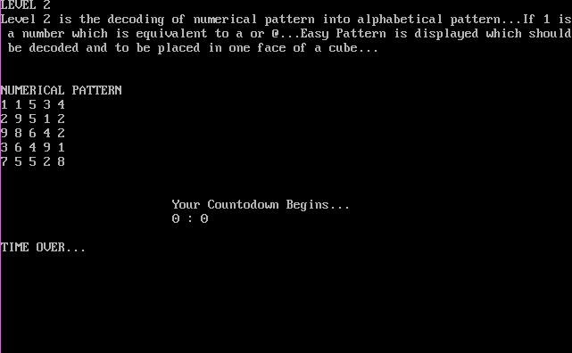

* **Num-Char Pattern Making**

*Num-Char Pattern Making is the decoding of number into character and character into number. If 1 is a number which is equivalent to a or @. In other way,@ is character which is equivalent to 1.Pattern should be decoded and placed in a cube.*

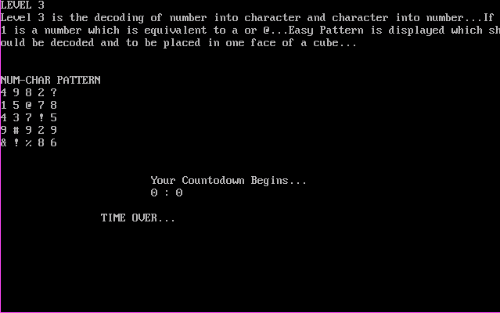

* **Magic Square Pattern Making**

*Magic Square Pattern Making (****Level 4****)is process of Making pattern of Magic Square of 5X5. It should be built and placed in one face of a cube.*

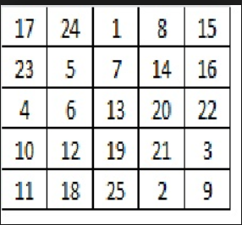

***Exiting Process During Any Level***

*Press 0 During any level, which can make you exit from current level.*

