**MASTER SLAVE ARCHITECTURE**

**1.Creating instances:**

* To achieve master slave architecture I created 3 instances on AWS-EC2.
* I take one instance for master and two instances for slaves.
* On master instance I installed Jenkins and Java-17.
* On slave instance I installed I installed Java-17 and Git.

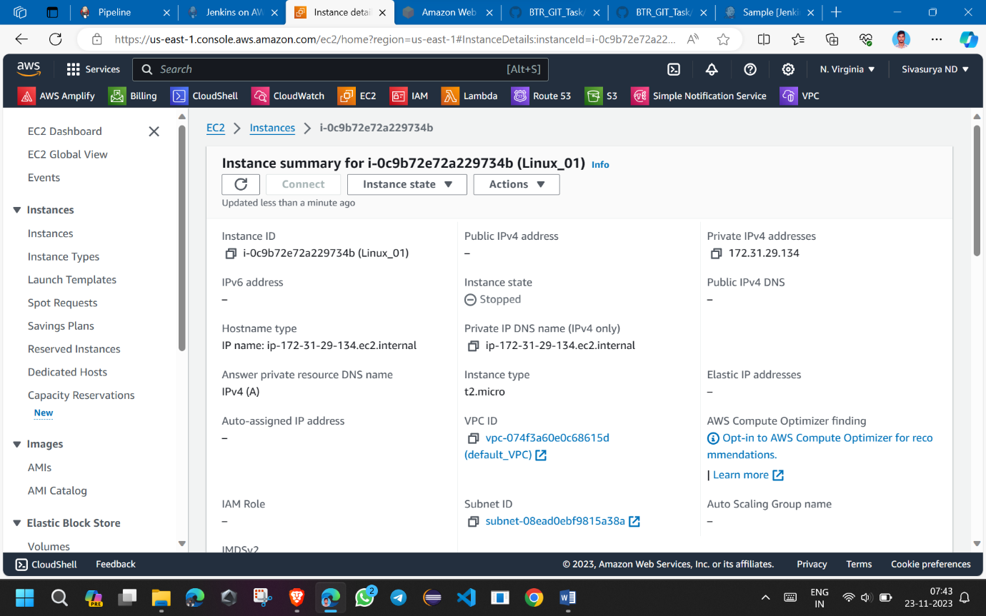

**2.Creating nodes:**

* After instance creation and software installation connect to the jenkins dashboard using master instance IP.
* In jenkins create two nodes and make it to connect with web socket.
* Create two nodes for the two slaves.

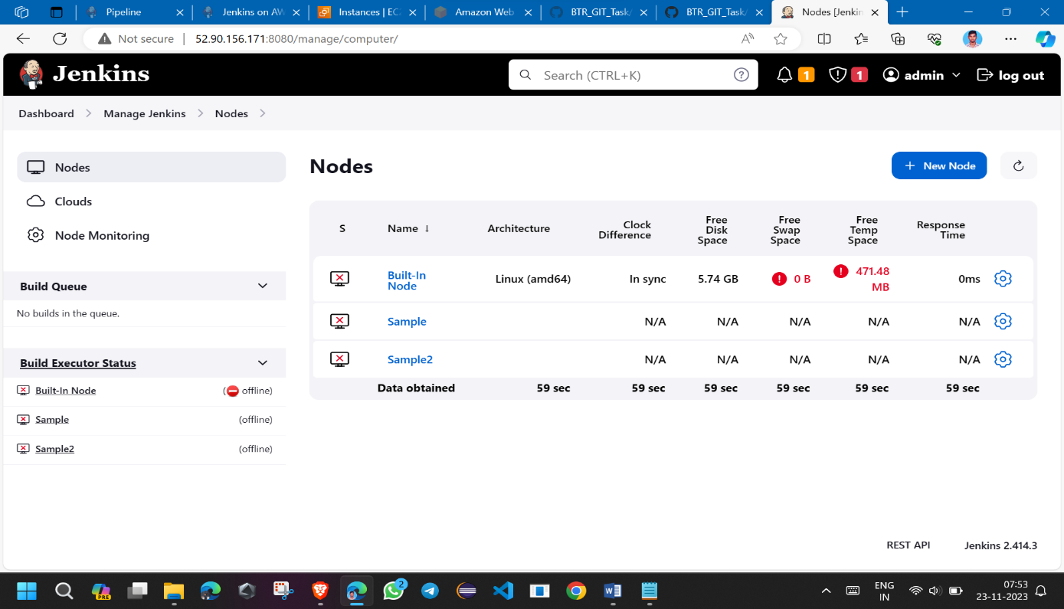

**3.Connecting slave to master:**

* After creating node copy the link of Run from agent command line.
* In slave-1 instance create one directory inside that paste that link.
* Now the agent.jar will be present in the directory(i.e the agent is connected to master)
* Again paste the link it shows connected after that don’t do anything keep it like that.

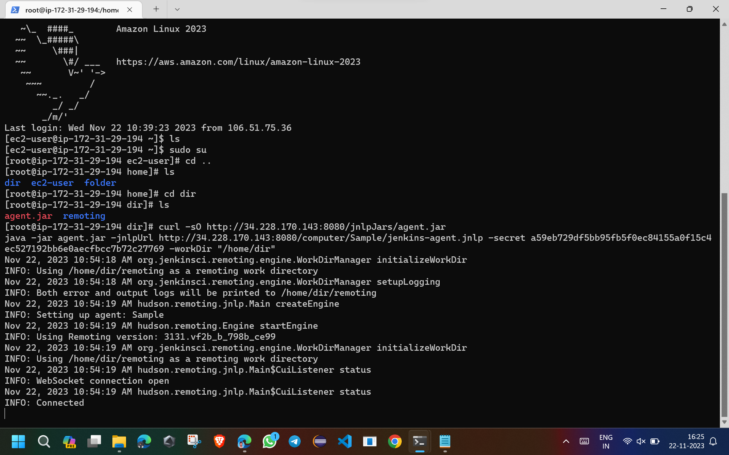

**4.Creating freestyle project:**

* In jenkins create one freestyle project in that we have to mention the git repository path.
* While creating in restrict where this project can be run mention our slave name
* In build step mention the execution command in the shell.
* After that save it and come back.

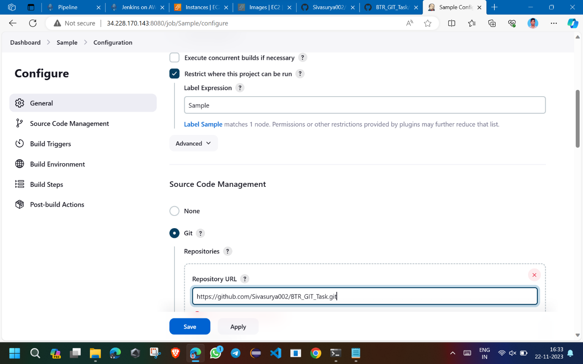

**5.Create build:**

* After creating freestyle project and completion of configuration come back to nodes and bring the slave to online mode.
* Then create build in freestyle project.
* After successful build, if it was a java files check the workspace path for the class files of java code present or not.
* If it was a Web application check the changes in the application.
* Same thing we have to do for slave-2, we have to make some changes in configuration based on slave-2 code.

