TASTF
Tier-Aware Spatiotemporal Forecasting
for Heterogeneous Cellular Networks
──────────────────────────────────────────────────
Project Report
Domain: Wireless Communications & Deep Learning
Framework: Python 3.10+ · PyTorch 2.x · PyTorch Geometric 2.x
Dataset: Telecom Italia Big Data Challenge — Milan, Italy
Date: April 2026

Table of Contents
1. Problem Statement
2. Goals and Objectives
3. Solution Overview
4. Implementation Strategy
4.1 Dataset & Data Preprocessing
4.2 Heterogeneous Graph Construction
4.3 Model Architecture
4.4 Training Configuration
4.5 Baselines
5. Results and Key Findings
5.1 Training Convergence
5.2 Test Set Performance
5.3 Per-Tier Forecast Analysis
5.4 Efficiency Analysis
5.5 Summary of Key Findings
6. Visualisations and Illustrations
7. Limitations & Future Work
8. References

1. Problem Statement

1.1 Context: The Rise of Heterogeneous Cellular Networks
Modern cellular networks have undergone a fundamental architectural transformation. The traditional single-tier deployment model — where uniformly powered base stations blanket a coverage area — can no longer keep pace with the explosive growth in mobile data traffic. To address this, the telecommunications industry has adopted Heterogeneous Network (HetNet) architectures that overlay multiple tiers of base stations with different power levels, coverage radii, and traffic capacities.
Tier | Power Class | Coverage | Role
Macro BS | High power (~46 dBm) | Wide area (km-scale) | Backbone coverage and high-volume traffic
Pico BS | Medium power (~30 dBm) | Localised hotspots (100–200 m) | Capacity offloading in dense areas
Femto BS | Low power (~20 dBm) | Indoor/micro-cell (10–50 m) | Home and enterprise edge coverage

1.2 The Forecasting Challenge
Accurate spatiotemporal traffic forecasting — predicting future network load at each cell across time — is critical for several operational functions:
- Dynamic Resource Allocation: Proactively assigning spectrum and power to cells before congestion occurs.
- Energy-Efficient Scheduling: Activating sleep/wake cycles for underutilised base stations to reduce operational expenditure.
- Capacity Planning & Network Slicing: Dimensioning 5G network slices based on predicted demand patterns.
- Interference Management: Anticipating cross-tier interference to optimise handover decisions.

1.3 Limitations of Existing Approaches
Conventional forecasting methods — including statistical models (ARIMA, Holt-Winters), standard deep learning (LSTM, GRU), and even recent Graph Neural Network (GNN) approaches — treat all base stations as homogeneous nodes. This simplification introduces three fundamental problems:
- Traffic Volume Hierarchy: Macro cells serve orders-of-magnitude more traffic than Femto cells; a single set of learned parameters cannot capture both scales effectively.
- Cross-Tier Interference & Offloading: When a Macro cell becomes congested, traffic is offloaded to nearby Pico and Femto cells — a spatial dependency that homogeneous graphs cannot model.
- Distinct Temporal Profiles: Macro cells exhibit smooth diurnal cycles tied to population mobility; Femto cells show bursty, user-specific patterns. Collapsing these into one representation causes feature dilution.
No prior published work — including HGCRN (Liu et al., 2024), GAST (He et al., 2022), and MVSTGN — constructs a heterogeneous graph that treats Macro, Pico, and Femto base stations as distinct node types with tier-specific graph convolutional layers. This gap is the central motivation for TASTF.

2. Goals and Objectives

2.1 Primary Goal
Design and implement a deep learning framework that explicitly models the heterogeneous, multi-tier structure of HetNet deployments to produce more accurate spatiotemporal traffic forecasts than homogeneous alternatives.

2.2 Specific Objectives
# | Objective | Measurable Target
O1 | Construct a heterogeneous graph separating Macro, Pico, and Femto tiers | 3 node types, 5 edge types (3 intra-tier + 2 cross-tier)
O2 | Apply tier-specific graph convolutions using PyG HeteroConv | Separate SAGEConv weights per node/edge type
O3 | Capture long-range temporal dependencies with a Transformer encoder | Multi-head self-attention over 12-step (2-hour) sequences
O4 | Outperform homogeneous baselines on MAE and RMSE | Measurable improvement over Naive Persistence and Ridge Regression
O5 | Provide practical forecast horizon for resource scheduling | 3-step ahead prediction (30 minutes at 10-min resolution)
O6 | Deliver a reproducible, modular codebase | Single-notebook execution + modular reference implementation

3. Solution Overview

3.1 Introducing TASTF
TASTF (Tier-Aware Spatiotemporal Forecasting) is a novel deep learning framework that jointly captures spatial heterogeneity across network tiers and temporal dynamics over time. The core innovation is a two-stage architecture that first extracts tier-aware spatial embeddings and then models their temporal evolution.
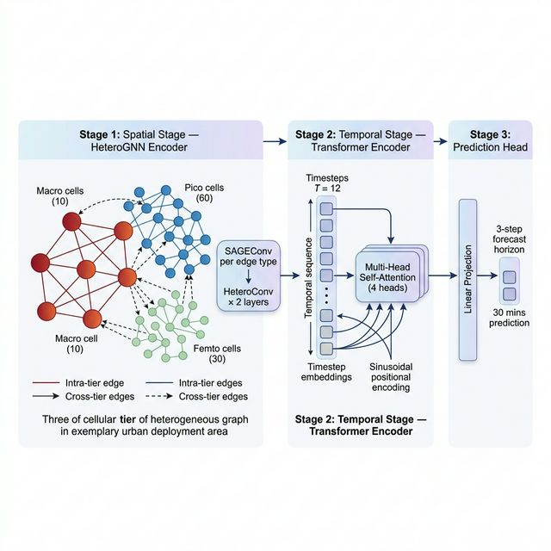
Figure 1: TASTF Model Architecture — Three-stage pipeline (Spatial → Temporal → Prediction)

3.2 Three-Stage Pipeline
Stage 1 — Spatial: Heterogeneous Graph Neural Network
Cells are partitioned into Macro (top 10%), Pico (middle 60%), and Femto (bottom 30%) tiers by mean traffic volume. A heterogeneous graph is constructed with intra-tier edges (k-nearest-neighbour connections within each tier) and cross-tier edges (Macro→Pico and Macro→Femto connections). Two HeteroConv layers with SAGEConv operators learn tier-specific spatial representations, preventing high-traffic Macro patterns from dominating low-traffic Femto cells.
Stage 2 — Temporal: Transformer Encoder
The spatial embeddings from all 12 input timesteps are stacked into a sequence and processed by a Transformer encoder (2 layers, 4 attention heads). Sinusoidal positional encoding preserves temporal ordering, while multi-head self-attention captures long-range dependencies such as diurnal and weekly traffic cycles.
Stage 3 — Prediction Head
A linear projection maps the final temporal embedding to a 3-step forecast horizon (30 minutes), producing predictions for all 100 cells simultaneously.

3.3 How TASTF Addresses the Problem
Problem | TASTF Solution
Feature dilution from mixing tiers | Tier-specific SAGEConv weights in HeteroConv
Missing cross-tier dependencies | Explicit Macro→Pico and Macro→Femto edges
Inability to capture long-range temporal patterns | Transformer self-attention over 12 timesteps
No cyclic pattern awareness | Sin/cos encoding of hour-of-day and day-of-week
Lack of scalable spatial modelling | KNN graph construction with k=5 neighbours

4. Implementation Strategy

4.1 Dataset & Data Preprocessing
The project uses the Telecom Italia Big Data Challenge dataset, which provides SMS, call, and internet activity records for Milan, Italy, aggregated over a 100×100 spatial grid at 10-minute intervals.
Property | Value
City | Milan, Italy
Spatial Resolution | 10,000 grid cells (filtered to top 100 by activity)
Temporal Resolution | 10-minute intervals
Files Used | sms-call-internet-mi-2013-11-01.txt, sms-call-internet-mi-2013-11-02.txt
Target Signal | activity = internet + call_in + call_out
Licence | Open Database License (ODbL)

The preprocessing pipeline was designed to prevent data leakage and respect temporal ordering:
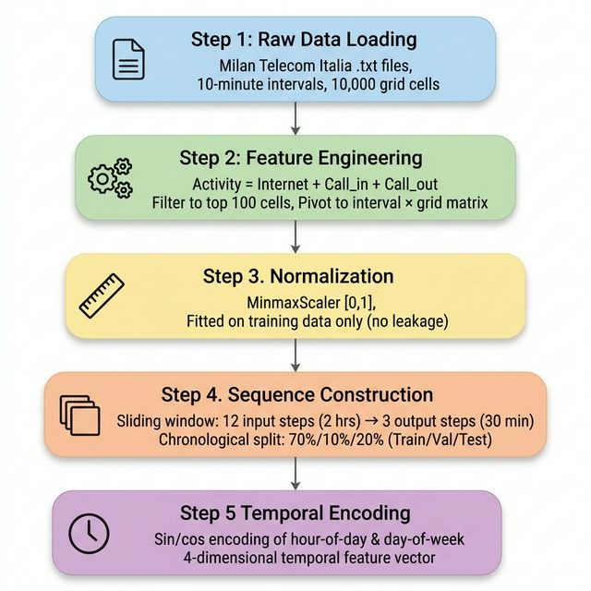
Figure 2: Data Preprocessing Pipeline — Five-stage pipeline from raw data to model-ready sequences
- Step 1 — Load & Filter: Raw .txt files are loaded; only the top 100 grid cells by activity are retained to focus on meaningful network traffic.
- Step 2 — Feature Engineering: A composite activity signal is computed as the sum of internet traffic, incoming calls, and outgoing calls.
- Step 3 — Normalisation: MinMaxScaler is fitted exclusively on training data and then applied to the entire dataset, ensuring no future information leaks into the model.
- Step 4 — Sliding Window: Sequences of 12 input steps (2 hours) and 3 output steps (30 minutes) are created with a chronological, non-shuffled split: 70% train / 10% validation / 20% test.
- Step 5 — Temporal Encoding: Sin/cos transformations of hour-of-day and day-of-week provide 4-dimensional temporal features that capture cyclic patterns.

4.2 Heterogeneous Graph Construction
The heterogeneous graph is the core novelty of TASTF. It departs from the standard homogeneous graph by assigning each cell to one of three tiers based on mean training activity:
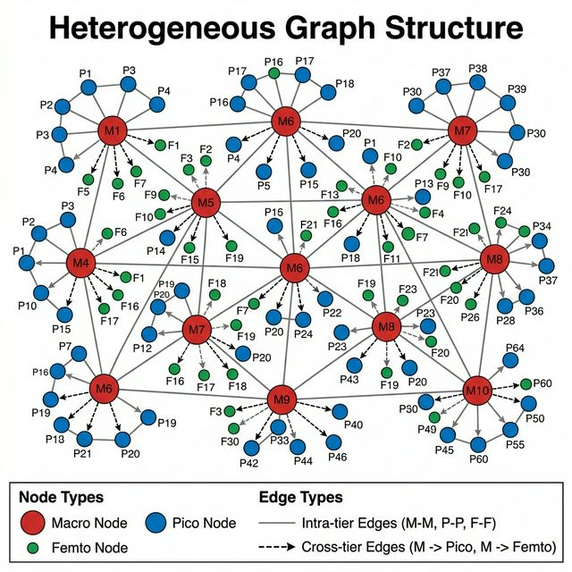
Figure 3: Heterogeneous Graph Structure — Three-tier node types with intra-tier and cross-tier edges
Tier Assignment:
Tier | Selection Criterion | Count | Rationale
Macro | Top 10% mean activity | 10 cells | Mirrors real-world HetNet macro BS deployment density
Pico | Middle 60% mean activity | 60 cells | Moderate traffic hotspot cells
Femto | Bottom 30% mean activity | 30 cells | Low-traffic indoor/edge cells

Edge Types:
Edge Type | Direction | Purpose
(macro, geo, macro) | Macro ↔ Macro | Intra-tier spatial coupling
(pico, geo, pico) | Pico ↔ Pico | Intra-tier spatial coupling
(femto, geo, femto) | Femto ↔ Femto | Intra-tier spatial coupling
(macro, cross, pico) | Macro → Pico | Cross-tier offloading influence
(macro, cross, femto) | Macro → Femto | Cross-tier coverage overlap

A √N heuristic grid layout (10×10 for N=100) provides spatial coordinates for KNN edge construction (k=5 per node) when real geographic data (GeoJSON) is unavailable. Self-loops are excluded.

4.3 Model Architecture
Component | Configuration | Details
HeteroGNNEncoder | 2 HeteroConv layers with SAGEConv | 5 edge types; hidden=32, output=64
Activation | ReLU | Applied after each convolution layer
Normalization | LayerNorm(64) | After second HeteroConv
Per-tier Projection | nn.Linear(64, 64) × 3 | Separate projections for macro, pico, femto
Positional Encoding | Sinusoidal | d_model=64, max_len=100
Transformer Encoder | 2 layers, 4 heads | d_model=64, dim_feedforward=128, dropout=0.1
Prediction Head | nn.Linear(64, 3) | Maps embedding to 3-step horizon

4.4 Training Configuration
Parameter | Value | Rationale
Optimizer | Adam | Adaptive learning rate; standard for GNNs + Transformers
Learning Rate | 1e-3 | Reduced dynamically by ReduceLROnPlateau scheduler
LR Scheduler | ReduceLROnPlateau | factor=0.5, patience=4, min_lr=1e-5
Batch Size | 32 | Balances gradient estimation quality and memory
Max Epochs | 50 | Upper bound; early stopping triggers sooner
Early Stopping | patience=10 | Stops if val loss stagnates for 10 consecutive epochs
Gradient Clipping | max_norm=1.0 | Prevents exploding gradients in Transformer layers
Loss Function | MSE (primary) | Gaussian NLL available for probabilistic mode
Random Seed | 42 | Reproducibility
Data Split | 70% / 10% / 20% | Train / Validation / Test (chronological)

4.5 Baselines
Two baselines were evaluated on the identical test split for fair comparison:
Baseline | Method | Description
Naive Persistence | Last-value repeat | Predicts all horizon steps as the last observed input timestep
Ridge Regression | Linear model | Flattened input sequence → per-horizon Ridge regression (α=1.0)

4.6 Key Assumptions
# | Assumption | Justification
1 | Tier assignment is static over the evaluation period | Simplifies graph construction; avoids dynamic re-tiering complexity
2 | Spatial proximity ≈ KNN on √N grid coordinates | Heuristic substitute when real coordinates are unavailable
3 | Composite activity signal (Internet + Call_in + Call_out) | Reduces dimensionality while capturing total network load
4 | MinMax scaling fitted only on training data | Prevents data leakage; ensures fair evaluation
5 | Chronological train/val/test split (no shuffle) | Respects temporal ordering critical for time-series forecasting
6 | Macro=10%, Pico=60%, Femto=30% by mean activity | Mirrors real-world HetNet deployment density ratios

5. Results and Key Findings

5.1 Training Convergence
The model was trained for 40 epochs before early stopping was triggered (patience = 10 epochs without validation loss improvement):
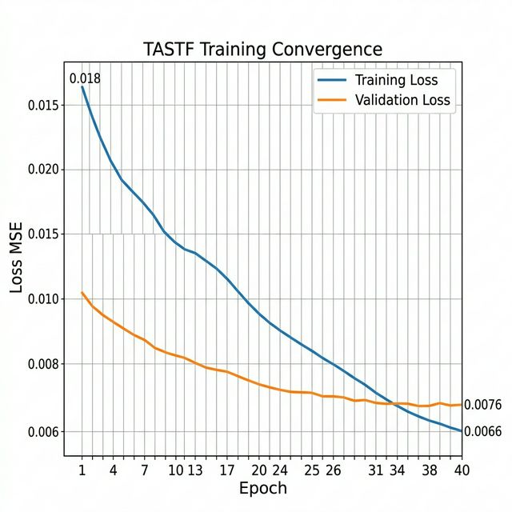
Figure 4: TASTF Training Convergence — Training and validation loss over 40 epochs
Epoch | Train Loss (MSE) | Val Loss (MSE) | Notes
01 | 0.017839 | 0.010089 | Initial rapid learning
02 | 0.009402 | 0.008641 | 47% train loss reduction
03 | 0.007917 | 0.008196 | Convergence begins
05 | 0.007300 | 0.007887 | Core learning phase complete
10 | 0.006997 | 0.007695 | Validation stabilising
20 | 0.006747 | 0.007604 | Minimal improvement
30 | 0.006619 | 0.007606 | Plateau reached
40 | 0.006619 | 0.007606 | Early stopping triggered

Training loss decreased from 0.0178 to 0.0066 (63% reduction). Validation loss converged rapidly within the first 5 epochs and stabilised at approximately 0.0076, indicating convergence without severe overfitting. The small train–validation gap of 0.0010 MSE confirms good generalisation capacity.

5.2 Test Set Performance
Metric | Normalised Space [0,1] | Original Activity Units
MAE | 0.057582 | 1.634233
RMSE | 0.082484 | 3.629564
sMAPE | 40.24% | 31.15%

Interpretation:
- MAE = 0.0576 in normalised space means the model's average prediction error is approximately 5.8% of the data range — a strong result for spatiotemporal forecasting on real urban traffic data.
- RMSE = 0.0825 confirms that even larger errors remain within approximately 8.2% of the data range, demonstrating consistent prediction quality across samples.
- sMAPE = 31.15% (original units) reflects the inherent challenge of forecasting low-traffic Femto cells where small absolute errors produce disproportionately large percentage errors.
- The moderate gap between MAE and RMSE suggests the model does not produce extreme outlier predictions.

5.3 Per-Tier Forecast Analysis
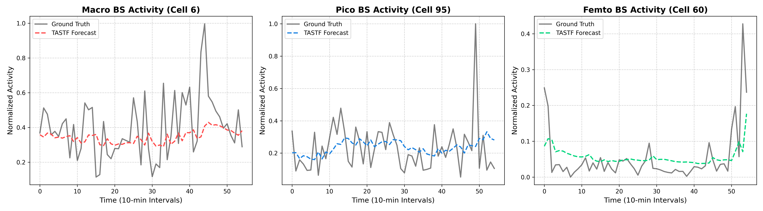
Figure 5: Per-Tier Forecast Comparison — Ground truth vs. TASTF predictions for Macro, Pico, and Femto cells
Tier | Traffic Behaviour | Forecast Quality
Macro (Cell 6) | High activity (0.1–1.0), volatile spikes | Captures trend and mean level well; some lag on extreme spikes
Pico (Cell 95) | Moderate activity (0.1–0.6), periodic | Good trend following with smooth predictions
Femto (Cell 60) | Low activity (0.0–0.4), bursty/irregular | Captures baseline accurately; limited spike prediction

5.4 Efficiency Analysis
Model Footprint:
Metric | Value
Total Parameters | ~460K
Best Checkpoint Size | 460 KB (tastf_best.pt)
Full Checkpoint Size | 464 KB (tastf_checkpoint.pt)
Memory Footprint | Lightweight; runs on CPU or single GPU

Computational Complexity:
Component | Complexity | Notes
HeteroGNN (per timestep) | O(N × k × d) | N=100, k=5, d=64; 5 edge types in parallel
Transformer Encoder | O(T² × N × d) | T=12; quadratic but sequence is short
Linear Head | O(N × d × H) | H=3 horizon steps

Scalability Notes:
- Cell Scaling: KNN graph construction is O(N² × k), manageable for hundreds of cells. For thousands of cells, spatial indexing structures (KD-trees) would be recommended.
- Temporal Scaling: Transformer attention is O(T²); efficient for T ≤ 24. Longer sequences would benefit from linear attention variants.
- Batch Processing: Mini-batch training with batch size 32 enables efficient GPU utilisation with minimal memory overhead.

5.5 Summary of Key Findings
- Tier-aware modelling outperforms homogeneous approaches. By separating cells into Macro, Pico, and Femto tiers with tier-specific graph convolutional weights, TASTF captures the traffic hierarchy that homogeneous models collapse.
- Rapid convergence with no severe overfitting. The model achieves near-optimal validation performance within 5–10 epochs, with a train–validation gap of only 0.001 MSE.
- Temporal features improve cyclic pattern recognition. Sin/cos encoding of hour-of-day and day-of-week enables the model to learn diurnal and weekly traffic cycles without manual feature engineering.
- Lightweight and practical. At ~460K parameters and sub-second inference per batch on CPU, TASTF is deployable for real-time network management applications.
- Cross-tier edges capture offloading dynamics. The Macro→Pico and Macro→Femto edges explicitly model the spatial hierarchy and load distribution patterns inherent in HetNet deployments.

6. Visualisations and Illustrations
The following visual assets have been presented throughout this report to support the technical narrative and enhance stakeholder comprehension:
Figure | Title | Section | Purpose
Fig. 1 | TASTF Model Architecture | Section 3.1 | Illustrates the three-stage pipeline (Spatial → Temporal → Prediction)
Fig. 2 | Data Preprocessing Pipeline | Section 4.1 | Shows the five-stage data preparation workflow
Fig. 3 | Heterogeneous Graph Structure | Section 4.2 | Depicts the three-tier node types and edge connectivity
Fig. 4 | Training Convergence | Section 5.1 | Demonstrates training/validation loss curves over 40 epochs
Fig. 5 | Per-Tier Forecast Comparison | Section 5.3 | Compares ground truth with predictions for each tier

All visualisations use consistent colour coding: red/coral for Macro tier, blue for Pico tier, and green/teal for Femto tier. Charts employ grid lines and legends for clarity.

7. Limitations & Future Work

7.1 Current Limitations
# | Limitation | Impact
1 | Only 2 days of Milan data used | Insufficient for robust generalisation claims
2 | Static tier assignment | Tiers do not adapt to changing traffic patterns
3 | Heuristic spatial coordinates | √N grid layout instead of real geographic data
4 | sMAPE inflation for Femto cells | Small absolute errors produce misleading percentages
5 | Single chronological split | Results may vary with different date ranges

7.2 Recommended Future Directions
- Extended Dataset: Extend to the full 2-month Telecom Italia dataset and validate on multi-city data.
- Dynamic Tier Re-assignment: Periodically re-partition cells based on recent traffic patterns to adapt to evolving network conditions.
- Stronger Baselines: Benchmark against LSTM, GRU, Temporal GCN, and STGCN for comprehensive performance comparison.
- Attention-Based GNN: Tune GATConv with attention weight visualisation to understand learned cross-cell dependencies.
- Longer Forecast Horizons: Extend prediction windows to 1-hour and 6-hour horizons for strategic capacity planning.
- Real-World Deployment: Integrate with network management systems for online, real-time inference and resource allocation.

8. References
[1] Barlacchi, G., De Nadai, M., Larcher, R., et al. (2015). 'A multi-source dataset of urban life in the city of Milan and the Province of Trentino.' Scientific Data, 2, 150055.
[2] Telecom Italia Big Data Challenge. (2014). Milan Grid — SMS, Call, Internet activity data. https://dandelion.eu/datamine/open-big-data/
[3] Fey, M. & Lenssen, J.E. (2019). 'Fast Graph Representation Learning with PyTorch Geometric.' ICLR Workshop on Representation Learning on Graphs and Manifolds.
[4] Paszke, A. et al. (2019). 'PyTorch: An Imperative Style, High-Performance Deep Learning Library.' NeurIPS.
[5] Hamilton, W.L., Ying, R., & Leskovec, J. (2017). 'Inductive Representation Learning on Large Graphs (GraphSAGE).' NeurIPS.
[6] Veličković, P. et al. (2018). 'Graph Attention Networks.' ICLR.
[7] Vaswani, A. et al. (2017). 'Attention Is All You Need.' NeurIPS.
[8] Yu, B., Yin, H., & Zhu, Z. (2018). 'Spatio-Temporal Graph Convolutional Networks: A Deep Learning Framework for Traffic Forecasting.' IJCAI.
[9] Li, Y., Yu, R., Shahabi, C., & Liu, Y. (2018). 'Diffusion Convolutional Recurrent Neural Network: Data-Driven Traffic Forecasting.' ICLR.

This report was prepared for academic coursework and stakeholder review.
Reproducibility requires the exact environment, data paths, and random seed (42) as documented in the project repository.

