PayFlow API - Write-Up
A simplified wallet/money-transfer REST API built with Spring Boot, Spring Data JPA, and an in-memory H2 database. This document contains the task deliverables, curl output, generated SQL, and the conceptual write-up.

Task 2 - Entities & Database

Generated create table statements
With spring.jpa.show-sql=true, these are the two statements Hibernate printed on first startup (user is an H2 reserved word, so the datasource URL adds ;NON_KEYWORDS=USER to allow it as a plain table name):
create table transaction (
transaction_id bigint generated by default as identity,
amount float(53),
note varchar(255),
receiver_upi_id varchar(255),
sender_upi_id varchar(255),
primary key (transaction_id)
)
create table user (
user_id bigint generated by default as identity,
balance float(53),
name varchar(255),
phone_number varchar(255),
upi_id varchar(255),
primary key (user_id)
)

H2 console - empty tables
Screenshot: open http://localhost:8080/h2-console, connect with JDBC URL jdbc:h2:mem:payflow, run SELECT * FROM USER; and SELECT * FROM TRANSACTION; right after startup (before any data is inserted).
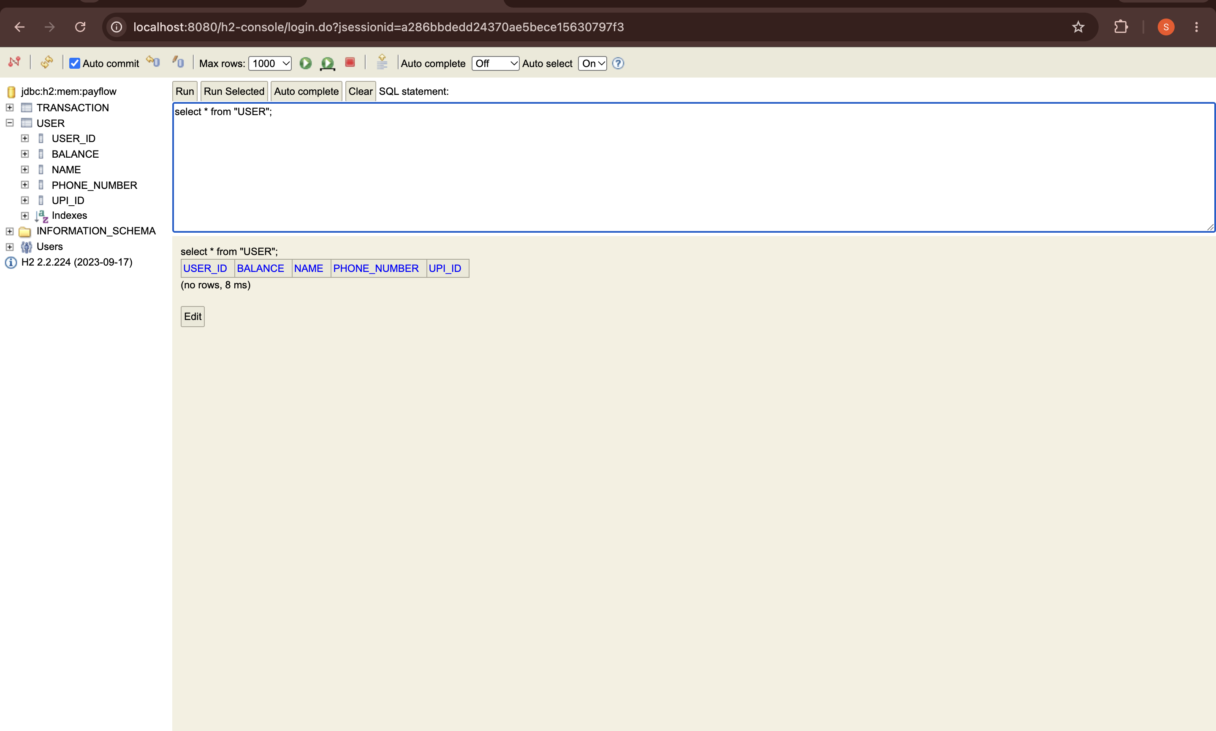
SELECT * FROM USER; -- empty table
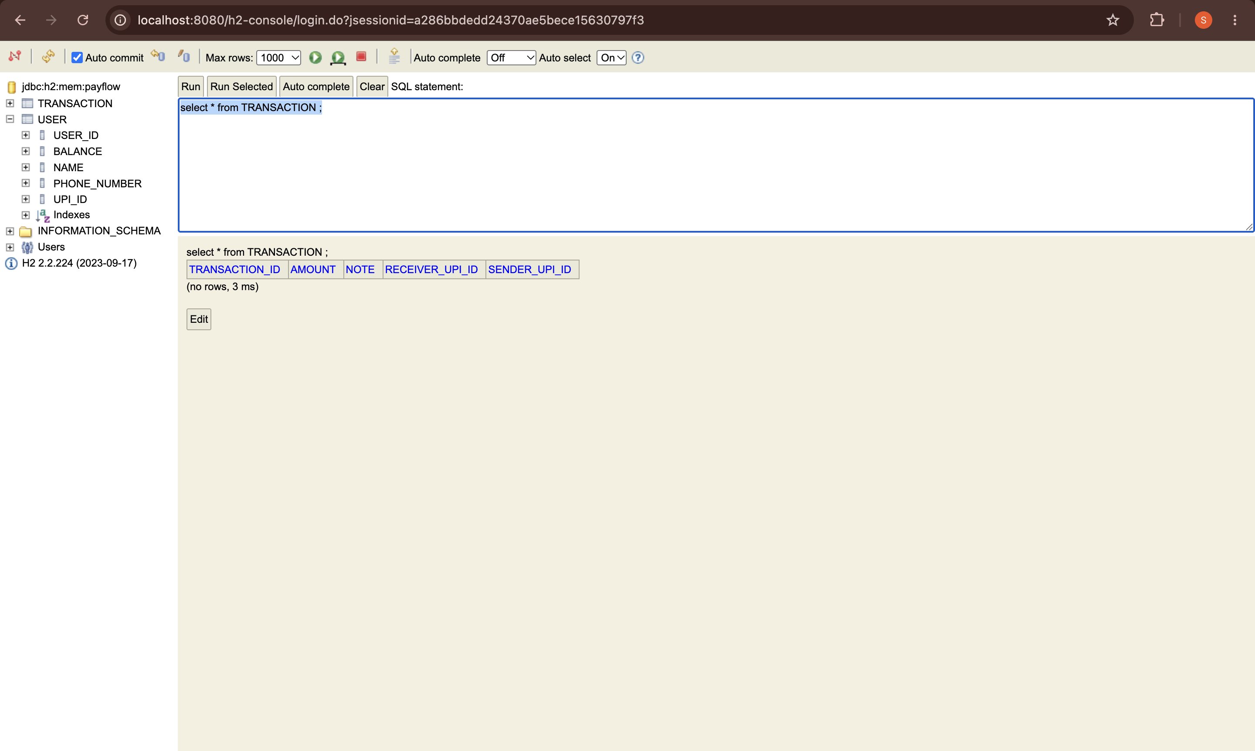
SELECT * FROM TRANSACTION; -- empty table

Task 3 - Repository Layer

SQL generated for findByUpiId
select
u1_0.user_id,
u1_0.balance,
u1_0.name,
u1_0.phone_number,
u1_0.upi_id
from
user u1_0
where
u1_0.upi_id=?
(a) How JPA derives it from the method name: Spring Data JPA parses the method name findByUpiId into a subject (find) and a predicate (By UpiId). It matches UpiId against the upiId property on the User entity and builds a JPQL query equivalent to SELECT u FROM User u WHERE u.upiId = ?1, which Hibernate then translates into the SQL above. No method body is needed - the name alone is the query specification.
(b) What the ? placeholder means: it is a positional JDBC parameter. Instead of concatenating the upiId argument into the SQL string, the driver sends the query text and the parameter value separately; the database binds the value when it executes the prepared statement. This is what prevents SQL injection and lets the database cache/reuse the query plan across calls with different values.

Task 5 - Controller & REST Endpoints

curl commands and output
Register two users:
curl -s -X POST http://localhost:8080/users \
-H "Content-Type: application/json" \
-d '{"name":"Priya Sharma","upiId":"priya@okaxis","balance":5000.0,"phoneNumber":"9876543210"}'
{"userId":1,"name":"Priya Sharma","upiId":"priya@okaxis","balance":5000.0,"phoneNumber":"9876543210"}
curl -s -X POST http://localhost:8080/users \
-H "Content-Type: application/json" \
-d '{"name":"Rohit Verma","upiId":"rohit@okhdfc","balance":2000.0,"phoneNumber":"9123456780"}'
{"userId":2,"name":"Rohit Verma","upiId":"rohit@okhdfc","balance":2000.0,"phoneNumber":"9123456780"}
List all users:
curl -s http://localhost:8080/users
[{"userId":1,"name":"Priya Sharma","upiId":"priya@okaxis","balance":5000.0,"phoneNumber":"9876543210"},{"userId":2,"name":"Rohit Verma","upiId":"rohit@okhdfc","balance":2000.0,"phoneNumber":"9123456780"}]
Get a user by id:
curl -s http://localhost:8080/users/1
{"userId":1,"name":"Priya Sharma","upiId":"priya@okaxis","balance":5000.0,"phoneNumber":"9876543210"}
Get a user by UPI id:
curl -s http://localhost:8080/users/upi/priya@okaxis
{"userId":1,"name":"Priya Sharma","upiId":"priya@okaxis","balance":5000.0,"phoneNumber":"9876543210"}
Send money:
curl -s -X POST http://localhost:8080/transactions \
-H "Content-Type: application/json" \
-d '{"senderUpiId":"priya@okaxis","receiverUpiId":"rohit@okhdfc","amount":500.0,"note":"dinner split"}'
{"transactionId":1,"senderUpiId":"priya@okaxis","receiverUpiId":"rohit@okhdfc","amount":500.0,"note":"dinner split"}
Users with balance above a threshold (custom @Query):
curl -s http://localhost:8080/users/balance-above/3000
[{"userId":1,"name":"Priya Sharma","upiId":"priya@okaxis","balance":5000.0,"phoneNumber":"9876543210"}]

H2 console - populated tables
Screenshot: after running the above, open the H2 console and screenshot SELECT * FROM USER; and SELECT * FROM TRANSACTION; showing the two users and the one transaction just created.
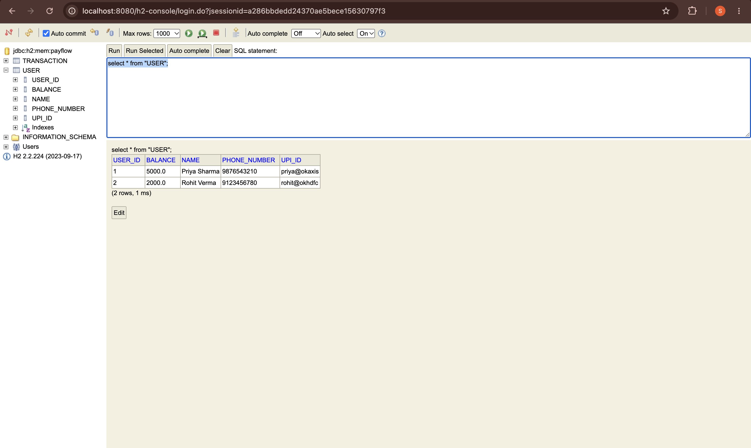
SELECT * FROM USER; -- two rows
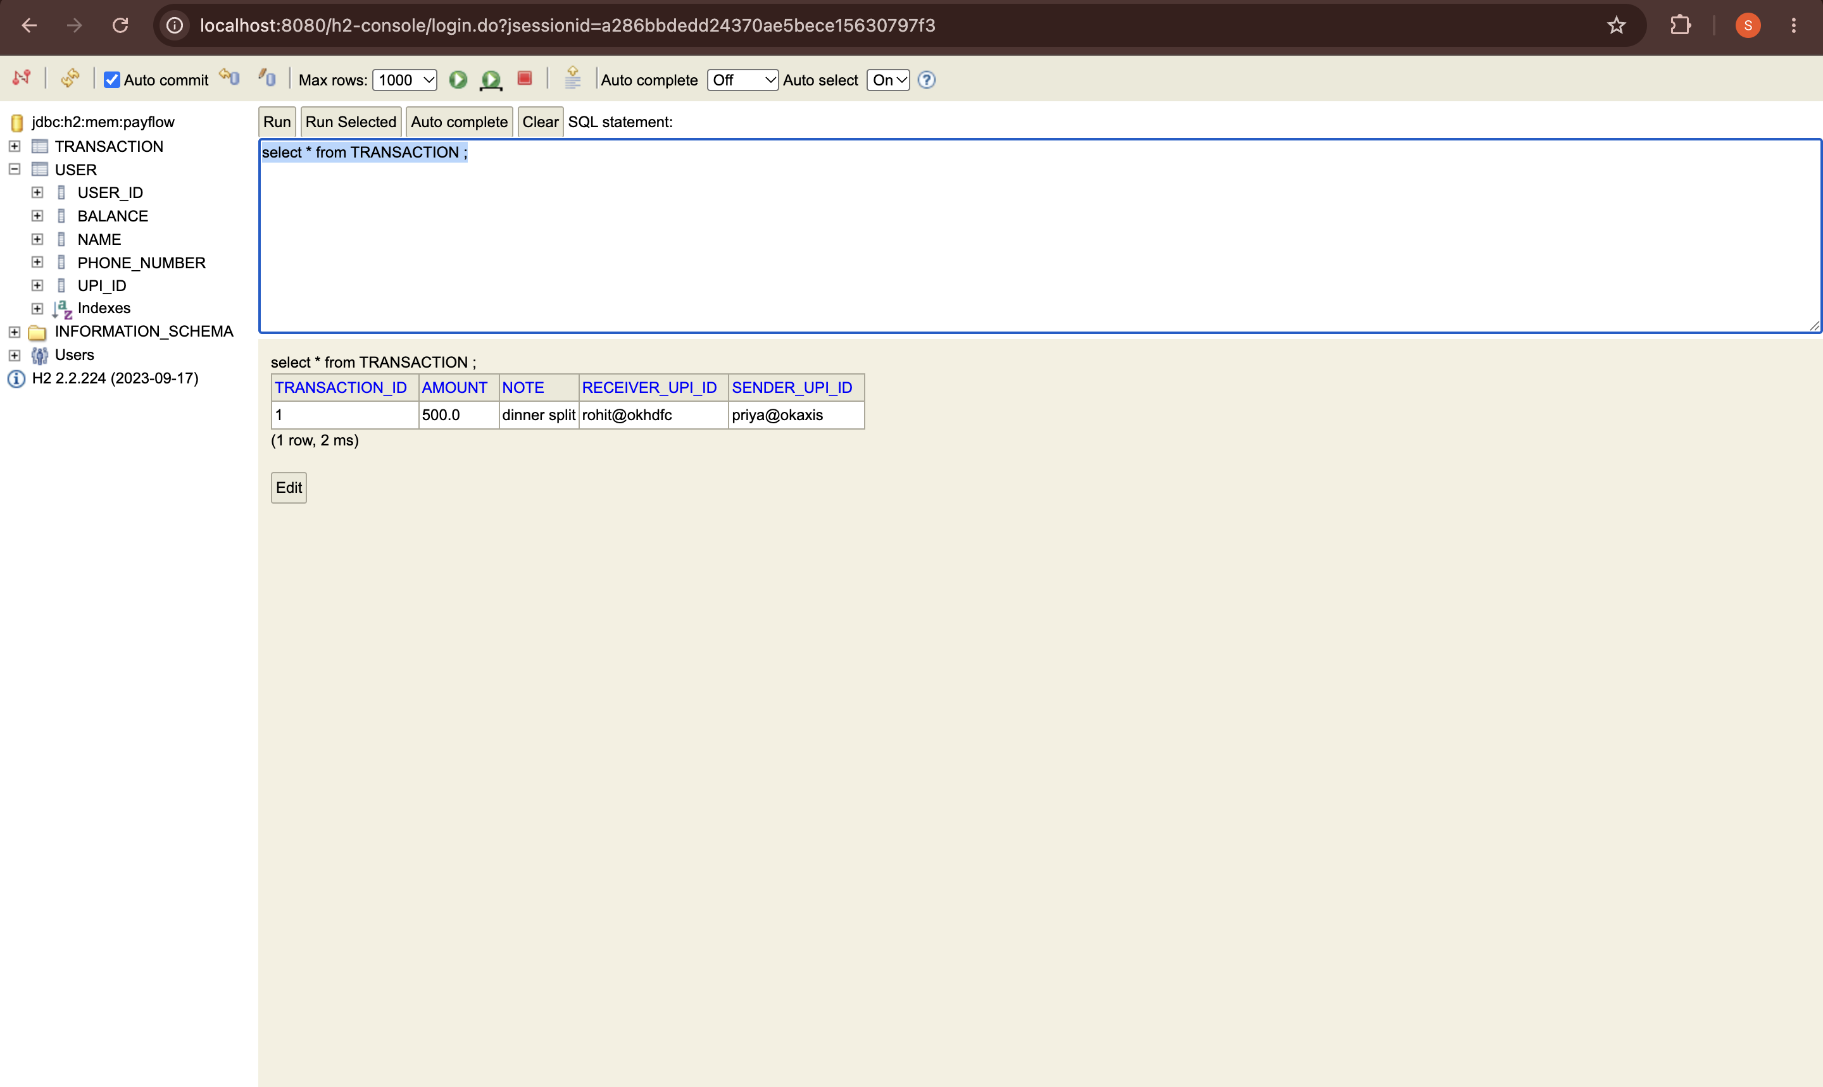
SELECT * FROM TRANSACTION; -- one row

@RequestBody demonstration
UserController has two POST handlers: createUser (with @RequestBody) and createUserWithoutRequestBody (same shape, no @RequestBody), both logging the incoming User's fields with System.out.println before returning it.
With @RequestBody:
curl -s -X POST http://localhost:8080/users \
-H "Content-Type: application/json" \
-d '{"name":"Priya Sharma","upiId":"priya@okaxis","balance":5000.0,"phoneNumber":"9876543210"}'
Console output:
createUser (with @RequestBody) received: Priya Sharma, priya@okaxis, 5000.0
Without @RequestBody, same JSON body:
curl -s -X POST http://localhost:8080/users/no-request-body-demo \
-H "Content-Type: application/json" \
-d '{"name":"Test2","upiId":"test2@ok","balance":200.0,"phoneNumber":"8888888888"}'
Response:
{"userId":null,"name":null,"upiId":null,"balance":null,"phoneNumber":null}
Console output:
createUser (without @RequestBody) received: null, null, null
Why the fields are null without @RequestBody: Spring MVC only reads and deserializes the raw HTTP request body into a method parameter when that parameter is explicitly annotated with @RequestBody - that annotation is what tells the HttpMessageConverter machinery (Jackson, for JSON) to parse the body against the parameter's type. Without it, Spring instead tries to populate the object using its data-binding mechanism for request parameters (query string or form fields), which here finds nothing matching, so it constructs the User with its no-arg constructor and leaves every field at its default (null for objects, 0/0.0 for primitives). The JSON payload is never touched, so the object comes back empty.

Task 6 - Custom Query
GET /users/upi/{upiId} is wired through UserService.findByUpiId into UserController.getUserByUpiId (see Task 5 curl output above).
A second UserRepository method uses @Query with JPQL:
@Query("SELECT u FROM User u WHERE u.balance > :amount")
List<User> findUsersWithBalanceAbove(@Param("amount") Double amount);

Three approaches to custom queries, compared
1. Derived query methods (findByUpiId(String upiId)) - Spring Data parses the method name and builds the query automatically. Fastest to write, but limited to what the naming convention can express, and the method name gets unwieldy for complex conditions.
2. @Query with JPQL (findUsersWithBalanceAbove) - you write the query against entity names and properties (User, u.balance), not table/column names. It's portable across databases (Hibernate translates it) and lets you express joins, aggregations, and conditions a derived name can't.
3. Native SQL (@Query(nativeQuery = true)) - you write raw SQL against the actual table/column names. Most flexible and can use database-specific features, but it is the least preferred for day-to-day use because it breaks database portability (SQL dialect differences), bypasses JPQL's entity-aware validation (typos surface at runtime, not compile time), and couples the code to the physical schema rather than the logical object model - a column rename silently breaks every native query that touches it.

Conceptual Write-Up

1. Request lifecycle
When curl sends POST /users, the request first hits the embedded Tomcat server, which hands it to Spring's front controller, the DispatcherServlet. The DispatcherServlet consults its HandlerMapping to find that /users with method POST maps to UserController.createUser, then delegates execution to a HandlerAdapter (specifically RequestMappingHandlerAdapter), which knows how to invoke @RequestMapping-style methods. That adapter resolves the method's arguments - here, converting the JSON body into a User object because of @RequestBody - and finally invokes createUser, which calls into UserService and returns the saved user, which the DispatcherServlet then serializes back to JSON for the response.

2. Serialisation
Jackson (MappingJackson2HttpMessageConverter), wired in automatically by Spring Boot's auto-configuration, converts the incoming JSON body into a User object - it reads the JSON keys and matches them against the User class's fields/setters. If the JSON key were upi_id instead of upiId, Jackson would not find a matching property (it matches by exact field name by default, with no case/separator translation), so upiId on the resulting User object would simply stay null - no error is thrown, the field is just silently left unset.

3. Spring Boot features
The three are the embedded server, auto-configuration, and production-ready defaults. In PayFlow: the embedded Tomcat means java -jar payflow-api-0.0.1-SNAPSHOT.jar is a complete, runnable server with no external container; auto-configuration is what turns the h2 and spring-boot-starter-data-jpa dependencies into a working DataSource, EntityManagerFactory, and repository beans with zero manual bean definitions; production-ready defaults show up in things like the one-line spring.jpa.show-sql=true toggle and the ready-to-use /h2-console endpoint, both of which are sensible conventions Spring Boot already ships rather than things built from scratch.

4. Spring vs. Spring Boot
With plain Spring, this project would need manual configuration of a DataSource bean, a LocalContainerEntityManagerFactoryBean, a PlatformTransactionManager, Jackson message converters registered with WebMvcConfigurer, and a servlet container (Tomcat/Jetty) set up and deployed as a WAR - typically dozens of lines of Java or XML config before any business code runs. Spring Boot's auto-configuration detects the dependencies on the classpath (H2, Spring Data JPA, Spring MVC) and wires all of that automatically, so the project only needed the four entity/repository/service/controller layers plus application.properties.

5. Stateless REST
Stateless means each HTTP request carries all the information the server needs to process it; the server does not keep any per-client session data between requests. POST /transactions does not rely on anything remembered from a prior call - every field it needs (senderUpiId, receiverUpiId, amount, note) arrives in that one request. This matters once PayFlow runs on three servers behind a load balancer because the load balancer can route any request to any server without needing sticky sessions - if state were kept in one server's memory, a request landing on a different server wouldn't have access to it, breaking the client's flow.

6. Persistence
If transactions were stored in a Java List instead of the H2 database, that list would live only in the JVM's heap memory for as long as the process runs. Restarting the server (a deploy, a crash, a routine restart) would wipe the list completely, losing every transaction ever recorded. For a payments app this is unacceptable because transaction records are the system's source of truth for who paid whom, how much, and when - losing them means losing the ability to reconcile balances, resolve disputes, or prove a transfer happened at all.

Verification
The app was started fresh (mvn clean package, then java -jar target/payflow-api-0.0.1-SNAPSHOT.jar) against a clean in-memory H2 database immediately before the curl commands above were run, and it started cleanly with no errors.

