Brief

1. The Scenario
Every time you tap Pay on PhonePe or Google Pay, a backend server receives that request, validates the sender, records the transaction, and updates balances, all in under a second.
PayFlow is a simplified version of that system. You are building the REST API that powers it: registering users, giving them a wallet balance, and recording money transfers between them.
There is no UI. No frontend. Just a clean, database-backed API that a frontend team could plug into tomorrow which is exactly how real fintech backends are built and handed off.
By the end of this assignment, the following will work entirely through HTTP calls from your terminal:
- Register a user - POST a new user with a name, UPI ID, and opening balance.
- Look up a user - GET a user by their ID, or search by their UPI ID.
- List all users - GET every registered user in the system.
- Send money - POST a transaction from one user to another. The amount and sender/receiver get persisted.

2. Your Entities
PayFlow has one entity for this assignment: the User. Keep it simple, relationships (like linking transactions to users via foreign keys) are a topic for the next session.

The User Entity
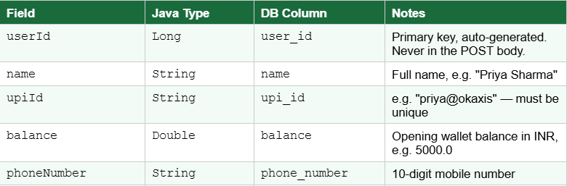
Notice that camelCase Java field names (upiId, phoneNumber) automatically become snake_case column names (upi_id, phone_number) in the database, this is the JPA naming convention demonstrated in class.

The Transaction Entity
A Transaction records a single money transfer. It is a second entity, build it as a plain @Entity with the fields below. You do not need to model the relationship between Transaction and User with foreign keys yet (that comes in a future session). Simply store the sender and receiver UPI IDs as plain strings for now.
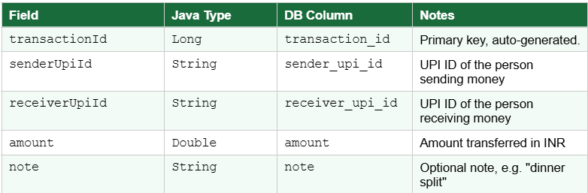
3. Tasks

Task 1 — Project Setup (10 marks)
- Create a Spring Boot project via Spring Initializr with: Spring Web, Spring Data JPA, H2 Database.
- Organise into four packages: entity, repository, service, controller.
- Write a README.md covering: how to run the app, what each layer does, and how Spring Boot's three features (embedded server, auto-configuration, production-ready defaults) appear in this PayFlow project specifically.

Task 2 — Entities & Database (15 marks)
- Create both the User and Transaction entity classes with the fields above.
- Annotate each with @Entity, @Id, @GeneratedValue. No hand-written SQL — DataJPA creates both tables automatically.
- Add spring.jpa.show-sql=true to application.properties. On first startup, paste the two create table (...) statements from the console into your write-up.
- Open /h2-console and screenshot both tables (SELECT FROM USER and SELECT FROM TRANSACTION) showing correct columns before any data is inserted.

Task 3 -- Repository Layer (10 marks)
- Create UserRepository extending JpaRepository<User, Long> and TransactionRepository extending JpaRepository<Transaction, Long>.
- In UserRepository, add the derived query method findByUpiId(String upiId). This is how your app will look up a user before sending money.
- In your README, paste the SQL JPA generates for findByUpiId and explain: (a) how JPA derives it from the method name, and (b) what the ? placeholder means.

Task 4 -- Service Layer (15 marks)
- Create UserService (@Service) with methods: registerUser(User user), getAllUsers(), getUserById(Long id), findByUpiId(String upiId).
- Create TransactionService (@Service) with method: sendMoney(Transaction transaction). For now this just saves the transaction record — balance deduction logic is not required.
- In both services, inject the respective repository using @Autowired. Add a comment in the code explaining what Spring is doing at startup to make this work.

Task 5 -- Controller & REST Endpoints (30 marks)
- Create UserController (@RestController, base path /users) and TransactionController (@RestController, base path /transactions).
- Implement the following endpoints:
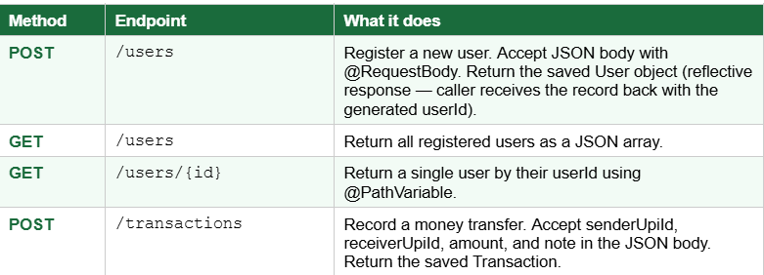
  - Test all four endpoints using curl from your terminal. Include the curl commands and output for each. After registering two users and sending money between them, screenshot SELECT FROM USER and SELECT FROM TRANSACTION in the H2 console.
  - Demonstrate @RequestBody: call POST /users once with @RequestBody and once without. Show the difference in what the User object looks like inside the controller (debugger or println). Explain in one paragraph why the fields are null without it.
- Task 6 -- Custom Query (10 marks)
  - Wire findByUpiId into the service and controller, add a GET /users/upi/{upiId} endpoint that returns the user matching that UPI ID.
  - Add a second method to UserRepository using the @Query annotation with a JPQL query (not native SQL) for example, find all users whose balance is above a given amount.
  - In your README, compare the three approaches to custom queries derived method names, @Query (JPQL), and native SQL, and explain why native queries are the least preferred.
4. Conceptual Write-Up (10 marks)
Answer all six questions in your own words, 3–5 sentences each. Every question maps to something covered in class.
    - Request lifecycle: Trace what happens from the moment curl sends POST /users to the moment your createUser method runs. Name the Dispatcher Servlet and Handler Adapter in your answer.
    - Serialisation: When you POST a JSON payload like {"name":"Priya","upiId":"priya@okaxis"}, what converts it into a Java User object? What happens if the JSON key is "upi_id" instead of "upiId"?
    - Spring Boot features: Name the three Spring Boot features. For each one, point to a specific thing in your PayFlow project where that feature is doing work for you.
    - Spring vs. Spring Boot: If you had used plain Spring instead of Spring Boot for PayFlow, what would you have had to set up manually? What does Spring Boot take care of automatically?
    - Stateless REST: Your POST /transactions endpoint does not remember anything about the previous request. What does stateless mean, and why does it matter if PayFlow eventually runs on three servers behind a load balancer?
    - Persistence: You stored transactions in the H2 database, not in a Java List. What would have happened to all the transaction records if you had used a List and then restarted the server? Why is this unacceptable for a payments app?

Submission guidelines
- Push the complete Spring Boot project to a public GitHub repo, name it payflow-api or similar.
- Place your write-up (answers + screenshots) as a PDF or Word doc in the repo root.
- Make sure the app starts cleanly from a fresh run before submitting.

