**CS898 CA**

**Introduction to Intelligent Robotics, 2022**

**Navigate Mobile car in simulation**

**Name: Sreekar Chigurupati**

**WSU ID:**

**Introduction:**

Nearly all automobile collisions are caused by human error, which can be avoided with the use of advanced driver assistance systems (ADAS). The purpose of ADAS is to prevent deaths and injuries by minimising the frequency and severity of auto accidents that cannot be avoided. Self-driving cars use a variety of different applications and technology to obtain near and far 360-degree vision. This indicates that hardware designs are utilising increasingly advanced process nodes to achieve ever-increasing performance goals while simultaneously reducing power and footprint requirements. Car navigation systems give on-screen directions and audio prompts to allow drivers to concentrate on the road while following a route. Some navigation systems can display accurate traffic information and, if necessary, suggest an alternate route to avoid traffic congestion. Even more advanced systems may offer heads-up displays to reduce driver attention. Night vision systems allow drivers to view objects that would be difficult or impossible to see in the dark. There are two types of night vision systems: active and passive. Active night vision systems emit infrared light, whilst passive systems utilise the thermal energy emitted by vehicles, animals, and other objects. Automatic emergency braking employs sensors to determine if the driver is about to collide with another vehicle or other road objects. This programme can calculate the distance between close vehicles and warn the driver of any potential risk. In order to avoid a collision, some emergency braking systems might tighten seatbelts, reduce speed, and engage adaptive steering. The detection of driver drowsiness alerts drivers of sleepiness or other road distractions. There are numerous methods for determining if a driver's concentration is waning. In one scenario, sensors can assess the head movement and pulse rate of the driver to decide if they indicate tiredness. Other systems generate driving alerts comparable to the lane detecting warning signals. The driver monitoring system is an additional method for gauging the driver's focus. The camera sensors can determine if the driver's eyes are on the road or if they are wandering. Driver monitoring systems can inform drivers via sounds, steering wheel sensations, and flashing lights. In some instances, the vehicle

will take the extreme measure of entirely stopping. These systems are currently employed in advanced driver assistance systems. This ADAS is utilised in LIDAR-based autonomous vehicles, which is the

most effective technology. LIDAR technology gives increased accuracy in the detection of objects and recognition of obstructions when in auto driving mode. Combined with radar and vision-based technologies, this technology can enhance the user experience.

The automobile industry has always been interested in the development of self-driving or autonomous automobiles or vehicles, which represent the industry's bright future. Now, with the use of sensors and equipment based on LIDAR technology that comprehensively check for obstructions in all directions, as well as low-cost sensors that enable improved efficiency and a safer journey for passengers.

To maintain the safety of the user, the ADAS system demands more exact data and more efficient object detection, for which we utilise LIDAR with other possibilities such as other detection methods. Object detection can also be performed using radar and vision-based systems. For superior vision, however, LIDAR has to be coupled to two additional systems in addition to a complete turn-around vision and increased precision.

Thus, the future of the enhanced driver support system for self-driving automobiles lies in fully controlled vehicles with speed and steering control.

**Procedure:**

1. Let's install the required software, which consists of spyder, pybullet python, and anakonda.

2. Only after installing these four applications can the "main.py" file be opened.

3.Finish the navigation and control functions next. Then, we must do these functions.

i. use a path finding method based on histograms

ii. As a LIDAR, it releases 50 beams at once, which then travel around us and enable it to locate the target. So that the ray's colour changes when it returns non-zero values.

4. These rays must be saved as histbins, and the maximum range of the histbin closest to the object's location must now be obtained.

5. Now, calculate the angle depending on the position, orientation, and location of the car's histbin. Then, after obtaining the value of the angle.

We are sending the controller this angle value. The controller then twists its steering and moves in the direction of the histbin or path.

6. The path described above leads to the desired location.

**Detailed Project Description**

Using pybullet, this project aims to transport the autonomous vehicle from one site to another.

For this purpose, the car's navigation system is automated to operate autonomously. For this automatic movement of the autonomous car in a graphical environment, the project code is written. By estimating the angle based on the position of the autonomous vehicle. In addition, the car's radiated rays are transformed into histbins. The value derived from the position that will be transmitted to the controller. The steering then rotates and moves towards the destination automatically.

**Algorithms Employed**

Histogram-based route finding automobile:

As a network traffic model that captures the arrival rate distribution in VANET, the proposed approach employs histograms. In addition, the research proposes a method of analysis that works directly with the histogram model to derive the queue occupancy distribution at cross-junctions or traffic signals using a finite queue model. A microscopic simulation model is used to evaluate the traffic model's ability to detect traffic congestion and instruct vehicles to take better routes.

Driving identification and path type identification are becoming crucial concerns because to the vehicle industry's growing interest in enhancing driver experience and safety, and the need to minimise global environmental problems. Since a large number of ever-more-advanced and precise automotive sensors and monitoring systems have been developed in recent years, numerous proposed methodologies are based on the analysis of vast quantities of real-time data representing the driving experience. In this paper, a collection of behavioural traits extracted by a vehicle monitoring system is provided to achieve driver identification and path type identification, as well as to assess a driver's familiarity with a given vehicle.

However, the network that connects these vehicles is currently uncertain, as we cannot ensure that all roads have adequate networking. In addition, abrupt or intense weather changes such as storms, heavy snowfall, or rainfall can disrupt the network, making it difficult for the vehicle to connect and detect its surroundings. However, there are improvements that might be made to the current system that would result in a safer experience and a more accurate forecast. The vehicle industry has always endeavoured to improve automobiles gradually via several phases of speed, mileage, and comfort. As they seek future possibilities, this autonomous driver system is one such future potential and cutting-edge technology that would improve the current vehicle business landscape. By combining radar, lidar, and vision sensing technologies for autonomous driving, we can ensure the user's safety. These sensors are substantially more cost-effective and efficient, which is currently garnering the attention of the business. This equipment can support a vehicle in all modes and improve the driving experience for the driver. The primary components of a lidar instrument are a laser, a scanner, and a specialised GPS receiver. Airplanes and helicopters are the most frequent platforms for collecting lidar data across expansive regions. Topographic and bathymetric lidar are two varieties. Bathymetric lidar employs water-penetrating green light to determine seafloor and riverbed elevations, whereas topographic lidar uses a near-infrared laser to map the land.

Lidar systems enable scientists and mapping experts to analyse both natural and manmade settings with precision, flexibility, and accuracy. Utilizing lidar, NOAA scientists are able to create more accurate shoreline maps, create digital elevation models for use in geographic information systems, aid in emergency response operations, and perform a variety of other tasks. As the majority of road accidents are caused by human error, ADAS are designed to automate, adapt, and improve vehicle technology for safety and improved driving. ADAS have been shown to prevent fatalities on the road by minimising human error. Safety features are aimed to avoid mishaps and collisions by delivering technology that warn the driver to hazards, enacting protections, and taking control of the vehicle if necessary. Adaptive features may automate lighting, provide adaptive cruise control, assist in avoiding collisions, incorporate satellite navigation and traffic warnings, warn drivers of potential obstacles, assist in lane departure and lane centering, provide navigational assistance via smartphones, and provide additional features.

Automobiles, lorries, and buses, as well as agricultural, construction, and military equipment, use ADAS systems nowadays. In 2019, the NHTSA (National Highway Traffic Safety Administration) reports that more than 36,000 Americans were killed in automotive accidents. According to the NHTSA's August 2016 Traffic Safety Facts Research Note, 94 percent of these accidents were the result of driver error, or human error.

Through a secure human-machine interface, ADAS enhances the safety of automobiles and roads. ADAS uses automated technology, including as sensors and cameras, to detect and respond to nearby impediments and driver errors. Depending on the features installed in the vehicle, ADAS can enable varying levels of autonomous driving.

Picture:

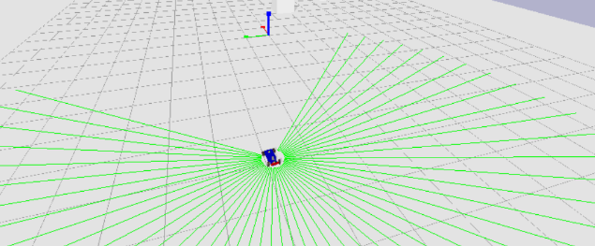

Result

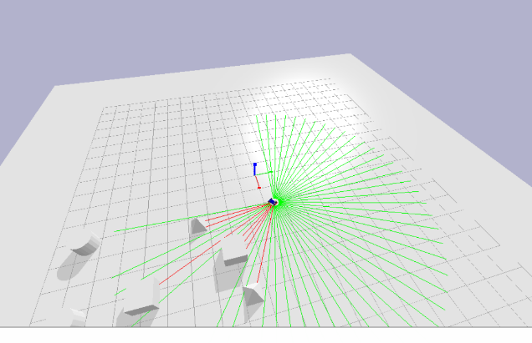

Pros and cons of autonomous vehicles

Advantages of self-driving cars:

It is generally acknowledged that around 95% of road accidents are caused by human drivers. We are susceptible to error, distracted, and potentially hazardous. Our culpability at the wheel is not only a concern for other human drivers, but can also be challenging for autonomous vehicles.

Autonomous vehicles provide freedom and independence to those with disabilities who may not have been able to drive without assistance. For the elderly, driverless vehicles make driving safer by requiring less concentration.

Even the most conscientious drivers occasionally struggle with parallel parking. Among their numerous autonomous capabilities, driverless cars offer automatic parking assistance, saving you time and allowing you to safely continue with your regular activities.

With less likelihood of tailgating and difficult or dangerous passing, driverless vehicles will make travel stress-free and rage-free for all. Everyone eventually encounters road rage. Without having to deal with dangerous or irresponsible driving, there are fewer opportunities for violence and conflict.

Cons of Self-driving automobile:

Once you've mastered driving, it's similar to riding a bicycle: you never forget. However, without the opportunity to practise as they normally would, drivers run the risk of losing their driving skills over time. What happens if the driver is unable to act quickly and the onboard computer programme requires human intervention? Safety will feel inadequate. The inherent vigilance that drivers must maintain may diminish.

Any computer software and over-the-air communications are susceptible to hacking. As vehicles become more connected, they will be more susceptible to hackers, who may be able to take control of the vehicle while it is in motion. There are also privacy risks, as hackers can track destinations and potentially steal personal information.

Self-driving cars can prevent accidents caused by human error, but they could cause accidents caused by technology, such as failed software updates or technical glitches.

While it appears that self-driving cars are still some time away from becoming commonplace and accepted (both socially and legally), it is important to understand how they will fit into our lives, whether safely or dangerously.

There is evidence that certain weather conditions hinder the operation of autonomous vehicles. Snow can interfere with cameras, and heavy rain can interfere with roof-mounted laser sensors.

**Conclusion:**

This project focuses on using pybullet to move an autonomous vehicle from one location to another. This is implemented because self-driving cars lead to an increase in accidents, and it regulates the speed and traffic flow. During the implementation of this project, we learned how to create a path navigation system, how to lose a pybullet, and how to create prototypes.

Demo URL: [Sreekar_final_project.mp4](https://wichitaedu-my.sharepoint.com/:v:/g/personal/u992x777_wichita_edu/Eb0VRFaRn6lPmfcLbeMF3GUBuH5PcZM--4qVCfq_PO5lfA?e=ewvwri)

**References:**

Penttinen, Jyrki T.J. (2015). Engineering Guidelines for Fixed, Mobile, and Satellite Systems, The Telecommunications Handbook. The company John Wiley & Sons. ISBN 978-1-119-94488-1.

Dana, Peter H. (August 8, 1996). "GPS Orbital Planes". The original (GIF) file was archived on January 26, 2018. Retrieved on February 27

"GPS Completes Operational Control System PDR for the Next Generation." News Service for Air Force Space Command September 14, 2011. The original version was archived on October 2, 2011.

Gilbert Strang; Kai Borre (1997). GPS, Linear Algebra, and Geodesy. SIAM. pp. 448–449. ISBN 978-0-9614088-6-2. The original file was archived on October 10, 2021. Retrieved on May 22.

However, Butterly, Amelia (May 20, 2018). "100 Women: Gladys West, GPS's 'hidden figure'." The BBC News Original version archived on February 13, 2019. Retrieved on January 17

Audun Holme (2010). Our Cultural Heritage, as Defined by Geometry Science & Business Media, Springer. p. 338. ISBN 978-3-642-14441-7. The original file was archived on October 10, 2021. Retrieved on May 22.