RetailMart Profitability Review
Where we make money, where we lose it, and what to change
Data analysis project using Excel, SQL and Power BI
Prepared by: [ Sreekar K]
October 2026

1. Introduction
RetailMart sells furniture, office supplies and technology. The head of operations noticed that sales have grown for four years, but profit does not feel like it is growing at the same pace. The question I was asked to answer is: where does RetailMart make money, where does it lose money, and what should it change?
To answer this, I analysed 9,994 order lines from January 2014 to December 2017. The analysis covers products, discounts, regions, customers and yearly trends.

2. Tools used
- Excel: cleaning the data, pivot tables and checking my answers.
- SQL (MySQL Workbench): writing queries to answer the same questions, and confirming the Excel results.
- Power BI: building a 3-page dashboard so the results are easy to see.
All three tools gave the same totals: sales of $2,297,201 and profit of $286,397. This gives me confidence that the numbers are correct.

3. Data and cleaning
The dataset is the Sample Superstore dataset. It has 9,994 rows and 21 columns, including order date, ship date, customer, product, sales, quantity, discount and profit. Before analysing it, I did the following checks:
Check | What I found and did
Duplicate rows | None found.
Empty cells | None found.
Dates | Converted to real dates in YYYY-MM-DD format so they cannot be misread.
New columns | Added Order Year, Order Month and Days to Ship (always between 0 and 7, never negative).
Postal codes | 449 codes had lost their leading zero. I fixed them so all have 5 digits.
Negative profits | These are real losses, not errors, so I kept them.

4. Findings

Finding 1: Sales and profit over time
Sales fell by 2.8% in 2015, but profit still grew by 24.4%. In 2017, profit grew more slowly than sales (14.2% compared with 20.4%). The profit margin improved from 10.2% in 2014 to 12.7% in 2017, but it slipped from its peak of 13.4% in 2016.
Year | Sales growth | Profit growth | Profit margin | Profit slower than sales?
2014 | - | - | 10.2% | -
2015 | -2.8% | +24.4% | 13.1% | No
2016 | +29.5% | +32.7% | 13.4% | No
2017 | +20.4% | +14.2% | 12.7% | Yes

Conclusion: the manager is partly right. Profit has grown overall, but growth slowed in 2017, and the reason should be investigated.
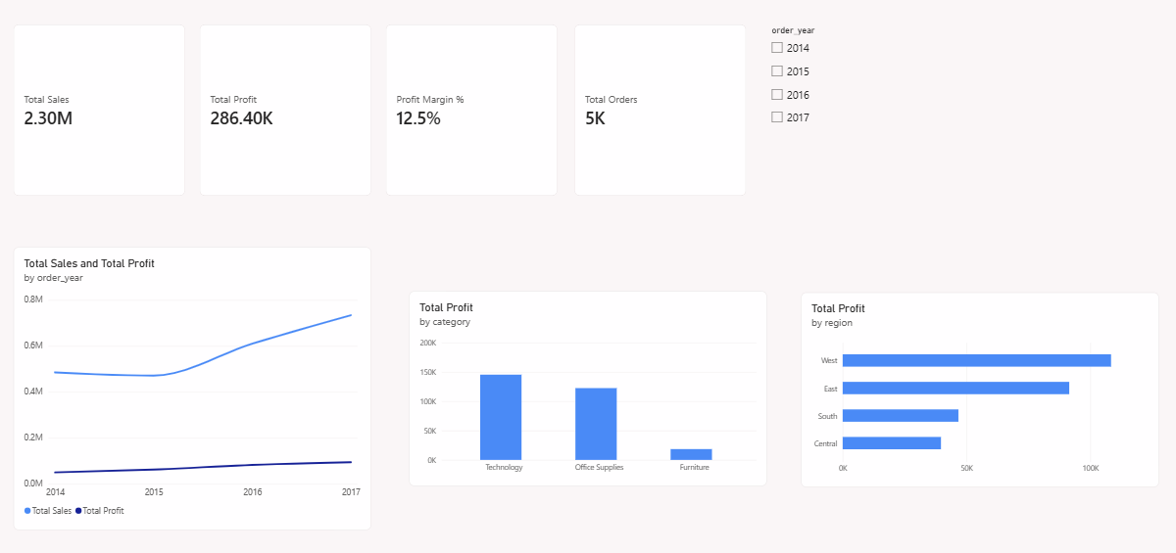
Figure 1: Dashboard page 1 (Overview) - cards, sales and profit by year, profit by category and region

Finding 2: Furniture sells a lot but earns very little
Furniture has sales of $742K, more than Office Supplies ($719K), but its profit is only $18K. That is a margin of 2.5%, compared with about 17% for Technology and Office Supplies. Inside Furniture, Tables lose $17.7K and Bookcases lose $3.5K, while Chairs make $26.6K.

Finding 3: Big discounts turn profit into losses
Profit is strongly positive when there is no discount and when the discount is up to 20%. It turns negative at a 30% discount. All order lines with discounts above 40% lost about $99.6K in total.
Discount level | Order lines | Total profit
No discount | 4,798 | +$320,988
Up to 20% | 3,803 | +$100,785
21% to 40% | 460 | -$35,817
Above 40% | 933 | -$99,559

Tables show this clearly. At full price they made $13,276. At discounts of 30% or more they lost about $30.7K.

Finding 4: One region and category loses money
Out of 12 combinations of region and category, only one loses money: Furniture in the Central region, at -$2.9K. In the same region, Technology makes $33.7K.
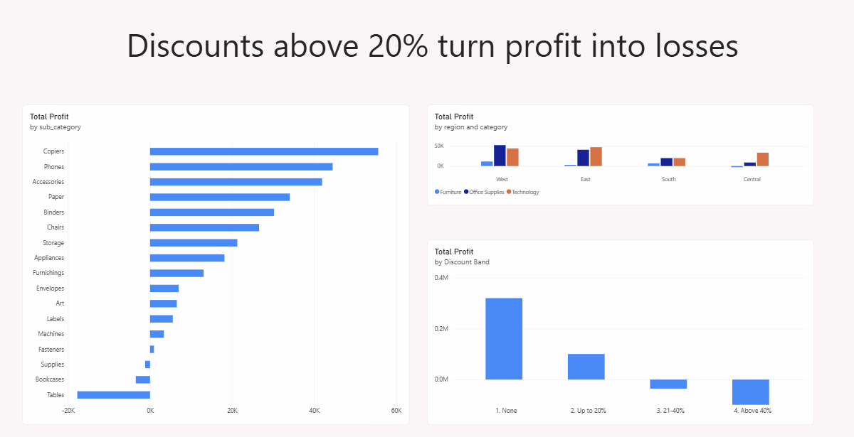
Figure 2: Dashboard page 2 (Profit Deep-Dive) - profit by sub-category, region and discount level

Finding 5: One in five customers loses money
155 of the 793 customers (19.5%) have a negative total profit, and together they cost RetailMart about $71K. The three biggest losses come from Cindy Stewart (-$6.6K), Grant Thornton (-$4.1K) and Luke Foster (-$3.6K). Some of these customers buy a lot. For example, Sean Miller bought $25K of goods but the store still lost $2K on him. High sales do not always mean high profit.
By segment, Consumer earns the most profit ($134K), but Home Office has the best margin (14.0%, compared with 13.0% for Corporate and 11.5% for Consumer).
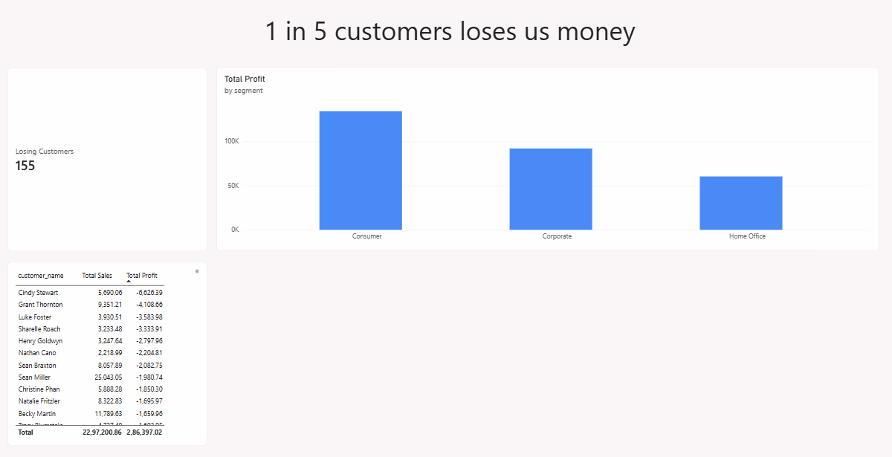
Figure 3: Dashboard page 3 (Customers) - losing customers, profit by segment and the biggest money-losers

5. Recommendations
1. Cap discounts at 20%. Discounts above 20% are linked to losses, and lines above 40% lost $99.6K. A cap would stop most of this loss.
2. Review Table and Bookcase pricing. Tables lose $17.7K and Bookcases lose $3.5K, mostly when heavy discounts are applied. Furniture overall keeps only 2.5% margin.
3. Check Furniture discounts in the Central region. It is the only region and category pair that loses money.
4. Look at the 155 losing customers. Check what they buy and how much discount they receive, instead of simply dropping them.
5. Find out why the margin slipped in 2017. Profit grew slower than sales that year, and discounts are a good place to start.

6. Conclusion and limits
Heavy discounts are the biggest problem at RetailMart. They turn products like Tables into money-losers and drag down the whole Furniture category. If discounts were limited to 20%, RetailMart could avoid most of its losses and keep growing profit alongside sales.
This project has some limits. The data covers only four years, it has no information about product costs or why discounts were given, and it cannot show whether discounts brought in extra customers. The recommendations should be tested before being applied to the whole business.

Appendix: Key SQL queries
These queries were written in MySQL and matched the results from Excel and Power BI.

Profit by discount level
SELECT discount,
COUNT(*) AS order_lines,
ROUND(SUM(profit),0) AS profit
FROM superstore
GROUP BY discount
ORDER BY discount;

Loss from discounts above 40%
SELECT ROUND(SUM(profit),2) AS loss_above_40
FROM superstore
WHERE discount > 0.4;

Profit of Furniture sub-categories
SELECT sub_category, ROUND(SUM(profit),0) AS profit
FROM superstore
WHERE category = 'Furniture'
GROUP BY sub_category
ORDER BY profit;

Region and category combinations that lose money
SELECT region, category, ROUND(SUM(profit),0) AS profit
FROM superstore
GROUP BY region, category
HAVING SUM(profit) < 0;

Yearly sales and profit growth
WITH yearly AS (
SELECT order_year,
SUM(sales) AS sales,
SUM(profit) AS profit
FROM superstore
GROUP BY order_year
)
SELECT order_year,
ROUND((sales - LAG(sales) OVER (ORDER BY order_year))
/ LAG(sales) OVER (ORDER BY order_year) * 100, 1) AS sales_growth_pct,
ROUND((profit - LAG(profit) OVER (ORDER BY order_year))
/ LAG(profit) OVER (ORDER BY order_year) * 100, 1) AS profit_growth_pct
FROM yearly;

Customers with negative total profit
SELECT COUNT(*) AS losing_customers
FROM (
SELECT customer_id
FROM superstore
GROUP BY customer_id
HAVING SUM(profit) < 0
) AS t;

