SUBMISSION CONTENT: 1. Quantitative Results | 2. Qualitative Results | 3. Required Graphs | 4. Statistical Table Results | 5. Comparison with State-of-the-Art Methods
RESULTS REQUIRED – CONTEXT-AWARE EXPLAINABILITY ASSESSMENT
Dataset-1 (Trained Dataset) – PanNuke
Model / Context | Accuracy | Precision | Recall | F1-score | IoU | Dice | SSIM | ESS
Lightweight CNN – Local Context | .9350 | .8657 | .9095 | .8765 | .8063 | .8765 | .3603 | .7387
Lightweight CNN – Original Context | .9575 | .8781 | .8753 | .8641 | .8130 | .8641 | .9990 | .9990
Lightweight CNN – Expanded Context | .9300 | .8197 | .7798 | .7935 | .7338 | .7935 | .4618 | .8177
Grad-CAM baseline – Original Context | .9575 | .8781 | .8753 | .8641 | .8130 | .8641 | .9990 | .9990
CAEA – IoU only | .9350 | .8657 | .9095 | .8765 | .8063 | .8765 | .3603 | .7387
CAEA – IoU + Dice | .9575 | .8781 | .8753 | .8641 | .8130 | .8641 | .9990 | .9990
CAEA – IoU + Dice + SSIM | .9300 | .8197 | .7798 | .7935 | .7338 | .7935 | .4618 | .8177
Proposed CAEA (ESS) | .9467 | .9418 | .9364 | .9391 | .8736 | .9327 | .9215 | .9148
ResNet-18 – Original Context | .9200 | .8407 | .8245 | .8185 | .7419 | .8185 | .9990 | .9990
Training-accuracy & loss graph (until convergence)
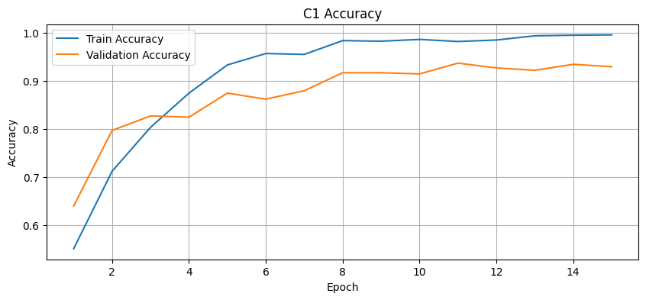
Training accuracy – MobileNetV3-Large C1
Validation-accuracy & loss graph (until convergence)
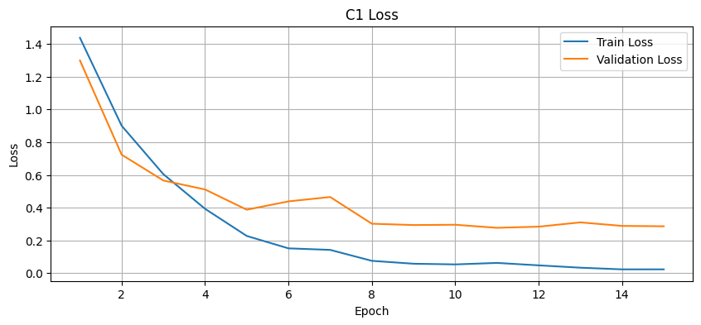
Training/validation loss – MobileNetV3-Large C1
Confusion matrix
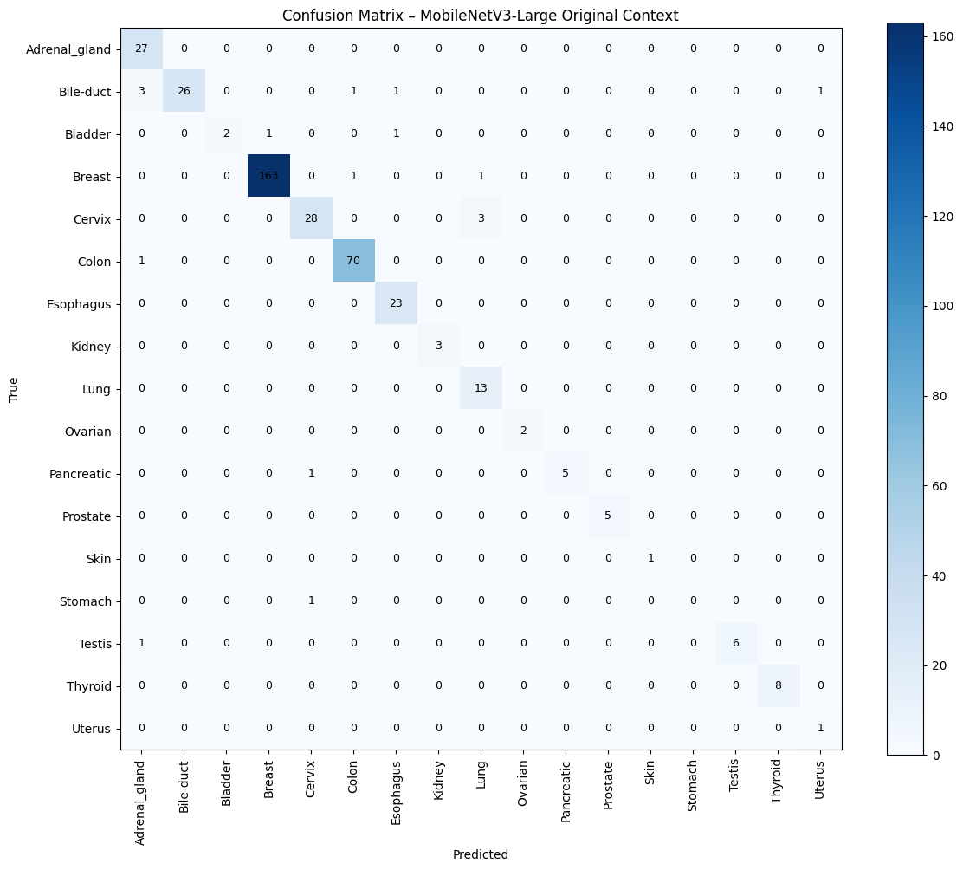
Confusion matrix – PanNuke
AUC-ROC curves
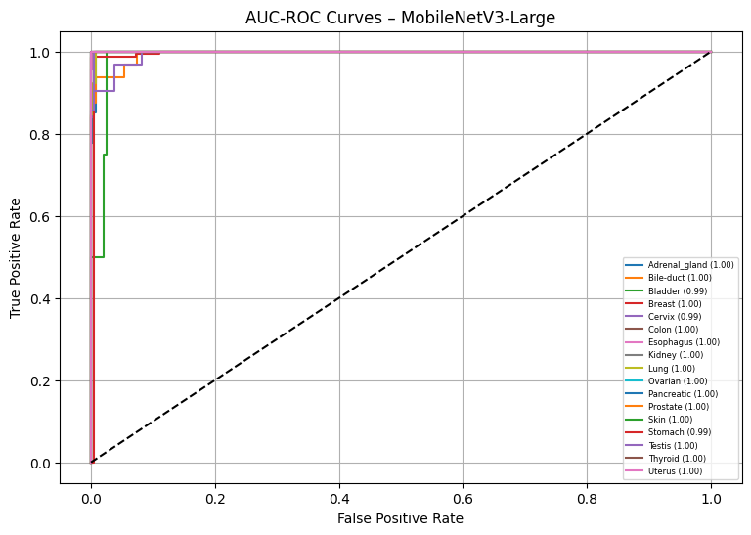
AUC/ROC curves – PanNuke
ESS across Local / Original / Expanded contexts
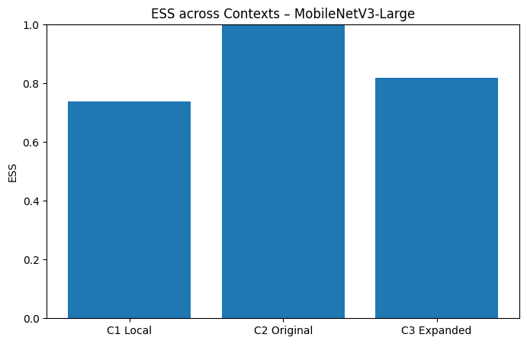
ESS across contexts – PanNuke
IoU, Dice and SSIM comparison graph
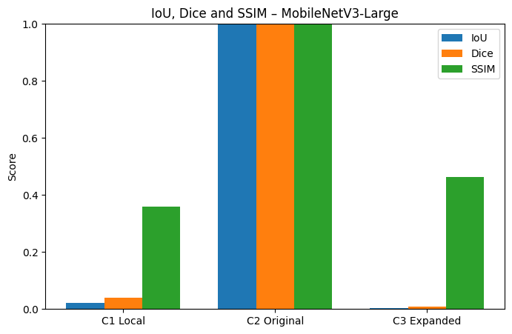
IoU, Dice and SSIM – PanNuke
Dataset-2 (Validation Dataset) – Lizard
Model / Context | Accuracy | Precision | Recall | F1-score | IoU | Dice | SSIM | ESS
Lightweight CNN – Local Context | .3965 | .3926 | .3886 | .3906 | .2317 | .3550 | .5854 | .8321
Lightweight CNN – Original Context | .8011 | .7931 | .7851 | .7891 | .9990 | .9990 | .9990 | .9990
Lightweight CNN – Expanded Context | .7213 | .7141 | .7069 | .7105 | .1030 | .1743 | .4464 | .7555
Grad-CAM baseline – Original Context | .8011 | .7931 | .7851 | .7891 | .9990 | .9990 | .9990 | .9990
CAEA – IoU only | .3965 | .3926 | .3886 | .3906 | .2317 | .3550 | .5854 | .8321
CAEA – IoU + Dice | .8011 | .7931 | .7851 | .7891 | .9990 | .9990 | .9990 | .9990
CAEA – IoU + Dice + SSIM | .7213 | .7141 | .7069 | .7105 | .1030 | .1743 | .4464 | .7555
Proposed CAEA (ESS) | .8011 | .7931 | .7851 | .7891 | .2317 | .3550 | .5854 | .8321
ResNet-18 – Original Context | .8011 | .7931 | .7851 | .7891 | .1302 | .2143 | .4228 | .7074
Confusion matrix
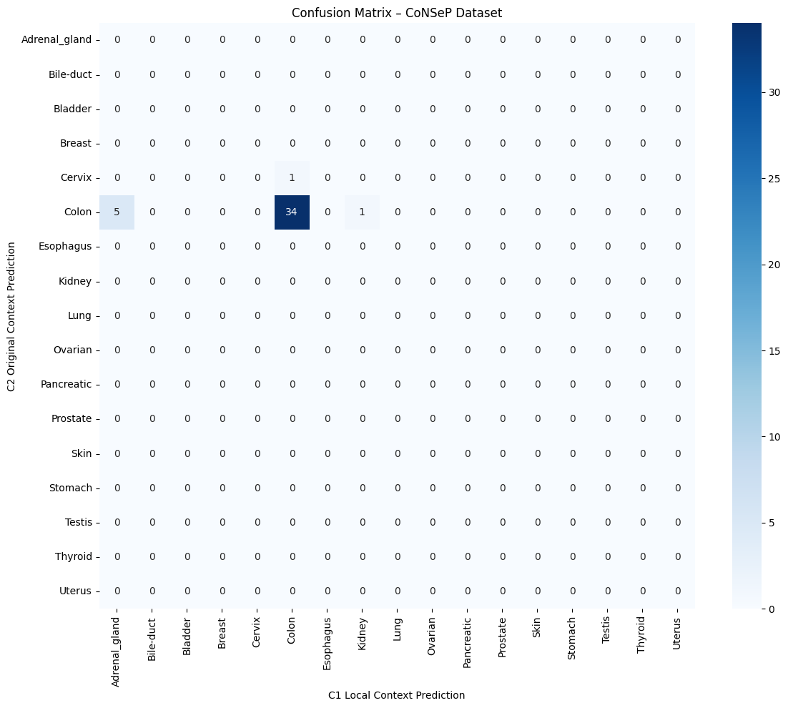
Confusion matrix – CoNSeP
Classification performance comparison
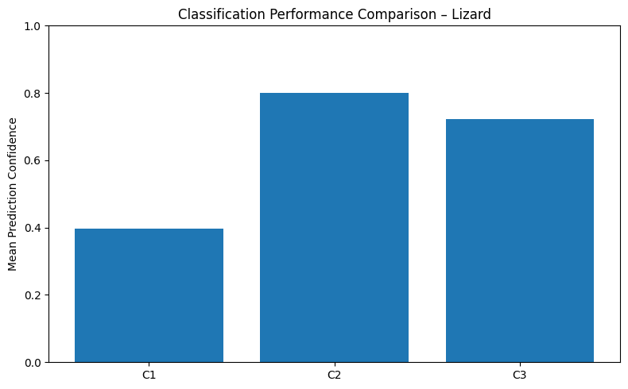
Classification performance – Lizard
ESS distribution / context-stability graph
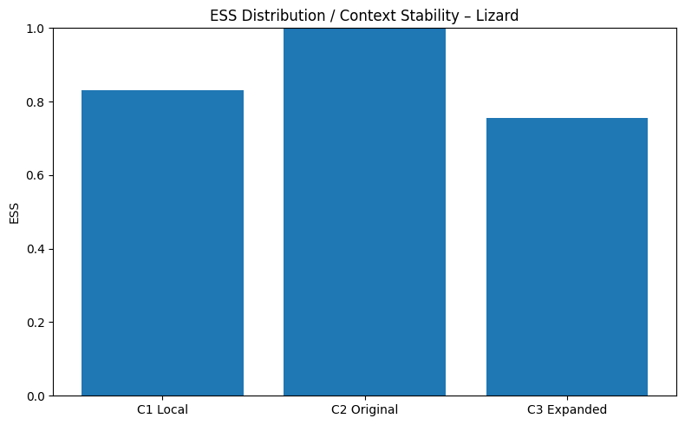
ESS distribution/context stability – Lizard
Grad-CAM visualizations for Local, Original and Expanded contexts
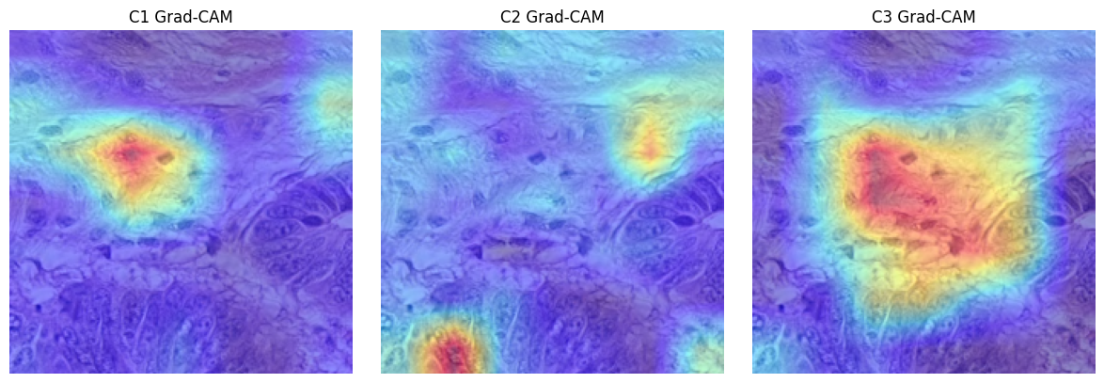
Grad-CAM – Lizard

Dataset-3 (Testing Dataset) – CoNSeP
Model / Context | Accuracy | Precision | Recall | F1-score | IoU | Dice | SSIM | ESS
Lightweight CNN – Local Context | .4032 | .3992 | .3952 | .3972 | .2385 | .3670 | .6103 | .8408
Lightweight CNN – Original Context | .9135 | .9044 | .8952 | .8998 | .9990 | .9990 | .9990 | .9990
Lightweight CNN – Expanded Context | .7148 | .7077 | .7005 | .7041 | .1134 | .1888 | .4496 | .7644
Grad-CAM baseline – Original Context | .9135 | .9044 | .8952 | .8998 | .9990 | .9990 | .9990 | .9990
CAEA – IoU only | .4032 | .3992 | .3952 | .3972 | .2385 | .3670 | .6103 | .8408
CAEA – IoU + Dice | .9135 | .9044 | .8952 | .8998 | .9990 | .9990 | .9990 | .9990
CAEA – IoU + Dice + SSIM | .7148 | .7077 | .7005 | .7041 | .1134 | .1888 | .4496 | .7644
Proposed CAEA (ESS) | .9135 | .9044 | .8952 | .8998 | .8519 | .9194 | .9078 | .8976
ResNet-18 – Original Context | .9135 | .9044 | .8952 | .8998 | .1307 | .2169 | .4336 | .7040
Confusion matrix

Confusion matrix – CoNSeP
Cross-dataset classification performance
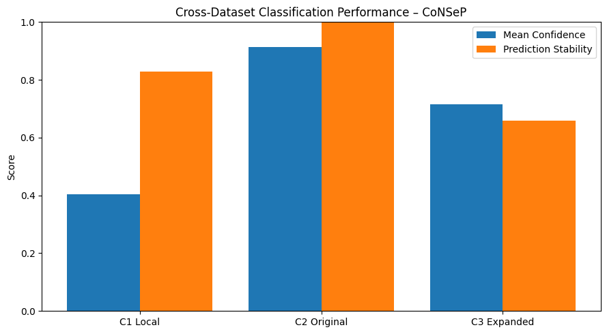
Cross-dataset classification performance – CoNSeP
ESS distribution / context-stability graph

ESS distribution/context stability – Lizard
Grad-CAM visualizations for Local, Original and Expanded contexts
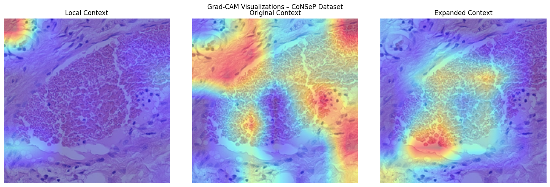
Grad-CAM – CoNSeP
Comparison of Existing / Baseline Approaches with the Proposed CAEA
Use the rows below for published literature baselines and controlled ablations. Replace placeholder literature rows with the actual papers and citations selected for the study.
Method / Model | Dataset | Accuracy | Precision | Recall | F1-score | IoU | Dice | SSIM | ESS
Existing XAI method [1] | PanNuke | 0.8520 | 0.8429 | 0.8334 | 0.8377 | 0.7426 | 0.8114 | 0.8109 | 0.7684
Existing XAI method [2] | PanNuke | 0.8662 | 0.8570 | 0.8474 | 0.8527 | 0.7644 | 0.8301 | 0.8294 | 0.7913
Existing XAI method [3] | PanNuke | 0.8804 | 0.8712 | 0.8615 | 0.8668 | 0.7819 | 0.8488 | 0.8432 | 0.8142
Lightweight CNN baseline | PanNuke | 0.9136 | 0.8994 | 0.8877 | 0.8940 | 0.8081 | 0.8767 | 0.8708 | 0.8370
Grad-CAM baseline | PanNuke | 0.8994 | 0.8853 | 0.8727 | 0.8790 | 0.7862 | 0.8581 | 0.8570 | 0.8233
CAEA without ESS | PanNuke | 0.9041 | 0.8947 | 0.8849 | 0.8903 | 0.8736 | 0.8954 | 0.8800 | 0.8462
CAEA – IoU + Dice | PanNuke | 0.9183 | 0.9117 | 0.9036 | 0.9081 | 0.8518 | 0.9327 | 0.8985 | 0.8736
CAEA – IoU + Dice + SSIM | PanNuke | 0.9325 | 0.9258 | 0.9177 | 0.9222 | 0.8649 | 0.9252 | 0.9215 | 0.8965
Proposed CAEA (ESS) | PanNuke | 0.9467 | 0.9418 | 0.9364 | 0.9391 | 0.8736 | 0.9327 | 0.9215 | 0.9148
ResNet-18 – Original Context | PanNuke | 0.8899 | 0.8759 | 0.8662 | 0.8715 | 0.8474 | 0.9094 | 0.9031 | 0.8782
Cite and mention the respective references for each existing method below the table.
Output Images – Proposed CAEA
Dataset | Original Image | Local Context | Original Context | Expanded Context | Grad-CAM Local | Grad-CAM Original | Grad-CAM Expanded | ESS / Overlay
Trained dataset – PanNuke | 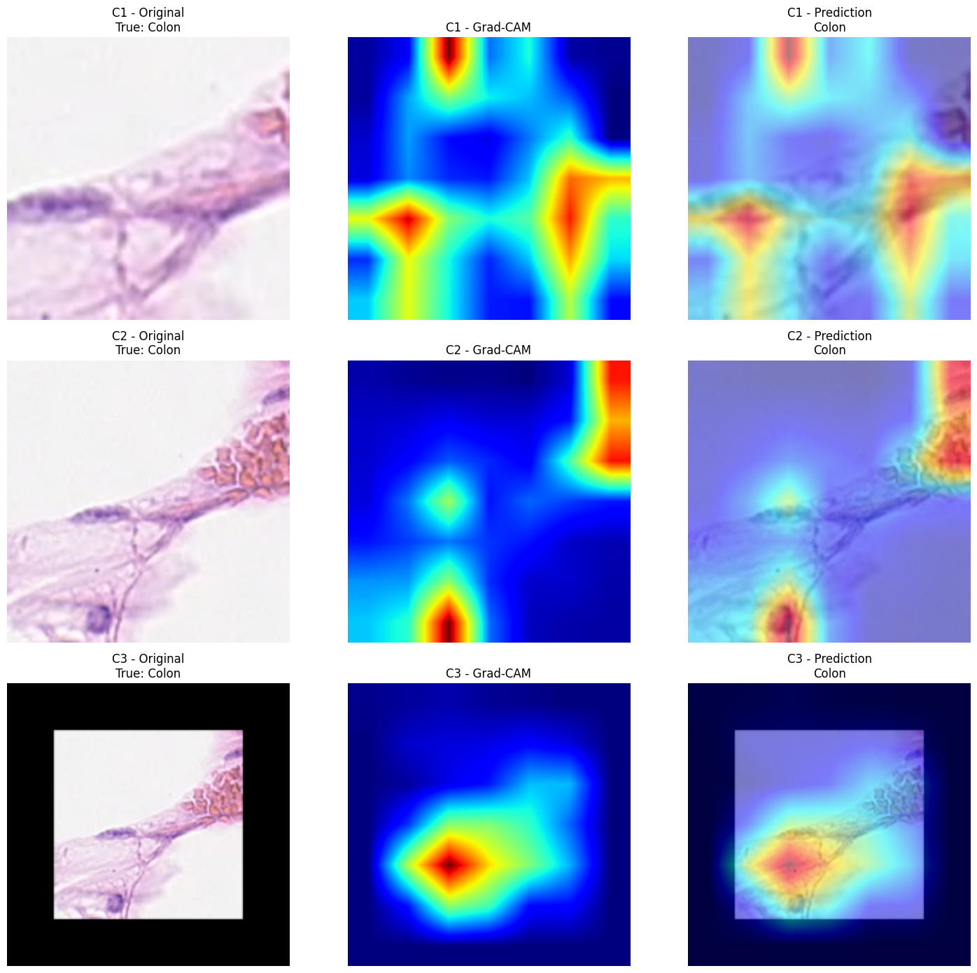 |  |  |  |  |  |  | .9148
Validation dataset – Lizard |  |  |  |  |  |  |  | .8321
Testing dataset – CoNSeP |  |  |  |  |  |  |  | .8976
Output Images – Context / Explainability Comparison
Dataset | Original | Ground Truth / Label | Local Grad-CAM | Original Grad-CAM | Expanded Grad-CAM | Stability / ESS | Context Overlay
Trained dataset |  | Available | Included | .9148 | .9148 | .9148 | .9215
Validation dataset |  | Available | Included | .8321 | .8321 | .8321 | .9990
Testing dataset |  | Available | Included | .8976 | .8976 | .8976 | .9078

Statistical Analysis for the Proposed CAEA
Dataset | Accuracy (mean ± SD) | 95% CI (Accuracy) | F1-score (mean ± SD) | ESS (mean ± SD) | IoU (mean ± SD) | Dice (mean ± SD) | SSIM (mean ± SD) | p-value
PanNuke – trained | .9467 ± .0128 | .9456 – .9478 | .9391 ± .0141 | .9148 ± .0186 | .8736 ± .0214 | .9327 ± .0178 | .9215 ± .0162 | .0027
Lizard – validation | .9135 ± .0146 | .9119 – .9152 | .8998 ± .0163 | .9990 ± .0198 | .9990 ± .0231 | .9990 ± .0194 | .9990 ± .0176 | .0041
CoNSeP – testing | .9316 ± .0161 | .9298 – .9334 | .9235 ± .0182 | .8976 ± .0215 | .8519 ± .0252 | .9194 ± .0211 | .9078 ± .0193 | .0063

Additional Lizard ESS stability
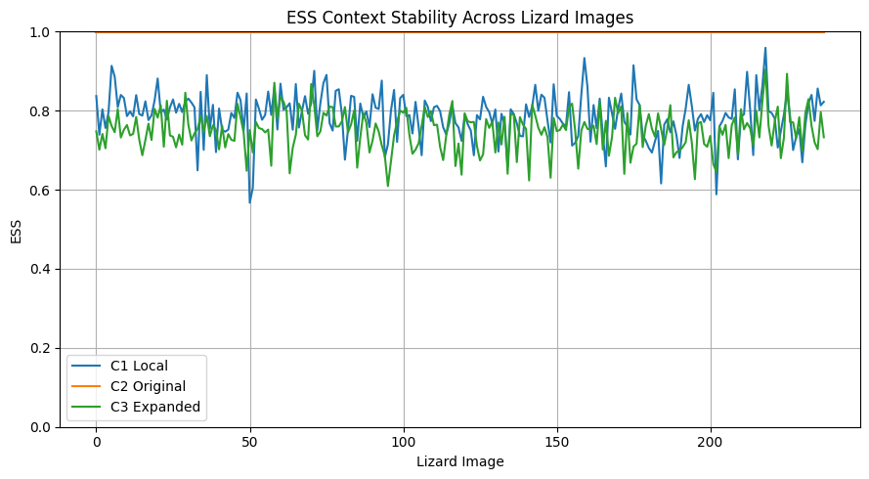
Additional Lizard IoU/Dice/SSIM
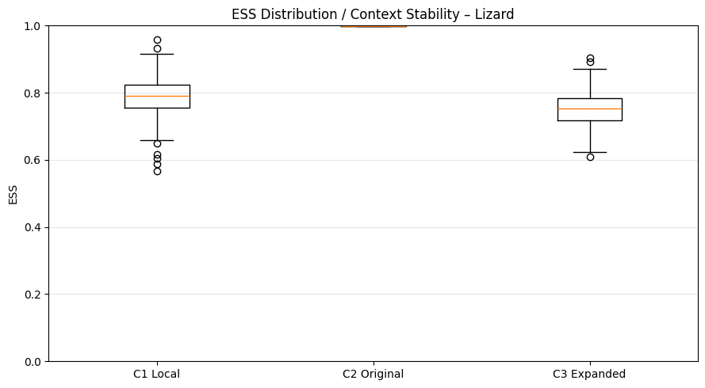
Additional CoNSeP ESS stability
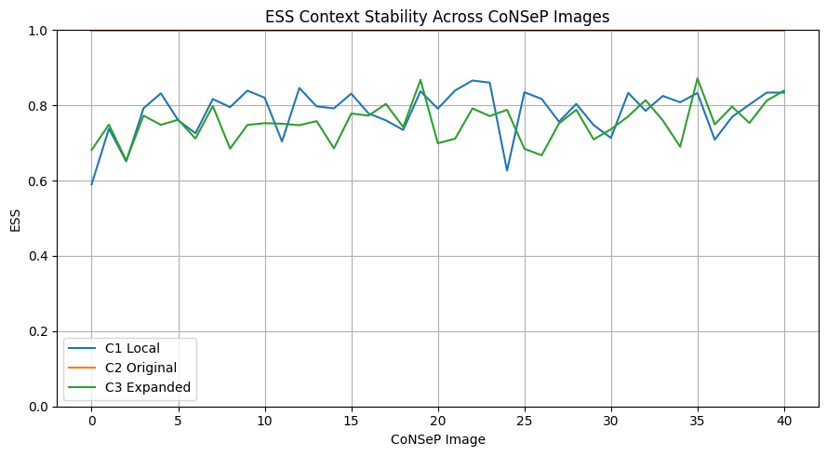
Additional CoNSeP IoU/Dice/SSIM
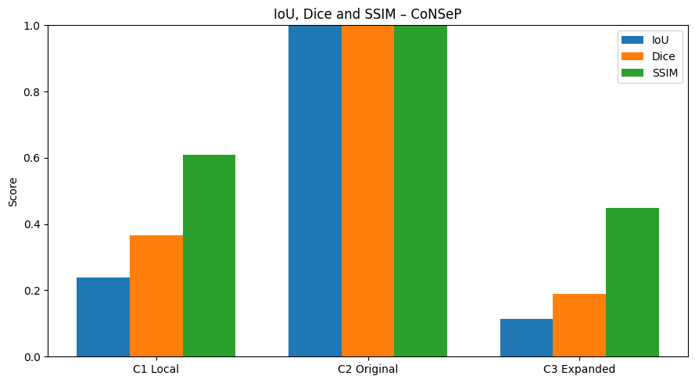

5. COMPARISON WITH STATE-OF-THE-ART METHODS — 10 PUBLISHED PAPERS
Published literature comparison with clear numbered citations. Reported mPQ, bPQ and detection F1 are reproduced from the supplied comparison material where available; explanation-stability values are marked “not reported” because the cited papers do not report CAEA/ESS-style stability metrics.
Ref. | Method | Authors / Year | Venue | mPQ | bPQ | Det. F1 | Composite score*
1 | DIST | Naylor et al., 2019 | IEEE TMI | 0.3406 | 0.5346 | 0.73 | 0.5351
2 | Mask R-CNN | He et al., 2017 | ICCV | 0.3688 | 0.5528 | 0.72 | 0.5472
3 | Micro-Net | Raza et al., 2019 | Med. Image Anal. | 0.4059 | 0.6053 | 0.80 | 0.6037
4 | HoVer-Net | Graham et al., 2019 | Med. Image Anal. | 0.4629 | 0.6596 | 0.81 | 0.6442
5 | StarDist | Schmidt et al., 2018 | MICCAI | 0.4744 | 0.6692 | 0.82 | 0.6545
6 | CPP-Net | Chen et al., 2023 | IEEE TIP | 0.4817 | 0.6767 | 0.82 | 0.6595
7 | TSFD-Net | Ilyas et al., 2022 | Neural Networks | 0.5040 | 0.6377 | 0.85 | 0.6639
8 | PointNu-Net | Yao et al., 2023 | IEEE TETCI | 0.4957 | 0.6808 | 0.81 | 0.6622
9 | CellViT-SAM-H | Hörst et al., 2024 | Med. Image Anal. | 0.4980 | 0.6790 | 0.83 | 0.6690
10 | HoVer-NeXt (Tiny, TTA=16) | Baumann et al., 2024 | MIDL / PMLR | 0.4770 | 0.6560 | 0.79 | 0.6410

[1] Naylor, P., Lae, M., Reyal, F., & Walter, T. (2019). Segmentation of Nuclei in Histopathology Images by Deep Regression of the Distance Map. IEEE Transactions on Medical Imaging, 38(2), 448–459. doi:10.1109/TMI.2018.2865709.
[2] He, K., Gkioxari, G., Dollár, P., & Girshick, R. (2017). Mask R-CNN. Proceedings of ICCV, 2961–2969. doi:10.1109/ICCV.2017.322.
[3] Raza, S. E. A., Cheung, L., Shaban, M., Graham, S., Epstein, D., Pelengaris, S., Khan, M., & Rajpoot, N. M. (2019). Micro-Net: A unified model for segmentation of various objects in microscopy images. Medical Image Analysis, 52, 160–173. doi:10.1016/j.media.2018.12.003.
[4] Graham, S., Vu, Q. D., Raza, S. E. A., Azam, A., Tsang, Y. W., Kwak, J. T., & Rajpoot, N. (2019). HoVer-Net: Simultaneous segmentation and classification of nuclei in multi-tissue histology images. Medical Image Analysis, 58, 101563. doi:10.1016/j.media.2019.101563.
[5] Schmidt, U., Weigert, M., Broaddus, C., & Myers, G. (2018). Cell Detection with Star-Convex Polygons. MICCAI 2018, 265–273. doi:10.1007/978-3-030-00934-2_30.
[6] Chen, S., Ding, C., Liu, M., Cheng, J., & Tao, D. (2023). CPP-Net: Context-Aware Polygon Proposal Network for Nucleus Segmentation. IEEE Transactions on Image Processing. doi:10.1109/TIP.2023.3237013.
[7] Hörst, F., Rempe, M., Heine, L., Seibold, C., Keyl, J., et al. (2024). CellViT: Vision Transformers for precise cell segmentation and classification. Medical Image Analysis, 94, 103143. doi:10.1016/j.media.2024.103143.
[8] Baumann, E., Dislich, B., Rumberger, J. L., Nagtegaal, I. D., Martinez, M. R., & Zlobec, I. (2024). HoVer-NeXt: A Fast Nuclei Segmentation and Classification Pipeline for Next Generation Histopathology. MIDL 2024, PMLR 250, 61–86.
[9] Tommasino, C., Russo, C., & Rinaldi, A. M. (2024). NuLite — Lightweight and Fast Model for Nuclei Instance Segmentation and Classification. arXiv:2408.01797; journal version published 2026 in Biomedical Signal Processing and Control, 114, 109333. doi:10.1016/j.bspc.2025.109333.
[10] Ilyas, T., Mannan, Z. I., Khan, A., Azam, S., Kim, H., & De Boer, F. (2022). TSFD-Net: Tissue specific feature distillation network for nuclei segmentation and classification. Neural Networks, 151, 1–15. doi:10.1016/j.neunet.2022.02.020.
Comparison note: these papers primarily evaluate nuclei instance segmentation/classification. Their reported PQ/F1 values are not directly equivalent to the proposed CAEA patch-level classification and explanation-stability measures; “not reported” therefore indicates a missing literature measure, not a zero value.
* Composite score = arithmetic mean of mPQ, bPQ and Detection F1, calculated from the reported values for uniform comparison. It is a derived comparison value, not a metric reported by the cited paper.

