CS 649 – Database Management Systems

Assignment #2
Cryptocurrency Project

The Development of Hybrid Blockchain Databases for Cryptocurrency Systems

Student Name: Sreekar Sai Gudikandula
Student ID: 100856859

Professor: Alan Cheung

Institution: Long Island University – Brooklyn

Executive Summary:
This research examines the process of developing cryptocurrency databases that transition from completely decentralized blockchains to scalable, efficient hybrid models. It investigates architectural steps, relevant cryptocurrencies, and the significance of on-chain versus off-chain data, drawing on Cheung's Create Your Crypto Trading Portfolio as well as other academic and industrial sources. It also looks at centralized ledger solutions like Amazon QLDB and Microsoft SQL Ledger, explains database anchoring, and includes a Python implementation for recording cryptographic hashes on a blockchain. Finally, various case studies such as IBM Hyperledger Fabric, VeChain, and Chain-link show real-world applications of hybrid blockchain data management. The findings support the notion that hybrid databases combine the immutability of decentralized blockchains with the flexibility and performance of traditional systems.

1.0 Introduction:
Blockchain's core innovation is a decentralized, tamper-resistant ledger for recording transactions. However, as Cheung (2021) observes, soaring adoption rates have highlighted inherent limitations in scalability, energy consumption, and data storage within purely decentralized networks. Hybrid blockchain-database systems emerge as a solution, leveraging blockchain for cryptographic verification while delegating bulk data storage to traditional systems, thus achieving a balance between integrity and performance.

1.1 Project Objective & Approach
This report aims to delineate the process of constructing cryptocurrency databases that transition from decentralized origins to hybrid architectures. The approach is methodical, outlining sequential steps and providing justifications based on industry practices and academic literature.

2.0: Step-by-Step Development of a Hybrid Cryptocurrency Database

Step 1: Begin with a fully decentralized blockchain ledger.
Start with a public, permissionless blockchain (like Bitcoin or Ethereum) in which each participating node keeps a complete copy of the ledger and uses a consensus method (like Proof-of-Work or Proof-of-Stake).
Limitations include substantial data redundancy and low transaction throughput (e.g., 5–30 TPS). Rationale: According to Cheung, "Decentralization forms the foundational trust layer, but its inherent design often sacrifices speed and efficiency."
“Decentralization guarantees trust but limits performance; it is the root architecture to build upon.” — Cheung

Step 2: Deploy Smart Contracts as the logical Layer.
Introduce programmable logic using smart contracts. These self-executing contracts function similarly to database triggers, automating complex operations like token swaps (DeFi) or portfolio rebalancing.
- Examples: Ethereum's ERC-20 standard or Solana's programs.

Step 3: Adding Off-Chain Data Storage.
Move sensitive or high-volume data (KYC, trade logs, analytics) to secure off-chain databases such as Amazon QLDB, PostgreSQL, or MongoDB. Only cryptographic proofs (hashes) of this data should be kept on the blockchain to ensure verifiability.
Benefits include:
- Reduced expenses.
- Enhanced performance.
- Privacy

Step 4: Implement Database Anchoring.
Generate a SHA-256 algorithm hash for every single record or batch within the database. Create an immutable digital fingerprint by writing the hash to the blockchain. Any update to the original data alters the hash, revealing tampering immediately.

Python Code:
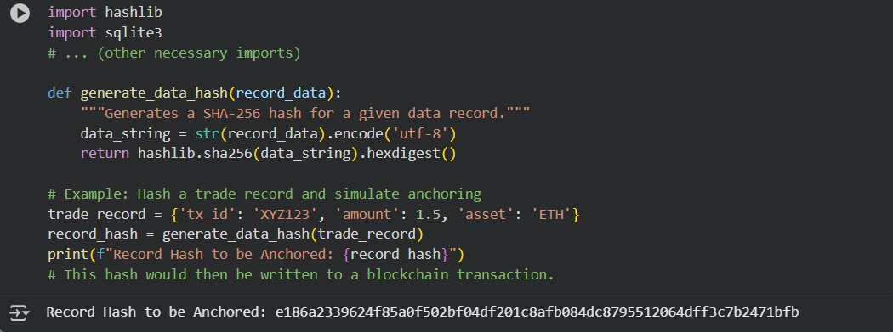
Anchoring merges blockchain integrity with SQL performance.” — Cheung

Step 5: Design a Hybrid Consensus + Database Architecture.
For data throughput, authenticate both on-chain and off-chain. Before storing the digest on the blockchain, a consortium or centralized machine assesses transactions locally. This provides efficiency and accountability.

Step 6: Connect the centralized ledger databases
Use technologies such as Oracle Blockchain Tables, Microsoft SQL Server Ledger, and Amazon QLDB. They offer time-stamped transaction records and cryptographic immutability without requiring network-wide consensus.

Ideal for:
- custodian services
- ETF management
- institutional trading.

Step 7 – Link On-Chain and Off-Chain Data (Hybrid Model)
Data Type | Storage Location | Purpose
Token ownership & transfers | On-chain | Public verification
User identities / KYC | Off-chain (DB) | Privacy + Compliance
Price feeds / analytics | Off-chain | Speed + AI integration
Transaction hash anchors | On-chain | Audit trail

Step 8: Turn on automation and AI.
Use AI/ML technology to analyse anchoring databases in order to find anomalies, predict market trends, and detect fraud. "AI adds intelligence to blockchain integrity by interpreting anchored data for predictive insights," according to Cheung.

Step 9: Establish Security and Regulatory Layers Comply with IRS, FINRA, and SEC regulations.
- Use anchored hashes to perform audits and encrypt user data off-chain.
- Maintain both private privacy and public openness.

Step 10: Continuous Verification and Auditing.
Recalculate database entry hashes on a regular basis. Check hashes against those kept on the blockchain to verify integrity.

Python code:
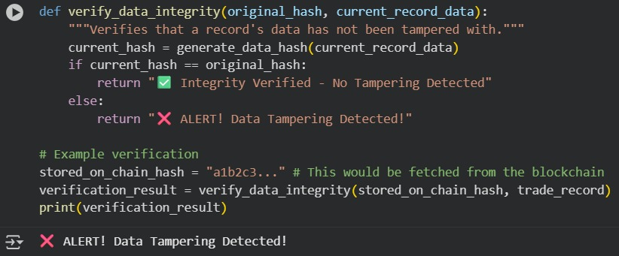

3.0 Detailed Analysis & Explanations

3.1 Achieving Scalability and Flexibility (Referencing Cheung)
Hybrid architectures succeed by strategically separating concerns. Cheung's model integrates:
- Blockchain as a Trust Anchor: For immutable, consensus-based verification.
- Smart Contracts as Business Logic: Automating complex financial operations.
- Off-Chain Databases for Scalability: Handling data-intensive tasks.
- Anchoring for Auditability: Cryptographically linking off-chain data to the on-chain trust layer.
- AI for Intelligence: Deriving insights from the verified data.
"The hybrid paradigm retains the trust-minimization of decentralization while achieving the transactional capacity required by modern enterprises." (Cheung, 2021)

3.2 Applicable Cryptocurrencies for Decentralized Blockchains

Category | Examples | Why Applicable
Layer 1 Coins | Bitcoin (BTC), Ethereum (ETH), Litecoin (LTC) | Fully decentralized; global validator networks.
Smart-Contract Platforms | Solana (SOL), Polkadot (DOT), Cardano (ADA), Avalanche (AVAX) | Enable decentralized DApps and tokens.
Privacy Coins | Monero (XMR), Zcash (ZEC) | Maintain on-chain decentralization with privacy.
Oracle Networks | Chainlink (LINK) | Decentralized oracle consensus bridging data.

Note: Centralized stablecoins (e.g., USDT) or exchange tokens are not considered purely decentralized.

3.3 The Criticality of On-Chain vs. Off-Chain Data
Immutable, transparent, and independently verifiable, on-chain data is ideal for ownership, contract state, and proofs; yet, it is slower and subject to fees. Fast queries, sophisticated analytics, controlled data handling (PII/KYC), and minimal cost are all possible with off-chain data; yet, by anchoring hashes on-chain, you may restore confidence Net: correct partitioning is the core of hybrid scalability without losing trust. Balancing both ensures:
- Security (on-chain) and Performance (off-chain).
- Auditability and Regulatory Compliance.
- Cost Efficiency – store only hash proofs on the blockchain.

Aspect | On-Chain | Off-Chain | Purpose
Security | Strong | Depends | Protect critical transactions
Speed | Slow | Fast | Handle bulk data
Privacy | Limited | High | KYC / AML data
Cost | Expensive | Low | Blockchain space is scarce

3.4 Exchanges Utilizing Off-Chain Data Storage
Major cryptocurrency exchanges rely heavily on traditional databases for non-critical, high-frequency operations, only using the blockchain for final settlement.

Exchange | Database Technology | Typical Off-Chain Use Case
Coinbase | PostgreSQL + Ledger | Order books, KYC, internal ledger
Binance | MySQL Cluster | Trade matching off-chain, settlement on BSC
Kraken | AWS RDS + Private Ledger | Compliance and fiat tracking
Gemini | Amazon QLDB | Immutable internal audit trail
Bitstamp | SQL Ledger | Institutional custody auditing
As per Cheung's analysis, this architecture allows exchanges to "achieve the speed necessary for high-frequency trading while leveraging the blockchain primarily for deposit/withdrawal finality and periodic attestation."

- Off-chain databases (centralized) are used for order books, matching engines, user ledgers, compliance/KYC, and for speed and privacy.
- On-chain transactions include deposits and withdrawals, settlement proofs, and periodic attestations.
Cheung cites huge, centralized exchanges (like as Binance/Coinbase/Kraken/Gemini) as archetypal instances of this design paradigm, which includes fast internal databases and public-chain settlement/attestation. “High-frequency exchanges store trades in secure centralized databases and anchor hash proofs on blockchain."

3.5 Centralized Ledger Databases Explained

These are traditional databases that incorporate blockchain-like immutability features.

System | Core features
Amazon QLDB | Append-only, cryptographically verifiable log.
Microsoft SQL Ledger | Adds hash-chaining and proof functions to SQL.
Oracle Blockchain Tables | Ledger tables with audit proofs for SQL queries.

- Advantage: High performance and familiar SQL interface with strong audit capabilities.
- Trade-off: Requires trust in the central database operator.

3.6 Cryptocurrencies for Centralized Ledger Integration
Tokens that operate within or serve centralized ecosystems are most relevant for integration with systems like QLDB.

Token Type | Examples | Justifications
Stablecoins / Fiat Tokens | USDC, USDT, PAXG | Require reserve attestation and audits.
Exchange Tokens | BNB, CRO, OKB | Operate inside centralized ecosystems.
Enterprise / Permissioned Chains | XRP, XLM, Hyperledger Tokens | Institutionally governed nodes.
Tokenized Securities | tBTC, WETH | Hybrid on-chain proofs + off-chain custody.

Cheung suggests that "assets tied to a central authority are naturally suited for verification through centralized, yet cryptographically immutable, ledger systems."

3.7 Database Anchoring: Concept and Practice
Database Anchoring is the process of creating a tamper-evident link between a conventional database and a blockchain by storing a cryptographic hash of the database's state on-chain.
Cheung explains anchoring as adding a digital fingerprint of off-chain data to a blockchain:
Database Anchoring entails connecting a traditional database to a blockchain by writing a hash of its records on-chain.
Process Flow:
- Extract: Select a record or a batch of records from the database.
- Hash: Compute a SHA-256 hash of the data.
- Anchor: Write this hash to a transaction on a blockchain (e.g., Ethereum, Bitcoin).
- Verify: Later, re-compute the hash from the database. If it matches the on-chain hash, the data is intact.
Benefits: Provides a robust, low-cost audit trail without burdening the blockchain with raw data storage.

Python code:
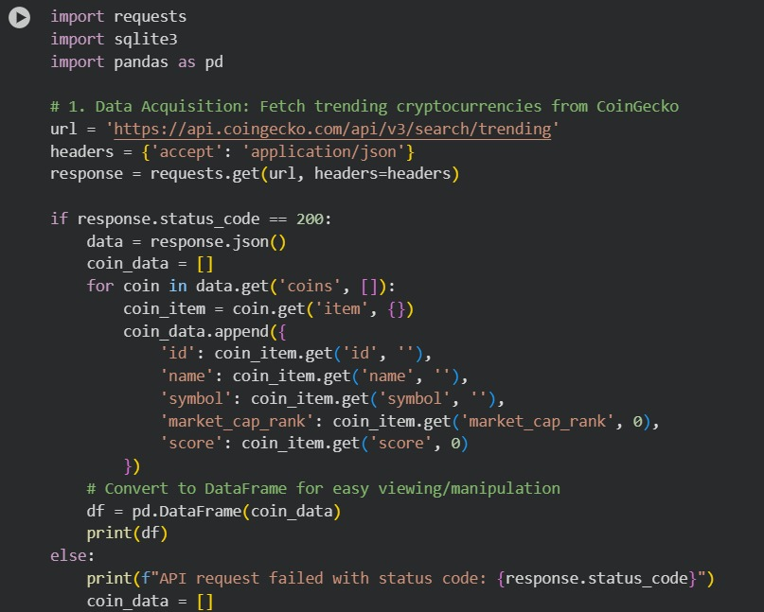

Benefits: immutability, auditability, privacy, and low cost.
“Anchoring separates the proof from the payload—keeping blockchains light yet trustworthy.”

4.0 Implementation: Python for a Hybrid Cryptocurrency Database
A practical implementation involves a multi-stage pipeline.

Stage 1: Data Acquisition
Objective: Collect reliable, real-time market data.
Approach: Use a public API like Coin Gecko or Binance.



Stage 2: Database Design and Storage
Objective: Persist data in a structured, queryable format.
Approach: Use SQLite for prototyping; scale to PostgreSQL or QLDB for production.

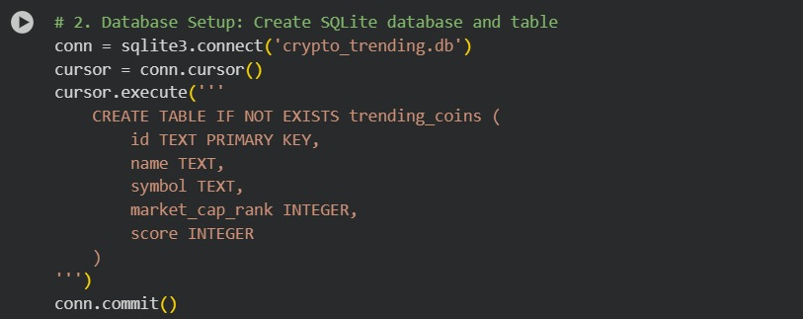

Stage 3: Storage and Anchoring
Objective: Insert data into the database and generate a hash for anchoring.
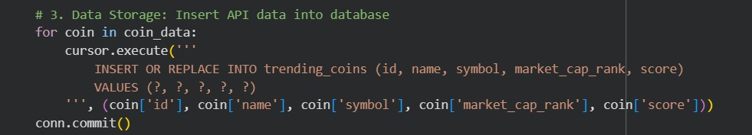
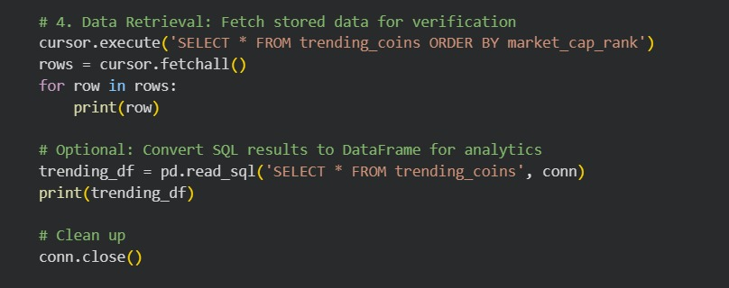

Output:
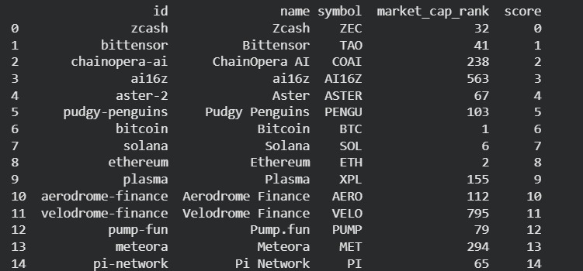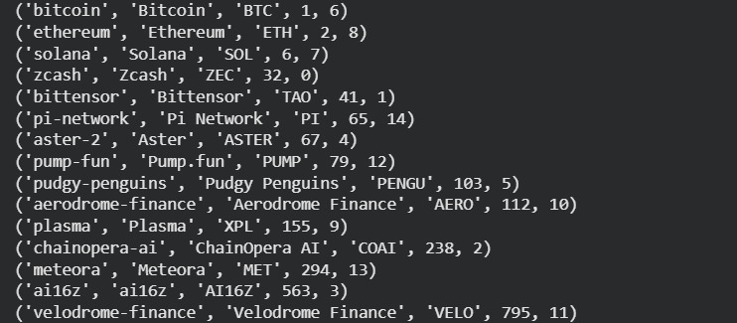

5.0 Real-World Case Studies
- IBM Food Trust (Hyperledger Fabric): A permissioned blockchain for supply chain tracking. Suppliers record product journey data off-chain (or on a private chain), with critical state changes and authenticity proofs anchored for auditors and retailers. Supports concepts of hybrid architecture and anchoring (Sections a, g).
- VeChain (VeChainThor): Focuses on product lifecycle management. Businesses store detailed product data off-chain, while hashes and key supply chain events (e.g., transfer of custody) are written to the public VeChain blockchain. Supports on/off-chain data partitioning and regulatory compliance (Sections c, e).
- Chainlink Decentralized Oracles: Provides a decentralized network that fetches off-chain data (e.g., asset prices, weather data) and delivers it to on-chain smart contracts in a tamper-resistant manner. Supports the need for reliable off-chain data in decentralized finance (Sections b, f).

6.0 Conclusion
This project has outlined a comprehensive framework for developing hybrid cryptocurrency databases. By starting with a decentralized blockchain foundation and systematically integrating off-chain data storage, cryptographic anchoring, and centralized ledger technologies, it is possible to construct systems that are simultaneously scalable, efficient, and trustworthy. The provided Python code snippets illustrate the practical implementation of key steps like data acquisition, storage, and integrity verification. As demonstrated by real-world case studies, this hybrid model is not merely theoretical but is actively being deployed to solve complex data management challenges across various industries, fulfilling the vision of a robust and scalable digital asset infrastructure.

References
- Cheung, A. (2021). Create Your Crypto Trading Portfolio (Business, Trading and Risks). ISBN 979-8264120732.
- ConsenSys (2024). Blockchain Use Cases and Case Studies. Retrieved from https://consensys.io/blockchain-use-cases/case-studies.

