DESIGN AND SIMULATION OF
NULL-PRESERVING MVDR BEAMFORMING
USING A PHYSICS-INFORMED NEURAL NETWORK
A Course Based Project Report
B.E. V Semester submitted
By
Pranay Ganji 1602-24-735-096
Mukkala Praneeth 1602-24-735-097
Sreekar Balagoni 1602-24-735-117

Subject Name: Antennas and Wave Propagation
Department of Electronics and Communication Engineering Vasavi College of Engineering (Autonomous)
ACCREDITED BY NAAC WITH “A++” GRADE
IBRAHIMBAGH, HYDERABAD-500031
2026–2027
1

ABSTRACT
Adaptive beamforming enhances a desired signal while rejecting interference arriving from another direction. The minimum variance distortionless response (MVDR) beamformer provides a mathematically optimal solution for a known covariance matrix, but its deep nulls are highly sensitive to errors in complex element weights. This project studies whether a physics-informed neural network can reproduce such weights on an eight-element uniform linear array at 2.4 GHz.
A dataset of 14,042 desired and interference angle pairs is generated using an analytical MVDR solver. Six neural-network variants are compared using a common multilayer perceptron and different output representations and loss functions. The proposed null-aligned representation explicitly imposes unity gain in the desired direction and expresses the interference response through one complex coordinate. On 1,405 held-out examples the full model achieves a median null depth of −96.41 dB, compared with −96.17 dB for analytical MVDR and −26.81 dB for direct weight regression. Its median output SINR gap is approximately 0.0000054 dB.
Five exported Ansys HFSS full-wave patterns are compared with the ideal-array MVDR and neural predictions. Physical nulls are substantially shallower than ideal predictions, illustrating the effect of model mismatch and the limitations of uncalibrated ideal-array weights. The work demonstrates the importance of embedding physical structure in the output representation while distinguishing numerical accuracy from electromagnetic performance.
2

TABLE OF CONTENTS
1. INTRODUCTION
1.1 Background
1.2 Aim of the Project
2. LITERATURE SURVEY
3. THEORETICAL ANALYSIS
4. TOOLS USED
5. SYSTEM DESIGN
6. RESULTS AND DISCUSSION
7. CONCLUSION
8. FUTURE WORK
9. REFERENCES
3

1. INTRODUCTION
1.1 Background
Antenna arrays exploit spatial differences between incoming waves to enhance a signal of interest and suppress interferers. The complex weights applied to individual elements control the array pattern. As described in wireless channel and antenna literature [3], [6], beamforming can improve the quality of a link without increasing transmitter power, although practical arrays depart from ideal isolated-element models.
Capon’s MVDR method [1] minimizes output power under a distortionless constraint in the desired direction. In the high interference-to-noise regime, the required cancellation can be extremely deep: small weight errors may preserve the main-beam direction while destroying the null. A neural approximation trained only on component-wise error may therefore appear accurate while providing poor interference rejection.
1.2 Aim of the Project
The aim is to design and assess a physics-informed network that predicts MVDR weights while preserving a deep interference null. The objectives are to derive the array and MVDR equations, generate a reproducible dataset, compare six output/loss variants, measure null and SINR performance, and assess the ideal predictions against five full-wave HFSS cases. This is a simulation study, not a measurement on a fabricated antenna.
2. LITERATURE SURVEY
Capon [1] introduced minimum-variance spectral estimation, the basis for MVDR beamforming. Van Trees [2] develops optimum array processing, covariance modeling and spatial filtering. Molisch [3] explains wireless propagation and antenna-array concepts relevant to directional interference. Together, these works provide the signal model and performance context.
The matrix identities used to avoid repeated large inversions are part of standard numerical linear algebra [4]. Complex-valued networks have been studied by Trabelsi et al. [5]; the present implementation instead uses real-valued layers with real and imaginary outputs followed by complex analytical operations. Balanis [6] provides the physical antenna background. Physics-informed neural networks embed governing constraints in model construction or training [7]; here the distortionless condition is embedded in the output chart, and an MVDR cost contributes to the loss. HFSS [8] supplies a full-wave comparison beyond the ideal steering-vector model.
4

3. THEORETICAL ANALYSIS
3.1 Array and signal model
The uniform linear array has eight elements along the x-axis. Angles are measured from broadside and the half-wavelength spacing gives kd = π. Let aₛ and aᵢ denote the steering vectors for desired and interfering signals. The Hermitian transpose is denoted by H, and j is the imaginary unit [2], [6].
𝑎ₙ(𝜃) = 𝑒𝑥𝑝(𝑗 𝑛 𝜋 𝑠𝑖𝑛 𝜃), 𝑛 = 0, 1, … , 𝑁 − 1. (1)
𝑅 = 𝜎ₛ 𝑎ₛ 𝑎ₛᴴ + 𝜎ᵢ 𝑎ᵢ 𝑎ᵢᴴ + 𝜎ₙ 𝐼. (2)
Table 1: System parameters.
Parameter | Value
Elements N | 8
Frequency / wavelength | 2.4 GHz / 125 mm
Spacing d | 62.5 mm (λ/2)
Desired / interference / noise powers | 100 / 1000 / 1
SNR / INR | 20 dB / 30 dB
Angle grid | −60° to +60° in 1° steps; separation ≥ 3°
3.2 Minimum variance distortionless response
MVDR minimizes output power subject to unit response in the desired direction [1], [2]. Since σₙ is positive, R is positive definite for this setup. The inverse can be reduced to a two-dimensional solve by the Woodbury identity [4], which is used in dataset generation and checked against a direct inverse.
𝑚𝑖𝑛𝑖𝑚𝑖𝑧𝑒 𝑤ᴴ 𝑅 𝑤 𝑠𝑢𝑏𝑗𝑒𝑐𝑡 𝑡𝑜 𝑤ᴴ 𝑎ₛ = 1. (3)
𝑤𝑀𝑉𝐷𝑅 = 𝑅⁻¹𝑎ₛ / (𝑎ₛᴴ𝑅⁻¹𝑎ₛ), 𝐽𝑚𝑖𝑛 = 1 / (𝑎ₛᴴ𝑅⁻¹𝑎ₛ). (4)
The desired-signal term in R is constant under the constraint; therefore, minimizing total output power also minimizes the interference-plus-noise contribution. Null depth is normalized to the response at the desired angle; a more negative value indicates better rejection. Output SINR includes both residual interference and receiver noise.
𝑁𝑢𝑙𝑙 (𝑑𝐵) = 10 𝑙𝑜𝑔₁₀ ( |𝑤ᴴ𝑎ᵢ|² / |𝑤ᴴ𝑎ₛ|² ). (5)
𝑆𝐼𝑁𝑅 = 𝜎ₛ |𝑤ᴴ𝑎ₛ|² / (𝜎ᵢ |𝑤ᴴ𝑎ᵢ|² + 𝜎ₙ ||𝑤||²). (6)
3.3 Null-aligned representation
The exact-null vector u is constructed by removing the component of aₛ parallel to aᵢ and normalizing. With noncoincident steering vectors, it has unit desired response and zero interference response. The network predicts the small complex coefficient τ, and the analytical synthesis layer preserves the constraint for every prediction.
5

𝛾 = 𝑎ᵢᴴ𝑎ₛ / 𝑁, 𝑤₀ = 𝑎ₛ − 𝛾𝑎ᵢ, 𝑢 = 𝑤₀ / (𝑎ₛᴴ𝑤₀). (7)
𝜌 = 𝑎ₛᴴ𝑎ᵢ, 𝜏 = (0.05 𝛥)(𝑧₀ + 𝑗𝑧₁), 𝑔 = 1 − 𝜏𝜌, 𝑤 = 𝑔𝑢 + 𝜏𝑎ᵢ. (8)
𝛥 = 𝜎ₙ / (𝜎ₙ + 𝜎ᵢ𝑁) = 1/8001; 𝑎ₛᴴ𝑤 = 1; |𝑤ᴴ𝑎ᵢ| = 𝑁|𝜏|. (9)
This coordinate choice makes the small null response explicit instead of asking the network to achieve it by cancellation among sixteen independently predicted real components. The construction may become poorly conditioned when the two steering vectors are nearly parallel; the angle-separation rule does not eliminate all near-endfire difficulties.
4. TOOLS USED
Table 2: Software tools and their roles.
Tool | Application
Python, NumPy | Dataset generation, array equations and numerical verification
PyTorch | BeamNet training, loss computation and inference
Matplotlib | Analytical results and pattern overlays
Ansys Electronics Desktop / HFSS 2025 R2 | Full-wave driven-modal dipole-array model and far-field export [8]
Microsoft Word | Report preparation and presentation
The repository contains precomputed dataset, checkpoints, predictions, HFSS exports and plots. The scripts verify_physics.py, gen_dataset.py, train_ablation.py, make_plots.py, hfss_build_array.py and hfss_overlay.py describe the reproducible numerical workflow. HFSS itself is required to repeat the electromagnetic solve; the comparisons in this report use the supplied exports.
5. SYSTEM DESIGN
Figure 1 summarizes the flow from analytical labels to neural training and electromagnetic comparison. The reported data are drawn from the repository rather than newly measured hardware.
6

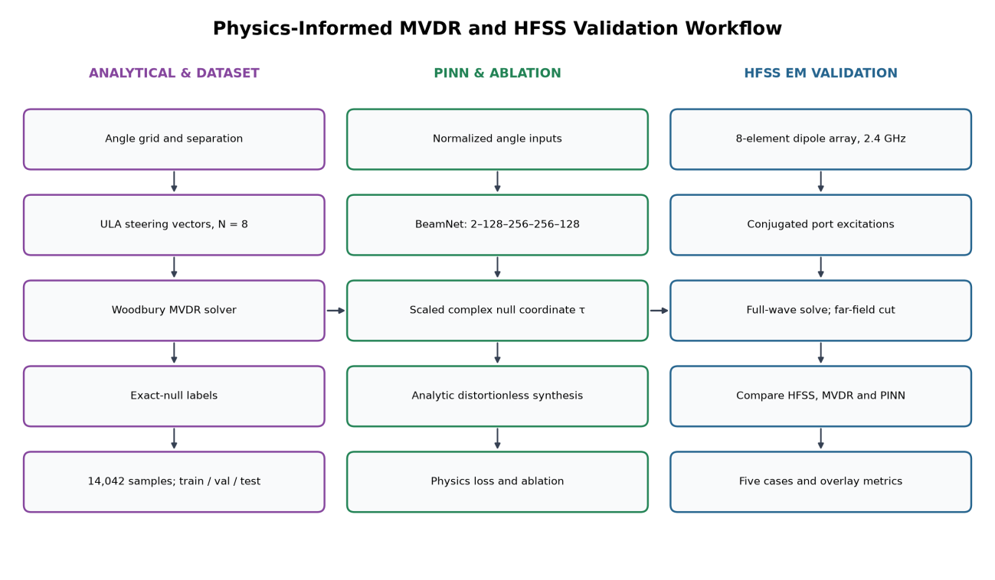
Figure 1: Analytical dataset, physics-informed learning and HFSS validation workflow.
5.1 Dataset and learning architecture
An integer grid from −60° to +60° produces 14,641 candidate pairs. Excluding 599 pairs with angular separation below 3° leaves 14,042 examples. A deterministic seed of 42 gives 11,233 training, 1,404 validation and 1,405 test examples. Each input is the two angles divided by 60°. All variants use a 2 → 128 → 256 → 256 → 128 → output multilayer perceptron with ReLU hidden layers, Adam learning rate 0.001, batch size 256 and 200 epochs; the best validation checkpoint is used.
The baseline directly regresses sixteen real weight components. The normalized raw variant additionally imposes unit response. Two subspace variants predict a complex coefficient in the span of the signal and interference steering vectors. Two null-aligned variants instead predict τ and use the synthesis in (8). The full variant combines logarithmic MVDR cost, a 0.01 weight-MSE anchor and a 0.02 null-depth hinge, activated at epoch 30 and annealed from −25 dB to −60 dB by epoch 80. This design is motivated by physics-informed learning [7], not by claiming that the electromagnetic solver is part of training.
5.2 HFSS configuration and comparison
The physical model consists of eight y-directed, center-fed PEC dipoles positioned on the x-axis, with 60 mm total arm length, 1 mm radius and 62.5 mm spacing. The 50 Ω lumped ports are Port1:1 through Port8:1. The 2.4 GHz far-field cut is sampled at φ = 0° and θ = −90° to +90° in 1° steps. The ideal receive weights are conjugated for transmit excitation; normalized incident source powers
7

are Pₙ = |wₙ* / ||w||∞|² W and phases are ∠wₙ* in degrees. HFSS source CSVs use Source, Magnitude and Phase fields [8].
Overlay curves compare normalized HFSS gain to ideal-array MVDR and network patterns. Null depth is evaluated at the specified interference angle relative to the desired angle. Whole-cut dB RMSE is sensitive to very deep sampled zeros and is not a direct measure of main-lobe agreement. Mutual coupling, source loading and finite-array effects are plausible causes of differences; the supplied comparisons do not independently isolate or quantify each cause.
6. RESULTS AND DISCUSSION
6.1 Numerical verification
For θₛ = 30° and θᵢ = −40°, verify_physics.py compares the direct inverse with equivalent Woodbury and Sherman–Morrison calculations and checks the distortionless constraint and signal–interferer subspace. The results in Table 3 are numerical verification values, not experimental measurements.
Table 3: Numerical verification for the representative geometry.
Check | Result
Relative direct vs. Woodbury weight difference | 2.074 × 10⁻¹³
Relative direct vs. Sherman–Morrison difference | 2.100 × 10⁻¹³
Desired response error |wᴴaₛ − 1| | 8.699 × 10⁻¹⁵
Subspace residual | 2.084 × 10⁻¹³
MVDR / exact-null depth | −95.99 / −318.61 dB
Output / input SINR | 28.962 / −10.004 dB
In this case the MVDR null changes from −37.02 dB at 0 dB INR to −115.99 dB at 40 dB INR, approximately 20 dB deeper per decade of interference power. Figure 2 shows why weight perturbation matters; Figure 6 shows this INR trend. Figure 7 relates an intentionally shallow null to output SINR loss.
6.2 Held-out ablation study
Table 4: Held-out ablation results.
Variant | Null median  dB | Null p90 dB | SINR gap  median dB | Gap p90 dB | Point median ° | Weight error median % | Train s
MVDR ground truth | -96.17 | -76.57 | 0.00000 | — | — | — | —
Exact-null analytic | -299.99 | -299.94 | 0.00001 | — | — | — | —
baseline | -26.81 | -21.66 | 11.99892 | 17.152 | 0.151 | 7.1720 | 327
raw16_norm | -21.45 | -13.86 | 17.55579 | 24.683 | 0.082 | 9.6719 | 412
subspace_mse | -26.63 | -22.24 | 12.63310 | 16.829 | 0.122 | 4.6637 | 422
subspace_cost | -44.72 | -33.51 | 0.87348 | 6.423 | 0.167 | 0.5817 | 434
nullaligned_mse | -92.95 | -92.07 | 0.00002 | 0.000 | 0.171 | 0.0021 | 341
nullaligned_full | -96.41 | -76.38 | 0.00001 | 0.000 | 0.171 | 0.0013 | 521
8

Table 4 reports held-out metrics from data/ablation_results.json. The JSON fields named “worst” represent the reported 90th-percentile statistic, not the maximum. Exact-null is an analytical comparator rather than a trained model; its numerical floor should not be interpreted as a physical null. Training times are from the recorded run and depend on hardware.
Direct regression reaches a median pointing error of 0.151° but a −26.81 dB median null and 11.999 dB median SINR gap. The physics-cost subspace model improves the median null to −44.72 dB. The null-aligned MSE model reaches −92.95 dB and the full model −96.41 dB; the latter has a median SINR gap of 5.43 × 10⁻⁶ dB. Figures 3–5 illustrate the ablation comparison, representative patterns and null-depth distribution. The comparison isolates the importance of the output chart and loss for this dataset, not a general guarantee for unseen propagation conditions.
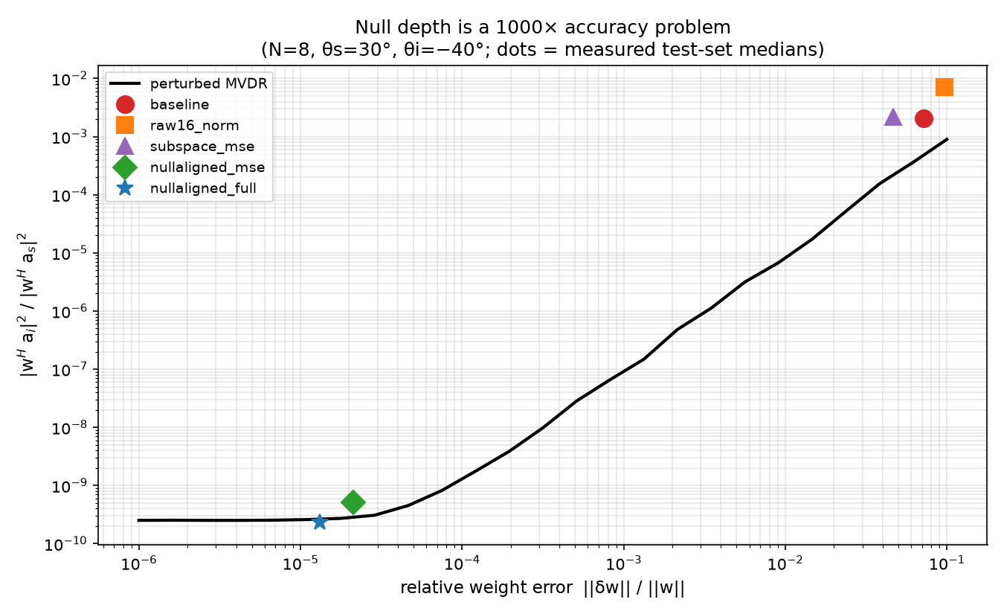
Figure 2: Sensitivity of MVDR performance to weight perturbations.
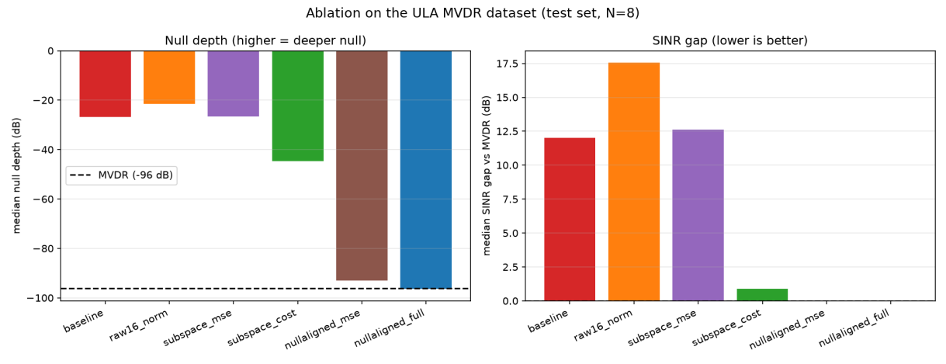
Figure 3: Comparison of ablation variants.
9

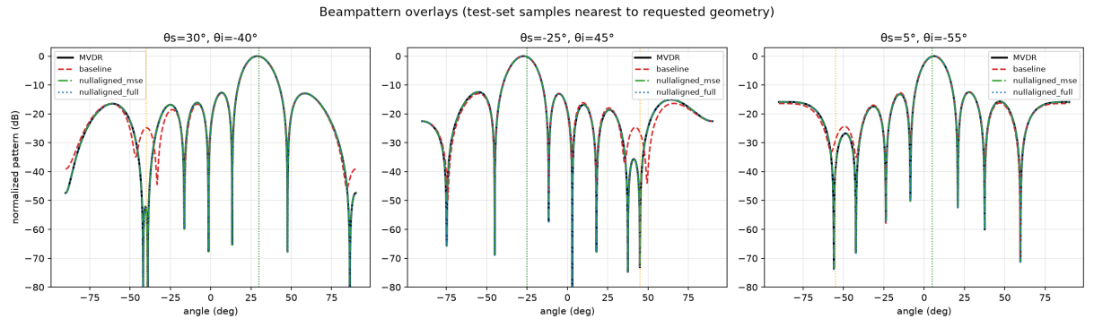
Figure 4: Representative analytical and predicted array patterns.
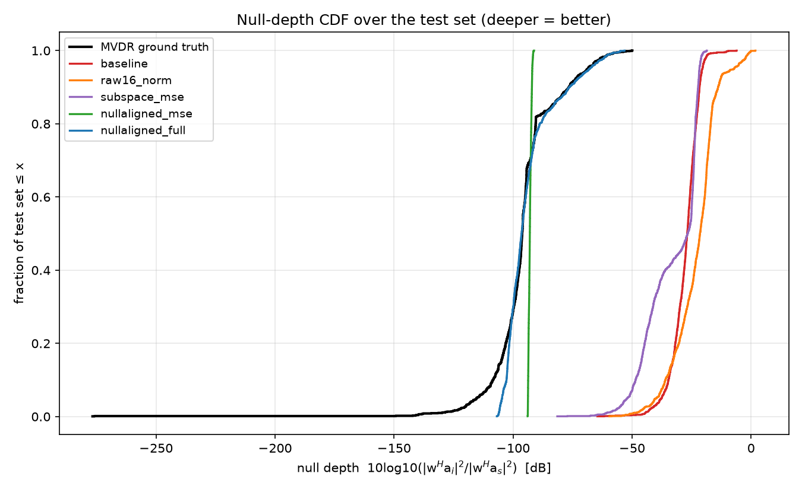
Figure 5: Distribution of test-set null depths.
10

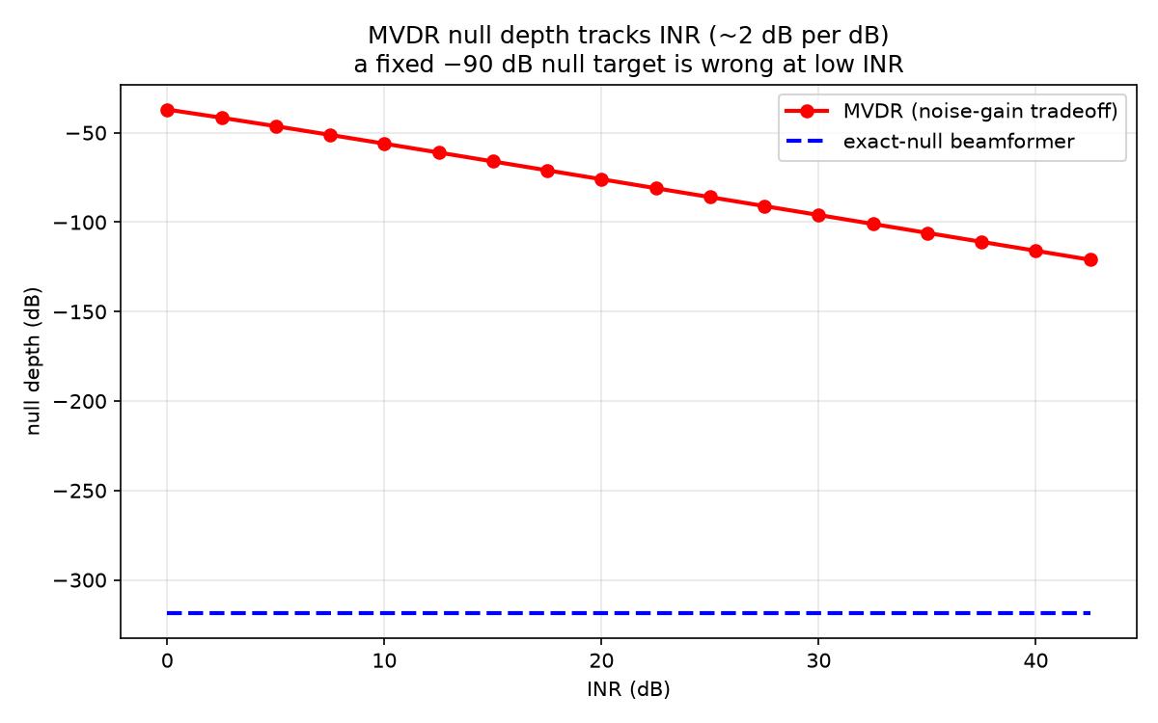
Figure 6: MVDR null depth versus interference-to-noise ratio.
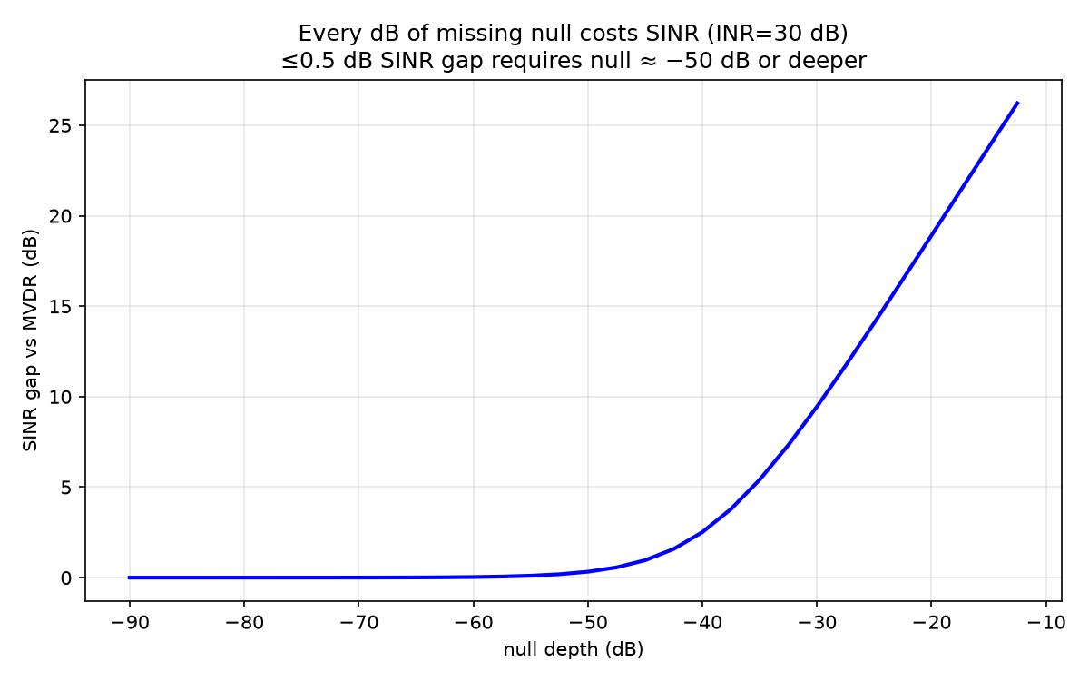
Figure 7: Output SINR penalty for shallow interference nulls.
6.3 Full-wave HFSS comparison
Table 5 summarizes the five exported cases, and Figures 8–12 show the corresponding overlays. All comparisons use 181 angular samples. Analytical and neural curves describe ideal steering-vector
11

arrays; HFSS represents the simulated dipole array driven by ideal weights, not a separately trained full-wave network.
Table 5: HFSS comparison at the interference angle and whole-cut RMSE.
Case | (θₛ, θᵢ) | HFSS null dB | MVDR null dB | NN null dB | MVDR RMSE dB | NN RMSE dB
1 | (0°, 30°) | -28.37 | -120.00 | -98.25 | 13.227 | 12.472
2 | (30°, -40°) | -33.72 | -95.99 | -99.07 | 7.167 | 7.318
3 | (-25°, 45°) | -32.79 | -95.82 | -98.67 | 6.721 | 6.866
4 | (5°, -55°) | -27.83 | -96.60 | -103.44 | 6.361 | 6.776
5 | (58°, 55°) | -5.50 | -50.85 | -55.00 | 5.046 | 5.264
Cases 01–04 have HFSS peaks at the desired sampled angles, with gains from 11.27 to 12.61 dBi. The physical nulls at the specified interferer directions are −27.83 to −33.72 dB, far shallower than the ideal predictions. For case 01 the ideal −120 dB value is a plotting floor, and sampled exact zeros strongly affect the 13.227 dB whole-cut RMSE. The physical notch can also shift in angle: in case 02 it reaches −36.80 dB near −38°, while in case 03 it reaches −40.42 dB near 43°.
Case 05 is a stress case: the desired direction 58° and interferer 55° are only 3° apart, near endfire. Aperture foreshortening and the proximity of the two directions make the separation difficult. HFSS gives a −5.50 dB relative null at 55° and its peak occurs at 82°, despite its comparatively small whole-curve RMSE. The five-case comparison therefore supports a physical-model-mismatch finding, not a claim that ideal −96 dB nulls have been achieved in hardware.
Case 01 compares desired direction 0° with interference at 30°; the corresponding pattern is shown in Figure 8.
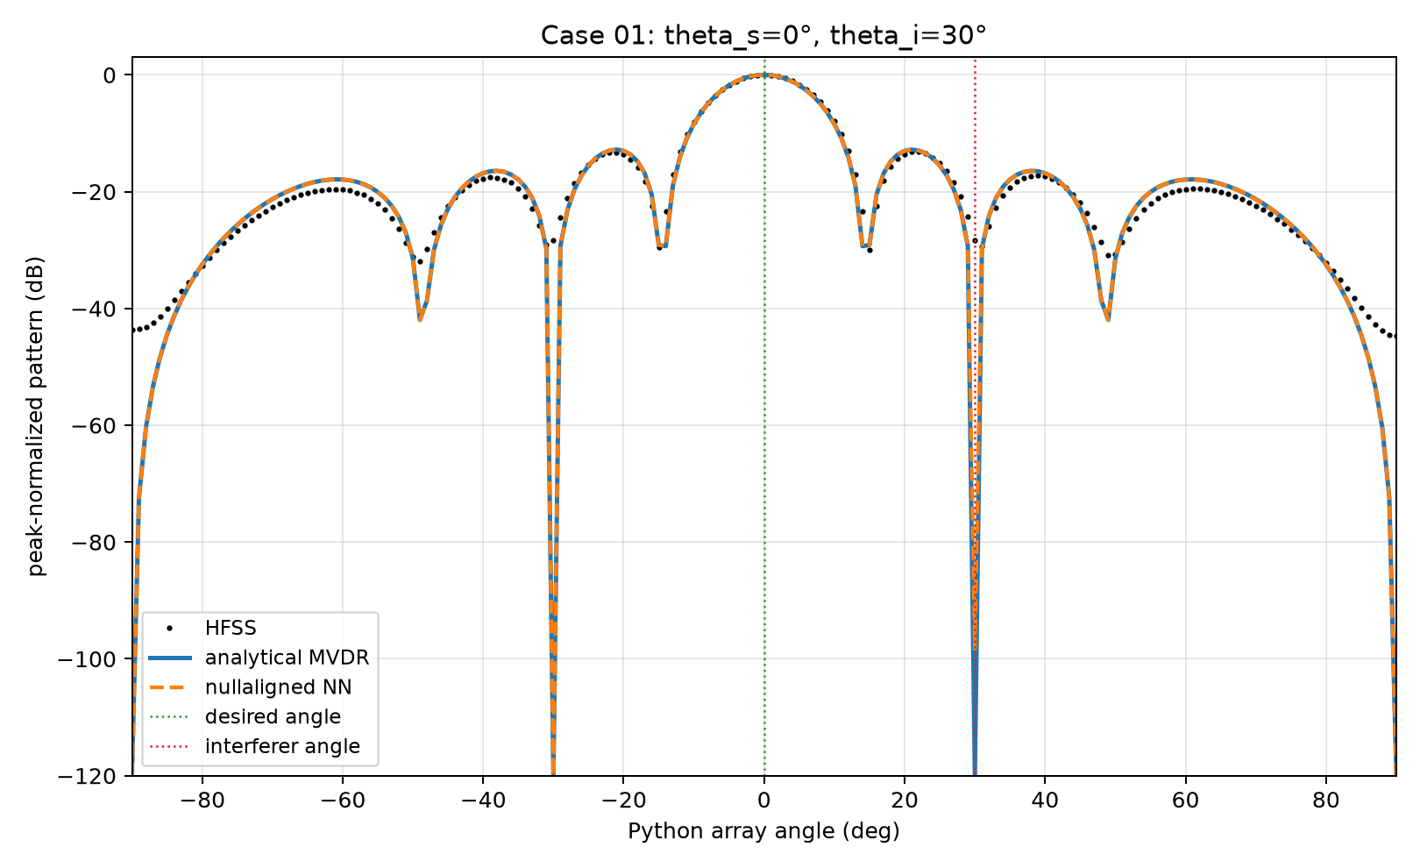
Figure 8: HFSS, MVDR and null-aligned network overlay for case 01.
12

Case 02 compares desired direction 30° with interference at -40°; the corresponding pattern is shown in Figure 9.
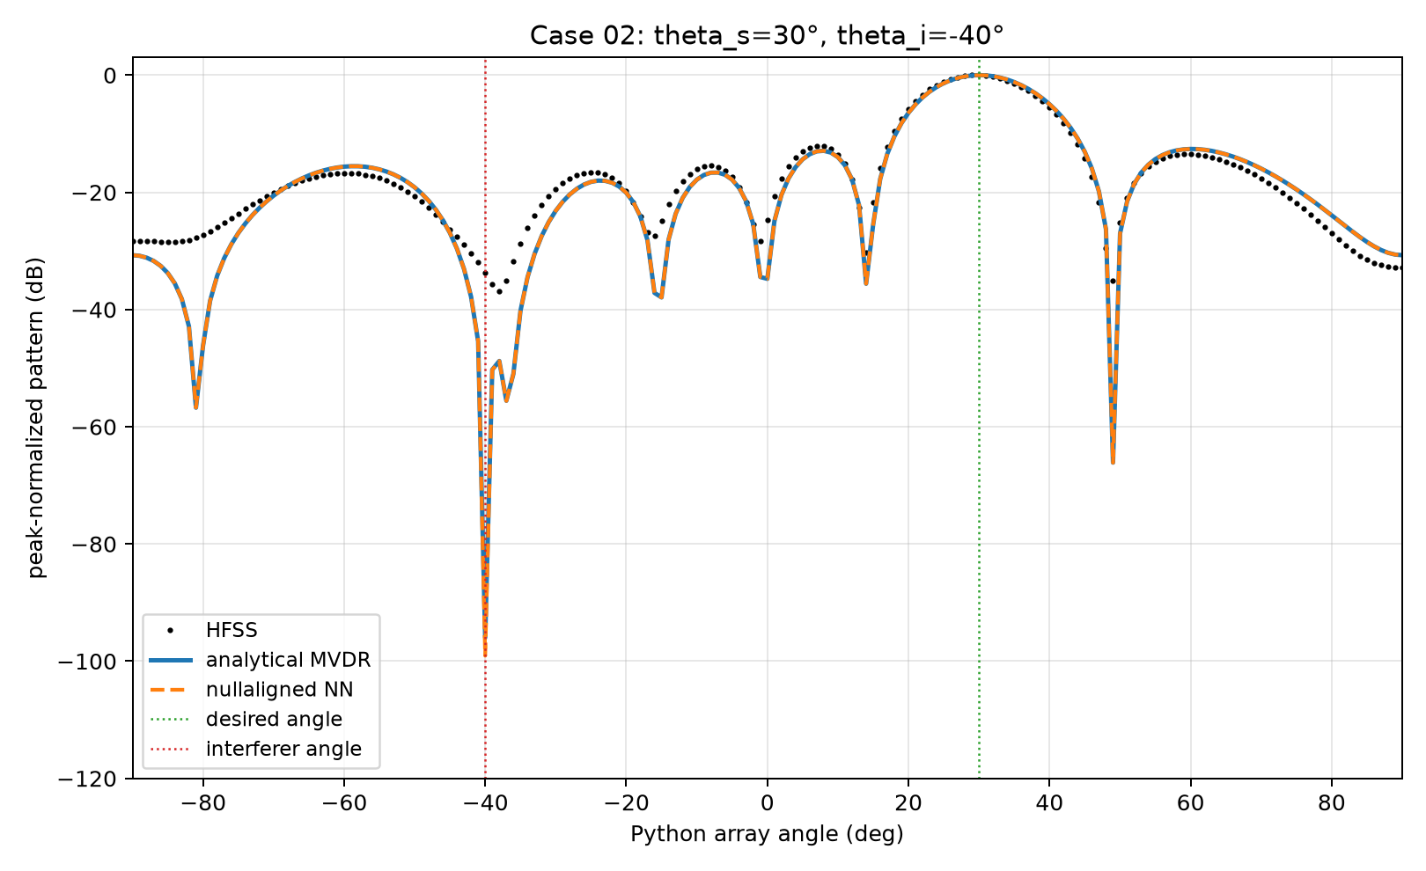
Figure 9: HFSS, MVDR and null-aligned network overlay for case 02.
Case 03 compares desired direction -25° with interference at 45°; the corresponding pattern is shown in Figure 10.
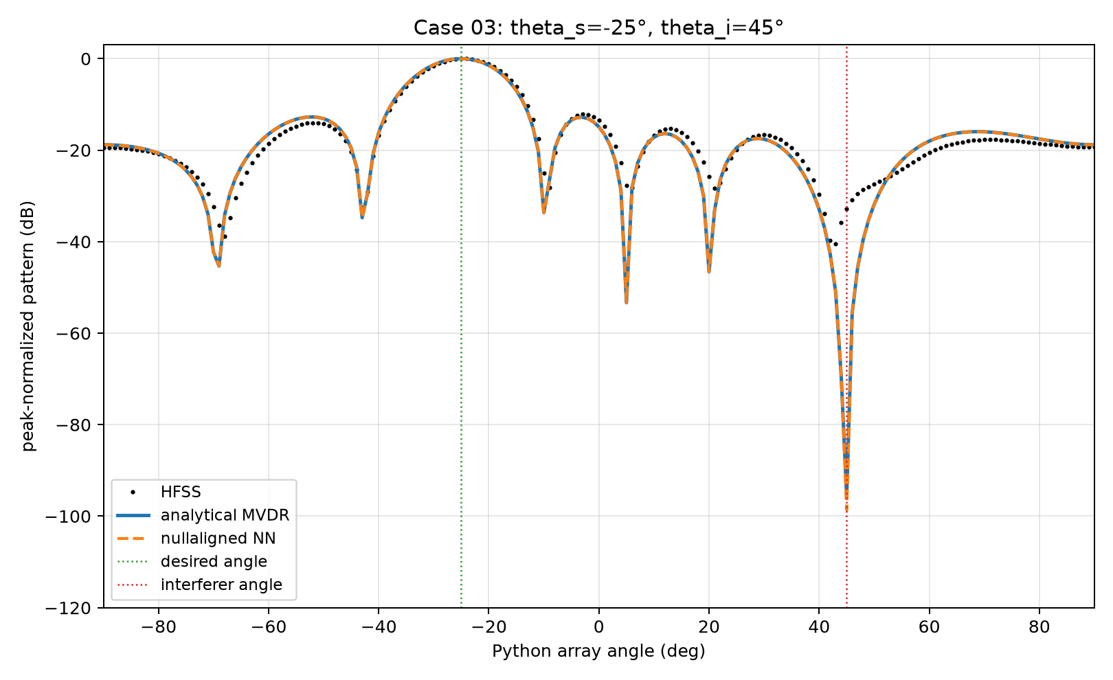
Figure 10: HFSS, MVDR and null-aligned network overlay for case 03.
13

Case 04 compares desired direction 5° with interference at -55°; the corresponding pattern is shown in Figure 11.
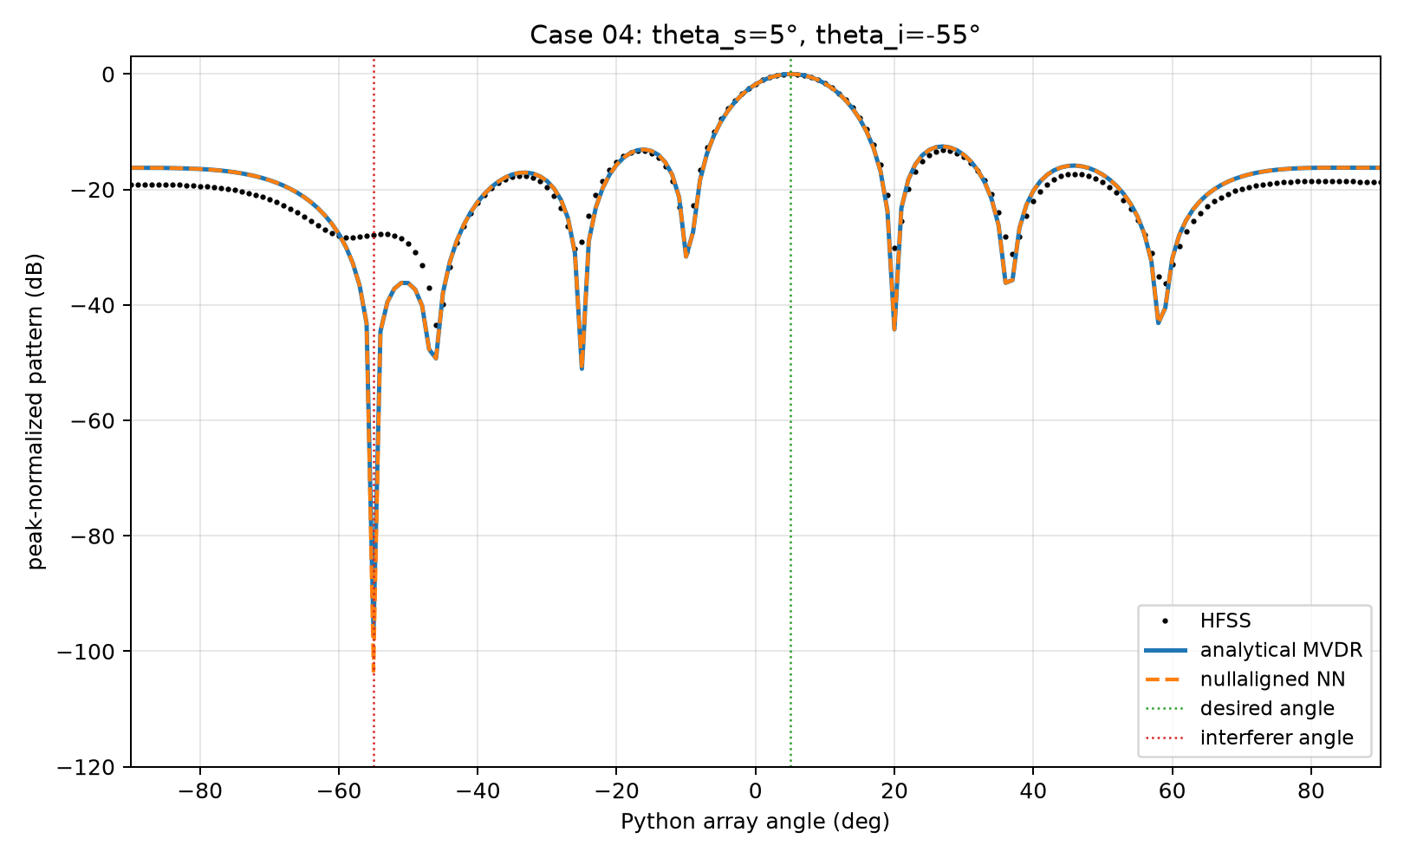
Figure 11: HFSS, MVDR and null-aligned network overlay for case 04.
Case 05 compares desired direction 58° with interference at 55°; the corresponding pattern is shown in Figure 12.
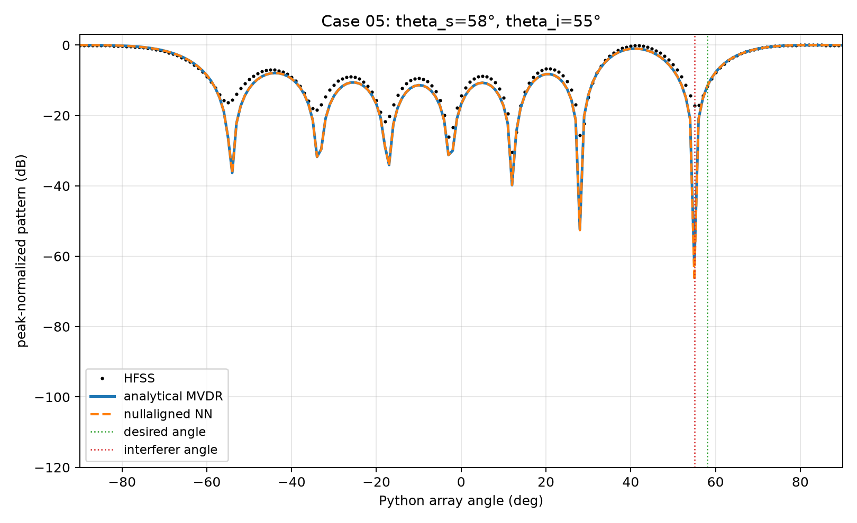
Figure 12: HFSS, MVDR and null-aligned network overlay for case 05.
14

7. CONCLUSION
A null-aligned output representation was used to encode the distortionless condition and directly control the interference response. On the held-out ideal-array test set, the full model closely matched the median MVDR null and SINR, whereas direct weight regression produced a much shallower null despite good pointing. The numerical solver checks support the analytical implementation.
Full-wave comparisons reveal a substantial gap between ideal-array nulls and the supplied dipole-array results. Deep digital cancellation alone is therefore insufficient evidence of physical rejection: coupling, port behavior and calibration must be considered. The conclusions are limited to one array configuration, one interferer, simulated far-field exports and the stated train/test grid.
8. FUTURE WORK
Future work can incorporate embedded element patterns or measured multiport calibration, use coupling-aware training and evaluate independent hardware measurements. Multiple interferers, broadband and off-grid angles, uncertain direction estimates, phase and amplitude quantization, noise covariance mismatch, other array geometries, and reproducibility across random training seeds should be studied. Inference latency should be benchmarked against an optimized analytical solver before asserting a speed advantage.
9. REFERENCES
[1] J. Capon, “High-resolution frequency-wavenumber spectrum analysis,” Proceedings of the IEEE, vol. 57, no. 8, pp. 1408–1418, 1969.
[2] H. L. Van Trees, Optimum Array Processing. Wiley-Interscience, 2002.
[3] A. F. Molisch, Wireless Communications, 2nd ed. Wiley-IEEE Press, 2011.
[4] G. H. Golub and C. F. Van Loan, Matrix Computations, 4th ed. Johns Hopkins University Press, 2013.
[5] C. Trabelsi et al., “Deep Complex Networks,” International Conference on Learning Representations (ICLR), 2018.
[6] C. A. Balanis, Antenna Theory: Analysis and Design, 4th ed. Wiley, 2016.
[7] M. Raissi, P. Perdikaris, and G. E. Karniadakis, “Physics-informed neural networks: A deep learning framework for solving forward and inverse problems involving nonlinear partial differential equations,” Journal of Computational Physics, vol. 378, pp. 686–707, 2019.
[8] Ansys, Ansys Electronics Desktop / HFSS 2025 R2 documentation, 2025.
END OF REPORT
15

