**TRADITIONAL CLOTHES AROUND THE WORLD**

A PROJECT REPORT

*SUBMITTED BY*

SREELAKSHMI ES

*IN PARTIAL FULLFILLMENT FOR THE AWARD OF THE DEGREE OF THE*

*OF*

*BACHELOR OF TECHNOLOGY*

*IN*

*COMPUTER SCIENCE AND ENGINEERING*

IN

BRANCH OF STUDY



**Lovely Professional University, Punjab**

ENROLLMENT NUMBER: 12417418

Section: K24PR

Roll No:58

Date:05.11.2024

**APPENDIX II**

**Lovely Professional University, Punjab**

**BONAFIDE CERTIFICATE**

Certified that this project report **“TRADITIONAL CLOTHES AROUND THE**

**WORLD”** is the bonafide work of “**SREELAKSHMI E S”** who carried out the

project work under my supervision.

**SIGNATURE**

ABASS HASSAN

**SUPERVISOR**

**School Of Computer**

**Science and Engineering**

**SIGNATURE**

Dr. PARVINDER SINGH  
**CLASS MENTOR**

**SIGNATURE**

Dr. DEEPAK KUMAR  
**HEAD OF THE DEPARTMENT**

**APPENDIX II**

**TABLE OF CONTENTS**

|  |  |  |
| --- | --- | --- |
| **CHAPTER NO.** | **CHAPTER NAME** | **PAGE NO.** |
| **1** | **Title Page** | **i** |
| **2** | **Bonafide Certificate** | **ii** |
| **3** | **Table Of Contents** | **iii** |
| **4** | **Introduction to the project** | **iv** |
| **5** | **Technology Used** | **v** |
| **6** | **Workflow (include a flowchart of the project)** | .. |
| **7** | **Project Functionality (Working of the project)** | .. |
| **8** | **Code Snippets** | … |
| **9** | **Screenshots** | .. |
| **10** | **Conclusion** | .. |

**INTRODUCTION TO PROJECT**

The **"Traditional Clothes Around the World"** webpage is an exploration of the diverse and vibrant cultures of the world, through the lens of their traditional attire. This project was created using **HTML** and **CSS**, focusing on showcasing the rich history and cultural significance of traditional clothing worn in different regions.

Throughout history, clothing has been an essential part of human identity, symbolizing cultural heritage, social status, and personal expression. From the intricate, handwoven fabrics of South America to the colorful, flowing garments of the Middle East, every piece of traditional clothing tells a unique story. This project aims to highlight and celebrate these traditions, providing a visual journey into the heart of global fashion.

By using HTML for the structure and CSS for styling, the webpage provides an aesthetically pleasing and user-friendly experience. Visitors can navigate through various sections dedicated to specific regions and explore the significance, history, and modern-day relevance of traditional clothes.

The design and layout are clean and minimalistic, ensuring the focus stays on the vibrant images and descriptions of the clothing. The goal of this project is not only to educate visitors about global fashion but also to foster appreciation and respect for the diversity of cultures and their unique sartorial practices.

• **HTML Structure**:

* The header contains a title and a brief introductory sentence that gives visitors an overview of the site’s purpose.
* The introduction section (<section class="intro">) contains the main introduction text, describing what the page is about.
* The footer is just a simple copyright notice.

• **CSS Styling**:

* The CSS is designed to make the page look clean and modern.
* The hero section within the header is styled to draw attention with a bold title and a welcoming sentence.
* The Intro section has padding, rounded corners, and a subtle shadow to make it stand out.
* The page uses a simple, neutral colour scheme with whites, blacks, and greys to keep the focus on the content.

**Key Features of the Project:**

* **HTML Structure**: Semantic HTML elements were used to create a well-organized layout for easy navigation and readability.
* **CSS Styling**: The page is styled with a modern, simple design, emphasizing the beauty of the traditional clothing through images, typography, and color schemes.
* **Responsive Design**: The webpage is responsive, meaning it is optimized for both desktop and mobile devices, providing an enjoyable experience on any screen size.
* **Cultural Exploration**: Each section of the page is dedicated to exploring a different culture’s traditional attire, with a brief historical background and images.

This project serves as an educational tool for anyone interested in learning more about the diversity of cultures and the role traditional clothing plays in preserving cultural identity across the globe.

**TECHNOLOGY USED**This section provides an in-depth look at how each technology was utilized to structure and style the website:

HTML Structure:

HTML (Hypertext Markup Language) is the backbone of the website, responsible for the structure and content organization. The webpage relies on semantic HTML elements to ensure accessibility, SEO optimization, and clarity in the presentation of content. Here's a breakdown of how HTML is used:

1. Document Structure:

The webpage begins with the <!DOCTYPE html> declaration, which tells the browser to use the latest HTML version (HTML5). This is followed by the <html> element with the lang="en" attribute to specify that the content is in English, helping with accessibility and SEO.

html

Copy code

<!DOCTYPE html>

<html lang="en">

2. Head Section:

In the <head> section, we define metadata for the document, such as the character encoding, viewport settings for mobile responsiveness, and the title of the webpage. We also link to the external CSS file, ensuring that the styles are applied properly.

html

Copy code

<head>

<meta charset="UTF-8">

<meta name="viewport" content="width=device-width, initial-scale=1.0">

<title>Traditional Clothes Around the World</title>

<link rel="stylesheet" href="styles.css">

</head>

3. Header:

The <header> element is used to group introductory content or navigational elements. In this case, it contains the page title and a brief tagline that invites users to explore traditional clothing around the world. The text is wrapped in <h1> and <p> tags to define a main heading and a short paragraph.

html

Copy code

<header>

<div class="hero">

<h1>Traditional Clothes Around the World</h1>

<p>Discover the unique and vibrant traditions of clothing across cultures</p>

</div>

</header>

4. Main Content:

The body of the page is organized into sections using the <section> tag. Each section is used to group related content and can be styled separately. For example, the introduction section that provides an overview of the page is inside a <section class="intro"> tag.

html

Copy code

<section class="intro">

<h2>Explore Traditional Clothing from Across the Globe</h2>

<p>Traditional clothing plays an important role in shaping the identity and cultural heritage of nations around the world...</p>

</section>

Each section of the website (for example, sections for specific regions like Asia, Africa, Europe) could follow a similar structure, with headings and paragraphs or images showcasing the different clothing styles.

5. Footer:

The <footer> element is used for the bottom section of the page, where copyright information or any secondary content (like contact details or links) is displayed.

CSS Styling:

CSS (Cascading Style Sheets) is used to control the visual appearance of the webpage. It allows for the design and layout to be customized, making the website more visually appealing and user-friendly. Here’s how CSS is used for this project:

**1. Global Styling:**

A global reset is applied to remove default margins and padding from all elements, ensuring consistent spacing across browsers. The box-sizing: border-box; property is used to make sure that padding and borders are included in the element's total width and height.

**2. Typography:**

CSS is used to style the fonts for readability and aesthetic appeal. The primary font for the page is set to Arial, and text alignment, line-height, and color are controlled for different sections. For example, the <h1> tag is styled to stand out with a larger font size, while the body text uses a smaller, legible size.

**3. Layout and Spacing:**

Spacing and layout control is handled using margin and padding properties. The hero class (used in the header) has padding to create space around the text, while the intro section has padding and margin to ensure enough whitespace between the content and the page edges.

**4. Responsive Design:**

The website is made responsive by ensuring that the layout adjusts to different screen sizes. The viewport meta tag in the HTML file ensures that the layout scales properly on mobile devices. Using flexible units like percentages or vw (viewport width) allows for content to resize based on the screen size.

**5. Visual Design Elements:**

CSS is also used to enhance the design with visual effects such as shadows, borders, and background colors. For example, the .intro section uses a subtle box shadow and rounded corners to create a clean, modern look. The background of the header is styled with a dark color to contrast with the white text, drawing attention to the page title.

**Conclusion:**

In summary, HTML and CSS work together to build a visually appealing, well-structured webpage. HTML provides the content and structure, while CSS enhances the look and feel, making the site both functional and engaging for users. The combination of semantic HTML for content organization and CSS for styling ensures that the "Traditional Clothes Around the World" webpage is user-friendly, responsive, and aesthetically pleasing, while also highlighting the diversity and beauty of traditional clothing from different cultures.

**WORKFLOW**

**FLOWCHART OF PROJECT**

**+---------------------------+**

**| Start Project Creation|**

**+---------------------------+**

**|**

**v**

**| Create HTML Structure |**

**| |**

**v v**

**| Add Header Section**

**(Title & Tagline) | | Add Main Content Section(s) |**

**| |**

**v v**

**| Create Navigation (Optional) | | Add Introduction Section |**

**| (Description of project) |**

**| |**

**v v**

**| Create Sections for Regions | | Add Region-Specific Content |**

**| (Africa, Asia, Europe, etc.) | | (Images, Descriptions of Clothes) |**

**| |**

**v v**

**| Add Footer Section (Copyright) | |Apply Layout Styling with CSS |**

**| (Spacing, Colors, Fonts) |**

**| |**

**v v**

**| Ensure Mobile Responsiveness | | Implement Image Styling and Effect**

**| |**

**v v**

**| Test and Debug HTML Structure | | Finalize Design and Layout |**

**| |**

**v v**

**| Test and Debug CSS Styles | | Final Review and Adjustments |**

**| |**

**v v**

**| Deploy Website (Go Live) | | End Project |**

**+-------------------------------+ +----------------------------------+**

**Project Functionality**

The project "Traditional Clothes Around the World" is a simple webpage created using HTML (Hypertext Markup Language) and CSS (Cascading Style Sheets). The purpose of the project is to showcase and educate users about the diversity of traditional clothing from various cultures around the world. Here’s a step-by-step explanation of how the project works:

**1. Initial Structure (HTML)**

HTML is responsible for the structure and content of the webpage. The HTML code organizes the content into different sections such as the header, body, and footer, and also defines the structure for each region's traditional clothing details.

Key Elements:

* <header>: Contains the main title and tagline for the webpage.
* <section>: Each section represents a different region or culture, displaying information about traditional clothing specific to that culture.
* <footer>: Typically contains copyright information and credits.
* <img>: Displays images of traditional clothing from different regions.
* <h1>, <h2>, <p>: These elements are used for headings and paragraphs to organize text and information.

**2. Styling the Content (CSS)**

CSS is used to style the HTML elements and make the page visually appealing. It controls the layout, colors, fonts, spacing, and other visual aspects of the website.

Key Styling Components:

* Fonts: Font families and sizes are set to make the text legible and visually appealing.
* Colors: Background colors, text colors, and other color properties are used to ensure the webpage is visually engaging.
* Spacing and Layout: Margin, padding, and positioning are used to arrange elements properly on the page. For example, content sections have padding to create space between text and the edges of the sections.
* Responsive Design: CSS media queries ensure that the layout adjusts based on screen size, making the webpage mobile-friendly.
* Images: CSS can be used to style images (e.g., setting width, height, borders) and make sure they fit well in the layout.

**3. How the Page Works:**

Step 1: Loading the Webpage

When a user visits the webpage:

* The browser loads the HTML file (structure/content) and the CSS file (styling).
* The browser reads the structure from the HTML and applies styles defined in the CSS.

Step 2: Displaying Content

* Header: The main title "Traditional Clothes Around the World" and the tagline are displayed at the top of the page.
* Sections: Each section (e.g., Asia, Africa, etc.) is shown with a heading and text. An image related to traditional clothing from the corresponding region is displayed.
* Responsive Design: The layout adjusts for different screen sizes. For example, if viewed on a mobile device, the sections stack vertically, and text sizes reduce to fit smaller screens.

Step 3: User Interaction

* Navigation: If navigation links or a menu were added, users could click on different sections or regions to explore the traditional clothing of that specific culture.
* Images and Text: Each region's section will contain descriptions and images of traditional clothing. Users can scroll through these sections to learn more about the cultural significance and unique styles of each clothing type.

Step 4: Footer

At the bottom of the page, the footer displays the copyright notice, ensuring users know the content is protected.

**Code Snippets**

**HTML CODE**

<!DOCTYPE html>

<html lang="en">

<head>

    <meta charset="UTF-8">

    <meta name="viewport" content="width=device-width, initial-scale=1.0">

    <title>Traditional Clothes Around the World</title>

    <link rel="stylesheet" href="styles.css">

</head>

<body>

        <header>

            <h1>Traditional Clothes Around the World</h1>

            <p>Explore the beauty of traditional attire from various cultures.</p>

        </header>

        <nav>

            <ul>

                <li><a href="#japan">Japan</a></li>

                <li><a href="#india">India</a></li>

                <li><a href="#scotland">Scotland</a></li>

                <li><a href="#mexico">Mexico</a></li>

            </ul>

        </nav>

        <section id="japan">

            <h2>Kimono - Japan</h2>

            <img src="Kimono.png" alt="Traditional Kimono" class="clothing-img">

            <p>The kimono is a traditional Japanese garment characterized by long sleeves and a wraparound style. It is worn for formal occasions like weddings, tea ceremonies, and festivals.</p>

        </section>

        <section id="india">

            <h2>Sari - India</h2>

            <img src="Sari.png" alt="Traditional Sari" class="clothing-img">

            <p>The sari is a long piece of cloth, typically around 6-9 yards, draped elegantly around the body. It is worn by women in India for both casual and formal occasions.</p>

        </section>

        <section id="scotland">

            <h2>Kilt - Scotland</h2>

            <img src="Kilt.png" alt="Traditional Kilt" class="clothing-img">

            <p>The kilt is a knee-length skirt-like garment with pleats at the back, originating from Scotland. It is typically worn by men as part of Scottish Highland dress.</p>

        </section>

<section id="mexico">

            <h2>Huipil - Mexico</h2>

            <img src="Huipil.png" alt="Traditional Huipil" class="clothing-img">

            <p>The huipil is a traditional Mexican garment, often hand-woven, and worn by indigenous women. It is typically paired with a skirt and is decorated with intricate patterns.</p>

        </section>

        <footer>

            <p>Created by Your Name | Traditional Clothes Website</p>

        </footer>

    </div>

  <script src="scripts.js"></script>

</body>

</html>

**CSS CODE**

/* styles.css */

body {

    font-family: Arial, sans-serif;

    margin: 0;

    padding: 0;

    background-color: #f4f4f4;

    color: #333;

}

header {

    background-color: #2a3d4f;

    color: white;

    padding: 20px;

    text-align: center;

}

header h1 {

    margin: 0;

    font-size: 36px;

}

nav ul {

    list-style: none;

    padding: 0;

    text-align: center;

    background-color: #1f2a35;

}

nav ul li {

    display: inline;

    margin: 10px;

}

nav ul li a {

    color: white;

    text-decoration: none;

    padding: 10px 20px;

    background-color: #1f2a35;

    border-radius: 5px;

}

nav ul li a:hover {

    background-color: #ff7b00;

}

section {

    padding: 20px;

    margin: 20px;

    background-color: white;

    border-radius: 8px;

}

section h2 {

    color: #2a3d4f;

}

.clothing-img {

    width: 100%;

    max-width: 600px;

    height: auto;

    display: block;

    margin: 20px auto;

    border-radius: 8px;

}

footer {

    background-color: #2a3d4f;

    color: white;

    text-align: center;

    padding: 10px;

    position: fixed;

    bottom: 0;

    width: 100%;

}

/* Login Page */

.login-container {

    text-align: center;

    padding: 50px;

}

.login-container h1 {

    font-size: 32px;

}

.login-container form {

    display: inline-block;

    text-align: left;

    background-color: white;

    padding: 20px;

    border-radius: 8px;

    box-shadow: 0 4px 8px rgba(0, 0, 0, 0.1);

}

.login-container input {

    width: 250px;

    padding: 10px;

    margin: 10px 0;

    border-radius: 4px;

    border: 1px solid #ddd;

}

.login-container button {

    padding: 10px 20px;

    background-color: #2a3d4f;

    color: white;

    border: none;

    border-radius: 4px;

    cursor: pointer;

}

.login-container button:hover {

    background-color: #ff7b00;

}

.error-message {

    color: red;

    font-size: 14px;

}

/* Hide content by default */

.main-content {

    display: none;

}

**SCREENSHOTS**

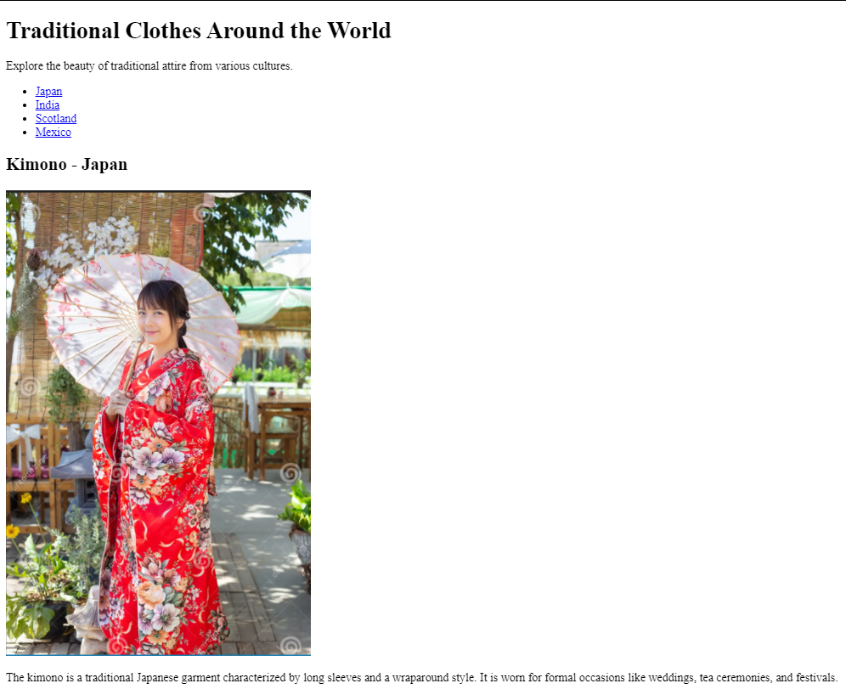

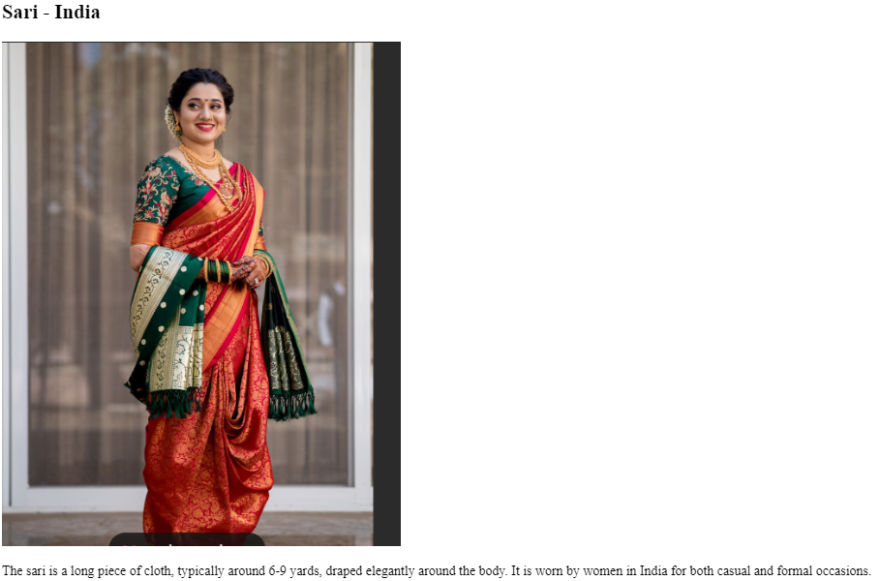

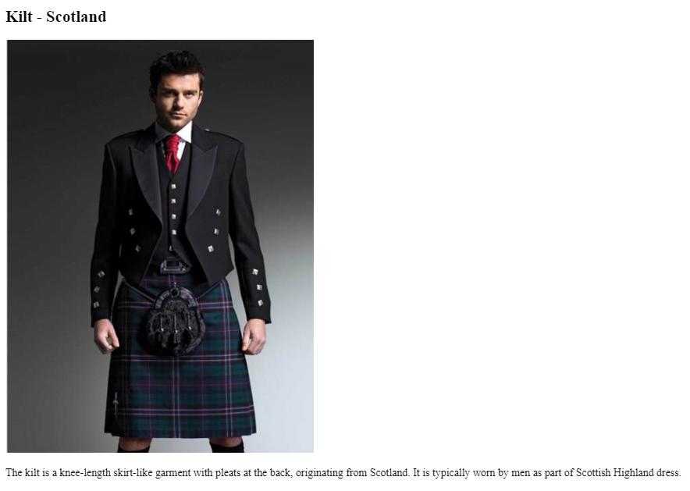

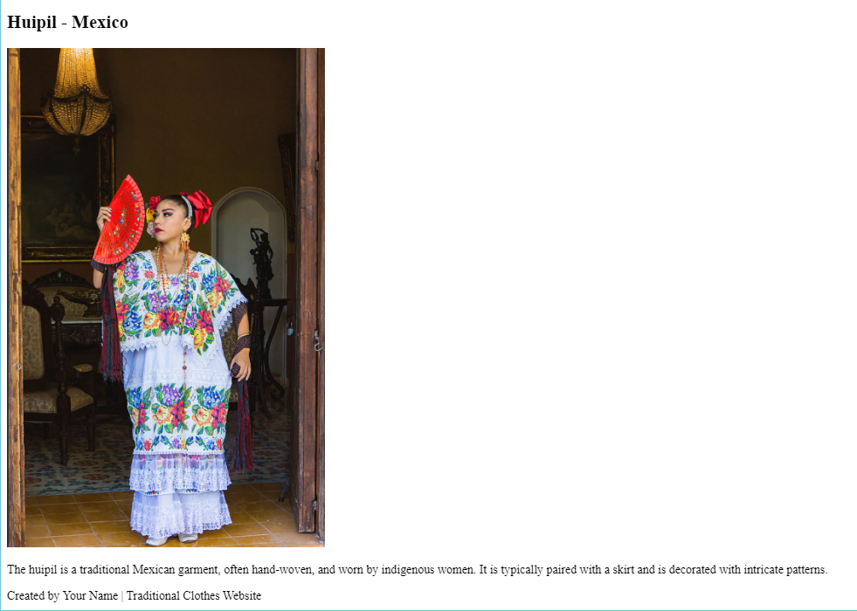

**Conclusion**

The "Traditional Clothes Around the World" webpage works by combining HTML for structure and CSS for styling. It organizes content about traditional clothing into sections based on geographical regions, with each section containing a mix of text and images. The CSS ensures that the webpage is visually appealing, easy to read, and mobile-friendly. The result is a well-organized, user-friendly, and educational webpage that helps users explore the diversity and significance of traditional clothing worldwide.

**\*\*\*\*\*\*\*\*\*\*\*\*\*\*\*\*\*\*\*\*\*\*\*\*\*\*\*\*\*\*\*\*\***