**Name:** Sreelakshmi Madhusoodhanan

**Roll No**:39

**Batch:** R-MCA

**Date:** 08-04-2022

**ADVANCED DBMS LAB**

**Experiment No.: 3**

**Aim**

To familiarize DDL Commands- ALTER,DROP,TRUNCATE,RENAME

**Questions**

1.Create a table emp with attributes empno number(4)as primary key, ename char(10),hiredate,  salary, commission

insert 5 rows of data

|  |  |  |  |  |
| --- | --- | --- | --- | --- |
| 101 | Ramesh | 17-Jan  1980 | 5000 |  |
| 102 | Ajay | 05-Jul  1985 | 5000 | 500 |
| 103 | Ravi | 12-Aug  1981 | 1500 |  |
| 104 | Nikesh | 03-Mar  1983 | 3000 | 700 |
| 105 | Ravi | 05-jul  1985 | 3000 |  |

2.Modifying the structure of tables

a.Add new columns: sal number(7,2)

b.Dropping a column from a table: sal

c.Modifying existing column :ename varchar2(15)

d.Renaming the tables: emp to emp1

e.truncating the tables:emp1

f.Destroying tables:emp

3.Create a table stud with sname varchar2(20) primary key , rollno number(10) not null,dob  date not null

4.Create a table student as regno number (6), mark number (3) check constraint (mark >=0 and  mark

<=100));

5.Create a table cust with(custid number(6) constraint unique, name char(10)

**Procedure**

**Commands:**

CREATE DATABASE d1;

use d1;

1.CREATE TABLE emp(EMPNO INT PRIMARY KEY, ENAME CHAR(10), HIREDATE DATE, SALARY INT,COMMISSION INT);

SELECT * FROM emp;

C:\Users\Student\Pictures\dbms\1.PNG

INSERT INTO emp(EMPNO,ENAME,HIREDATE,SALARY) VALUES (101,'RAM','1980-01-17',5000),(102,'AJAY','1985-07-05',5000),(103,'RAVI','1981-08-12',1500),(104,'Nikesh','1983-03-03',3000), (105,'Ravi','1985-07-05',3000);

SELECT * FROM emp;

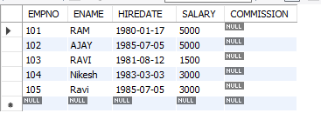

2.

a. ALTER TABLE emp ADD sal int;

SELECT * FROM emp;

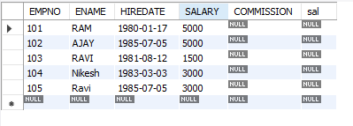

b. ALTER TABLE emp DROP COLUMN sal;

SELECT * FROM emp;

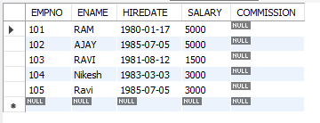

c. ALTER TABLE emp MODIFY ename VARCHAR(15);

C:\Users\Student\Pictures\dbms\5.PNG

d. RENAME table emp to emp1;

SELECT * FROM emp1;

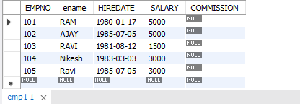

e. TRUNCATE TABLE emp1

SELECT * FROM emp1;

C:\Users\Student\Pictures\dbms\7.PNG

f. DROP TABLE emp1;

SELECT * FROM emp1;

C:\Users\Student\Pictures\dbms\8.PNG

3. CREATE TABLE stud(sname varchar(20) PRIMARY KEY, rollno int NOT NULL, dob date NOT NULL);

SELECT * FROM stud;

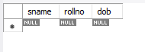

4. Create table student (regno int, mark int(3) constraint b check (mark >=0 and mark <=100));

SELECT * from STUDENT;

C:\Users\Student\Pictures\dbms\11.PNG

5. CREATE TABLE cust(custid INT(6) UNIQUE, name char(10));

SELECT * FROM cust;

C:\Users\Student\Pictures\dbms\10.PNG