**1) Matrix Addition**

X = [[1,2,3],

[4 ,5,6],

[7 ,8,9]]

Y = [[9,8,7],

[6,5,4],

[3,2,1]]

result = [[X[i][j] + Y[i][j] for j in range

(len(X[0]))] for i in range(len(X))]

for r in result:

print(r)

**Result:**

[10, 10, 10]

[10, 10, 10]

[10, 10, 10]

**2. Matrix Multipilication**

r1=int(input("Enter number of Rows of Matrix A: "))

c1=int(input("Enter number of Columns of Matrix A: "))

A=[[0 for i in range(c1)] for j in range(r1)]

print("Enter Matrix Elements of A:")

for i in range(r1):

for j in range(c1):

x=int(input())

A[i][j]=x

r2=int(input("Enter number of Rows of Matrix B: "))

c2=int(input("Enter number of Columns of Matrix B: "))

B=[[0 for i in range(c2)] for j in range(r2)]

print("Enter Matrix Elements of B:")

for i in range(r2):

for j in range(c2):

x=int(input())

B[i][j]=x

if(c1==r2): B

P=[[0 for i in range(c2)] for j in range(r1)]

for i in range(len(A)):

for j in range(c2):

for k in range(len(B)):

P[i][j]=P[i][j]+(A[i][k]*B[k][j])

print("Product of Matrices A and B: ")

for i in range(r1):

for j in range(c2):

print(P[i][j],end=" ")

print()

else:

print("Matrix Multiplication is not possible.")

**Result:**

Enter number of Rows of Matrix A: 2

Enter number of Columns of Matrix A: 2

Enter Matrix Elements of A:

1

2

3

4

Enter number of Rows of Matrix B: 2

Enter number of Columns of Matrix B: 2

Enter Matrix Elements of B:

5

6

7

8

Product of Matrices A and B:

19 22

43 50

**3.Identity matrix or not**

def Identity(size):

for row in range(0, size):

for col in range(0, size):

if (row == col):

print("1 ", end=" ")

else:

print("0 ", end=" ")

print()

size = 5

Identity(size)

**result:**

1 0 0 0 0

0 1 0 0 0

0 0 1 0 0

0 0 0 1 0

0 0 0 0 1

**4.Fint the determinent of the matrix**

import numpy as np

arr = np.array([[30, 12], [20, 11]])

print("Numpy Matrix =")

print(arr)

determinant = np.linalg.det(arr)

print("\nThe Determinant of 2 * 2 Matrix =")

print(int(determinant))

**result:**

Numpy Matrix =

[[30 12]

[20 11]]

The Determinant of 2 * 2 Matrix =

90

**ML**

import pandas as pd

csv_url = 'https://archive.ics.uci.edu/ml/machine-learning-databases/iris/iris.data'

      # using the attribute information as the column names

col_names = ['Sepal_Length','Sepal_Width','Petal_Length','Petal_Width','Class']

iris = pd.read_csv(csv_url, names = col_names)

print(iris.head())

print(iris.tail())

print(iris.dtypes)

O/P:

Sepal_Length Sepal_Width Petal_Length Petal_Width Class

0 5.1 3.5 1.4 0.2 Iris-setosa

1 4.9 3.0 1.4 0.2 Iris-setosa

2 4.7 3.2 1.3 0.2 Iris-setosa

3 4.6 3.1 1.5 0.2 Iris-setosa

4 5.0 3.6 1.4 0.2 Iris-setosa

Sepal_Length Sepal_Width Petal_Length Petal_Width Class

145 6.7 3.0 5.2 2.3 Iris-virginica

146 6.3 2.5 5.0 1.9 Iris-virginica

147 6.5 3.0 5.2 2.0 Iris-virginica

148 6.2 3.4 5.4 2.3 Iris-virginica

149 5.9 3.0 5.1 1.8 Iris-virginica

Sepal_Length float64

Sepal_Width float64

Petal_Length float64

Petal_Width float64

Class object

dtype: object

**2** iris.head()

O/P:

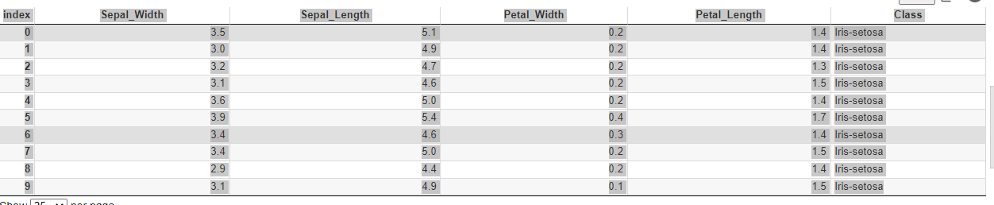

3) iris.sort_values(by='Petal_Width').head(10)

O/P

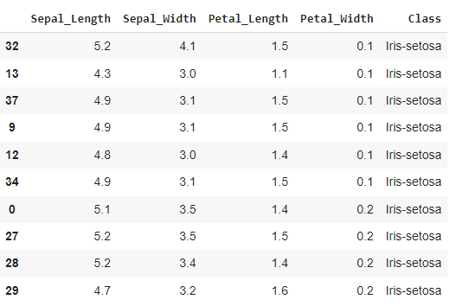

4) iris['Sepal_Length'].head()

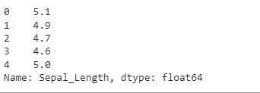

5)

iris[0:5]

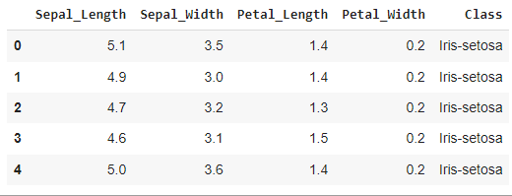

6) iris.loc[0:10, ['Sepal_Length', 'Petal_Length']]

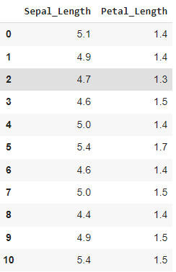

7) iris.loc[0, ['Sepal_Length', 'Petal_Length']]

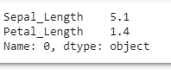

8) iris.loc[0, 'Petal_Length']



9) iris['Petal_Length'].head()

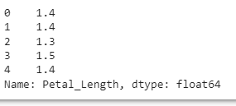

10)

iris.Sepal_Length.head()

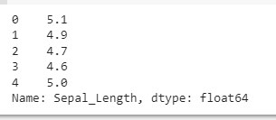

11) iris.loc[0]

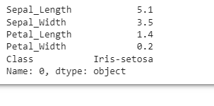

12) iris.iloc[0:3, 0:4]

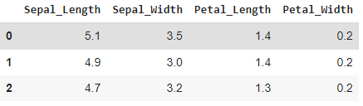

13)

iris.iat[0,0]

