**Experiment No.:**

**Name: Sreelakshmi Madhusoodhanan**

**Roll No:39**

**Batch:**

**Date:17-10-2022**

**Aim**

Implement Naive Bayes Algorithm using play golf data set

**Questions**

Naive Bayes Algorithm

**Program and Output**

import pandas as pd

import numpy as np

from sklearn import preprocessing

data= pd.read_csv('golf-dataset.csv')

data

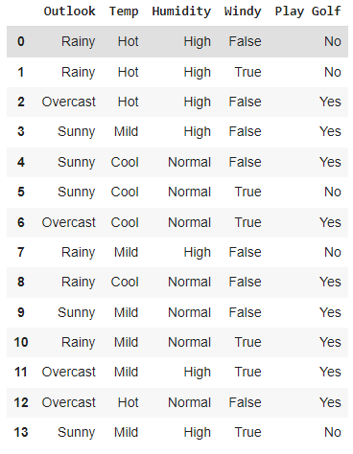

label_encoder = preprocessing.LabelEncoder()

data['Outlook']= label_encoder.fit_transform(data['Outlook'])

data['Temp']= label_encoder.fit_transform(data['Temp'])

data['Humidity']= label_encoder.fit_transform(data['Humidity'])

data['Windy']= label_encoder.fit_transform(data['Windy'])

data['Play Golf']= label_encoder.fit_transform(data['Play Golf'])

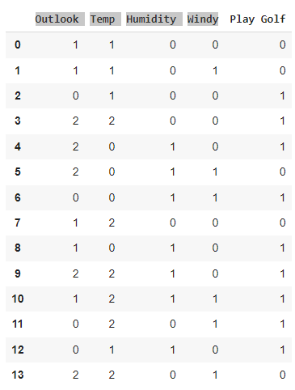

X=data.drop('Play Golf', axis=1)

Y=data['Play Golf']

Y

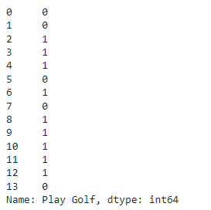

from sklearn.model_selection import train_test_split

X_train, X_test, y_train, y_test = train_test_split(X, Y, test_size=0.1, random_state=42)

from sklearn.naive_bayes import GaussianNB

gnb = GaussianNB()

gnb.fit(X_train, y_train)

y_pred = gnb.predict(X_test)

from sklearn import metrics

print("Gaussian Naive Bayes model accuracy(in %):", metrics.accuracy_score(y_test, y_pred)*100)



Confusion matrix:

from sklearn import metrics

confusion_matrix = metrics.confusion_matrix(Y, Y)

confusion_matrix

