**OBJECT ORIENTED PROGRAMMING LAB**

**Experiment No: 15**

**Name: Sreelakshmi Madhusoodhanan**

**Roll No:39**

**Batch: RMCA B**

**Date:24/05/2022**

**Aim**

Create an interface having prototypes of functions area() and perimeter(). Create two classes Circle and Rectangle which implements the above interface. Create a menu driven program to find area and perimeter of objects.

**Procedure**

import java.util.Scanner;

interface prop

{

void getdata();

void area();

void perimeter();

}

class Circle implements prop

{

double pi = 3.14;

double r;

Scanner sc = new Scanner(System.in);

public void getdata()

{

System.out.println("Enter the radius of the circle:");

r = sc.nextDouble();

}

public void perimeter()

{

System.out.println("Perimeter of the circle: "+(2*pi*r));

}

public void area()

{

System.out.println("Perimeter of the circle: "+(pi*r*r));

}

}

class Rectangle implements prop

{

double l,b;

Scanner sc = new Scanner(System.in);

public void getdata()

{

System.out.println("Enter the length of the rectangle:");

l = sc.nextDouble();

System.out.println("Enter the breadth of the rectangle:");

b = sc.nextDouble();

}

public void area()

{

System.out.println("Perimeter of a rectangle: "+(l*b));

}

public void perimeter()

{

System.out.println("Perimeter of a rectangle: "+(2*(l+b)));

}

}

public class CO3Q6

{

public static void main(String[] args)

{

int ch,u=0;

Scanner sc = new Scanner(System.in);

Circle ob = new Circle();

Rectangle obj = new Rectangle();

do

{

System.out.println("\n1.Circle\n2.Rectangle\n3.exit");

System.out.println("Enter your choice:");

ch = sc.nextInt();

switch(ch)

{

case 1 :ob.getdata();

ob.area();

ob.perimeter();

break;

case 2 :obj.getdata();

obj.area();

obj.perimeter();

break;

case 3 :System.out.println("Exited");

System.exit(0);

}

}while(u==0);

}

}

**Output Screenshot**

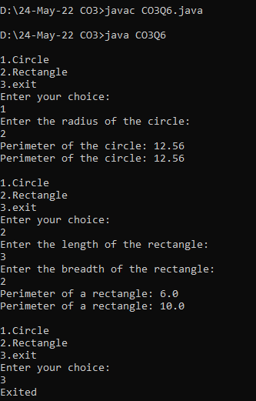

**Experiment No: 16**

**Name: Sreelakshmi Madhusoodhanan**

**Roll No:39**

**Batch: RMCA B**

**Date:24/05/2022**

**Aim**

Prepare bill with the given format using calculate method from interface.

Order No.

Product Id Name Quantity unit price Total

101 A 2 25 50

102 B 1 100 100

Net. Amount 150

**Procedure**

import java.util.Scanner;

interface calc

{

void calculate();

}

class bill implements calc

{

String date,name,p_id;

int quantity;

double unit_price,total,namount=0;

Scanner sc = new Scanner(System.in);

public void getdata()

{

System.out.println("\nEnter product id:");

p_id = sc.nextLine();

System.out.println("Enter product name:");

name = sc.nextLine();

System.out.println("Enter the Quantity:");

quantity = sc.nextInt();

System.out.println("Enter the unit price:");

unit_price = sc.nextDouble();

}

public void calculate()

{

total = quantity * unit_price;

}

public void display()

{

System.out.println(p_id+"\t\t"+name+"\t\t"+quantity+"\t\t"+unit_price+"\t"+total);

}

}

public class CO3Q7

{

public static void main(String[] args)

{

int n,i;

double namount=0,t;

int ran;

String date;

t = Math.random() *1000000;

ran = (int) t;

Scanner sc = new Scanner(System.in);

System.out.println("Order no. #"+ran);

System.out.println("Enter the date:");

date = sc.nextLine();

System.out.println("Enter how many products are there:");

n = sc.nextInt();

bill ob[] = new bill[n];

for(i=0;i<n;i++)

ob[i] = new bill();

for(i=0;i<n;i++){

ob[i].getdata();

ob[i].calculate();

}

System.out.println("Date:"+date);

System.out.println("Product Id Name Quantity unit price Total ");

System.out.println("--------------------------------------------------------------");

for(i=0;i<n;i++){

ob[i].display();

namount += ob[i].total;

}

System.out.println("--------------------------------------------------------------");

System.out.println("\t\t\t\tNet.Amount\t\t"+ namount);

}

}

**Output Screenshot**

