**OBJECT ORIENTED PROGRAMMING LAB**

**Experiment No: 17**

**Name: Sreelakshmi Madhusoodhanan**

**Roll No:39**

**Batch: RMCA B**

**Date:31/05/2022**

**Aim**

Program to list the sub directories and files in a given directory and also search for a file name.

**Procedure**

Import java .io.File;

Import java.io.*;

Import java.util.*;

public class p1 {

public static final String RESET = "\033[0m"; public static final String RED = "\033[0;31m"; public static final String TEXT_RESET = "\u001B[0m";

public static final String TEXT_BLACK = "\u001B[30m"; public static final String TEXT_RED = "\u001B[31m";

static void RecursivePrint(File[] arr, int index, int level, String searchfor) {

if (index == arr.length) return;

for (int i = 0; i < level; i++)

System.out.print("\t");

if (arr[index].getName().toLowerCase().contains(searchfor)) System.out.print(TEXT_RED);

else

System.out.print(RESET);

if (arr[index].isFile()) System.out.println(arr[index].getName());

else if (arr[index].isDirectory()) { System.out.println("[" + arr[index].getName() + "]");

RecursivePrint(arr[index].listFiles(), 0, level + 1, searchfor);

}

RecursivePrint(arr, ++index, level, searchfor);

}

public static void main(String[] args) { Scanner scan = new Scanner(System.in);

System.out.println("Enter the directory path"); String maindirpath = scan.nextLine();

System.out.println("Enter the file/directory name to search"); String searchfor = scan.nextLine();

File maindir = new File(maindirpath);

if (maindir.exists() && maindir.isDirectory()) { File arr[] = maindir.listFiles();

System.out.println("---------------------------------------------------");

System.out.println("Files from main directory" + maindir);

System.out.println("------------------------------------------------------");

RecursivePrint(arr, 0, 0, searchfor.toLowerCase()); // array,index,level,search

}

}

}

**Output Screenshot**

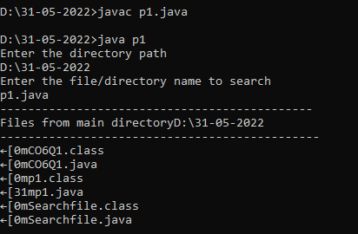

**Experiment No: 18**

**Name: Sreelakshmi Madhusoodhanan**

**Roll No:39**

**Batch: RMCA B**

**Date:31/05/2022**

**Aim**

Write a program to write to a file, then read from the file and display the contents on the console.

**Procedure**

import java.io.BufferedReader;

import java.io.FileReader;

import java.io.FileWriter;

import java.io.IOException;

public class FileOp {

public static void main(String[] args) {

try {

FileWriter writer = new FileWriter("file1.txt",true);

writer.write("File is Created");

writer.close();

FileReader reader = new FileReader("file1.txt");

BufferedReader br= new BufferedReader(reader);

String line;

System.out.println("Data read from the file");

while ((line = br.readLine()) != null) {

System.out.println(line);

}

reader.close();

} catch (IOException e) {

System.out.println("-----Error-----");

}

}

}

**Output Screenshot**

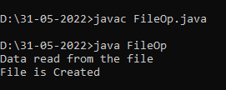

**Experiment No: 19**

**Name: Sreelakshmi Madhusoodhanan**

**Roll No:39**

**Batch: RMCA B**

**Date:31/05/2022**

**Aim**

Write a program to copy one file to another.

**Procedure**

import java.io.FileInputStream;

import java.io.FileOutputStream;

import java.io.IOException;

public class CopyFile {

public static void main(String[] args) throws IOException {

FileInputStream fileinput = new FileInputStream("1.txt");

FileOutputStream fileoutput = new FileOutputStream("2.txt");

int i;

while ((i = fileinput.read()) != -1) {

fileoutput.write(i);

}

System.out.println("Successfully copied one file to another");

fileinput.close();

fileoutput.close();

}

}

**Output Screenshot**

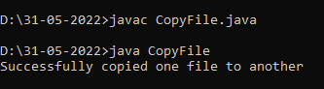

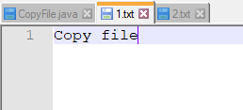

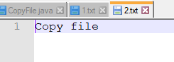

**Experiment No: 20**

**Name: Sreelakshmi Madhusoodhanan**

**Roll No:39**

**Batch: RMCA B**

**Date:31/05/2022**

**Aim**

Write a program that reads from a file having integers. Copy even numbers and odd numbers to separate files.

**Procedure**

import java.io.FileInputStream;

import java.io.FileOutputStream;

import java.io.IOException;

public class EO_Copy

{

public static void main(String[] args) throws IOException {

FileInputStream source = new FileInputStream ("source.txt");

FileOutputStream destination_odd = new FileOutputStream ("odd.txt");

FileOutputStream destination_even = new FileOutputStream ("even.txt");

int i;

while((i = source.read()) != -1){

if(i%2==0) {

destination_even.write(i);

}

else {

destination_odd.write(i);

}

}

System.out.println("copied");

source.close();

destination_even.close();

destination_odd.close();

}

}

**Output Screenshot**

