**Name: Sreelakshmi Madhusoodhanan**

**Roll No: 39**

**Batch: RMCA**

**Date:26-03-2022**

**Object Oriented Programming LAB**

**Experiment No.: 1**

**Aim**

Define a class product with data member pcode,pname and price .Create three objects usin the class and find the product having lowest price.

**Procedures**

**Source Code**

class Product{

String pcode, pname;

double price;

void details(){

System.out.println("PRODUCT DETAILS");

System.out.println("PCode : "+pcode);

System.out.println("PName : "+pname);

System.out.println("Price : "+price);

}

}

public class ProductDetails{

public static void main(String args[]){

Product p1 = new Product();

p1.pcode = "YT7";

p1.pname = "PEN";

p1.price = 30;

System.out.println("\nProduct1:");

p1.details();

Product p2 = new Product();

p2.pcode = "XE9";

p2.pname = "PENCIL";

p2.price = 45;

System.out.println("\nProduct2:");

p2.details();

Product p3 = new Product();

p3.pcode = "sr4";

p3.pname = "BOOK";

p3.price = 130;

System.out.println("\nProduct3:");

p3.details();

if(p1.price<p2.price && p1.price<p3.price){

System.out.println("\n\nProduct1 has the lowest price :");

p1.details();

}

else if(p2.price < p3.price){

System.out.println("\nProduct2 has the lowest price:\n");

p2.details();

}

else

{

System.out.println("\nProduct3 has the lowest price:\n");

p3.details();

}

}

}

**Output**

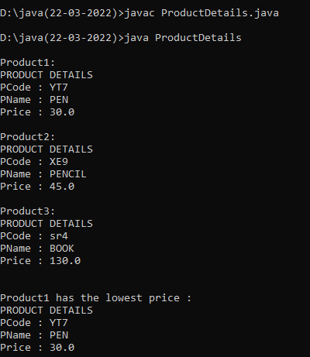

**OBJECT ORIENTED PROGRAMMING LAB**

**Name: Sreelakshmi Madhusoodhanan**

**Roll No: 39**

**Batch: RMCA**

**Date: 6-04-2022**

**Experiment No.: 2**

**Aim**

Read 2 matrices from the console and perform matrix addition.

.

**Procedure**

**Source Code**

import java.util.Scanner;

public class matrixAddition {

public void Display(int [][] arr,int row,int col){

for(int i=0;i<row;i++){

for(int j=0;j<col;j++){

System.out.print(arr[i][j]+"\t");

}

System.out.println();

}

}

public static void main(String[] args) {

int[][] mat1=new int[5][5];

int[][] mat2=new int[5][5];

int[][] mat3=new int[5][5];

int rows1, cols1, rows2, cols2;

matrixAddition obj=new matrixAddition();

Scanner s=new Scanner(System.in);

System.out.println("Enter the number of rows and columns of matrix 1");

rows1=s.nextInt();

cols1=s.nextInt();

System.out.println("Enter the elements of matrix 1");

for(int i=0;i<rows1;i++)

{

for(int j=0;j<cols1;j++)

{

mat1[i][j]=s.nextInt();

}

}

System.out.println("Enter the number of rows and columns of matrix 2");

rows2=s.nextInt();

cols2=s.nextInt();

System.out.println("Enter the elements of matrix 2");

for(int i=0;i<rows2;i++)

{

for(int j=0;j<cols2;j++)

{

mat2[i][j]=s.nextInt();

}

}

if(rows1==rows2 && cols1==cols2)

{

for(int i=0;i<rows1;i++)

{

for(int j=0;j<cols1;j++)

{

mat3[i][j]=mat1[i][j]+mat2[i][j];

}

}

System.out.println("1st matrix");

obj.Display(mat1,rows1,cols1);

System.out.println("2nd matrix");

obj.Display(mat2,rows2,cols2);

System.out.println("Addition of matrix");

obj.Display(mat3,rows1,cols1);

}

else

{

System.out.println("The matrices cannot be added");

}

}

}

**Output Screenshot**

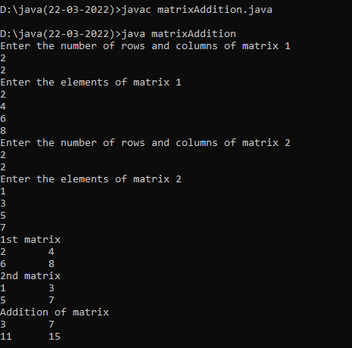

**OBJECT ORIENTED PROGRAMMING LAB**

**Name: Sreelakshmi Madhusoodhanan**

**Roll No: 39**

**Batch: RMCA**

**Date: 6-04-2022**

**Experiment No.: 3**

**Aim**

Add complex numbers.

**Procedure**

**Source Code**

import java.util.Scanner;

class complex{

int r,b;

void display(){

System.out.println("Complex Number is "+r+"+"+b+"i");

}

}

public class addComplex {

public static void main(String[] args) {

complex c1=new complex();

complex c2=new complex();

complex c3=new complex();

Scanner s=new Scanner(System.in);

System.out.println("Enter the real and imaginary parts of complex number 1");

c1.r=s.nextInt();

c1.b=s.nextInt();

System.out.println("Enter the real and imaginary parts of complex number 2");

c2.r=s.nextInt();

c2.b=s.nextInt();

c3.r=c1.r+c2.r;

c3.b=c1.b+c2.b;

c3.display();

}

}

**Output Screenshot**

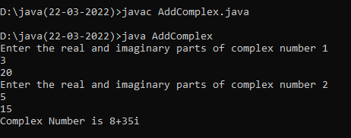

**OBJECT ORIENTED PROGRAMMING LAB**

**Name: Sreelakshmi Madhusoodhanan**

**Roll No: 39**

**Batch: RMCA**

**Date: 6-04-2022**

**Experiment No.: 4**

**Aim**

Read a matrix from the console and check whether it is symmetric or not.

.

**Procedure**

**Source Code**

import java.util.Scanner;

public class SymmetricMatrix {

public void Display(int [][] arr,int row,int col){

for(int i=0;i<row;i++){

for(int j=0;j<col;j++){

System.out.print(arr[i][j]+"\t");

}

System.out.println();

}

}

public static void main(String[] args) {

int [][] mat = new int[3][3];

int [][] trans=new int[3][3];

int row,col;

SymmetricMatrix obj=new SymmetricMatrix();

Scanner s=new Scanner(System.in);

System.out.println("Enter the rows and columns of the matrix");

row=s.nextInt();

col=s.nextInt();

System.out.println("Enter the elements of the matrix");

for(int i=0;i<row;i++)

{

for(int j=0;j<col;j++)

{

mat[i][j]=s.nextInt();

}

}

for(int i=0;i<row;i++)

{

for(int j=0;j<col;j++)

{

trans[j][i]=mat[i][j];

}

}

System.out.println("Entered matrix");

obj.Display(mat,row,col);

System.out.println("Transpose of the matrix");

obj.Display(trans,row,col);

for(int i=0;i<row;i++){

for(int j=0;j<col;j++){

if(mat[i][j]!=trans[i][j]){

System.out.println("Matrix is not symmetric");

System.exit(0);

}

}

}

System.out.println("The given matrix is symmetric");

}

}

**Output Screenshot**

