 20MCA136 – NETWORKING & SYSTEM ADMINISTRATION LAB Dept. of Computer Applications

**NETWORKING & SYSTEM ADMINISTRATION LAB**

**Name: Sreelakshmi Madhusoodhanan**

**Roll No: 39**

**Batch: B**

**Date: 23/05/2022**

**Experiment No: 19**

**Aim**

Docker installation.

**Procedure**

Step 1: Open the terminal on Ubuntu.

Step 2: Remove any [Docker files](https://www.simplilearn.com/tutorials/docker-tutorial/what-is-dockerfile) that are running in the system, using the following command:

$ sudo apt-get remove docker docker-engine docker.io

After entering the above command, you will need to enter the password of the root and press enter.

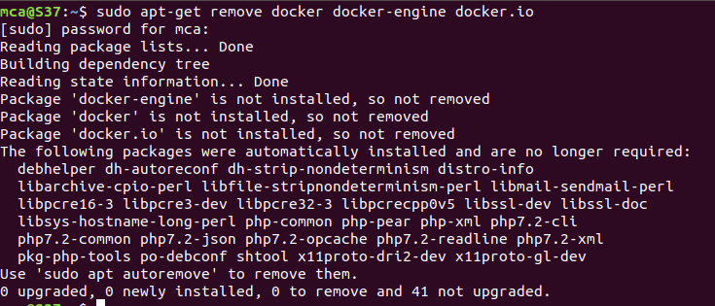

Step 3: Check if the system is up-to-date using the following command:

$ sudo apt-get update

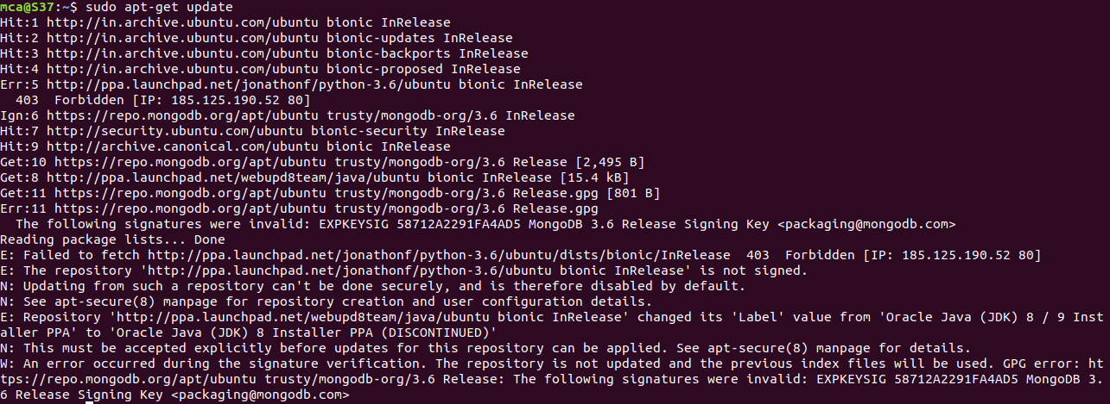

Step 4: Install Docker using the following command:

$ sudo apt install docker.io

You’ll then get a prompt asking you to choose between y/n - choose y

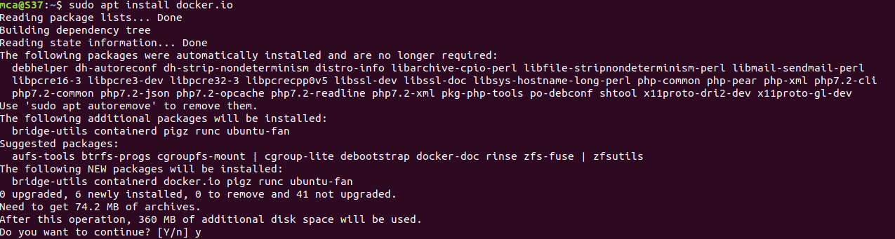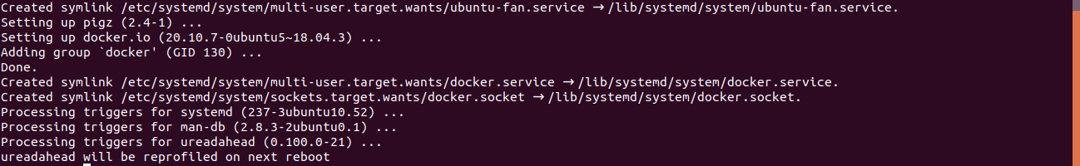

Step 5:Install all the dependency packages using the following command:

$ sudo snap install docker



Step 6: Before testing Docker, check the version installed using the following command:

$ docker --version



Step 7: Pull an image from the Docker hub using the following command:

$ sudo docker run hello-world

Here, hello-world is the docker image present on the Docker hub.

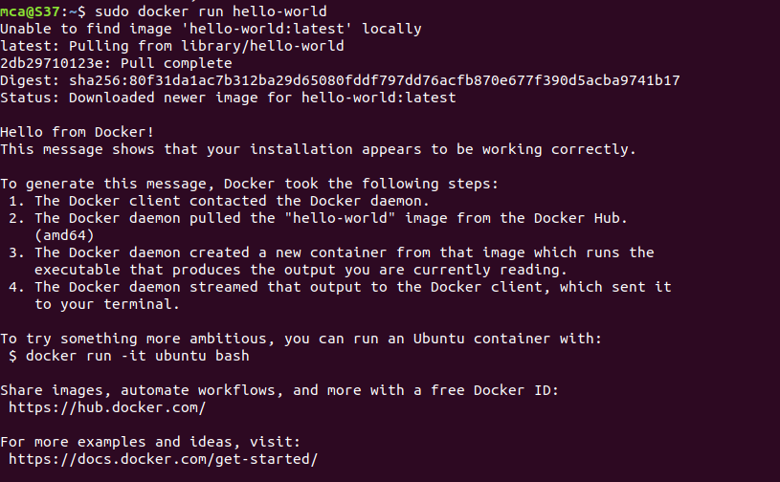

Step 8: Check if the docker image has been pulled and is present in your system using the following command:

$ sudo docker images



Step 9: To display all the containers pulled, use the following command:

$ sudo docker ps -a



Step 10: To check for containers in a running state, use the following command:\

$ sudo docker ps

Successfully installed Docker on Ubuntu!