**NETWORKING & SYSTEM ADMINISTRATION LAB**

**Name: Sreelakshmi Madhusoodhanan**

**Roll No: 39**

**Batch: B**

**Date: 31/03/2022**

**Experiment No.: 4**

**Aim**

Familiarization of the linux commands.

**Procedure**

**1. -n**

This command is used to displays line numbers in contents.

Syntax :- $ cat -n filename

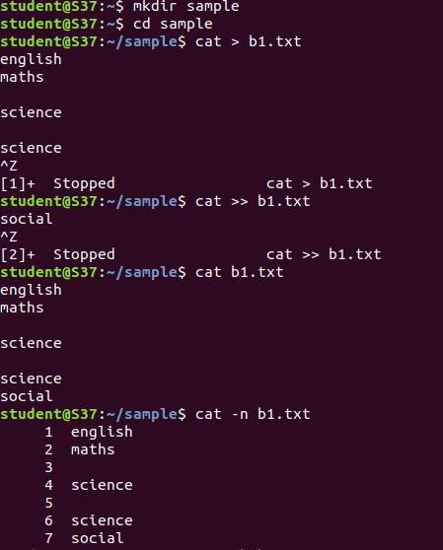 Output :-

**2. -b**

This command is used to removes the empty lines.

Syntax :- $ cat -b filename

Output :-

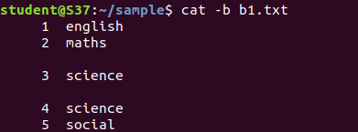

**3. Touch**

This command is used to create an empty file.

Syntax :- $ touch filename

Output :-

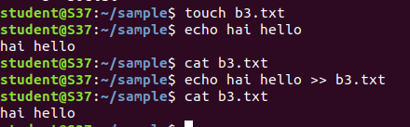



**4. head, head -4**

This head command is used to display the first ten line of contents and head -4 which displays the first four lines of contents.

Syntax :- $ head filename

$ head -4 filename

Output :-

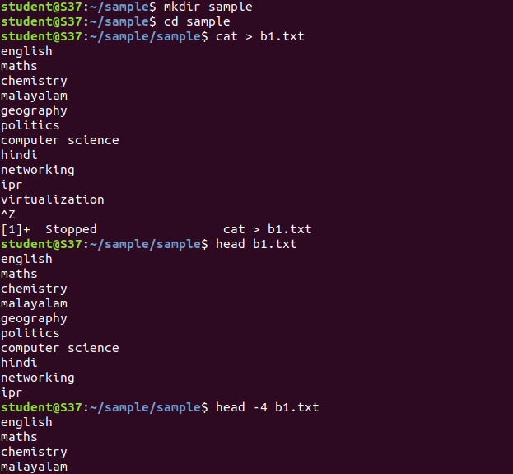

**5. Tail, -3**

This tail command is used to displays the last ten lines of contents and tail -3 which displays the last 3 lines of contents.

Syntax :- $ tail filename.txt

$ tail -3 filename.txt

Output:-

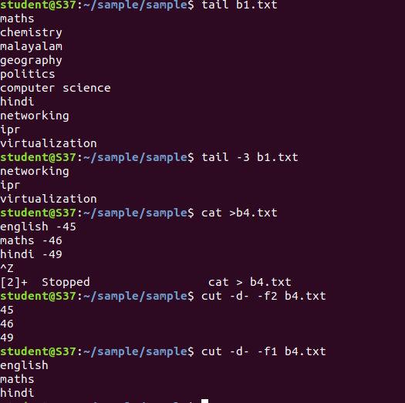

**6. Cut f2,Cut f1**

This cut f2 command is used to display the second column contents and f1 which displays the first column contents.

Syntax :- $cut –d- -f2 filename.txt

$cut –d- -f1 filename.txt

Output :-



**7. cut ‘ ‘**

This command is used cut the spaces.

Syntax :- $cut –d ‘ ‘ –f2 filename.txt

Output :-

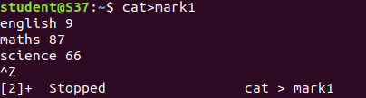

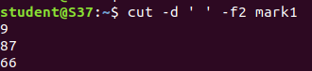

**8. cut –b 2**

This command is used to displays the second letters.

Syntax :- $ cut –b 2 filename.txt

Output :-

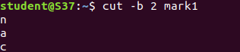

**9. cut –complement –c 1**

This command is used to displays the contents except the first letter .

Syntax :- $ cut –complement –c 1 filename.txt

Output :-

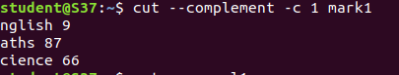

**10. Paste**

This command is used to paste one file contents to another.

Syntax :- $ paste filename1.txt filename2.txt

Output :-

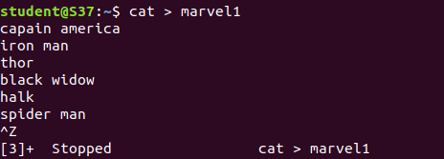

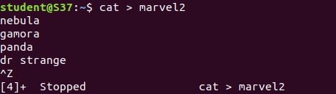

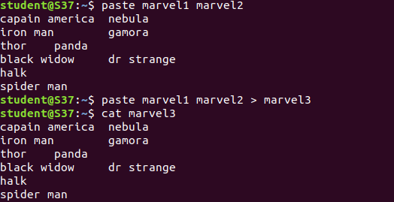

**11. Paste –d ‘-‘ file1 file2, Paste –d ‘%‘ file1 file2**

This command is used to displays ‘–‘ and ‘%’ in between the contents.

Syntax :- $ paste –d ‘-‘ file1.txt file2.txt

$ paste –d ‘%‘ file1.txt file2.txt

Output :-

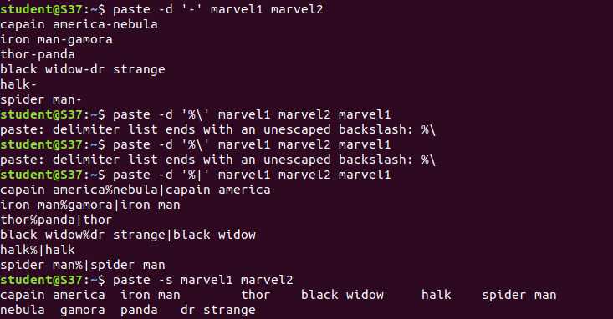

**12. Paste –s file1 file2**

This command is used to displays the contents as single line.

Syntax :- $ paste –s file1.txt file2.txt

Output :-



**13. More, more -3 filename,+3 filename**

This more command displays the output one screenful at a time ,more -3 command which displays the first 3 lines of contents and +3 displays the lines excepts the first three lines.

Syntax :- $ more filename.txt

$ more -3 filename.txt

$ more +3 filename.txt

Output :-

