**NETWORKING & SYSTEM ADMINISTRATION LAB**

**Name: Sreelakshmi Madhusoodhanan**

**Roll No: 39**

**Batch: B**

**Date: 25/04/2022**

**Experiment No.: 7**

**Aim**

Familiarization of the linux commands.

**Procedure**

**1. sudo useradd**

This command is used to add a user.

Syntax :- $ sudo useradd username

 Output :-

**2. passwd**

This command is used to create password for the user.

Syntax :- $ sudo passwd username

Output :-

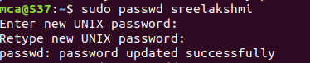

**3.groupadd**

This command is used to create new group.

Syntax :- $ sudo groupadd -g id groupname

Output :-



**4.usermod**

This command is used to add users to the group.

Syntax :- $ sudo usermod -G groupname usernme

Output :-



**5. id username**

This command which shows a particular user belongs to which group.

Syntax :- $ id username

Output:-



**6. compgen**

This command is used to view all groups.

Syntax :- $ compgen -g

Output:-

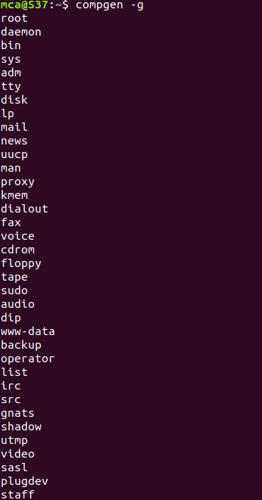

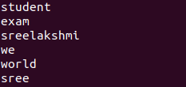

Syntax :- $ compgen -g groupname

Output:-



**7. userdel,groupdel**

This command is used to delete a user and group.

Syntax :- $ sudo userdel username

$ sudo groupdel groupname

Output:-

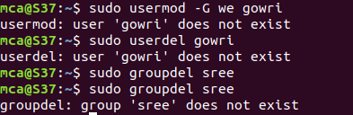

**8. chmod**

This command is used to change directory permission of files (read,write,execute).

Syntax :- $ chmod +rwx filename

$ chmod -wx filename

$ chmod -rwx filename

Output:-

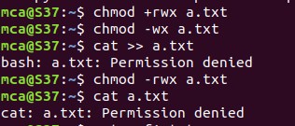

**9. chown, ls -l**

This command is used to give ownership to userand ls -l command is used to show the ownership details of a file.

Syntax :- $ sudo chown username filename

$ ls -l filename

Output:-



**10. ssh**

This command is used to provides a secure encrypted connection between two hosts over an insecure network.

Syntax :- $ sudo ssh [mca@ipaddress](mailto:mca@ipaddress)

Output:-

