 20MCA136 – NETWORKING & SYSTEM ADMINISTRATION LAB Dept. of Computer Applications

**NETWORKING & SYSTEM ADMINISTRATION LAB**

**Name: Sreelakshmi Madhusoodhanan**

**Roll No: 39**

**Batch: B**

**Date: 05/05/2022**

**Experiment No: 8**

**Aim**

Write shell script to print details.

**Program**

#!/bin/bash

echo "Enter your name:"

read name

echo "College name:"

read add

echo "Course of Study:"

read c

echo "Year"

read y

echo "Entererd details is:"

echo $name,$add,$c,$y

**Output**

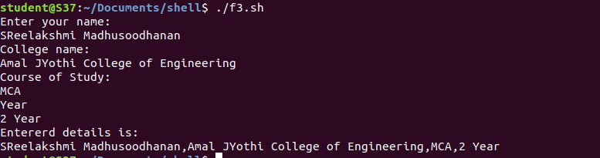

**Aim**

Write shell script program to find largest amoung 2 numbers..

**Program**

#!/bin/bash

echo "Enter the first number"

read a

echo "Enter the second number"

read b

if [ $a -gt $b ]

then

echo $a" is larger"

else

echo $b"is larger"

fi

**Output**

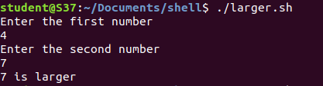

**Aim**

Write shell script program to find largest amoung 3 numbers.

**Program**

#!/bin/bash

echo "Enter the first number"

read a

echo "Enter the second number"

read b

echo "Enter the second number"

read c

if [ $a -gt $b ] && [ $a -gt $c ]

then

echo $a" is larger"

elif [ $b -gt $a ] && [ $b -gt $c ]

then

echo $b" is larger"

else

echo $c"is larger"

fi

**Output**

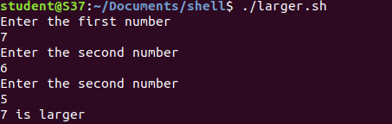

**Aim**

Write shell script program to find sum of two numbers.

**Program**

#!/bin/bash

echo "Enter the first number"

read a

echo "Enter the second number"

read b

if [ $a -gt $b ]

then

echo $a" is larger"

else

echo $b"is larger"

fi

**Output**

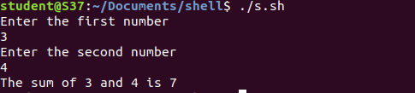

**Aim**

Write shell script program to check the number is even or odd.

**Program**

#!/bin/bash

echo "Enter the number"

read a

r=$(($a % 2))

if [ $r -eq 0 ]

then

echo "is even"

else

echo "is odd"

fi

**Output**

