**Name: Sreelakshmi Madhusoodhanan**

**Roll No: 39**

**Batch: S2 MCA**

**Date: 21-03-2022**

## NETWORKING & SYSTEM ADMINISTRATION LAB

**Experiment No.: 2**

## Aim:-

Identify major components of a computer system such as

* Motherboard
* Ram modules
* Daughters card
* Bus slots
* SMPS
* Internal storage devices
* Interfacing ports

## Motherboard

The motherboard is a printed [circuit board](https://www.computerhope.com/jargon/p/pcb.htm) and foundation of a computer that is the biggest board in a computer [chassis](https://www.computerhope.com/jargon/c/chassis.htm). It allocates power and allows communication to and between the [CPU](https://www.computerhope.com/jargon/c/cpu.htm), [RAM](https://www.computerhope.com/jargon/r/ram.htm), and all other computer [hardware](https://www.computerhope.com/jargon/h/hardware.htm) components. A motherboard provides connectivity between the hardware components of a computer, like the processor ([CPU](https://www.computerhope.com/jargon/c/cpu.htm)), memory ([RAM](https://www.computerhope.com/jargon/r/ram.htm)), [hard drive](https://www.computerhope.com/jargon/h/harddriv.htm), and [video card](https://www.computerhope.com/jargon/v/video-card.htm). There are multiple types of motherboards, designed to fit different types and sizes of computers.

Each type of motherboard is designed to work with specific types of processors and memory, so they don't work with every processor and type of memory. However, hard drives are mostly universal and work with the majority of motherboards, regardless of the type or brand.

A computer motherboard is located inside the [computer case](https://www.computerhope.com/jargon/c/chassis.htm) and is where most of the parts and computer [peripherals](https://www.computerhope.com/jargon/p/peripher.htm) connect. With [tower computers](https://www.computerhope.com/jargon/t/tower.htm), the motherboard is on the left or right side of the tower and is the biggest [circuit board](https://www.computerhope.com/jargon/p/pcb.htm).

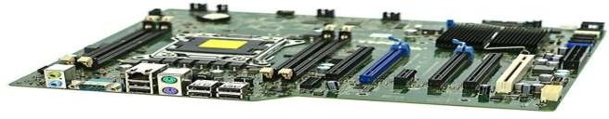

## RAM modules

Random-access memory is a form of [computer memory](https://en.wikipedia.org/wiki/Computer_memory) that can be read and changed in any order, typically used to store working [data](https://en.wikipedia.org/wiki/Data_(computing)) and [machine code](https://en.wikipedia.org/wiki/Machine_code). A [random-](https://en.wikipedia.org/wiki/Random_access) [access](https://en.wikipedia.org/wiki/Random_access) memory device allows [data](https://en.wikipedia.org/wiki/Data) items to be [read](https://en.wikipedia.org/wiki/Read_(computer)) or written in almost the same amount of time irrespective of the physical location of data inside the memory.

There are two main types of RAM: Dynamic RAM (DRAM) and Static RAM (SRAM). DRAM (pronounced DEE-RAM), is widely used as a computer's main memory. It can be thought of like a computer's short term memory. It works by storing common data that programs are in constant use of, rather than storing the data on a much slower medium like a Solid State Hard Drive (or SSD). RAM doesn't automatically have data saved on each chip though.

## Single In-Line Memory Module (SIMM)

SIMM modules were widely used from the late 1980s to 1990s, and are now obsolete. They typically had 32-bit data bus and were available in two physical types—30- and 72- pin.

## Dual In-Line Memory Module (DIMM)

Current memory modules come in DIMMs. "Dual in-line" refers to pins on both sides of the modules. A DIMM originally had a 168-pin connector supporting 64-bit data bus, which is twice the data width of SIMMs. The wider bus means that more data can pass through a DIMM, translating to faster overall performance. Latest DIMMs based on fourth-generation double data rate (DDR4) SDRAM have 288-pin connectors for increased data throughput.

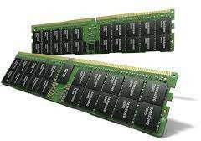

# Daughter guards

A daughterboard (or *daughter board* , *daughter card* , or *daughtercard* ) is a circuit board that plugs into and extends the circuitry of another circuit board. The other circuit board may be the computer's main board (its motherboard ) or it may be another board or card that is already in the computer, often a sound card. The term is commonly used by manufacturers of wavetable daughterboards that attach to existing sound cards.

A mezzanine card is a kind of daughterboard that is installed in the same plane as but on a second level above the motherboard.

A daughterboard is connected directly to the motherboard. Unlike expansion cards, which connect with the motherboard using bus and other serial interfaces, daughterboards are usually directly embedded through soldering. Like a motherboard, a daughterboard has sockets, pins, plugs and connectors to be attached to other boards. Typically, daughterboards are released as a post-launch update to a motherboard or expansion card. For example, a MIDI daughterboard is used to add on the functionality of the sound card.

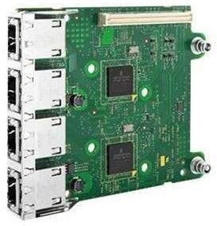

# Bus Slots

Computers have expansion slots to give the user the ability to add new devices to their computer. For example, a computer gamer may upgrade their [video card](https://www.computerhope.com/jargon/v/video-card.htm) to get better performance in their games. An expansion slot allows them to remove the old video card and add a new video card without replacing the motherboard.

Below is a listing of expansion slots commonly found in a computer and the devices associated with those slots.

* + AGP - Video card.
  + AMR - Modem, sound card.
  + CNR - Modem, network card, sound card.
  + EISA - SCSI, network card, video card.
  + ISA - Network card, sound card, video card.
  + PCI - Network card, SCSI, sound card, video card.
  + PCI Express - Video card, modem, sound card, network card.
  + VESA - Video card.

Many of the expansion card slots above are obsolete.

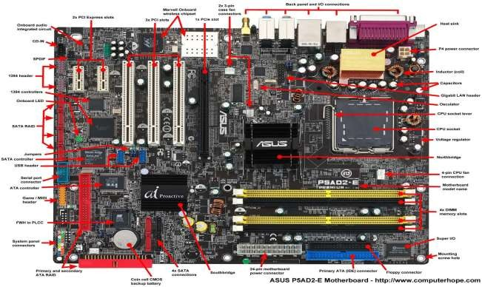

# SMPS

SMPS is an electronic power supply system that makes use of a switching regulator to transfer electrical power effectively. It is a PSU (power supply unit) and is usually used in computers to change the voltage to the appropriate range for the computer. A switched-mode power supply (SMPS) can be understood as an electronic circuit converting power with switching devices that turn on and off at high frequencies. They are also storage component like inductors or capacitors that supplies power when the switching as at its non-conduction state.

An SMPS adjusts output voltage and current between different electrical configurations by switching the basics of typically lossless storage such as capacitors and inductors. Ideal switching concepts determined by transistors controlled outside of their active state that have no resistance when ‘on’ and carry no current when ‘off.’ It is the idea why switches with an ideal function will operate with 100 per cent output, that is, all input energy is provided to the load; no power is wasted as dissipated heating. In fact, such ideal systems do not exist, which is why a switching power source can not be 100 per cent proficient, but it is still a vital improvement in effectiveness over a linear regulator.

Switch mode power supplies, SMPS provide improved efficiency & space saving over traditional linear supplies, but care has to be taken to ensure noise on the output is low. Switch mode power supplies are widely used because of the advantages they offer in terms of size, weight, cost, efficiency and overall performance.

## Benefits of SMPS

* + The switch-mode power source is small in scale.
  + The SMPS is very lightweight.
  + SMPS power consumption is typically 60 to 70 per cent, which is ideal for use.
  + SMPS is strongly anti-interference.
  + The SMPS production range is large.

## Limitations of SMPS

* + The complexity of SMPS is very large.
  + The production reflection is high and its control is weak in the case of SMPS.
  + Use of SMPS can only be a step-down regulator.
  + In SMPS, the voltage output is just one.

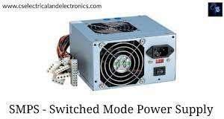

# Internal storage devices

A storage unit is a part of the computer system which is employed to store the information and instructions to be processed. A storage device is an integral part of the computer hardware which stores information/data to process the result of any computational work.

Internal storage can mean several different things, but most often refers to a computer's [internal hard drive](https://pc.net/glossary/definition/internalharddrive). This is the primary [storage device](https://pc.net/glossary/definition/storagedevice) used to store a user's [files](https://pc.net/glossary/definition/file) and [applications](https://pc.net/glossary/definition/application). If a computer has multiple internal hard drives, they are all considered part of the computer's internal storage.

Another popular type of internal storage is [flash memory](https://pc.net/glossary/definition/flashmemory). It serves the same purpose as a hard drive, but stores data electronically rather than magnetically. Flash memory is the most common type of internal storage used by portable electronic devices, such as mobile phones and portable music players. Some computers now use flash drives rather than [hard drives](https://pc.net/glossary/definition/harddrive) as well.

Internal storage can be contrasted with external storage, which includes devices such as [external hard drives](https://pc.net/glossary/definition/externalharddrive), network drives, and removable media, such as [CDs](https://pc.net/glossary/definition/cd) and [DVDs](https://pc.net/glossary/definition/dvd).

1. **Hard Disk Drives**

A hard disk drive (also known as a hard drive, HD, or HDD) can be found installed in almost every desktop and laptop computer. It stores files for the operating system and software programs as well as user documents, such as photographs, text files, videos, and audio. The hard drive uses magnetic storage to record and retrieve digital information to and from one or more fast-spinning disks.

1. **Floppy Disks**

Also know as a diskette, floppy, or FD, the floppy disk is another type of storage medium that uses magnetic storage technology to store information. Floppy disks were once a common storage device for computers and were very common from the mid- 1970s through to the start of the 21st century.

## Tapes

In the past, magnetic tape was often used for digital data storage because of its low cost and ability to store large amounts of data. The technology essentially consisted of a thin, magnetically coated piece of plastic wrapped around wheels. Its relative slowness

and unreliability compared to other data storage solutions have resulted in it now being largely abandoned as a storage medium.

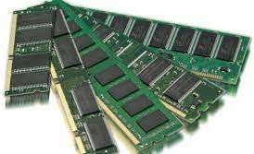

# Interfacing ports

A Computer Port is an interface or a point of connection between the computer and its peripheral devices. Some of the common peripherals are mouse, keyboard, monitor or display unit, printer, speaker, flash drive etc.

The main function of a computer port is to act as a point of attachment, where the cable from the peripheral can be plugged in and allows data to flow from and to the device.

**PS/2**

PS/2 connector is developed by IBM for connecting mouse and keyboard. It was introduced with IBM’s Personal Systems/2 series of computers and hence the name PS/2 connector. PS/2 connectors are color coded as purple for keyboard and green for mouse.

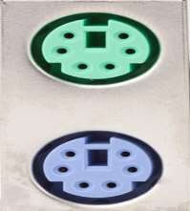

## Serial Port

Even though the communication in PS/2 and USB is serial, technically, the term Serial Port is used to refer the interface that is compliant to RS-232 standard. There are two types of serial ports that are commonly found on a computer: DB-25 and DE-9.

### DB-25

DB-25 is a variant of D-sub connector and is the original port for RS-232 serial communication. They were developed as the main port for serial connections using RS- 232 protocol but most of the applications did not require all the pins.

Hence, DE-9 was developed for RS-232 based serial communication while DB-25 was rarely used as a serial port and often used as a parallel printer port as a replacement of the Centronics Parallel 36 pin connector.

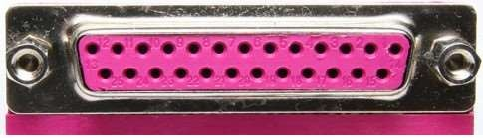

### DE-9 or RS-232 or COM Port

DE-9 is the main port for RS-232 serial communication. It is a D-sub connector with E shell and is often miscalled as DB-9. A DE-9 port is also called as a COM port and allows full duplex serial communication between the computer and it’s peripheral.

Some of the applications of DE-9 port are serial interface with mouse, keyboard, modem, uninterruptible power supplies (UPS) and other external RS-232 compatible devices.

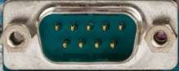

## Parallel Port or Centronics 36 Pin Port

Parallel port is an interface between computer and peripheral devices like printers with parallel communication. The Centronics port is a 36 pin port that was developed as an interface for printers and scanners and hence a parallel port is also called as a Centronics port.

Before the wide use of USB ports, parallel ports are very common in printers. The Centronics port was later replaced by DB-25 port with parallel interface.

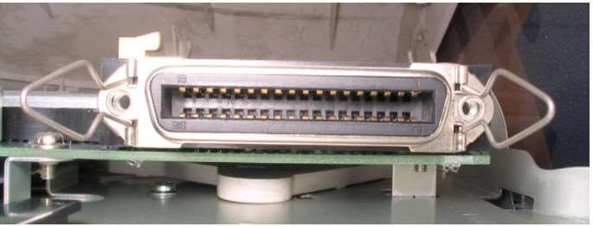

## Audio Ports

Audio ports are used to connect speakers or other audio output devices with the computer. The audio signals can be either analogue or digital and depending on that the port and its corresponding connector differ.

### Surround Sound Connectors or 3.5 mm TRS Connector

It is the most commonly found audio port that can be used to connect stereo headphones or surround sound channels. A 6 connector system is included on majority of computers for audio out as well as a microphone connection.

The 6 connectors are color coded as Blue, Lime, Pink, Orange, Black and Grey. These 6 connectors can be used for a surround sound configuration of up to 8 channels.

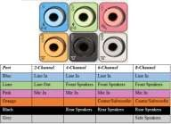

## Video Ports

### VGA Port

VGA port is found in many computers, projectors, video cards and High Definition TVs. It is a D-sub connector consisting of 15 pins in 3 rows. The connector is called as DE-15.

VGA port is the main interface between computers and older CRT monitors. Even the modern LCD and LED monitors support VGA ports but the picture quality is reduced. VGA carries analogue video signals up to a resolution of 648X480.

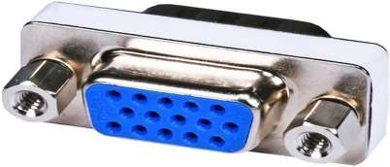

## Display Port

Display Port is a digital display interface with optional multiple channel audio and other forms of data. Display Port is developed with an aim of replacing VGA and DVI ports as the main interface between a computer and monitor.

The latest version DisplayPort 1.3 can handle a resolution up to 7680 X 4320.

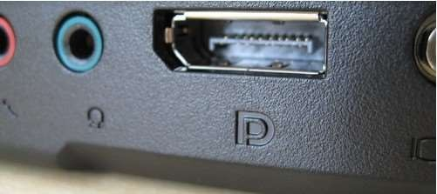

### Mini DisplayPort

Apple introduced a miniature version of DisplayPort and called it Mini DisplayPort (mDP or Mini DP). Even though Mini DisplayPort has 20 pins, the physical size of the connector is smaller than a regular DisplayPort and the pin out is also different.

