**Name: Sreelakshmi Madhusoodhanan**

**Roll No:39**

**Batch: MCA-R**

**Date:**

**NETWORKING & SYSTEM ADMINISTRATION LAB**

**Experiment No.: 1**

**Aim**

Install the latest version of Ubuntu on an Oracle VM VirtualBox.

**Procedure**

**Step 1:** Install VirtualBox, then click "Next".

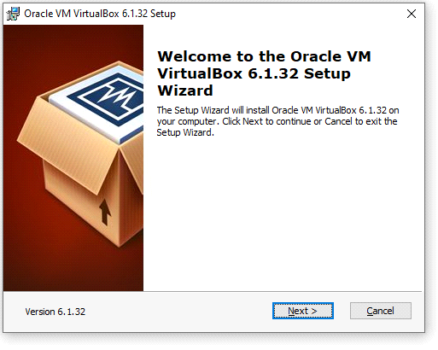

**Step 2:** Select features.

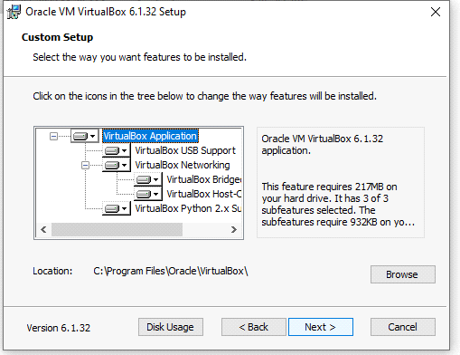

**Step 3:** Choose the options.

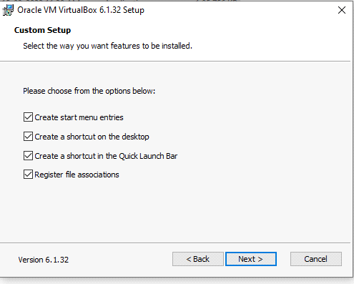

**Step 4:** Proceeding installation.

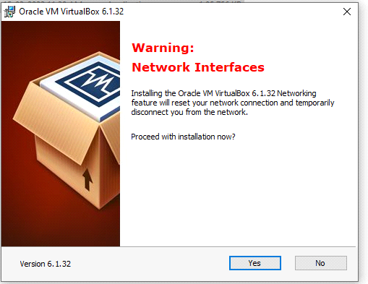

**Step 5:** Ready to install.

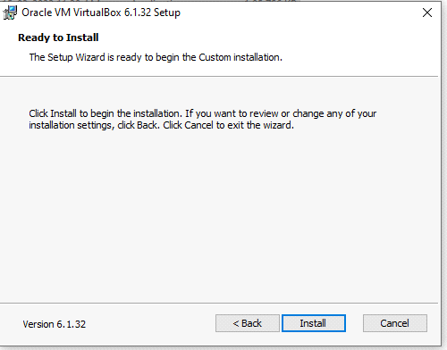

**Step 6:** Installing the Oracle vm virtualBox.

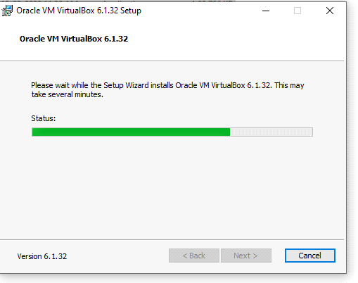

**Step 7:** Installation finished.

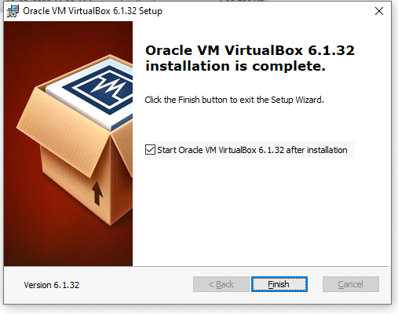

**Step 8:** Open VirtualBox, then click "New" to create a virtual machine.

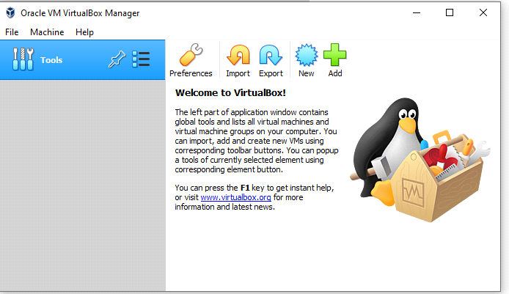

**Step 9:** Enter "Ubuntu" as the name, select "Linux" as the type, and select Ubuntu (64-bit) as the version. Select any amount of memory you wish, but don't add more than 50 percent of your total RAM.

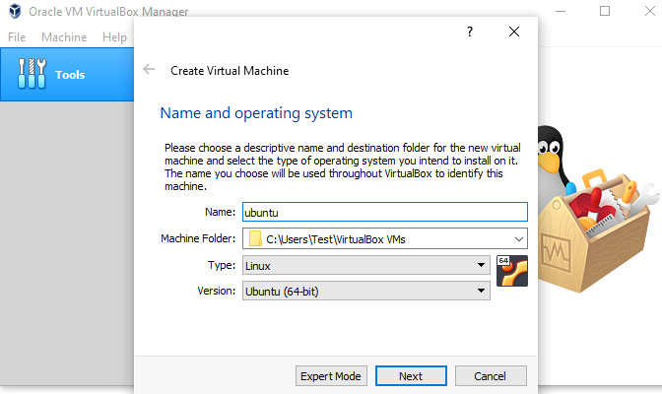

**Step 10:** We want to specify Memory size.

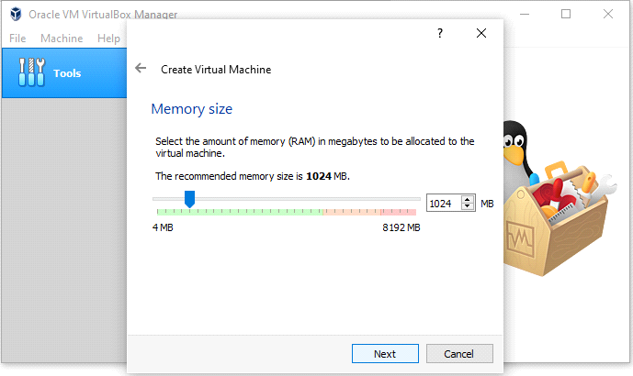

**Step 11:** Check the "Create a virtual hard disk now" option so we can later define our Ubuntu OS virtual hard disk size.

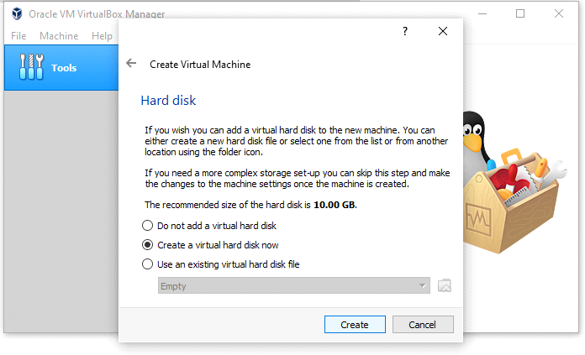

**Step 12:** Now, we want to select "VHD (Virtual Hard Disk)".

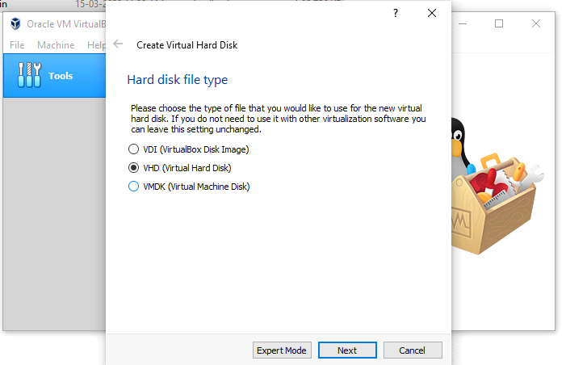

**Step 13:** Next, we'll dynamically allocate storage on our physical hard disk.

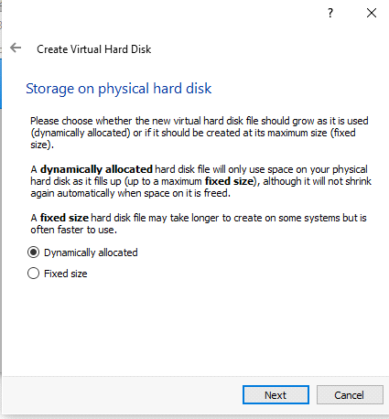

**Step 14:** We want to specify our Ubuntu OS's size. The recommended size is 10 GB, but you can increase the size if you wish.

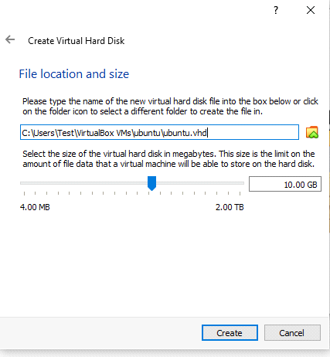

**Step 15:** After creating a virtual hard disk, you'll see Ubuntu in your dashboard.

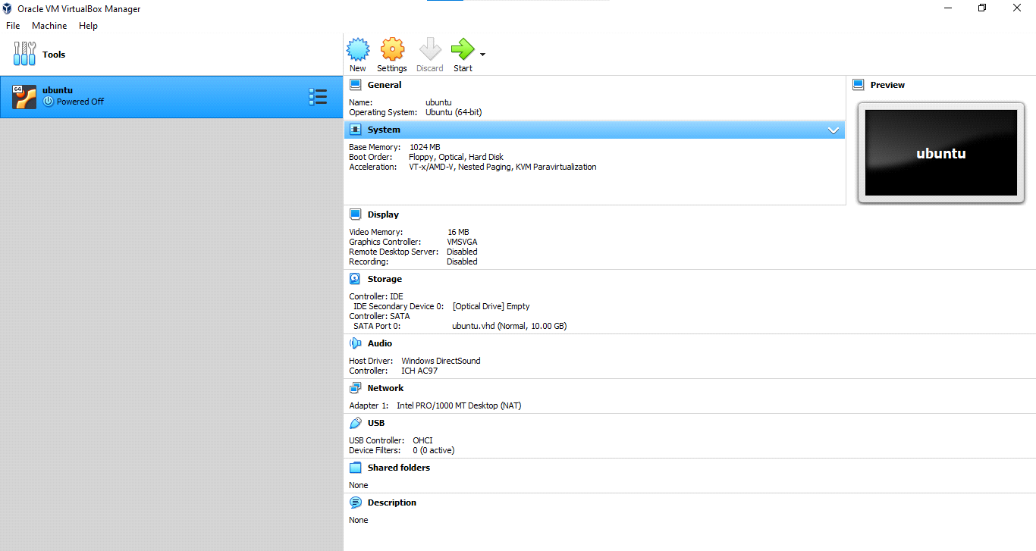

**Step 16:** Now, we have to set up the Ubuntu disk image file (.iso).

The Ubuntu disk image file can be downloaded here: [Ubuntu OS download](https://ubuntu.com/#download)

To set up the Ubuntu disk image file, go to settings and follow these steps:Click "Storage".

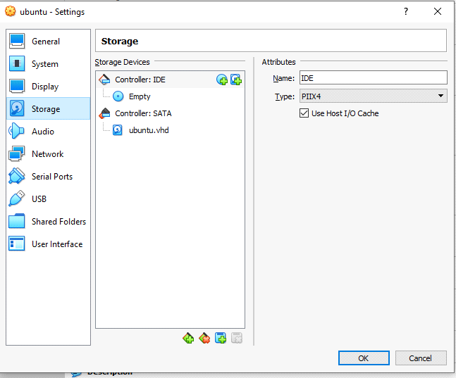

**Step 17:** In storage devices, click "Empty", then click the disk image and "Choose Virtual Optical Disk File" and Select the Ubuntu disk image file and open it. Click OK. Your Ubuntu OS is ready to install in VirtualBox. Let's start!

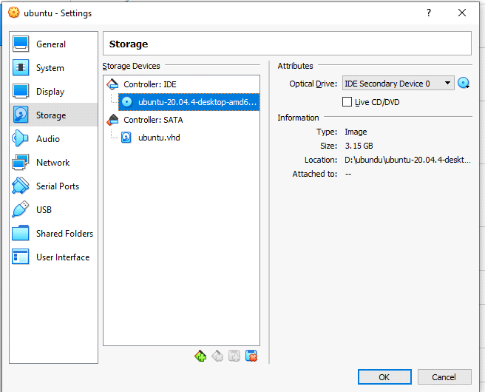

**Step 18:** Click Install Ubuntu.

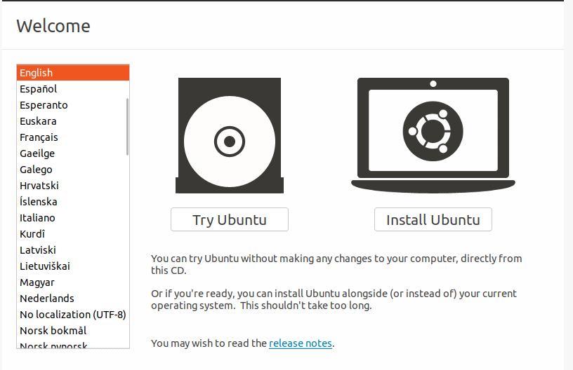

**Step 19:** Select your keyboard layout.

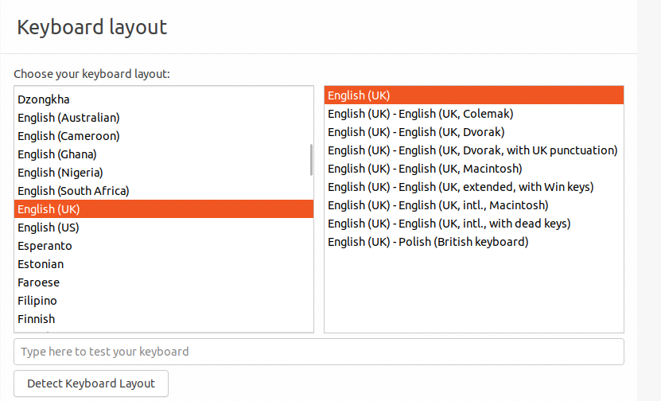

**Step 20:** In the "Updates and other software" section, check "Normal installation" and continue.

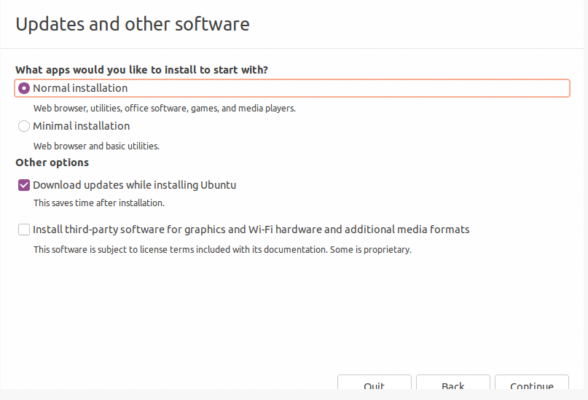

**Step 21:** In "Installation type", check "Erase disk and install Ubuntu"and Click "Continue".

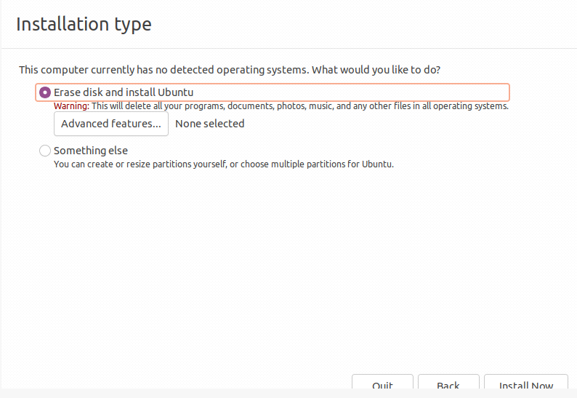

**Step 22:** Now, set up your profile.

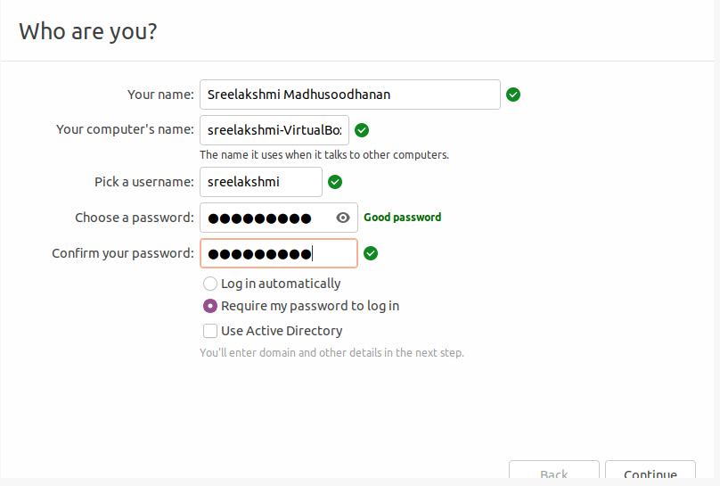

**Step 23:** You'll see Ubuntu installing.

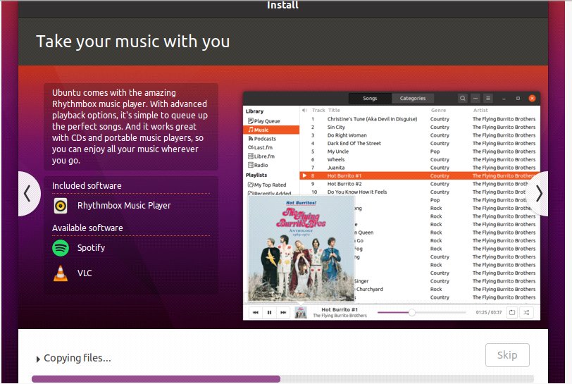

**Step 24:** After the installation, restart it.

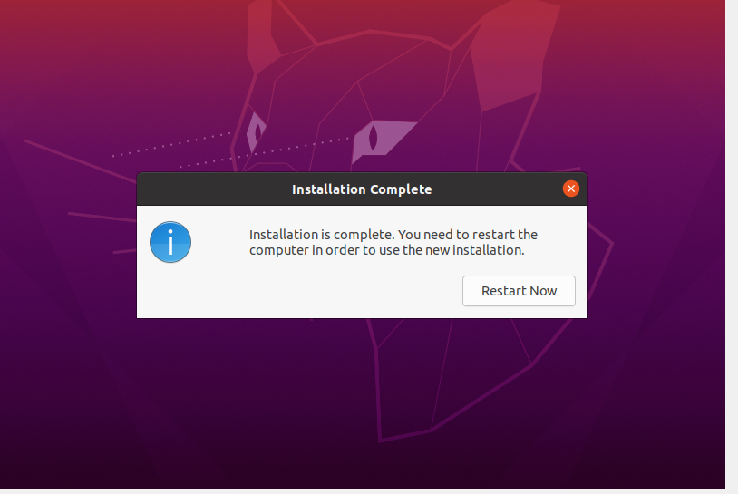

**Step 25:** After logging in, you'll see the Ubuntu desktop.

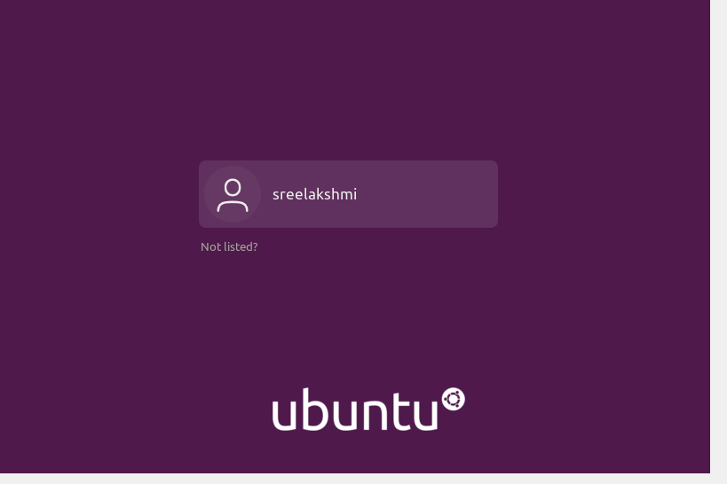

**Step 26:**

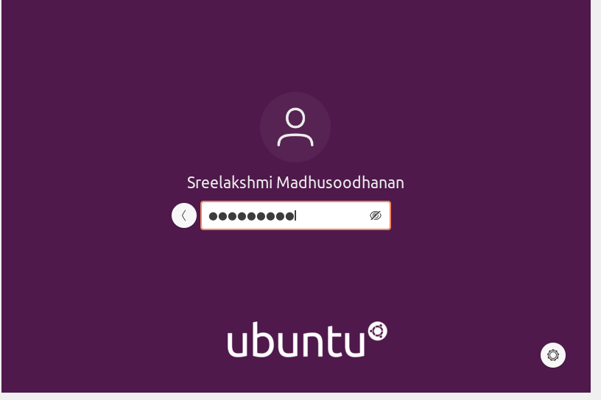

**Step 27:**

We have successfully installed Ubuntu in VirtualBox. It's ready to use for your future development projects.

**Output Screenshot**

