**Experiment No.: 10**

**Aim**

 Linear Regression

**Program**

**1)Simple Linear Regression**

import numpy as np

import matplotlib.pyplot as plt

def estimate_coef(x, y):

# number of observations/points

n = np.size(x)

# mean of x and y vector

m_x = np.mean(x)

m_y = np.mean(y)

# calculating cross-deviation and deviation about x

SS_xy = np.sum(y*x) - n*m_y*m_x

SS_xx = np.sum(x*x) - n*m_x*m_x

# calculating regression coefficients

b_1 = SS_xy / SS_xx

b_0 = m_y - b_1*m_x

return (b_0, b_1)

def plot_regression_line(x, y, b):

# plotting the actual points as scatter plot

plt.scatter(x, y, color = "m",

marker = "o", s = 30)

# predicted response vector

y_pred = b[0] + b[1]*x

# plotting the regression line

plt.plot(x, y_pred, color = "g")

# putting labels

plt.xlabel('x')

plt.ylabel('y')

# function to show plot

plt.show()

def main():

# observations / data

x = np.array([0, 1, 2, 3, 4, 5, 6, 7, 8, 9])

y = np.array([1, 3, 2, 5, 7, 8, 8, 9, 10, 12])

# estimating coefficients

b = estimate_coef(x, y)

print("Estimated coefficients:\nb_0 = {} \

\nb_1 = {}".format(b[0], b[1]))

# plotting regression line

plot_regression_line(x, y, b)

if __name__ == "__main__":

main()

**output:**

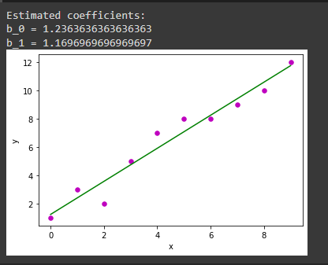

**2)Multiple Linear Regression**

import matplotlib.pyplot as plt

import numpy as np

from sklearn import datasets, linear_model, metrics

# load the boston dataset

boston = datasets.load_boston(return_X_y=False)

# defining feature matrix(X) and response vector(y)

X = boston.data

y = boston.target

# splitting X and y into training and testing sets

from sklearn.model_selection import train_test_split

X_train, X_test, y_train, y_test = train_test_split(X, y, test_size=0.4,

random_state=1)

# create linear regression object

reg = linear_model.LinearRegression()

# train the model using the training sets

reg.fit(X_train, y_train)

# regression coefficients

print('Coefficients: ', reg.coef_)

# variance score: 1 means perfect prediction

print('Variance score: {}'.format(reg.score(X_test, y_test)))

# plot for residual error

## setting plot style

plt.style.use('fivethirtyeight')

## plotting residual errors in training data

plt.scatter(reg.predict(X_train), reg.predict(X_train) - y_train,

color = "green", s = 10, label = 'Train data')

## plotting residual errors in test data

plt.scatter(reg.predict(X_test), reg.predict(X_test) - y_test,

color = "blue", s = 10, label = 'Test data')

## plotting line for zero residual error

plt.hlines(y = 0, xmin = 0, xmax = 50, linewidth = 2)

## plotting legend

plt.legend(loc = 'upper right')

## plot title

plt.title("Residual errors")

## method call for showing the plot

plt.show()

**Output:**

