20MCA132 –OBJECT ORIENTED PROGRAMMING LAB Dept. of Computer Applications

|  |
| --- |
| **Name: SREELAKSHMI R**  **Roll No:41**  **Batch:MCA**  **Date:06/04/22** |

# OBJECT ORIENTED PROGRAMMING LAB

## Experiment No.: 4

## Aim

Read a matrix from the console and check whether it is symmetric or not.

## Procedure

**Source Code**

import java.util.Scanner; public class SymmetricMatrix {

public void Display(int [][] arr,int row,int col){ for(int i=0;i<row;i++){ for(int j=0;j<col;j++){

System.out.print(arr[i][j]+"\t");

}

System.out.println();

}

}

public static void main(String[] args) { int [][] mat = new int[3][3]; int [][] trans=new int[3][3]; int row,col;

SymmetricMatrix obj=new SymmetricMatrix();

Scanner s=new Scanner(System.in);

System.out.println("Enter the rows and columns of the matrix:"); row=s.nextInt(); col=s.nextInt();

System.out.println("Enter the elements of the matrix:"); for(int i=0;i<row;i++)

{ for(int j=0;j<col;j++)

{ mat[i][j]=s.nextInt();

20MCA132 –OBJECT ORIENTED PROGRAMMING LAB Dept. of Computer Applications

}

}

for(int i=0;i<row;i++)

{ for(int j=0;j<col;j++)

{ trans[j][i]=mat[i][j];

}

}

System.out.println("Entered matrix:"); obj.Display(mat,row,col);

System.out.println("Transpose of the matrix:"); obj.Display(trans,row,col); for(int i=0;i<row;i++){ for(int j=0;j<col;j++){ if(mat[i][j]!=trans[i][j]){

System.out.println("Matrix is not symmetric.");

System.exit(0);

}

}

}

System.out.println("The given matrix is symmetric.");

}

}

**OUTPUT SCREENSHOT**

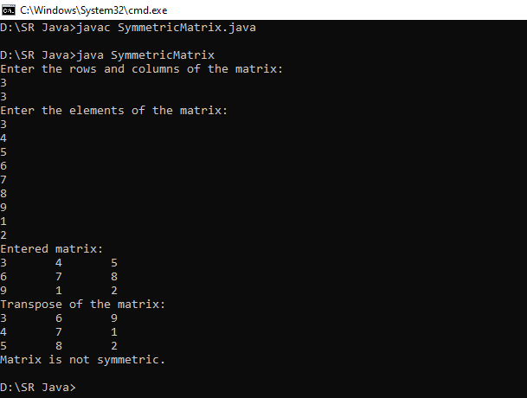

Amal Jyothi College of Engineering, Kanjirappally