**NETWORKING & SYSTEM ADMINISTRATION LAB**

**Name: Sreelakshmi R**

**Roll No: 41**

**Batch: S2B**

**Date: 23/05/2022**

**Experiment No.: 24**

**Aim**

## Setting Up an Apache Container

**Procedure**

**Step 1:** Pull Docker Apache Container

**$ sudo docker run -dit --name tecmint-web -p 8080:80 -v /home/user/website/:/usr/local/apache2/htdocs/ httpd:2.4**

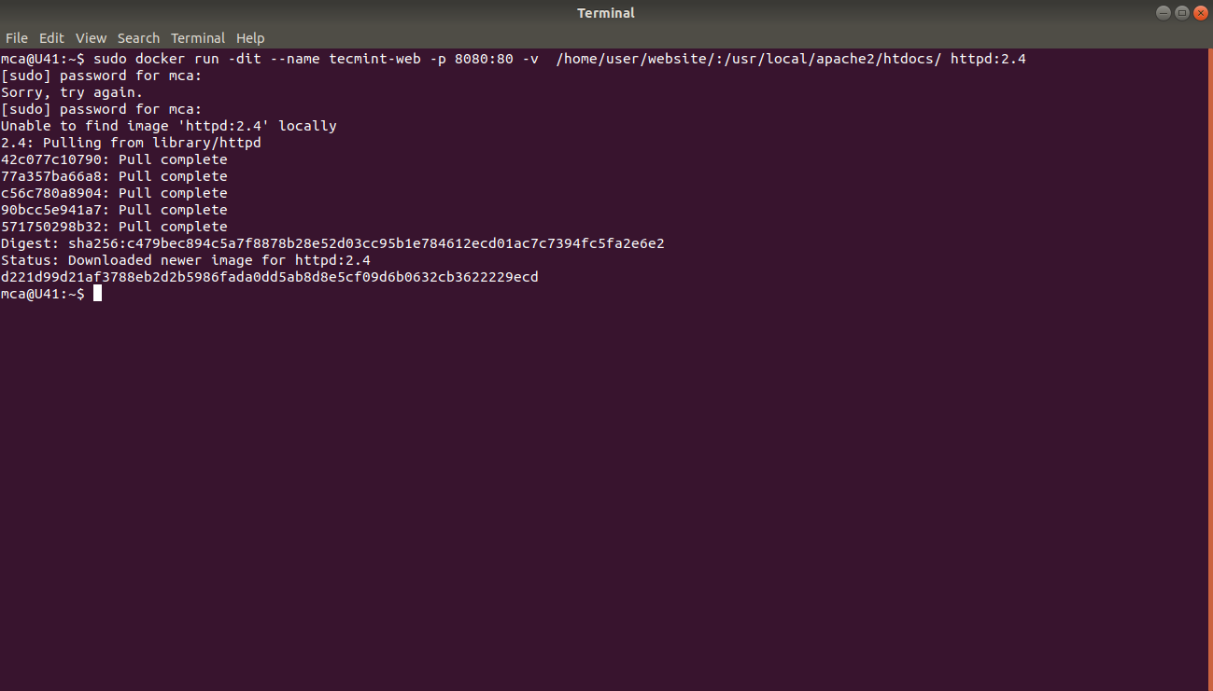

At this point, our Apache container should be up and running.

**Step 2:** Check Apache Docker Container.

**$ sudo docker ps**



Now let’s create a simple web page named docker.html inside the /home/user/website directory.

**Step 3: $ sudo gedit /home/user/website/docker.html**

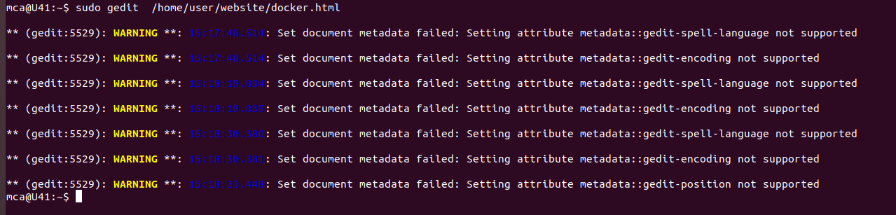

Add the following sample HTML content to the file.

<!DOCTYPE html>

<html lang="en">

<head>

<meta charset="UTF-8">

<title>Learn Docker at Tecmint.com</title>

</head>

<body>

<h1>Learn Docker With Us</h1>

</body>

</html>

Next, point your browser to Server-IP:8080/docker.html (where Server-IP is your host’s public IP address). You should be presented with the page we created previously.

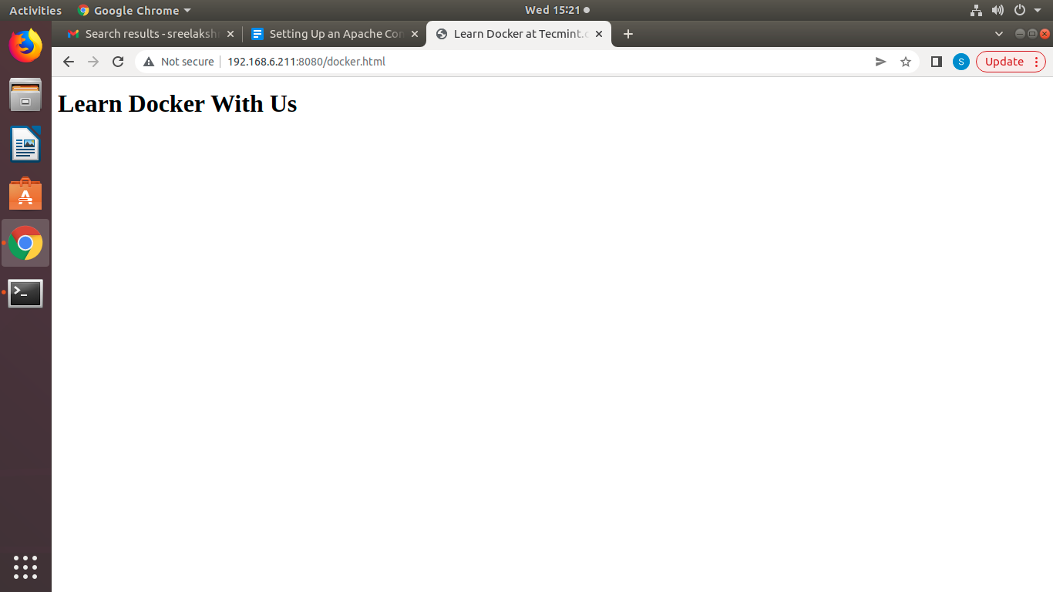

**Step 4:** If you wish, you can now stop the container.

**$ sudo docker stop tecmint-web**

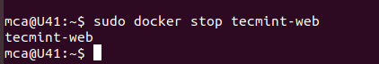

**Step 5:**  Remove it

**$ sudo docker rm tecmint-web**

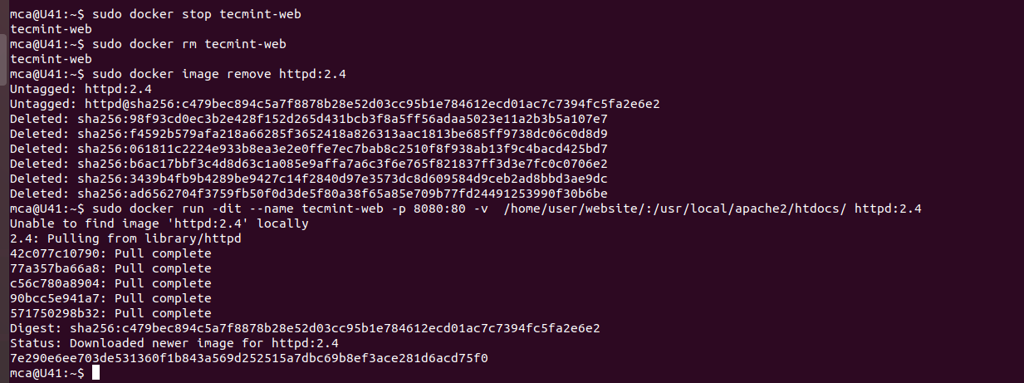

**Step 6 :** To finish cleaning up, you may want to delete the image that was used in th container (omit this step if you’re planning on creating other Apache 2.4 containers soon).

**$ sudo docker image remove httpd:2.4**



Note that in all the above steps we never had to install the webserver on our host.

**Step 7: $ sudo docker run -dit --name tecmint-web -p 8080:80 -v /home/user/website/:/usr/local/apache2/htdocs/ httpd:2.4**

