**Name: Sreelakshmi R**

**Roll No: 41**

**Batch: S2B RMCA**

**Date: 06/06/22**

**NETWORKING & SYSTEM ADMINISTRATION LAB**

**Experiment No.: 26**

**Aim**

Wireshark

**Procedure**

1. **sudo apt install wireshark :** Wireshark’s latest version has been added to the APT, you can download and install.

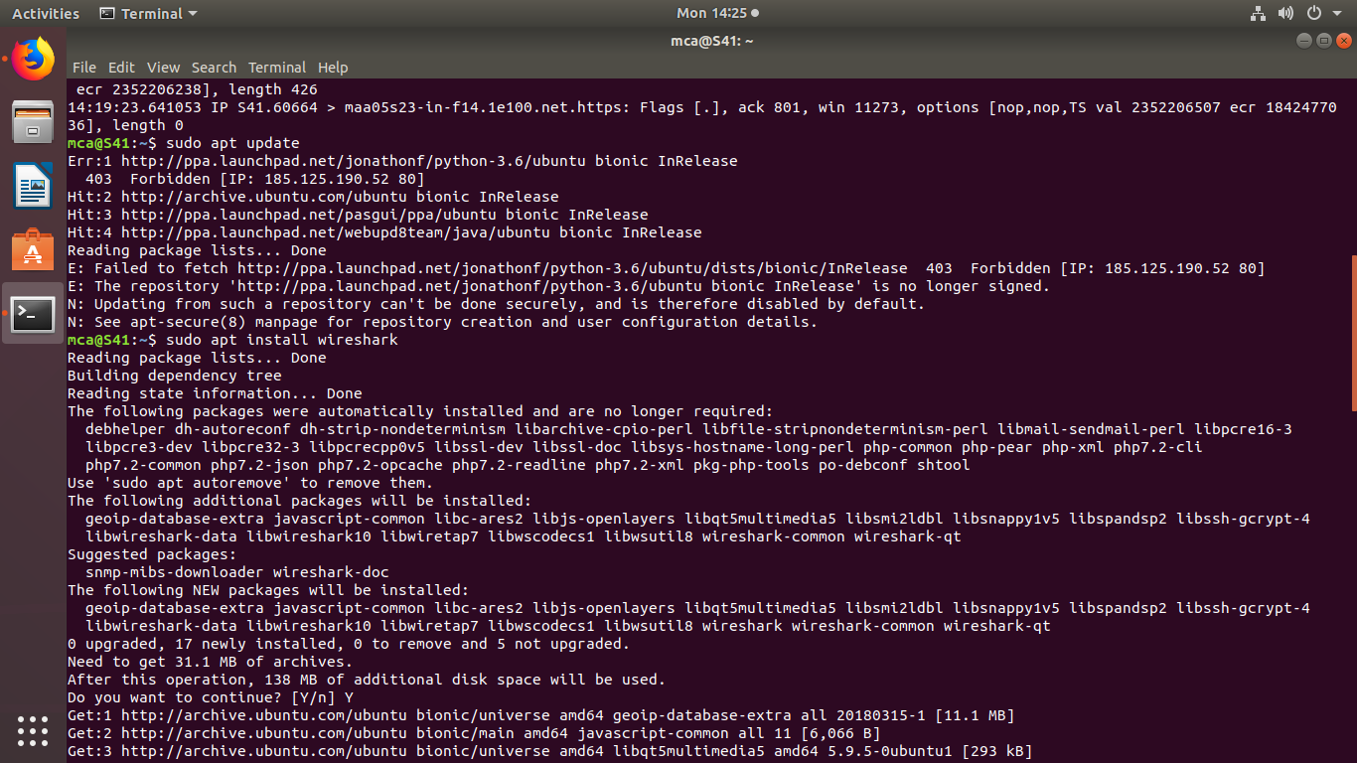

1. **sudo adduser $USER wireshark :**

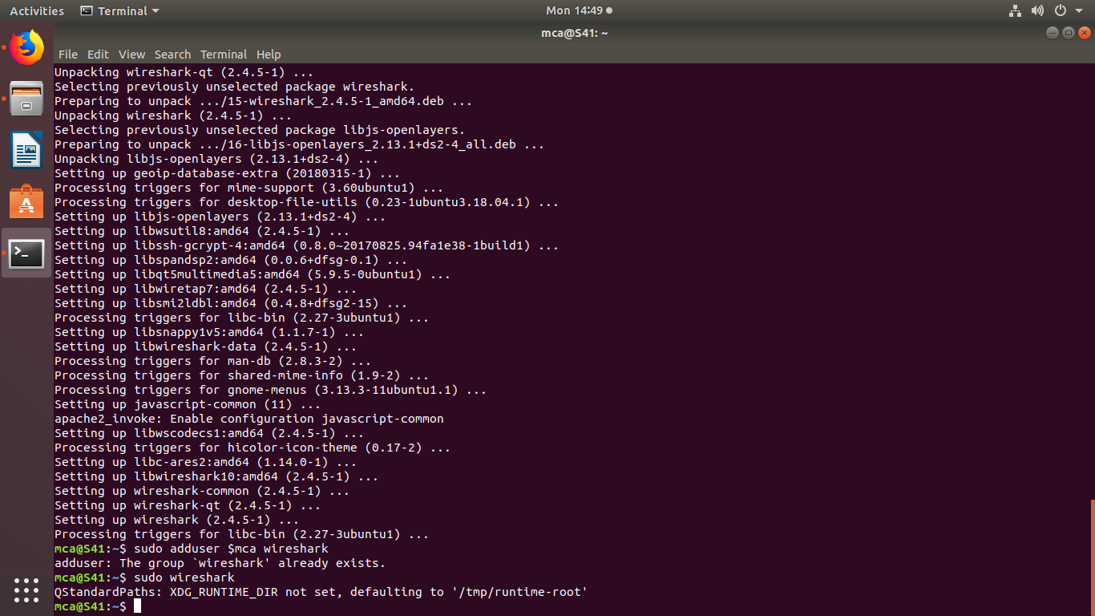

1. **sudo wireshark :** To start wireshark application.



**4.Capturing packet using wireshark :** List of interfaces that you can capture packets to and from. There are many types of interfaces you can monitor using Wireshark, for example,**Wired**, **Wireless,** USB and many external devices. You can choose to show specific types of interfaces in the welcome screen from the marked section of the 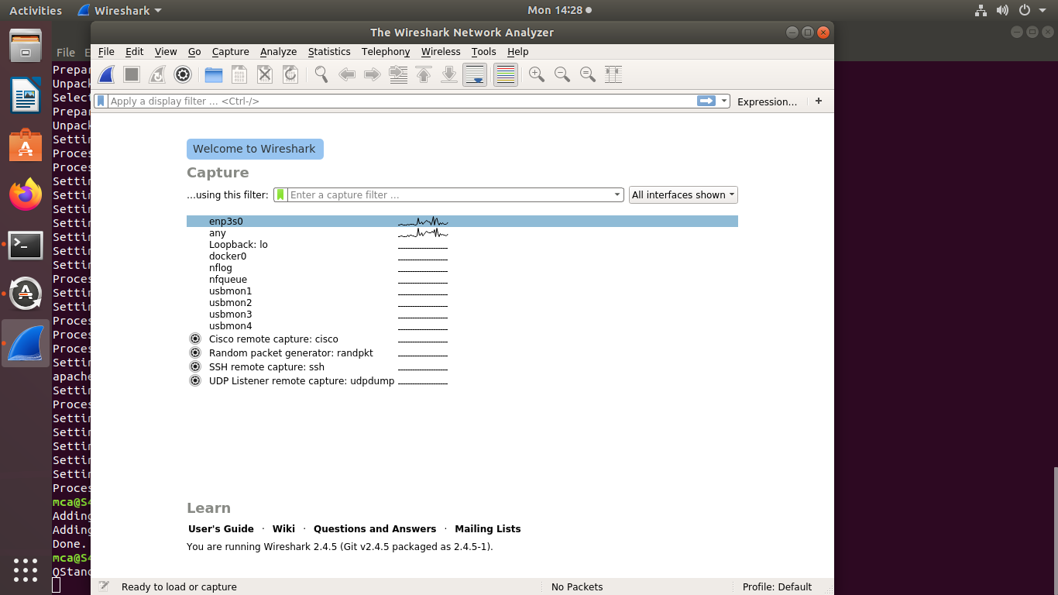

screenshot below:

Many packets were captured:

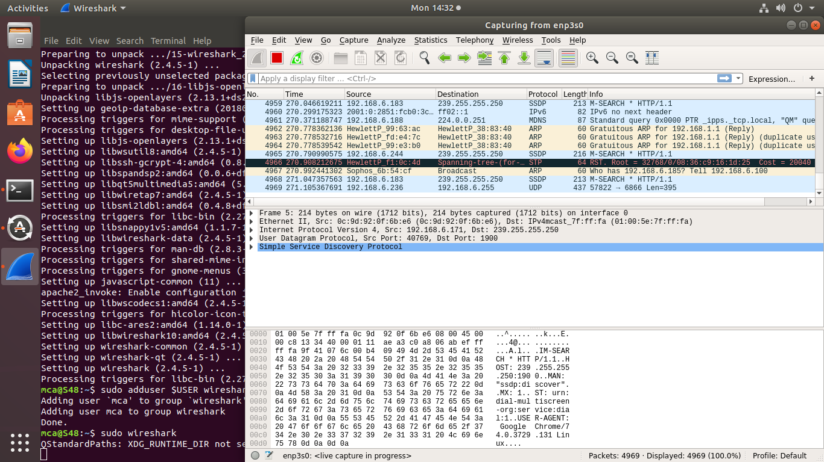

1. **sudo apt –get install netcat :** Installing netcat.



1. **sudo nc –l –p 443 :** To set up the server using Netcat in listening mode. We will use port 12345 and will specify the port number with the -p option.

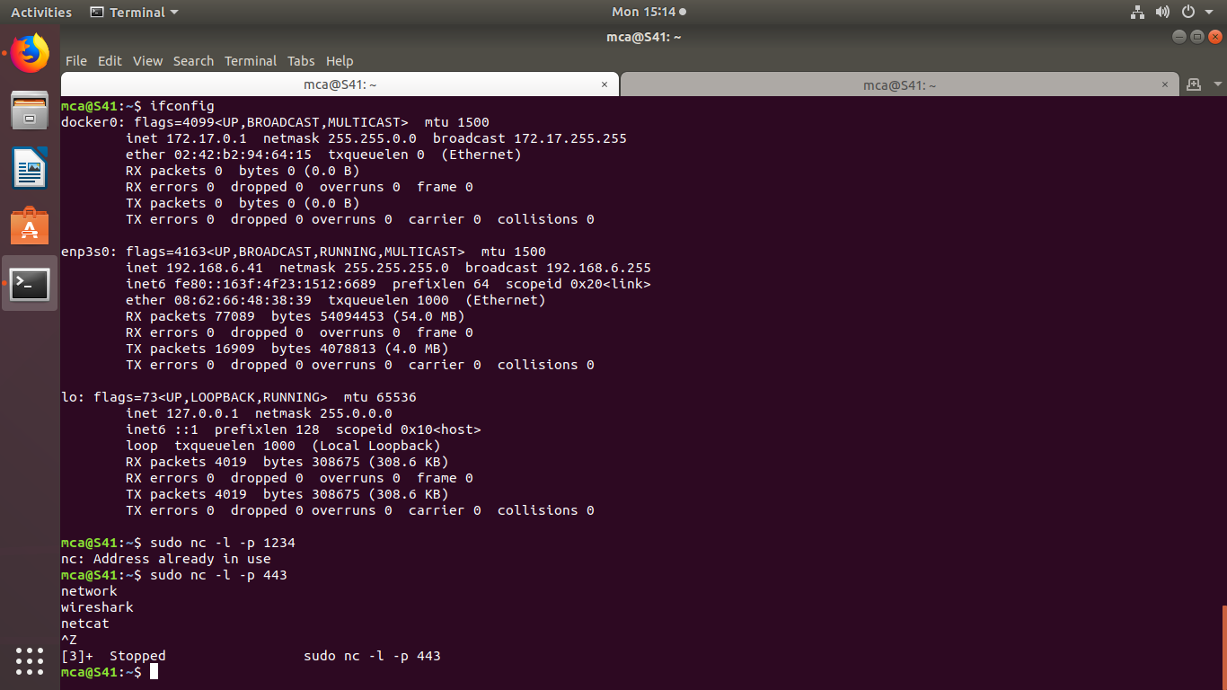

1. **nc localhost 1234 :** The client needs the server ip to connect to it. My server and my client are on the same machine so I use localhost for the hostname. The command ‘nc hostname port’ puts Netcat in client mode and connects to the specified hostname on the specified port.

