RA1911029010074_SREELAKSHMI NAMBIAR

AIM-RIP Configuration in Packet Tracer

PROCEDURE-First we take each of the required devices and connect them

We then configure each of the router and the PCs we also make sure to set the default gateway in the PCs

router rip command tells the router to enable the RIP routing protocol.

network command allows us to specify the networks which we want to advertise.

We only need to specify the networks which are directly connected with the router.

Access the command prompt of PC0 and use ping command to test the connectivity from PC1

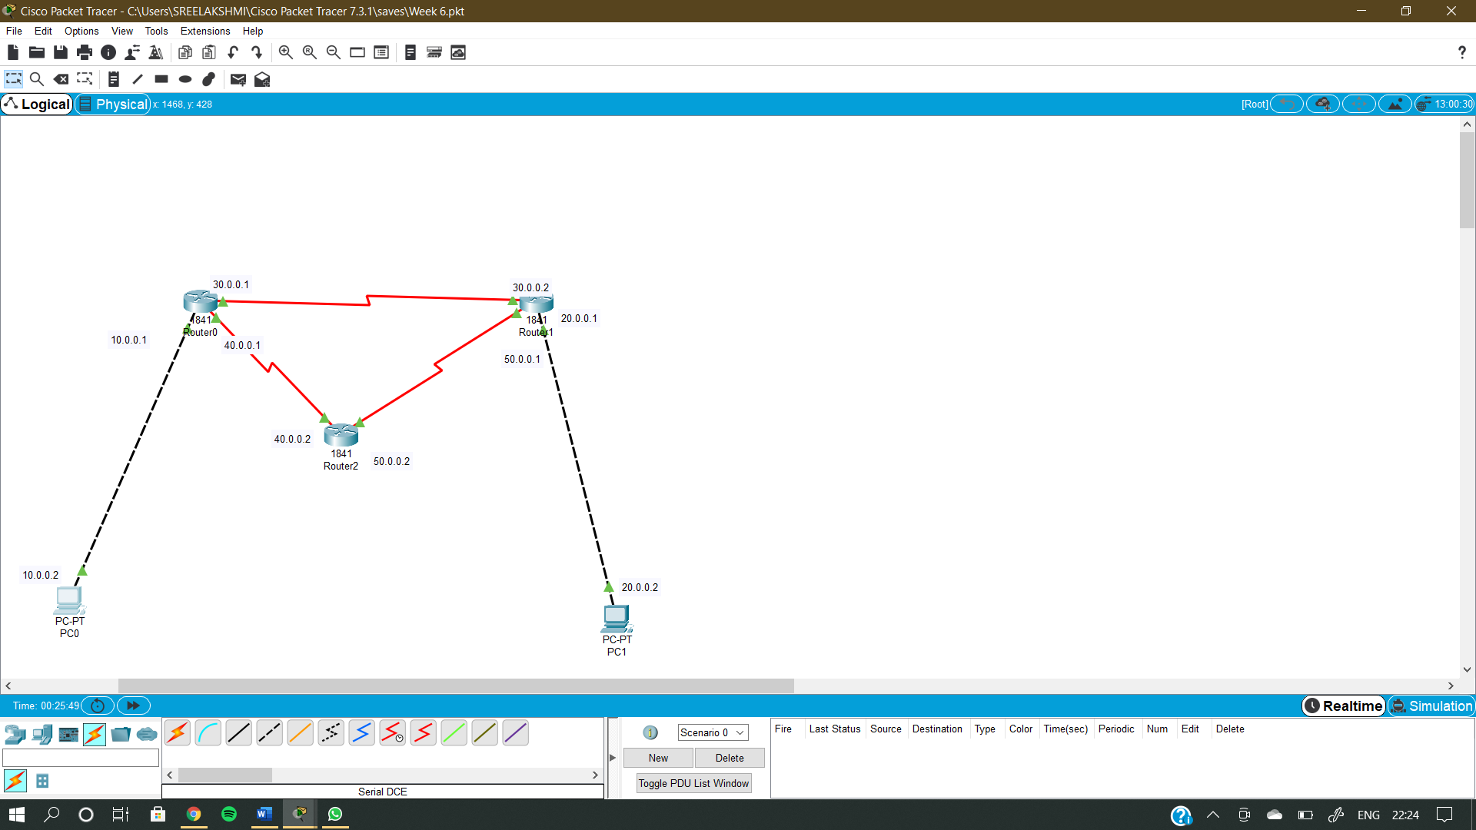

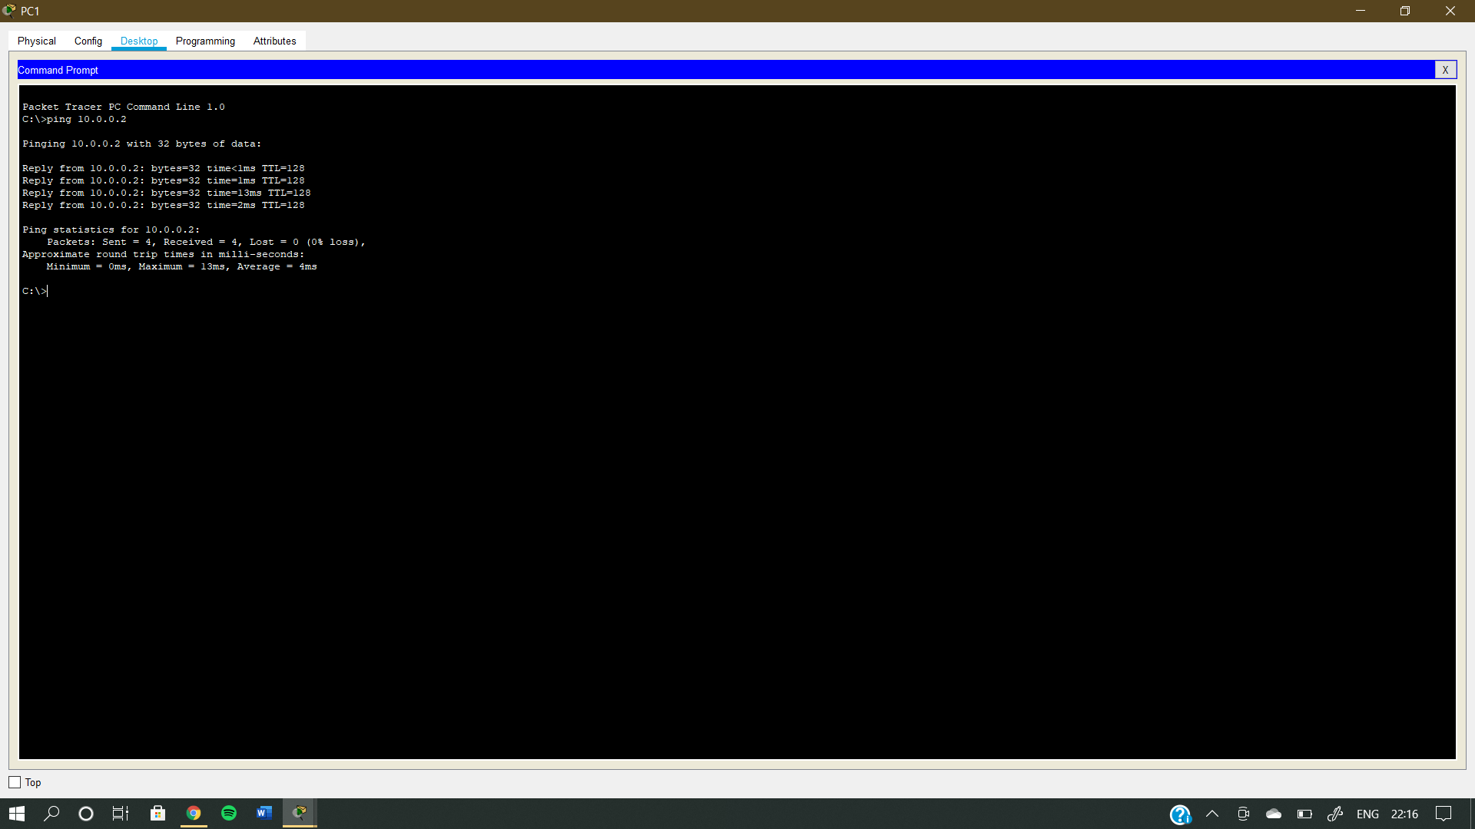

RESULT- We achieved RIP