Overfitting Analysis and Regularization in MNIST Handwritten Digit Recognition
Sree Krishnan M
sreelm10sj@gmail.com
GitHub Repository: https://github.com/Sreelm10sj/mnist-overfit-regularization

Abstract— This report presents an empirical study of overfitting and its mitigation in fully connected neural networks trained on the MNIST handwritten digit dataset. The experimental pipeline was implemented in four stages. Stage 1 established a fixed data preparation pipeline in which the complete MNIST dataset of 70,000 images was partitioned into training (50,000), validation (10,000), and test (10,000) subsets, which remained unchanged throughout the study. Stage 2 trained a compact baseline network (≈109K parameters) that generalized well, achieving 97.35% validation accuracy with a small generalization gap of only 1.45 percentage points. Stage 3 introduced a substantially larger fully connected architecture (≈25 million parameters) and trained it without regularization, producing severe overfitting: training loss converged to 0.009 while validation loss increased to 0.226 despite continued improvement in training performance. Stage 4 reused the identical high-capacity architecture from Stage 3 without any structural modification and retrained it using L2 weight decay, geometric data augmentation, and a reduced learning rate. These interventions reduced validation loss to 0.054 and largely eliminated the generalization gap while preserving a final test accuracy of approximately 98.3%. The results demonstrate that overfitting is governed not only by model capacity but also by the training procedure, and that appropriately chosen regularization techniques can enable a high-capacity model to generalize comparably to a much smaller baseline network.
Index Terms—MNIST, overfitting, regularization, weight decay, data augmentation, fully connected neural network, generalization gap.
I. INTRODUCTION
Handwritten digit recognition is a canonical benchmark problem in machine learning, commonly evaluated using the MNIST dataset of 70,000 grayscale images spanning ten digit classes (0–9). While MNIST is now considered a relatively simple task by contemporary deep learning standards, it remains an excellent vehicle for isolating and studying fundamental training phenomena without the confounding factors introduced by larger, noisier, real-world datasets.
A central challenge in supervised learning is overfitting: a condition in which a model learns to represent the idiosyncrasies of its training data — including noise and sampling artifacts — rather than the underlying data-generating distribution. An overfit model exhibits excellent performance on data it was trained on but degraded performance on unseen data, limiting its practical utility.
This report documents a controlled, four-stage experiment. Stage 1 fixes the data pipeline and partitioning. Stage 2 establishes a compact, appropriately sized baseline network that generalizes well under normal conditions. Stage 3 modifies this baseline by substantially increasing its capacity and training it without regularization, deliberately inducing overfitting. Stage 4 reuses that identical over-parameterized architecture from Stage 3 — with no further structural modification whatsoever — and substantially closes the resulting generalization gap using only training-procedure-level interventions. This design isolates two effects in turn: first, how architectural capacity alone can induce overfitting relative to a healthy baseline; second, how the training procedure alone can reverse it without touching that architecture.
II. BACKGROUND
A. Overfitting
Overfitting arises when a model's effective capacity substantially exceeds what is required to represent the true patterns in the training data. Formally, this can be characterized by a divergence between the training loss and the validation loss over the course of optimization: as training proceeds, training loss approaches zero while validation loss plateaus or increases, producing a generalization gap that widens with continued training [1], [3].
B. Regularization Techniques
Regularization refers to any technique that constrains a model's effective capacity during training without altering its architecture. This study employs three such techniques. L2 regularization (weight decay) adds a penalty term proportional to the squared magnitude of the network weights to the loss function, discouraging large weights and encouraging smoother decision boundaries [2]. Data augmentation synthetically expands the effective diversity of the training set through label-preserving transformations — in this case, random rotation and translation — preventing the model from memorizing exact pixel arrangements [3].
III. METHODOLOGY
The methodology follows the four-stage structure of the project: Stage 1 (Data Preparation), Stage 2 (Baseline / Normal Model), Stage 3 (Overfitting), and Stage 4 (Regularization). The dataset partition established in Stage 1 is held fixed and reused, without modification, across Stages 2, 3, and 4.
A. Stage 1: Data Preparation
The complete MNIST dataset (70,000 28×28 grayscale images) was used. Pixel intensities were normalized using the dataset-wide mean (0.1307) and standard deviation (0.3081). The dataset was partitioned once, using a fixed random seed, into training, validation, and test subsets as summarized in Table I. This partition was held constant across every subsequent stage to ensure that any observed differences in outcome are attributable exclusively to the training procedure, not to differences in data.
TABLE I
DATASET PARTITION SUMMARY (STAGE 1)
Split | Images | Source
Train | 50,000 | MNIST train
Validation | 10,000 | MNIST train
Test | 10,000 | MNIST test (held out)

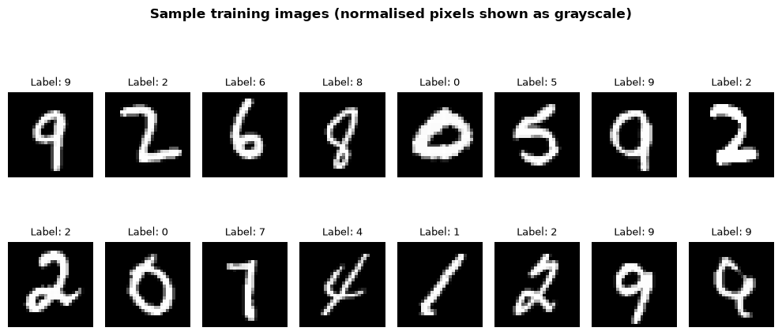
Fig. 1. Representative sample of normalized MNIST training images from Stage 1.

B. Stage 2: Baseline (Normal) Model
Before inducing overfitting, a compact, appropriately sized fully connected network, referred to as BaselineNet, was trained to establish a healthy reference point. The architecture consists of two hidden linear layers (128–64 units) each followed by a ReLU activation, and a final linear output layer of 10 units. The network contains approximately 109,000 trainable parameters against 50,000 training examples — a ratio of roughly 2 parameters per training sample, in contrast to the 500-to-1 ratio used later to induce overfitting.
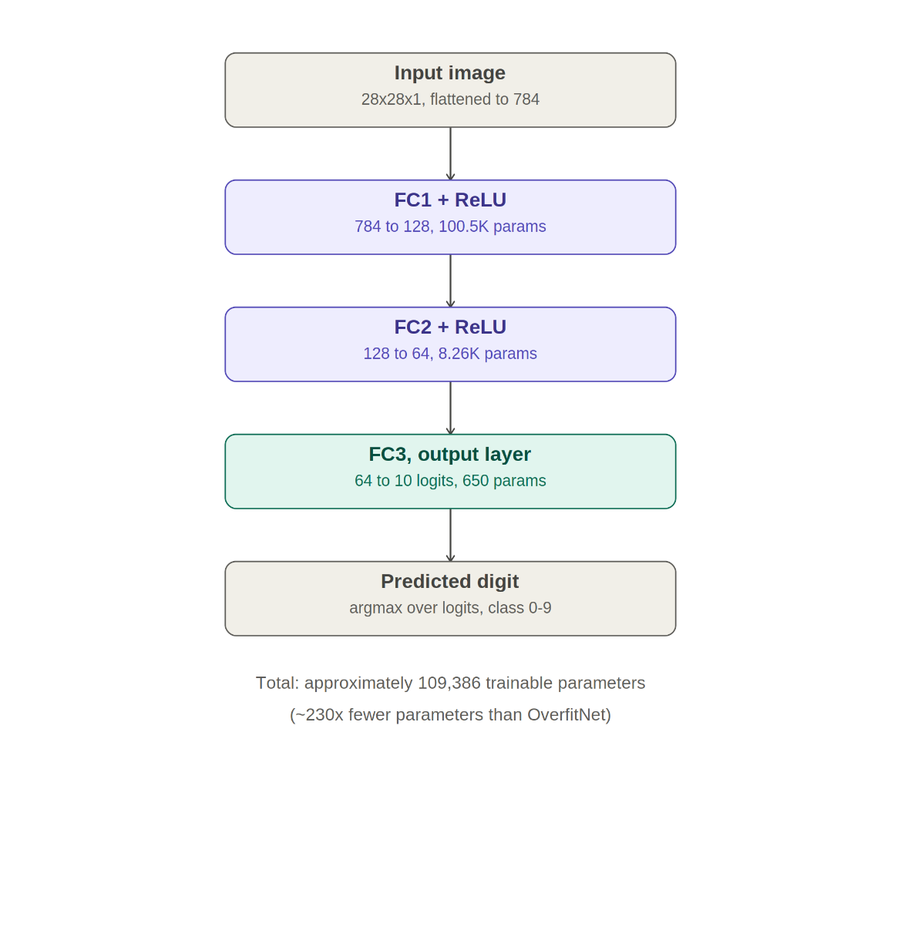
Fig. 2. Architecture of the BaselineNet used as the reference model in Stage 2. The network comprises two fully connected hidden layers (128 and 64 neurons) with ReLU activations and approximately 109,386 trainable parameters.
BaselineNet was trained using the Adam optimizer with a learning rate of $1×{10}^{-3}$and no weight decay on the fixed data partition established in Stage 1. Training was monitored on the validation set after each epoch and conducted for 7 epochs. Throughout training, validation loss decreased steadily from 0.2178 at epoch 1 to 0.0921 at epoch 7, while validation accuracy improved from 93.07% to 97.35%. The resulting model exhibited stable learning behavior and good generalization, making it a suitable reference model for comparison with the deliberately overfitted and regularized architectures used in subsequent stages. In contrast, Stage 3 was trained for the full 50 epochs without early stopping to allow overfitting behaviour to fully emerge.
C. Stage 3: Overfitting
The baseline architecture was then deliberately modified to induce overfitting, yielding a network referred to as OverfitNet. Capacity was substantially increased and depth extended: five hidden linear layers (2048–2048–2048–2048–1024 units) each followed by a ReLU activation, and a final linear output layer of 10 units corresponding to the digit classes. The network contains approximately 25 million trainable parameters against the same 50,000 training examples — a ratio of roughly 500 parameters per training sample, more than 200 times the parameter density of BaselineNet.
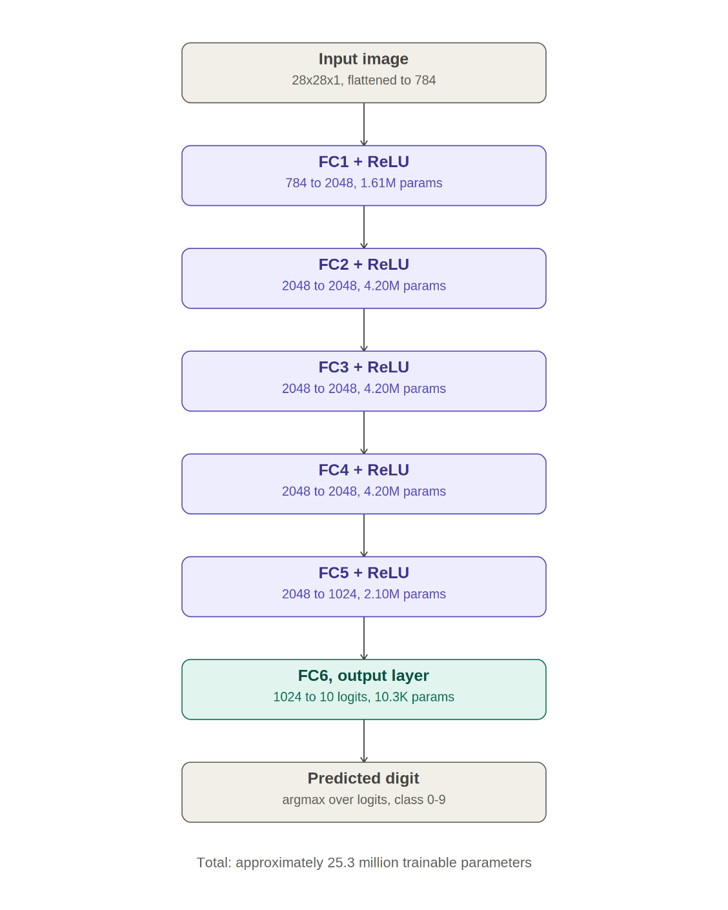
Fig. 3. Architecture of the proposed OverfitNet used in Stage 3. The network consists of five fully connected hidden layers with ReLU activations and approximately 25.3 million trainable parameters.

OverfitNet was trained for 50 epochs using the Adam optimizer with a learning rate of 1×10⁻³ and zero weight decay. No data augmentation was applied and no early stopping was used. This configuration was designed to maximize the network's ability to memorize the training set, using the same fixed data partition from Stage 1.
D. Stage 4: Regularization
The identical OverfitNet architecture from Stage 3 — unchanged at the class-definition level, with no layers added, removed, or resized — was reinitialized and retrained for the same number of epochs (50), on the same fixed data partition from Stage 1, with three modifications restricted entirely to the training procedure: (i) L2 weight decay of 1×10⁻⁴ added to the Adam optimizer, (ii) random rotation (±10°) and random translation (±10%) applied to training images only, and (iii) the learning rate reduced to 5×10⁻⁴. Validation and test data remained unaugmented throughout.
E. Evaluation Protocol
The Stage 2, Stage 3, and Stage 4 models were each evaluated after every epoch on the held-out validation set, and once, at the conclusion of training, on the fully held-out test set. Cross-entropy loss and top-1 classification accuracy were recorded for both training and validation splits at each epoch.
IV. RESULTS
A. Stage 2 Results: Baseline Behaviour
BaselineNet was trained for 7 epochs using the fixed dataset partition established in Stage 1. Throughout training, both training and validation performance improved steadily. Training loss decreased from 0.2973 to 0.0364, while validation loss decreased from 0.2178 to 0.0921. Similarly, training accuracy increased from 91.31% to 98.80%, and validation accuracy improved from 93.07% to 97.35%. The final generalization gap was only 1.45 percentage points, indicating that the model generalized well to unseen data. Furthermore, the validation loss continued to decrease throughout training, suggesting that the model had not yet begun to exhibit significant overfitting. The close correspondence between training and validation metrics confirms BaselineNet as a healthy reference model against which the deliberately overfitted and subsequently regularized models are compared. The corresponding loss and accuracy curves are shown in Fig.4.
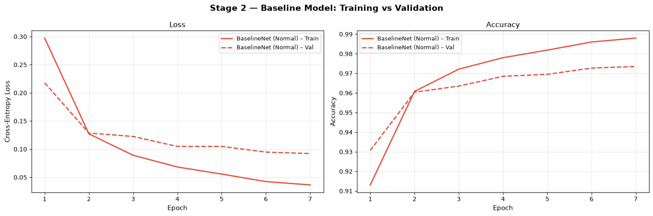
Fig. 4. Training and validation loss/accuracy for BaselineNet across 7 epochs (Stage 2).
B. Stage 3 Results: Overfitting Behaviour
Training loss decreased monotonically to 0.009 by epoch 50, while validation loss, after an initial decrease, began to rise and exhibited substantial instability, reaching values as high as 0.402 at epoch 40. The final train-validation loss gap increased dramatically relative to the baseline model, with validation loss rising to 0.226 despite near-zero training loss. Training accuracy reached 99.82%, while validation accuracy plateaued near 98.32%, yielding a generalization gap of 1.50 percentage points. Although the accuracy gap appears modest, the large divergence between training and validation loss indicates that the model became increasingly overconfident on the training data and generalized poorly to unseen samples. The loss curves for this stage are shown in Fig. 5.
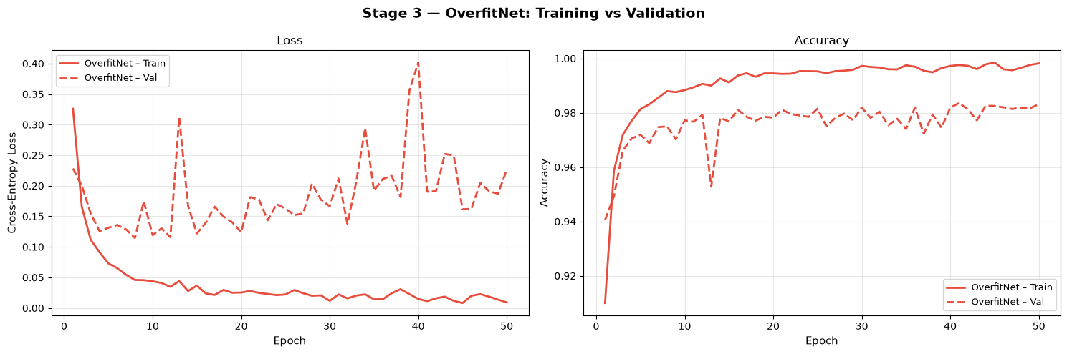
Fig. 5. Training and validation loss for the unregularized OverfitNet across 50 epochs (Stage 3).
C. Stage 4 Results: Regularized Behaviour
With regularization applied, training loss converged to 0.057 while validation loss converged to 0.054, producing nearly identical values and indicating a substantial reduction in the generalization gap observed in Stage 3. Both curves decreased smoothly throughout training with no significant instability or divergence. Final training and validation accuracies were 98.14% and 98.29% respectively, demonstrating that the model generalized effectively despite its substantially larger capacity. Compared with the overfitted model from Stage 3, regularization reduced validation loss from 0.226 to 0.054 while maintaining competitive classification accuracy. The corresponding loss curves are shown in Fig. 6.
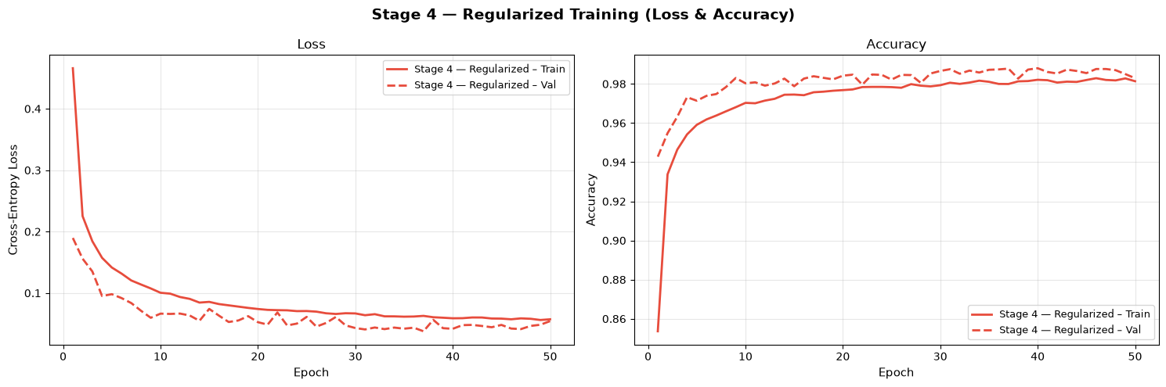
Fig. 6. Training and validation loss for the regularized OverfitNet across 50 epochs (Stage 4).
D. Comparative Analysis
Table IV summarizes the final metrics across all three trained models. The baseline model exhibited stable learning behaviour, achieving a training loss of 0.0364 and a validation loss of 0.0921, indicating good generalization with only a modest train-validation gap. In contrast, increasing model capacity by more than two orders of magnitude and removing regularization in Stage 3 produced severe overfitting, with training loss falling to 0.009 while validation loss rose to 0.226. When regularization techniques were introduced in Stage 4, the validation loss decreased substantially to 0.054 while maintaining competitive accuracy, despite Stage 3 and Stage 4 sharing the same 25.3-million-parameter architecture. Figures 7 and 8 present the overlaid loss and accuracy trajectories for direct visual comparison of the baseline, overfitted, and regularized models.
TABLE II
FINAL METRICS: BASELINE VS. OVERFIT VS. REGULARIZED
Metric | Stage 2 (Baseline) | Stage 3 (Overfit) | Stage 4 (Regularized)
Parameters | ≈109K | ≈25.3M | ≈25.3M
Train loss | 0.036 | 0.009 | 0.057
Val loss | 0.092 | 0.226 | 0.054
Loss ratio | 2.53 | 25.0 | 1.05
Train acc. | 98.80% | 99.82% | 98.14%
Val acc. | 97.35% | 98.32% | 98.29%
Test acc. | 97.49% | 98.19% | 98.56%

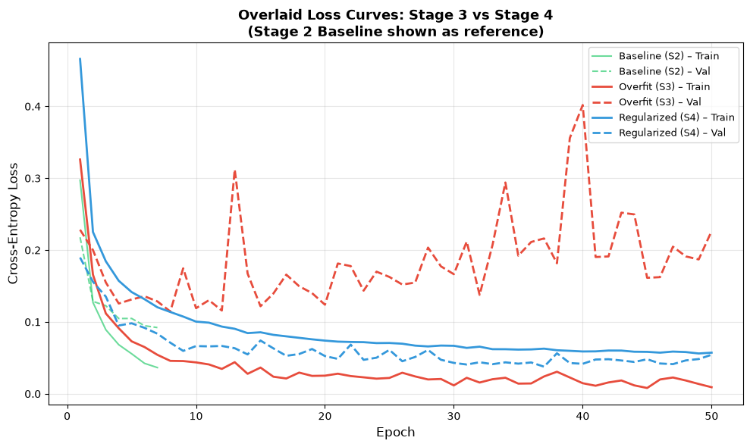
Fig. 7. Overlaid training/validation loss curves, Stage 3 vs. Stage 4 (with Stage 2 baseline as reference).
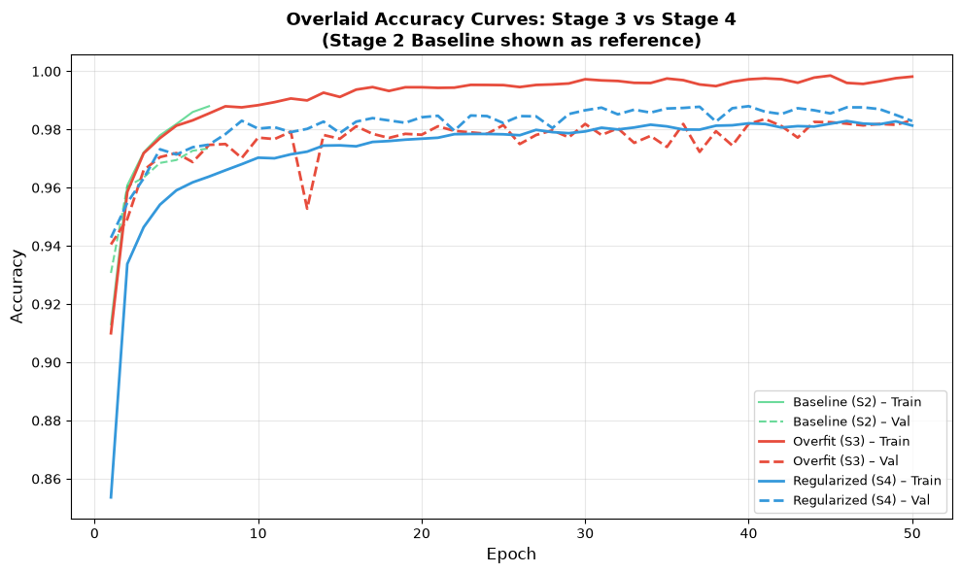
Fig. 8. Overlaid training/validation accuracy curves, Stage 3 vs. Stage 4 (with Stage 2 baseline as reference).
E. Per-Class Performance
Per-class test accuracy for the Stage 4 regularized model ranged from 94.05% (digit 9) to 99.80% (digit 4). Digit 9 was the most frequently misclassified class, consistent with its visual similarity to digits 4 and 7 in cursive handwriting styles. Digit 4 achieved the highest accuracy, attributable to its comparatively unambiguous stroke geometry. The full per-class distribution is shown in Fig. 9.
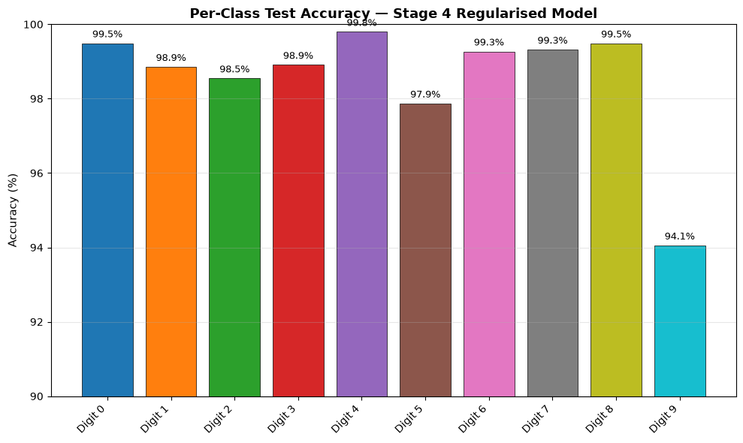
Fig. 9. Per-class test accuracy for the Stage 4 regularized model, digits 0–9.
F. Confusion Matrix
The confusion matrix for the Stage 4 regularized model on the test set is shown in Fig. 10, confirming that the dominant sources of residual error are the digit pairs (9, 4) and (9, 7), consistent with the per-class accuracy results.
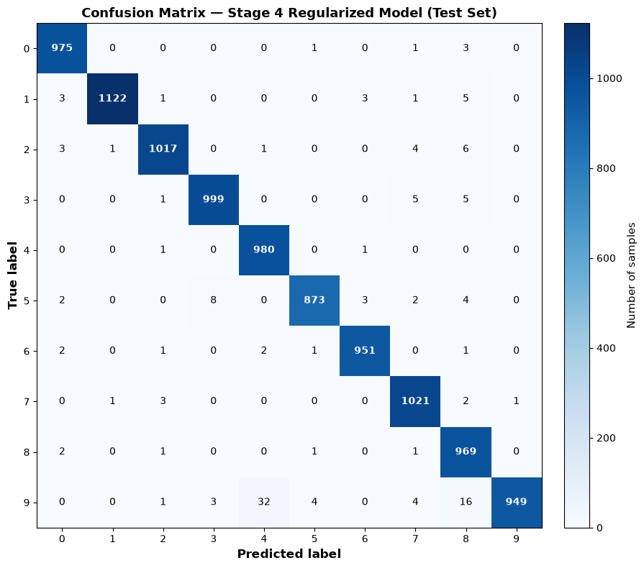
Fig. 10. Confusion matrix for the Stage 4 regularized model on the test set.
V. DISCUSSION
The results support the central claim of this study: overfitting is not an intrinsic and unavoidable consequence of using a high-capacity model on a comparatively small dataset, but is instead determined by the interaction between model capacity and the training procedure. BaselineNet, containing approximately 109,000 trainable parameters, achieved strong generalization performance, reaching 97.35% validation accuracy with only a 1.45-percentage-point train-validation accuracy gap. In contrast, increasing model capacity by more than two orders of magnitude while removing regularization was sufficient to induce substantial overfitting in Stage 3. The resulting model achieved near-perfect training performance while validation loss increased dramatically, indicating memorization of the training data. Critically, the same high-capacity architecture was subsequently retrained in Stage 4 using weight decay, data augmentation, and a reduced learning rate, producing validation performance comparable to the baseline model without any architectural modifications. These results demonstrate that model capacity creates the potential for overfitting, but the training procedure largely determines whether that potential is realized.
Notably, the accuracy-based generalization gap alone (1.50 percentage points in Stage 3) understated the severity of overfitting relative to the corresponding loss values. This occurs because MNIST's ten classes are visually well separated, allowing even an overfit model to maintain high classification accuracy. The loss function, however, is sensitive to prediction confidence and therefore provides a clearer indication of memorization and poor calibration. Consequently, both accuracy and loss should be considered when evaluating model generalization.
The persistence of lower per-class accuracy for digit 9 across both Stage 3 and Stage 4 suggests a data-driven, rather than training-driven, source of residual error. Examination of the confusion matrix revealed that digit 9 was most frequently misclassified as digits 4 and 8, reflecting genuine visual ambiguity among certain handwritten digit styles. These errors highlight a limitation of fully connected architectures, which lack the spatial inductive biases present in convolutional neural networks and therefore may struggle to distinguish visually similar digit patterns.
VI. CONCLUSION AND FUTURE WORK
This study demonstrated, using the MNIST handwritten digit dataset, a complete progression from a well-generalizing baseline model to a deliberately over-parameterized architecture driven to substantial overfitting, and finally to that same high-capacity architecture restored to strong generalization through regularization. The baseline model (Stage 2) achieved 97.35% validation accuracy with a small generalization gap, providing a reference point for comparison. In Stage 3, increasing model capacity and removing regularization produced severe overfitting, characterized by near-zero training loss and a large divergence between training and validation performance. In Stage 4, the identical architecture was retrained using L2 weight decay, data augmentation, and a reduced learning rate, reducing validation loss from 0.226 to 0.054 without any architectural modifications. The final regularized model achieved a test accuracy of approximately 98.3%, demonstrating that appropriate regularization can effectively reconcile high model capacity with strong generalization on unseen data.
Future work could extend this analysis by incorporating a convolutional neural network (CNN) architecture to investigate whether spatial inductive biases further reduce residual errors on visually ambiguous classes such as digit 9. Additional studies could systematically vary the weight decay coefficient and augmentation strength to characterize the regularization–generalization trade-off, as well as apply the same four-stage experimental framework to more complex image classification datasets to evaluate the broader applicability of the findings.
. REFERENCES
[1] Y. LeCun, L. Bottou, Y. Bengio, and P. Haffner, “Gradient-based learning applied to document recognition,” Proc. IEEE, vol. 86, no. 11, pp. 2278–2324, 1998.
[2] D. P. Kingma and J. Ba, “Adam: A method for stochastic optimization,” in Proc. Int. Conf. Learning Representations (ICLR), 2015.
[3] I. Goodfellow, Y. Bengio, and A. Courville, Deep Learning. Cambridge, MA, USA: MIT Press, 2016.
[4] A. Paszke et al., “PyTorch: An imperative style, high-performance deep learning library,” in Proc. Advances in Neural Information Processing Systems (NeurIPS), 2019, pp. 8026–8037.

