Overfitting Analysis and Regularization in MNIST Handwritten Digit Recognition
Sree Krishnan M
sreelm10sj@gmail.com
GitHub Repository: https://github.com/Sreelm10sj/mnist-overfit-regularization
Abstract— This report presents an empirical study of overfitting and its mitigation in fully connected neural networks trained on the MNIST handwritten digit dataset. The experimental pipeline was implemented in four stages. Stage 1 established a fixed data preparation pipeline in which the complete MNIST dataset of 70,000 images was partitioned into training (50,000), validation (10,000), and test (10,000) subsets, which remained unchanged throughout the study. Stage 2 trained a compact baseline network (101,770 parameters — a single hidden layer of 128 units with light dropout) for 30 epochs, reaching a validation accuracy of 97.65% and a test accuracy of 97.90%, with a generalization gap of 1.49 percentage points. Stage 3 introduced a substantially larger fully connected architecture (16,305,162 parameters) and trained it for 50 epochs without regularization, producing overfitting: training loss converged to 0.0072 while validation loss became unstable, peaking at 0.2356 and finishing at 0.1928, despite a training accuracy of 99.86%. Stage 4 reused the identical high-capacity architecture from Stage 3 without any structural modification and retrained it using L2 weight decay, geometric data augmentation, and a reduced learning rate. These interventions reduced the final validation loss to 0.0359 — below even the Stage 2 baseline — and produced a validation accuracy of 99.02% that exceeded the training accuracy of 98.51%, an expected effect of training on augmented images while validating on clean ones. The regularized model achieved a test accuracy of 99.04%, the best of the three models studied. The results demonstrate that overfitting is governed not only by model capacity but also by the training procedure, and that appropriately chosen regularization techniques can enable a high-capacity model to generalize better than both an unregularized version of itself and a much smaller baseline network.
Index Terms— MNIST, overfitting, regularization, weight decay, data augmentation, fully connected neural network, generalization gap.
I. INTRODUCTION
Handwritten digit recognition is a canonical benchmark problem in machine learning, commonly evaluated using the MNIST dataset of 70,000 grayscale images spanning ten digit classes (0–9). While MNIST is now considered a relatively simple task by contemporary deep learning standards, it remains an excellent vehicle for isolating and studying fundamental training phenomena without the confounding factors introduced by larger, noisier, real-world datasets.
A central challenge in supervised learning is overfitting: a condition in which a model learns to represent the idiosyncrasies of its training data — including noise and sampling artifacts — rather than the underlying data-generating distribution. An overfit model exhibits excellent performance on data it was trained on but degraded performance on unseen data, limiting its practical utility.
This report documents a controlled, four-stage experiment. Stage 1 fixes the data pipeline and partitioning. Stage 2 establishes a compact baseline network that generalizes reasonably well under normal conditions. Stage 3 modifies this baseline by substantially increasing its capacity and training it without regularization, deliberately inducing overfitting. Stage 4 reuses that identical over-parameterized architecture from Stage 3 — with no further structural modification whatsoever — and closes, and ultimately reverses, the resulting generalization gap using only training-procedure-level interventions. This design isolates two effects in turn: first, how architectural capacity alone can induce overfitting relative to a healthy baseline; second, how the training procedure alone can not only reverse it but improve on both the overfit model and the original baseline.
II. BACKGROUND
A. Overfitting
Overfitting arises when a model's effective capacity substantially exceeds what is required to represent the true patterns in the training data. Formally, this can be characterized by a divergence between the training loss and the validation loss over the course of optimization: as training proceeds, training loss approaches zero while validation loss plateaus, becomes unstable, or increases, producing a generalization gap [1], [3].
B. Regularization Techniques
Regularization refers to any technique that constrains a model's effective capacity during training without altering its architecture. This study employs three such techniques. L2 regularization (weight decay) adds a penalty term proportional to the squared magnitude of the network weights to the loss function, discouraging large weights and encouraging smoother decision boundaries [2]. Data augmentation synthetically expands the effective diversity of the training set through label-preserving transformations — in this case, random rotation and translation — preventing the model from memorizing exact pixel arrangements [3]. Dropout, used in the Stage 2 baseline, stochastically deactivates a fraction of hidden units during training, discouraging co-adaptation between neurons.
III. METHODOLOGY
The methodology follows the four-stage structure of the project: Stage 1 (Data Preparation), Stage 2 (Baseline Model), Stage 3 (Overfitting), and Stage 4 (Regularization). The dataset partition established in Stage 1 is held fixed and reused, without modification, across Stages 2, 3, and 4.
A. Stage 1: Data Preparation
The complete MNIST dataset (70,000 28×28 grayscale images) was used. Pixel intensities were normalized using the dataset-wide mean (0.1307) and standard deviation (0.3081). The dataset was partitioned once, using a fixed random seed (42), into training, validation, and test subsets as summarized in Table I. All DataLoaders used a batch size of 256. This partition was held constant across every subsequent stage to ensure that any observed differences in outcome are attributable exclusively to the training procedure, not to differences in data.
TABLE 1
DATASET PARTITION SUMMARY (STAGE 1)
Split | Images | Source
Train | 50,000 | MNIST train
Validation | 10,000 | MNIST train
Test | 10,000 | MNIST test (held out)

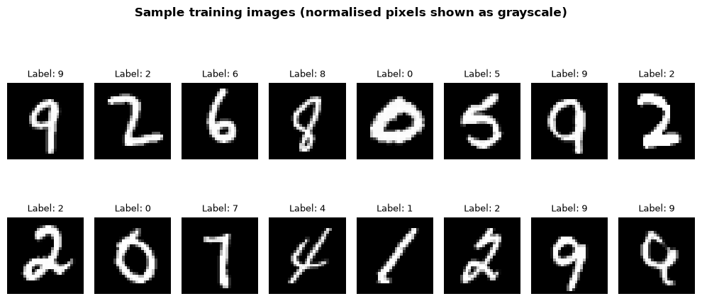
Fig. 1. Representative sample of normalized MNIST training images from Stage 1.
B. Stage 2: Baseline Model
Before inducing overfitting, a compact fully connected network, referred to as BaselineNet, was trained to establish a reference point. Although convolutional neural networks (CNNs) generally achieve superior performance on image classification tasks such as MNIST, a fully connected multilayer perceptron (MLP) was selected for this study because the primary objective was not to maximize classification accuracy, but to deliberately induce and analyze overfitting in a controlled setting. The behaviour of overfitting and subsequent regularization is more easily isolated and interpreted in a fully connected architecture. The architecture consists of a single hidden linear layer of 128 units followed by a ReLU activation and a Dropout layer (p = 0.2), and a final linear output layer of 10 units. The network contains 101,770 trainable parameters against 50,000 training examples — a ratio of roughly 2 parameters per training sample, in contrast to the 326-to-1 ratio used later to induce overfitting.
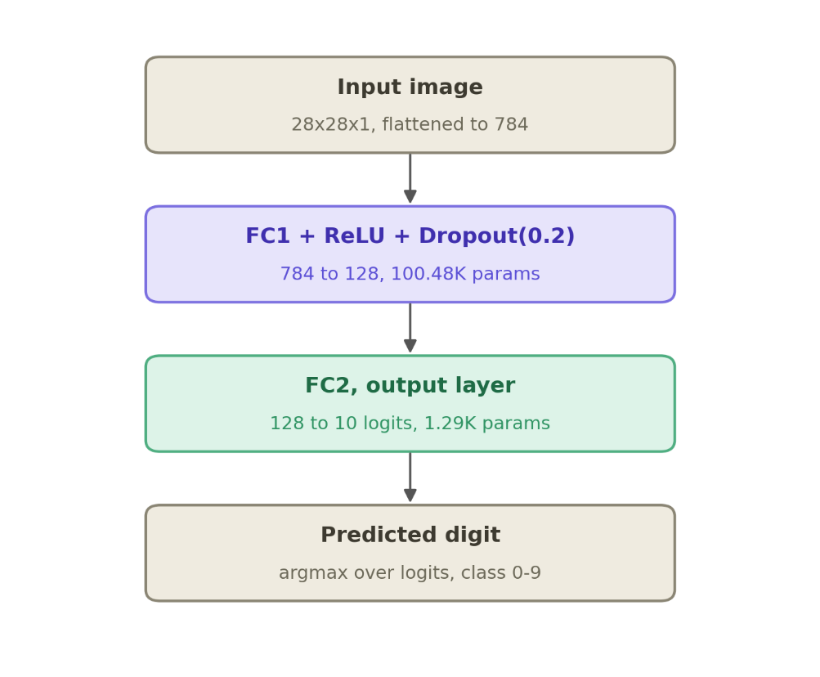
Fig. 2. Architecture of the BaselineNet used as the reference model in Stage 2. The network comprises a single fully connected hidden layer of 128 neurons with ReLU activation and Dropout (p = 0.2), totaling 101,770 trainable parameters.
BaselineNet was trained using the Adam optimizer with a learning rate of 5×10⁻⁴ and no weight decay on the fixed data partition established in Stage 1, for 30 epochs, with validation performance monitored after every epoch. Throughout training, validation loss decreased from 0.2921 at epoch 1 to 0.0781 at epoch 30, while validation accuracy improved from 91.32% to 97.65%. Validation loss decreased steadily throughout training and converged near epoch 20, while training performance continued to improve modestly through epoch 30. The relatively small gap between training and validation metrics indicates that the model maintained good generalization performance. In contrast, Stage 3 was trained for the full 50 epochs without early stopping to allow overfitting behaviour to fully emerge.
C. Stage 3: Overfitting
The baseline architecture was then deliberately modified to induce overfitting, yielding a network referred to as OverfitNet. Capacity was substantially increased and depth extended: five hidden linear layers (2048–2048–2048–2048–1024 units) each followed by a ReLU activation, and a final linear output layer of 10 units corresponding to the digit classes. The network contains 16,305,162 trainable parameters against the same 50,000 training examples — a ratio of roughly 326 parameters per training sample, more than 160 times the parameter density of BaselineNet.
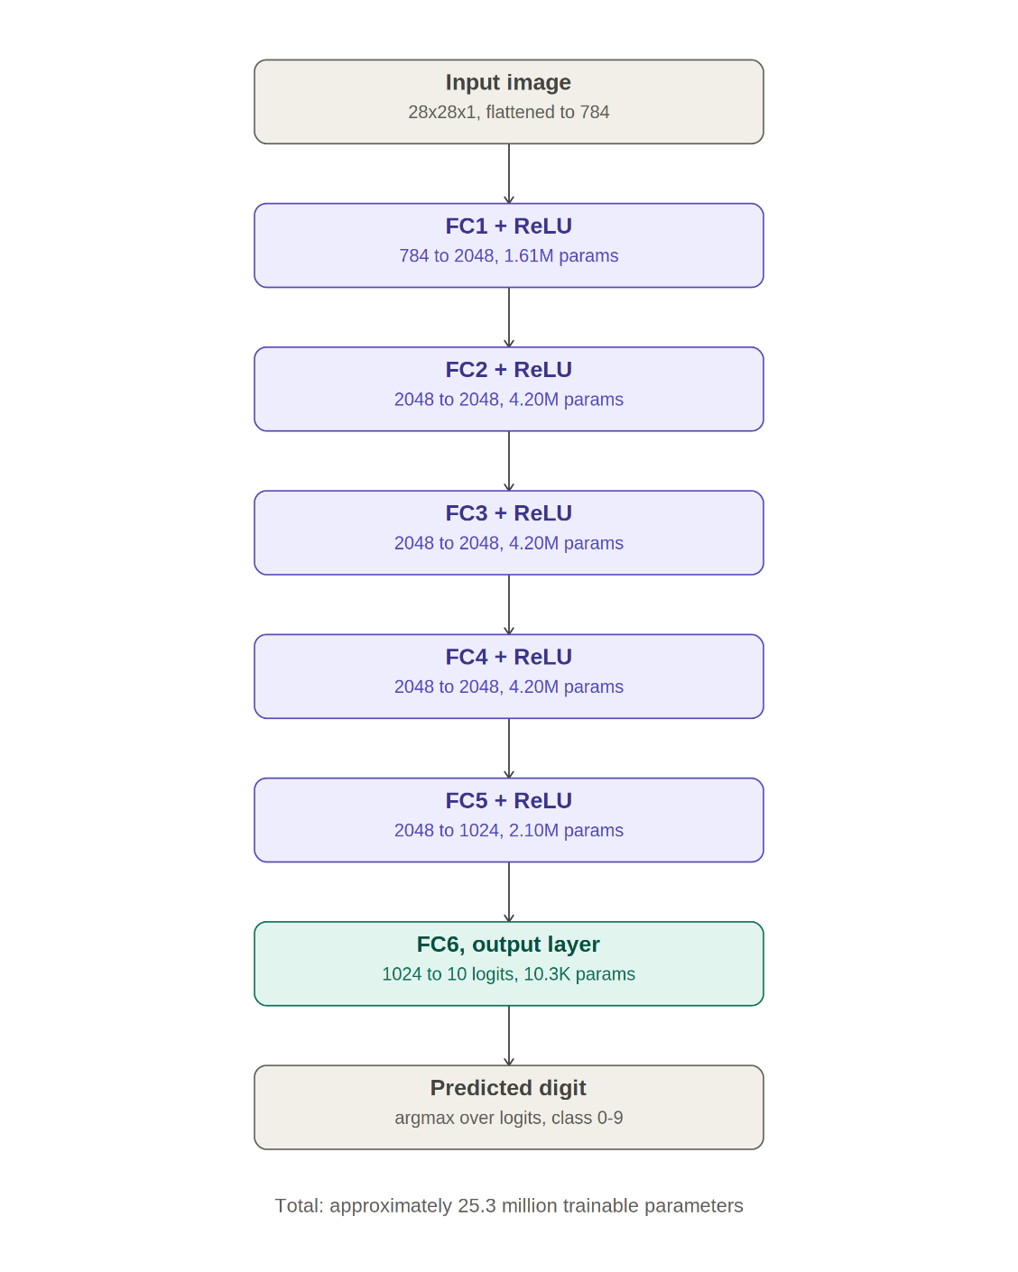
Fig. 3. Architecture of the OverfitNet used in Stages 3 and 4. The network consists of five fully connected hidden layers with ReLU activations and 16,305,162 trainable parameters.
OverfitNet was trained for 50 epochs using the Adam optimizer with a learning rate of 1×10⁻³ and zero weight decay. No data augmentation was applied and no early stopping was used. This configuration was designed to maximize the network's ability to memorize the training set, using the same fixed data partition from Stage 1.
D. Stage 4: Regularization
The identical OverfitNet architecture from Stage 3 — unchanged at the class-definition level, with no layers added, removed, or resized — was reinitialized and retrained for the same number of epochs (50), on the same fixed data partition from Stage 1, with three modifications restricted entirely to the training procedure: (i) L2 weight decay of 1×10⁻⁴ added to the Adam optimizer, (ii) random rotation (±10°) and random translation (±10%) applied to training images only, and (iii) the learning rate reduced to 5×10⁻⁴. Validation and test data remained unaugmented throughout.
E. Evaluation Protocol
The Stage 2, Stage 3, and Stage 4 models were each evaluated after every epoch on the held-out validation set, and once, at the conclusion of training, on the fully held-out test set. Cross-entropy loss and top-1 classification accuracy were recorded for both training and validation splits at each epoch.
IV. RESULTS
A. Stage 2 Results: Baseline Behaviour
BaselineNet was trained for 30 epochs using the fixed dataset partition established in Stage 1. Training loss decreased from 0.5519 at epoch 1 to 0.0280 at epoch 30, while validation loss decreased from 0.2921 to 0.0781 over the same period. Training accuracy rose from 84.48% to 99.14%, and validation accuracy improved from 91.32% to 97.65%. The final train–validation accuracy gap was 1.49 percentage points, and the validation-to-training loss ratio was 2.79. Validation loss decreased steadily throughout training and converged near epoch 20, while training performance continued to improve modestly through epoch 30. The relatively small gap between training and validation metrics indicates that the model maintained good generalization performance. The final test accuracy was 97.90%. The corresponding loss and accuracy curves are shown in Fig. 4.
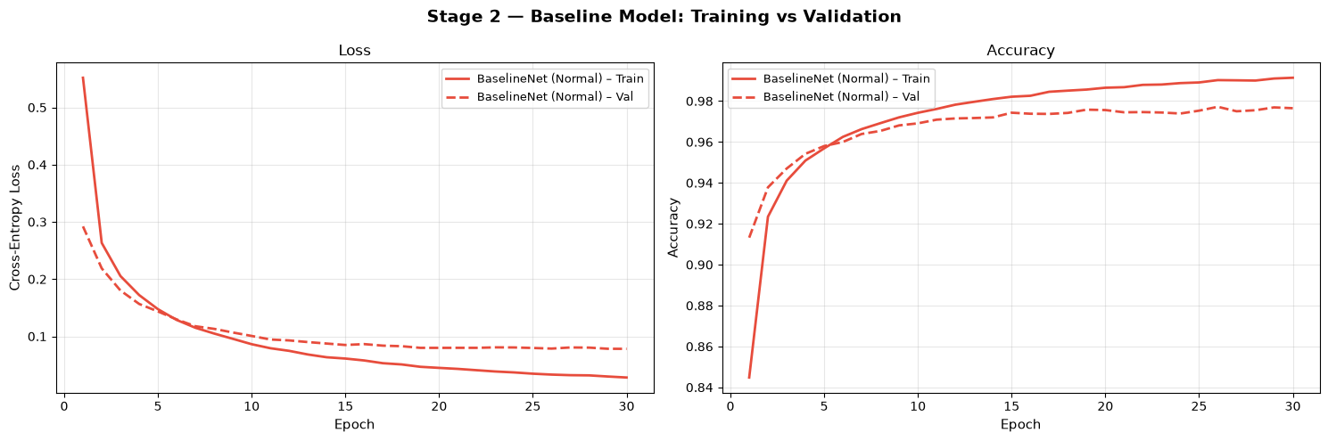
Fig. 4. Training and validation loss/accuracy for BaselineNet across 30 epochs (Stage 2).
B. Stage 3 Results: Overfitting Behaviour
Training loss decreased essentially monotonically to 0.0072 by epoch 50, while training accuracy reached 99.86%. Validation loss, by contrast, was highly unstable after an initial decrease to approximately 0.108 by epoch 3: it fluctuated for the remainder of training, reaching a peak of 0.2356 at epoch 42 before finishing at 0.1928 at epoch 50. Validation accuracy plateaued in the 97–98% range with visible epoch-to-epoch noise, finishing at 98.05%. The final train–validation accuracy gap was 1.81 percentage points, and the validation-to-training loss ratio reached approximately 26.8 — nearly ten times the ratio observed for BaselineNet — indicating that OverfitNet became substantially more overconfident on the training data despite achieving a test accuracy (98.32%) that slightly exceeded the baseline. This large divergence in loss, alongside a comparatively modest accuracy gap, is the classic signature of overfitting: near-perfect memorization of the training set paired with unstable, poorly calibrated predictions on unseen data. The loss curves for this stage are shown in Fig. 5.
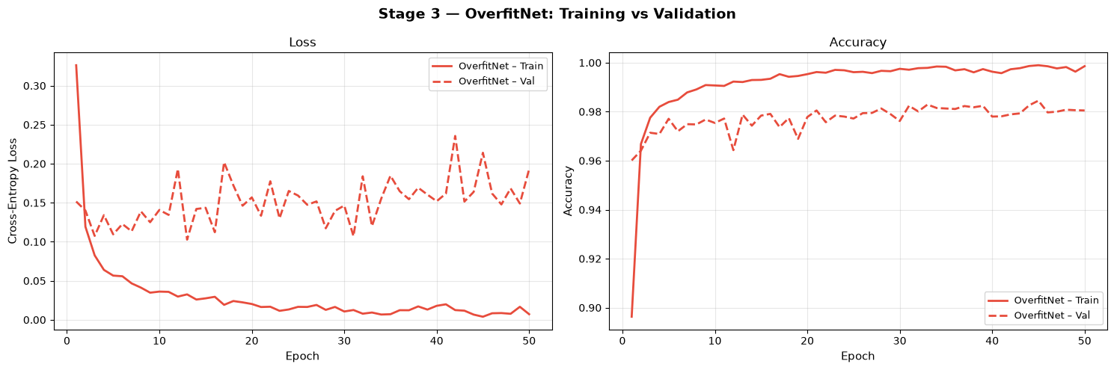
Fig. 5. Training and validation loss for the unregularized OverfitNet across 50 epochs (Stage 3).
C. Stage 4 Results: Regularized Behaviour
With regularization applied, training loss decreased more gradually than in Stage 3, reaching 0.0452 by epoch 50, while validation loss decreased smoothly throughout training to 0.0359 — lower than the final training loss. Final training accuracy was 98.51%, while final validation accuracy was 99.02%, giving a negative train–validation accuracy gap of −0.51 percentage points. This inversion is an expected consequence of the training setup rather than an anomaly: because training images were augmented with random rotation and translation while validation images were left unaugmented, the training task was intrinsically harder than the validation task, which naturally depresses training metrics relative to validation metrics. Both loss curves were smooth and free of the instability seen in Stage 3; the validation-to-training loss ratio of 0.79 (compared with 26.8 for the unregularized model) confirms that the generalization gap present in Stage 3 was not merely reduced but reversed. The corresponding loss curves are shown in Fig. 6.
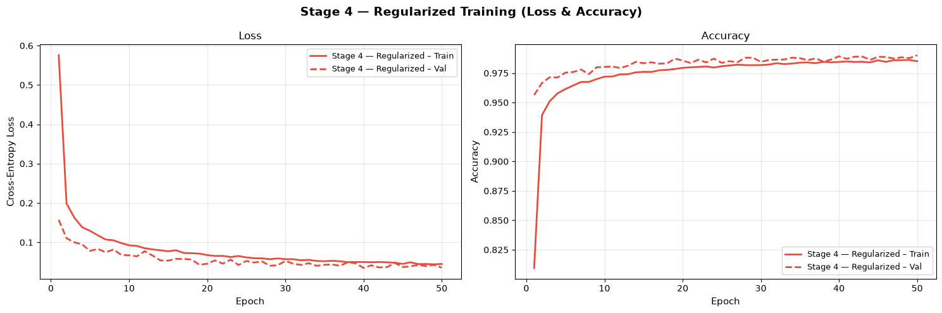
Fig. 6. Training and validation loss for the regularized OverfitNet across 50 epochs (Stage 4).

D. Comparative Analysis
Table II summarizes the final metrics across all three trained models, each evaluated on the same held-out 10,000-image test set. The baseline model achieved a test accuracy of 97.90% with a small train–validation gap. Increasing capacity by roughly 160× and removing regularization in Stage 3 produced a marginally higher test accuracy (98.32%), but at the cost of a much larger validation-to-training loss ratio (26.8 vs. 2.79) and visibly unstable validation loss. When the identical high-capacity architecture was retrained in Stage 4 with regularization, test accuracy rose further to 99.04% — the highest of all three models — while validation loss (0.0359) fell below even the Stage 2 baseline's validation loss (0.0781), despite Stage 4 using roughly 160 times more parameters than BaselineNet. This shows that, with an appropriate training procedure, a high-capacity model can be not only rescued from overfitting but made to outperform both the small baseline and its own unregularized counterpart on unseen data. Figs. 7 and 8 present the overlaid loss and accuracy trajectories for direct visual comparison.
TABLE 2
FINAL METRICS: BASELINE VS. OVERFIT VS. REGULARIZED
Metric | Stage 2 (Baseline) | Stage 3 (Overfit) | Stage 4 (Regularized)
Parameters | 101,770 | 16,305,162 | 16,305,162
Epochs | 30 | 50 | 50
Train loss | 0.0280 | 0.0072 | 0.0452
Val loss | 0.0781 | 0.1928 | 0.0359
Train acc. | 99.14% | 99.86% | 98.51%
Val acc. | 97.65% | 98.05% | 99.02%
Test acc. | 97.90% | 98.32% | 99.04%

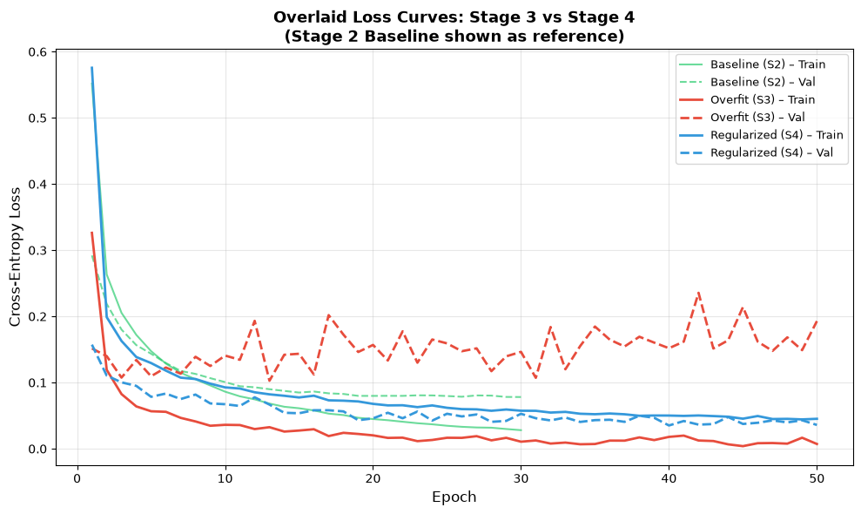
Fig. 7. Overlaid training/validation loss curves, Stage 3 vs. Stage 4, with Stage 2 baseline shown as reference.
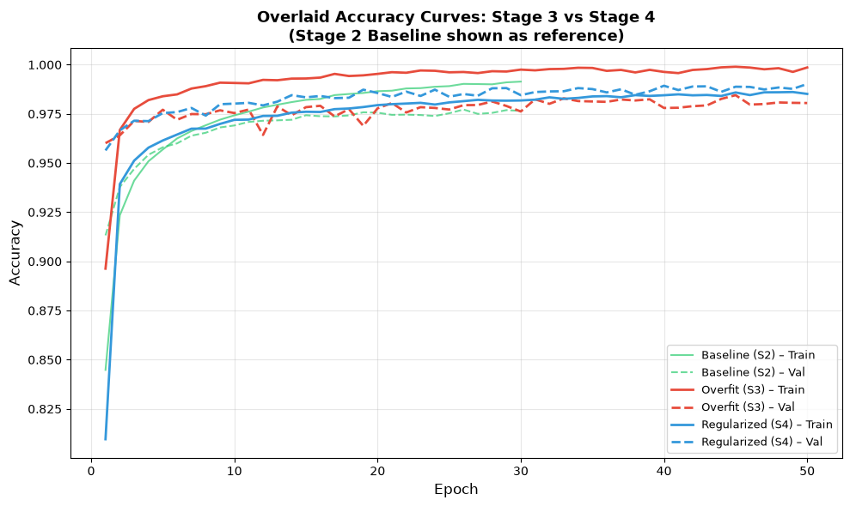
Fig. 8. Overlaid training/validation accuracy curves, Stage 3 vs. Stage 4, with Stage 2 baseline shown as reference.
E. Per-Class Performance
Per-class test accuracy for the Stage 4 regularized model ranged from 97.82% (digit 9) to 99.49% (digit 0). Digit 9 was the most frequently misclassified class, principally confused with digits 4 and 7, consistent with visual similarity in certain handwritten stroke styles. Digit 0 achieved the highest accuracy. The full per-class distribution is shown in Fig. 9.
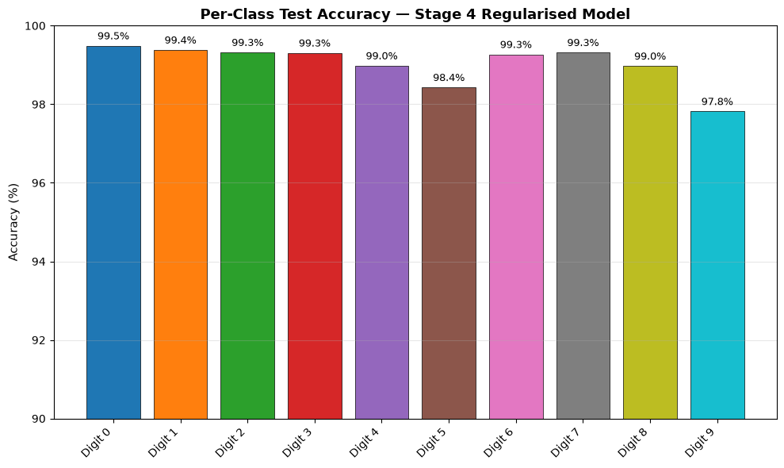
Fig. 9. Per-class test accuracy for the Stage 4 regularized model, digits 0–9.
F. Confusion Matrix
The confusion matrix for the Stage 4 regularized model on the test set is shown in Fig. 10. The dominant sources of residual error were true digit 9 misclassified as 4 (10 occurrences) and as 7 (5 occurrences), true digit 5 misclassified as 3 (9 occurrences), and true digit 4 misclassified as 9 (6 occurrences). The bidirectional confusion between digits 9 and 4 was the single largest error mode observed, consistent with the per-class accuracy results.
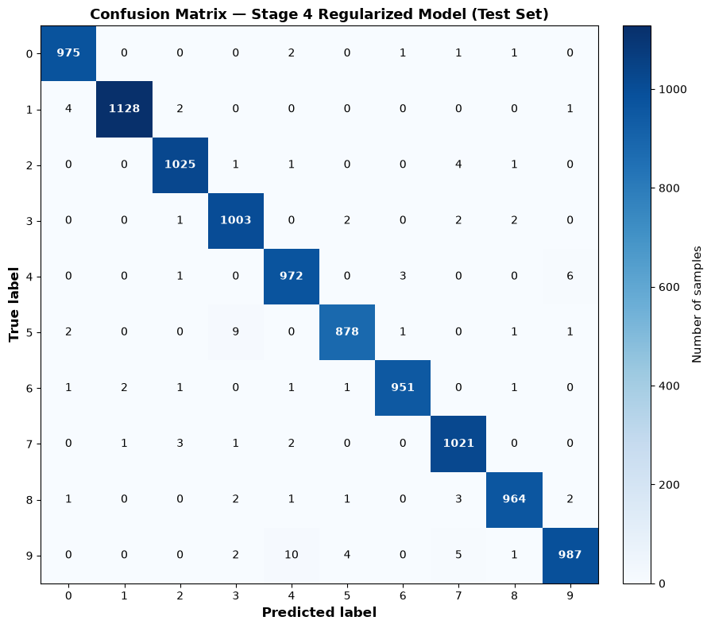

Fig. 10. Confusion matrix for the Stage 4 regularized model on the test set.
V. DISCUSSION
The results support the central claim of this study: overfitting is not an intrinsic and unavoidable consequence of using a high-capacity model on a comparatively small dataset, but is instead determined by the interaction between model capacity and the training procedure. BaselineNet, containing 101,770 trainable parameters, achieved 97.65% validation accuracy and 97.90% test accuracy, with a 1.49-percentage-point train–validation accuracy gap and a validation to training loss ratio was 2.79, reflecting a normal train–validation performance gap. However, validation accuracy remained high (97.65%) and validation loss remained stable, indicating that the model generalized effectively. Increasing model capacity by roughly 160× while removing regularization entirely in Stage 3 amplified the train–validation divergence considerably: although training accuracy reached near-perfect levels (99.86%) and test accuracy even edged past the baseline (98.32%), validation loss became unstable and rose to nearly 27 times the training loss, indicating severe miscalibration despite competitive raw accuracy. Critically, retraining the identical architecture in Stage 4 with weight decay, data augmentation, and a reduced learning rate not only closed this gap but produced the best-performing model of the study on every metric — a test accuracy of 99.04%, the lowest validation loss (0.0359) of all three models, and a stable, well-behaved loss ratio of 0.79. This demonstrates that model capacity creates the potential for overfitting, but the training procedure determines whether that potential is realized — and, when properly regularized, a high-capacity model can outperform a much smaller one rather than merely matching it.
The negative generalization gap observed in Stage 4 (validation accuracy exceeding training accuracy by 0.51 percentage points) is worth noting explicitly. Because training images were augmented with random rotation and translation while validation images were not, the training task was strictly harder than the validation task. A lower training accuracy than validation accuracy is therefore an expected artifact of this asymmetric evaluation setup, rather than evidence of additional overfitting or a methodological error.
As in Stage 3, the accuracy-based generalization gap alone understated the extent of overfitting relative to the loss-based measure. MNIST's ten classes are visually well separated, which allows even a poorly calibrated, overfit model to retain high classification accuracy; cross-entropy loss, by contrast, is sensitive to prediction confidence and therefore exposes memorization effects that accuracy alone conceals. Both metrics should be reported when assessing generalization.
Digit 9 remained the most error-prone class in the final regularized model (97.82% accuracy), and the confusion matrix confirms that the dominant error modes — 9 misclassified as 4, and the reverse confusion of 4 as 9 — reflect genuine visual ambiguity in certain handwriting styles rather than a training-procedure artifact, since this pattern is consistent with the digits' similar stroke geometry. This is a plausible limitation of fully connected architectures, which lack the spatial inductive biases of convolutional networks and may therefore struggle to disambiguate visually similar stroke patterns.
VI. CONCLUSION AND FUTURE WORK
This study demonstrated, using the MNIST handwritten digit dataset, a complete progression from a reasonably well-generalizing baseline model to a deliberately over-parameterized architecture driven to overfitting, and finally to that same high-capacity architecture restored — and improved upon — through regularization. The baseline model (Stage 2, 101,770 parameters) achieved 97.90% test accuracy with a modest generalization gap. In Stage 3, increasing capacity to 16,305,162 parameters and removing regularization produced clear signs of overfitting: near-zero training loss, unstable validation loss peaking at 0.2356, and a validation-to-training loss ratio of nearly 27, despite a test accuracy of 98.32%. In Stage 4, the identical architecture was retrained using L2 weight decay, data augmentation, and a reduced learning rate, reducing validation loss to 0.0359 and lifting test accuracy to 99.04% — the best result of the study — without any architectural modification whatsoever. These results demonstrate that appropriate regularization can not only reconcile high model capacity with strong generalization, but can allow a high-capacity model to exceed the performance of a much smaller network trained on the same data.
Future work could extend this analysis by incorporating a convolutional neural network (CNN) architecture to investigate whether spatial inductive biases further reduce the residual 9/4 confusion identified in this study. Additional studies could systematically vary the weight decay coefficient and augmentation strength to characterize the regularization–generalization trade-off, and apply the same four-stage experimental framework to more complex image classification datasets to evaluate the broader applicability of these findings.
REFERENCES
[1] Y. LeCun, L. Bottou, Y. Bengio, and P. Haffner, “Gradient-based learning applied to document recognition,” Proc. IEEE, vol. 86, no. 11, pp. 2278–2324, 1998.
[2] D. P. Kingma and J. Ba, “Adam: A method for stochastic optimization,” in Proc. Int. Conf. Learning Representations (ICLR), 2015.
[3] I. Goodfellow, Y. Bengio, and A. Courville, Deep Learning. Cambridge, MA, USA: MIT Press, 2016.
[4] A. Paszke et al., “PyTorch: An imperative style, high-performance deep learning library,” in Proc. Advances in Neural Information Processing Systems (NeurIPS), 2019, pp. 8026–8037.

