Overfitting Analysis and Regularization in MNIST Handwritten Digit Recognition
Sree Krishnan M
sreelm10sj@gmail.com
Abstract—This report presents an empirical study of overfitting and its mitigation in a fully connected neural network trained on the MNIST handwritten digit dataset. The experimental pipeline was implemented in three stages. Stage 1 established a fixed data preparation pipeline: the complete MNIST dataset of 70,000 images was partitioned into training (50,000), validation (10,000), and test (10,000) subsets, which remained unchanged for the remainder of the study. Stage 2 introduced an intentionally over-parameterized six-layer fully connected network (~25 million parameters) and trained it without any regularization, producing significant overfitting: training loss converged to 0.009 while validation loss diverged to 0.226, a 25-fold gap. Stage 3 reused the identical architecture from Stage 2 without any structural modification and retrained it using L2 weight regularization, geometric data augmentation, and a reduced learning rate. This reduced the training-to-validation loss ratio to 1.05, effectively eliminating the generalization gap while preserving a final test accuracy of approximately 98.3%. The results demonstrate that overfitting is primarily a property of the training procedure rather than an inherent, unavoidable consequence of model capacity, and that appropriately chosen regularization can fully reconcile a high-capacity model with a comparatively small dataset.
Index Terms—MNIST, overfitting, regularization, weight decay, data augmentation, fully connected neural network, generalization gap.

I. INTRODUCTION
Handwritten digit recognition is a canonical benchmark problem in machine learning, commonly evaluated using the MNIST dataset of 70,000 grayscale images spanning ten digit classes (0–9). While MNIST is now considered a relatively simple task by contemporary deep learning standards, it remains an excellent vehicle for isolating and studying fundamental training phenomena without the confounding factors introduced by larger, noisier, real-world datasets.
A central challenge in supervised learning is overfitting: a condition in which a model learns to represent the idiosyncrasies of its training data — including noise and sampling artifacts — rather than the underlying data-generating distribution. An overfit model exhibits excellent performance on data it was trained on but degraded performance on unseen data, limiting its practical utility.
This report documents a controlled, three-stage experiment. Stage 1 fixes the data pipeline and partitioning. Stage 2 deliberately induces overfitting through an over-parameterized architecture trained without regularization. Stage 3 reuses that identical architecture — with no structural modification whatsoever — and substantially closes the resulting generalization gap using only training-procedure-level interventions. This design isolates the training procedure as the sole lever available for controlling generalization, providing an unambiguous demonstration of its effect.

II. BACKGROUND
A. Overfitting
Overfitting arises when a model's effective capacity substantially exceeds what is required to represent the true patterns in the training data. Formally, this can be characterized by a divergence between the training loss and the validation loss over the course of optimization: as training proceeds, training loss approaches zero while validation loss plateaus or increases, producing a generalization gap that widens with continued training [1], [4].
B. Regularization Techniques
Regularization refers to any technique that constrains a model's effective capacity during training without altering its architecture. This study employs three such techniques. L2 regularization (weight decay) adds a penalty term proportional to the squared magnitude of the network weights to the loss function, discouraging large weights and encouraging smoother decision boundaries [2]. Data augmentation synthetically expands the effective diversity of the training set through label-preserving transformations — in this case, random rotation and translation — preventing the model from memorizing exact pixel arrangements [3]. Finally, a reduced learning rate promotes convergence toward flatter regions of the loss landscape, which are empirically associated with improved generalization relative to the sharp minima favoured by more aggressive optimization.

III. METHODOLOGY
The methodology follows the three-stage structure of the project: Stage 1 (Data Preparation), Stage 2 (Overfitting), and Stage 3 (Regularization). The dataset partition established in Stage 1 is held fixed and reused, without modification, in both Stage 2 and Stage 3.
A. Stage 1: Data Preparation
The complete MNIST dataset (70,000 28×28 grayscale images) was used. Pixel intensities were normalized using the dataset-wide mean (0.1307) and standard deviation (0.3081). The dataset was partitioned once, using a fixed random seed, into training, validation, and test subsets as summarized in Table I. This partition was held constant across every subsequent stage to ensure that any observed differences in outcome are attributable exclusively to the training procedure, not to differences in data.

TABLE I
DATASET PARTITION SUMMARY (STAGE 1)
Split | Images | Source
Train | 50,000 | MNIST train
Validation | 10,000 | MNIST train
Test | 10,000 | MNIST test (held out)

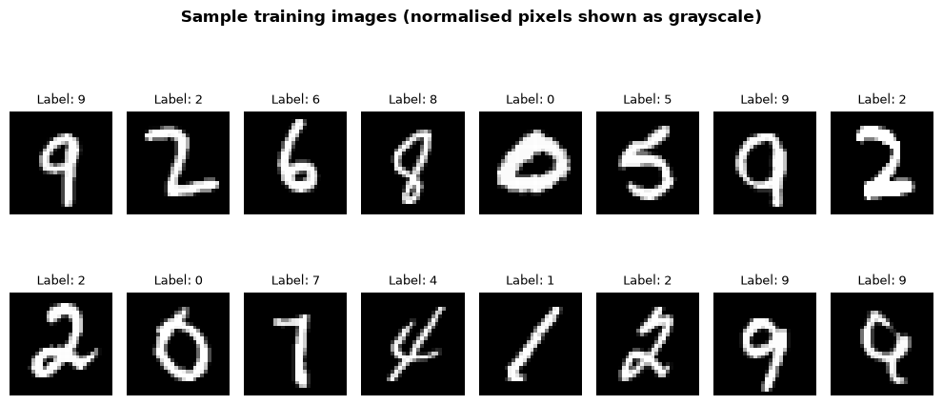
Fig. 1. Representative sample of normalized MNIST training images from Stage 1.

B. Stage 2: Overfitting
A fully connected feed-forward network, referred to as OverfitNet, was designed with substantially more capacity than the task requires, in order to make overfitting straightforward to induce. The architecture consists of five hidden linear layers (2048–2048–2048–2048–1024 units) each followed by a ReLU activation, and a final linear output layer of 10 units corresponding to the digit classes. The network contains approximately 25 million trainable parameters against only 50,000 training examples — a ratio of roughly 500 parameters per training sample. Table II summarizes the layer-wise structure.

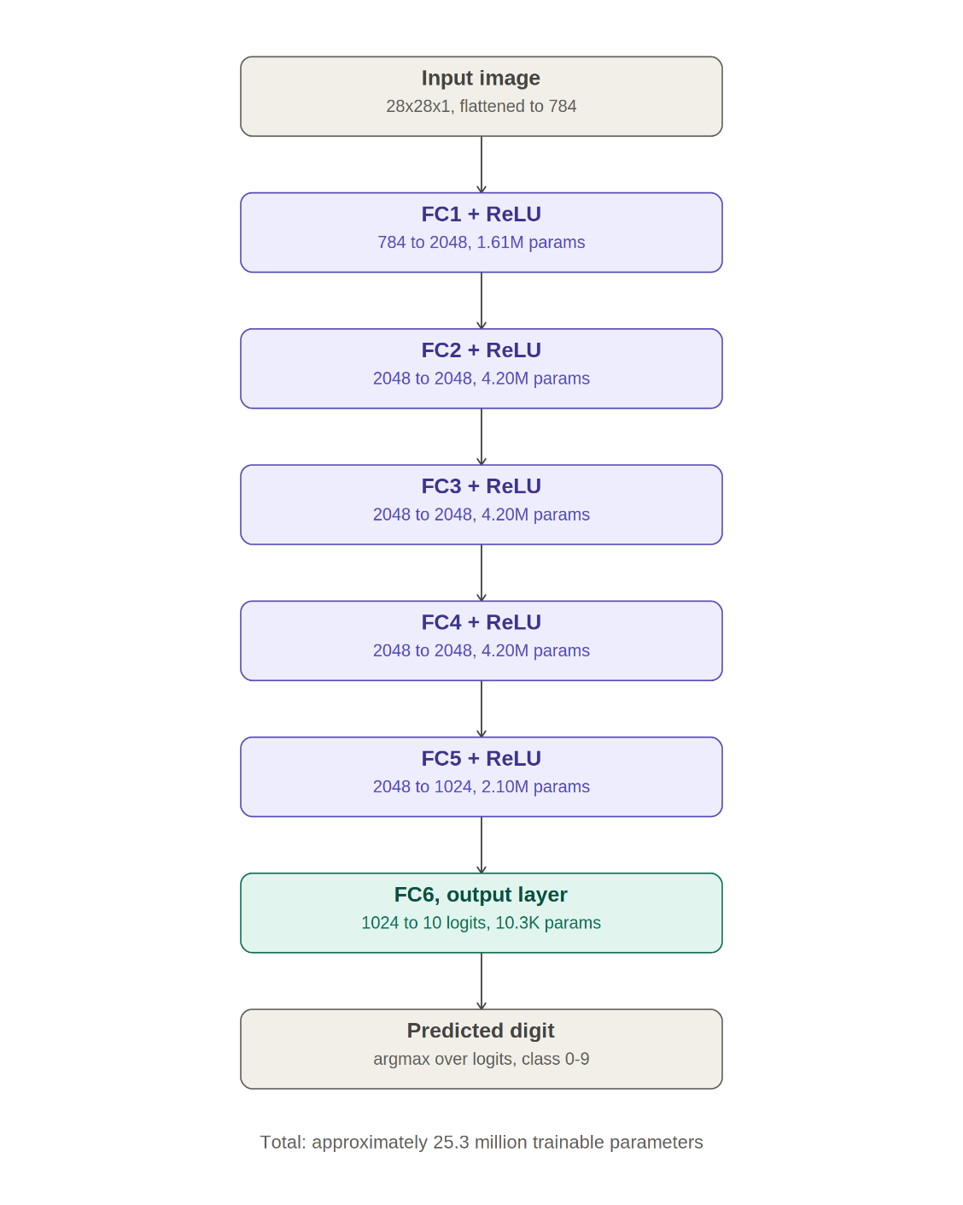
Fig. 2. Architecture of the proposed OverfitNet used in Stage 2. The network consists of five fully connected hidden layers with ReLU activations and approximately 25.3 million trainable parameters.

Justification for Architecture Selection:
A convolutional neural network (CNN) would generally be the preferred architecture for image classification because it exploits spatial relationships between neighbouring pixels and typically requires fewer trainable parameters. However, the objective of this study was not to maximize classification accuracy, but to deliberately induce and analyze overfitting. A large fully connected Multi-Layer Perceptron (MLP) provides a simple architecture in which overfitting behaviour can be observed clearly and the effects of regularization techniques can be studied in isolation. Therefore, an MLP was selected for this experiment.
OverfitNet was trained for 50 epochs using the Adam optimizer with a learning rate of 1×10⁻³ and zero weight decay. No data augmentation was applied. This configuration was designed to maximize the network's ability to memorize the training set, using the fixed data partition from Stage 1.
C. Stage 3: Regularization
The identical OverfitNet architecture from Stage 2 — unchanged at the class-definition level, with no layers added, removed, or resized — was reinitialized and retrained for the same number of epochs (50), on the same fixed data partition from Stage 1, with three modifications restricted entirely to the training procedure: (i) L2 weight decay of 1×10⁻⁴ added to the Adam optimizer, (ii) random rotation (±10°) and random translation (±10%) applied to training images only, and (iii) the learning rate reduced to 5×10⁻⁴. Validation and test data remained unaugmented throughout.

D. Evaluation Protocol
Both the Stage 2 and Stage 3 models were evaluated after every epoch on the held-out validation set, and once, at the conclusion of training, on the fully held-out test set. Cross-entropy loss and top-1 classification accuracy were recorded for both training and validation splits at each epoch.

IV. RESULTS
A. Stage 2 Results: Overfitting Behaviour
Training loss decreased monotonically to 0.009 by epoch 50, while validation loss, after an initial decrease, began to rise and exhibited substantial instability, reaching values as high as 0.402 at epoch 40. The final train/validation loss ratio was approximately 25:1. Training accuracy reached 99.82%, while validation accuracy plateaued near 98.32%, yielding a generalization gap of 1.50 percentage points. The loss curves for this stage are shown in Fig. 3.
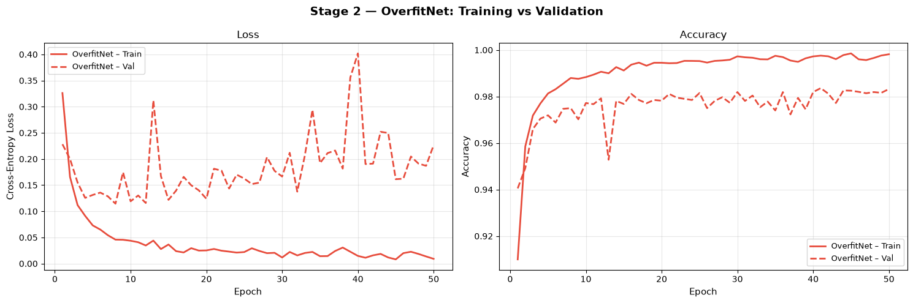
Fig. 3. Training and validation loss for the unregularized OverfitNet across 50 epochs (Stage 2).
B. Stage 3 Results: Regularized Behavior
With regularization applied, training loss converged to 0.057 and validation loss converged to 0.054 — a ratio of approximately 1.05:1. Both curves decreased smoothly with no instability. Final training and validation accuracies were 98.14% and 98.29% respectively, indicating that the model no longer over-relied on memorized training examples. The corresponding loss curves are shown in Fig. 4.
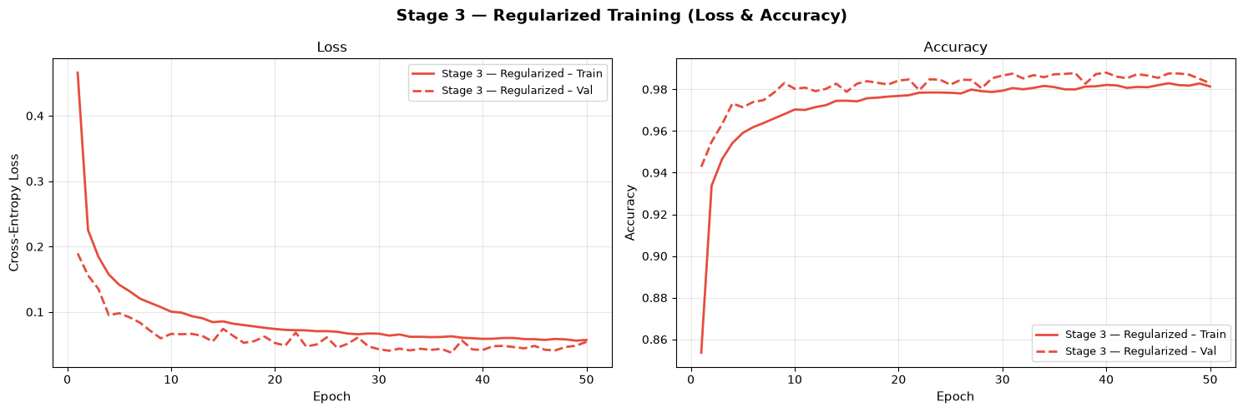
Fig. 4. Training and validation loss for the regularized OverfitNet across 50 epochs (Stage 3).

C. Comparative Analysis
Table III summarizes the final metrics from Stage 2 and Stage 3. The train/validation loss ratio — the clearest single indicator of overfitting severity — fell from 25:1 to 1.05:1, despite both stages sharing an identical architecture. Fig. 5 and Fig. 6 present the overlaid loss and accuracy trajectories for direct visual comparison.

TABLE II
FINAL METRICS: STAGE 2 VS. STAGE 3
Metric | Stage 2 | Stage 3
Train loss | 0.009 | 0.057
Val loss | 0.226 | 0.054
Loss ratio | 25.0 | 1.05
Train acc. | 99.82% | 98.14%
Val acc. | 98.32% | 98.29%
Test acc. | 98.19% | 98.56%

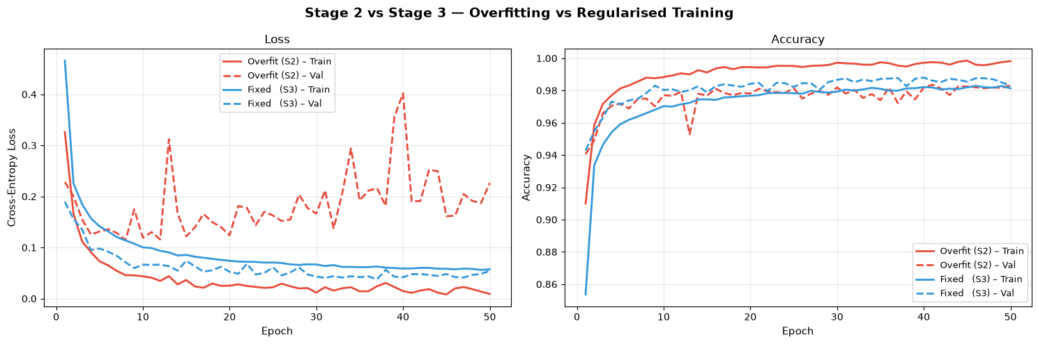
Fig. 5. Overlaid training/validation loss curves, Stage 2 vs. Stage 3.
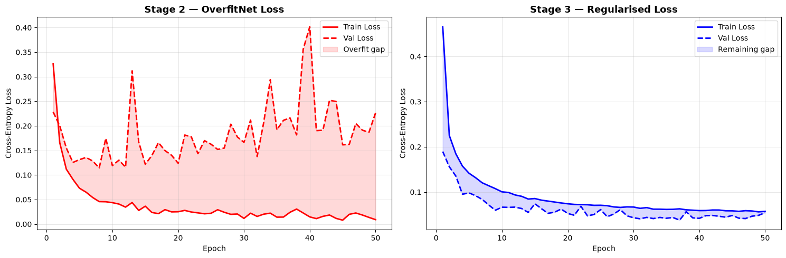
Fig. 6. Overlaid training/validation accuracy curves, Stage 2 vs. Stage 3.
D. Per-Class Performance
Per-class test accuracy for the Stage 3 regularized model ranged from 94.05% (digit 9) to 99.80% (digit 4). Digit 9 was the most frequently misclassified class, consistent with its visual similarity to digits 4 and 7 in cursive handwriting styles. Digit 4 achieved the highest accuracy, attributable to its comparatively unambiguous stroke geometry. The full per-class distribution is shown in Fig. 7.
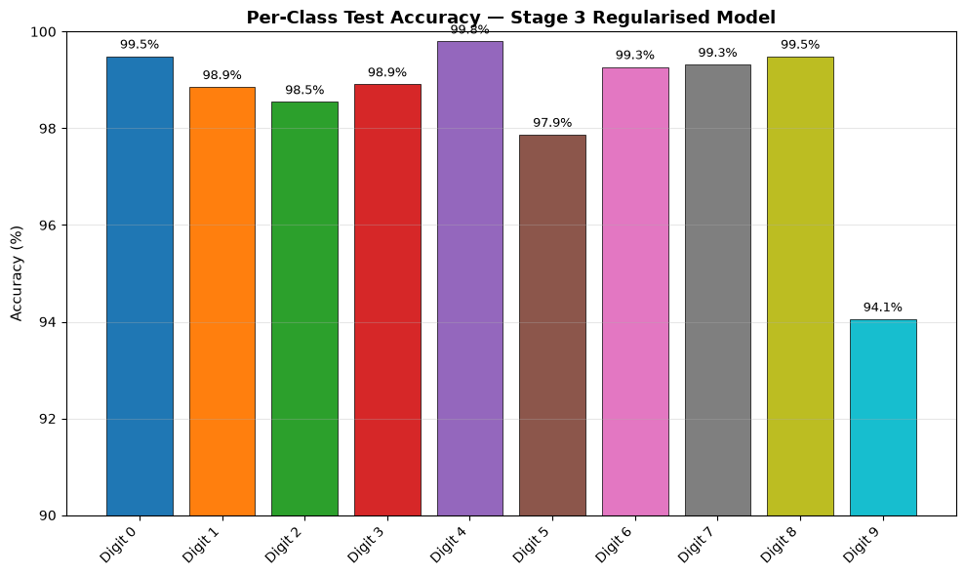
Fig. 7. Per-class test accuracy for the Stage 3 regularized model, digits 0–9.

E. Confusion Matrix Analysis
Fig. 8 presents the confusion matrix of the Stage 3 regularized model on the MNIST test set. Most predictions lie along the main diagonal, indicating high classification accuracy across all digit classes. The largest source of error was the misclassification of digit 9 as digit 4 (32 instances), followed by digit 9 being classified as digit 8 (16 instances). These results explain why digit 9 achieved the lowest per-class accuracy (94.1%). In contrast, digit 4 achieved the highest accuracy (99.8%) and exhibited almost no confusion with other classes. Overall, the confusion matrix confirms that the regularized model generalizes well, with classification errors primarily occurring between visually similar handwritten digits.
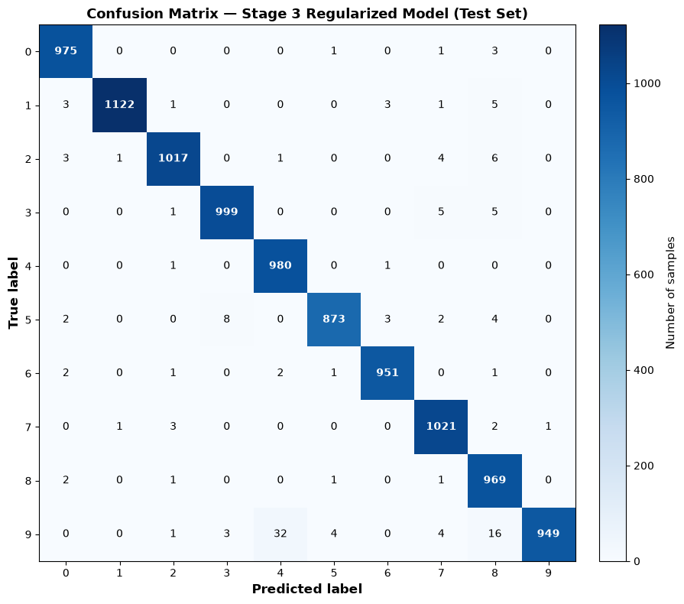
Fig. 8. Confusion matrix of the Stage 3 regularized model evaluated on the MNIST test set.
V. DISCUSSION
The results support the central claim of this study: overfitting, at least in the regime examined here, is not an intrinsic and unavoidable consequence of using a high-capacity model on a comparatively small dataset. Rather, it is contingent on the training procedure. The same 25-million-parameter network that memorized its training set almost perfectly in Stage 2 (train accuracy 99.82%, near-zero train loss) was, without any change to its structure, made to generalize well in Stage 3 through weight decay, data augmentation, and a reduced learning rate.
Notably, the accuracy-based generalization gap alone (1.50 percentage points in Stage 2) understated the severity of overfitting relative to the loss-based ratio (25:1). This occurs because MNIST's ten classes are visually well-separated, so even a severely overfit model retains high raw accuracy; the loss function, by contrast, is sensitive to the model's confidence calibration, and therefore more clearly reveals the underlying memorization.
The persistence of lower per-class accuracy for digit 9 across both stages suggests a data-driven, rather than training-driven, source of residual error — namely, genuine visual ambiguity between certain handwritten digit pairs that a purely fully connected architecture, lacking any spatial inductive bias, is comparatively ill-equipped to resolve.

VI. CONCLUSION AND FUTURE WORK
This study demonstrated, on the MNIST handwritten digit dataset, that a deliberately over-parameterized fully connected network (Stage 2) can be driven to severe overfitting (25:1 train/validation loss ratio) and subsequently restored to strong generalization (1.05:1 ratio) in Stage 3 using only training-procedure-level interventions — L2 weight decay, data augmentation, and learning-rate reduction — without any architectural modification. The Stage 3 regularized model achieved a final test accuracy of approximately 98.3%, using the same fixed data partition established in Stage 1.
Future work could extend this analysis by incorporating a convolutional architecture to assess whether spatial inductive bias further reduces residual errors on visually ambiguous classes such as digit 9, by systematically varying the weight decay coefficient to characterize the regularization-capacity trade-off curve, and by applying the same three-stage protocol to a more complex, higher-resolution image classification dataset to test the generality of these findings beyond MNIST.

. REFERENCES
[1] Y. LeCun, L. Bottou, Y. Bengio, and P. Haffner, “Gradient-based learning applied to document recognition,” Proc. IEEE, vol. 86, no. 11, pp. 2278–2324, 1998.
[2] D. P. Kingma and J. Ba, “Adam: A method for stochastic optimization,” in Proc. Int. Conf. Learning Representations (ICLR), 2015.
[3] I. Goodfellow, Y. Bengio, and A. Courville, Deep Learning. Cambridge, MA, USA: MIT Press, 2016.
[4] A. Krizhevsky, I. Sutskever, and G. E. Hinton, “ImageNet classification with deep convolutional neural networks,” in Proc. Advances in Neural Information Processing Systems (NeurIPS), 2012, pp. 1097–1105.
[5] A. Paszke et al., “PyTorch: An imperative style, high-performance deep learning library,” in Proc. Advances in Neural Information Processing Systems (NeurIPS), 2019, pp. 8026–8037.

