5a) Installation of KVM and creation of Virtual instances

Aim:
To install a KVM and creation of virtual instance for setting up a virtualized
environment on linux system.
What is KVM?
KVM (Kernel-based Virtual Machine) is an open-source virtualization technology built into the Linux kernel. It turns Linux into a type-1 hypervisor that allows you to run multiple virtual machines (VMs) on a physical host.
Each VM has its own virtual hardware (CPU, RAM, disk, etc.), and runs its own full-fledged operating system.
Benefits of KVM Feature Benefit
Open Source Free and supported by the Linux community.
Performance Near-native performance using hardware virtualization (Intel VT or AMD-V).
Security Isolation between VMs using SELinux and AppArmor. Scalability Can handle many VMs on a single host (scales well vertically). Flexibility Supports many OSes (Linux, Windows, BSD, etc.).
Integration Works with tools like libvirt, virt-manager, OpenStack, etc.

Live Migration
Procedure:
Supports live VM migration between hosts.

Virtualization Technology
- Check Hardware Virtualization Support.
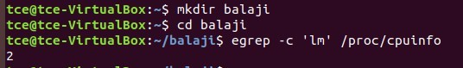
Output ≥ 1 indicates support. If 0, CPU doesn't support hardware virtualization.

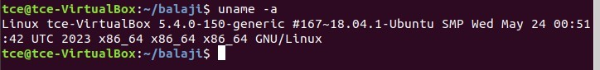

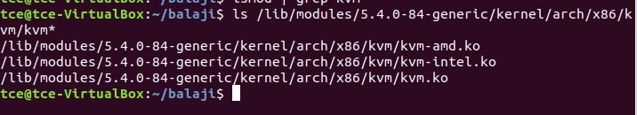
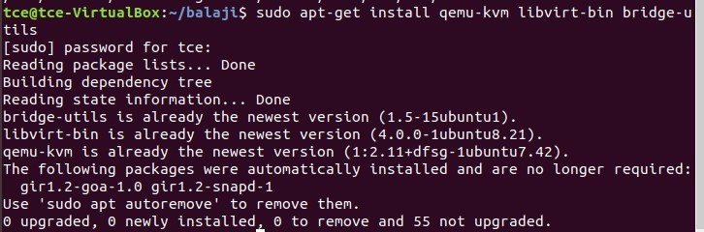

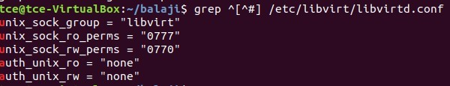

- Run virsh list - Displays no of Virtual machine running.
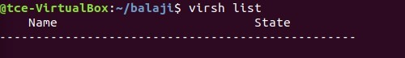

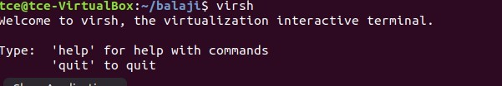

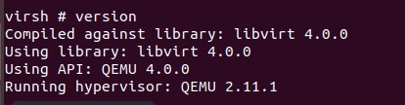
- Getting Node information
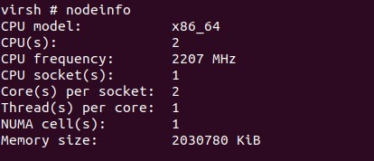

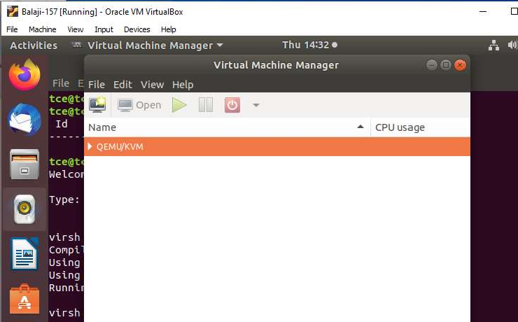

- Select import existing disk image and click forward.

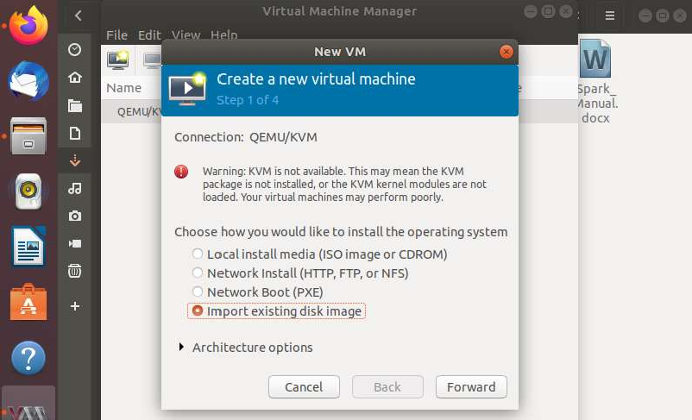

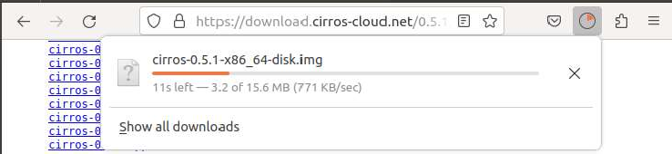

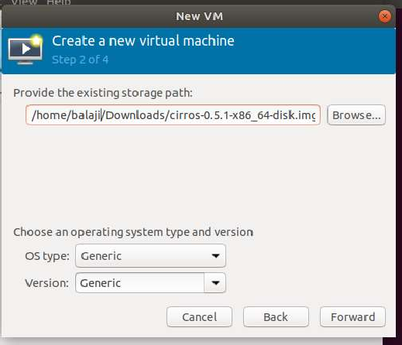

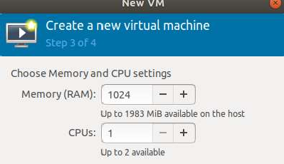

- Name your VM and click Finih.

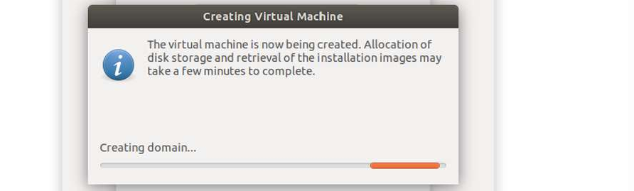

- The VM is booted successfully and the login was also successful.
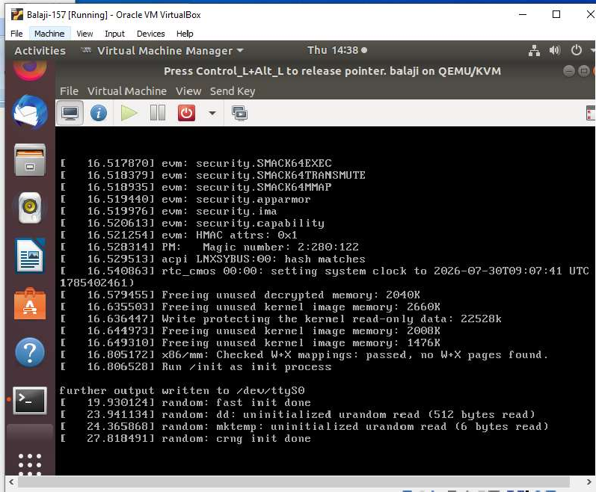

Result:
Thus, the KVM was successfully installed on the Linux system, and virtual instances were created and configured using Virt-Manager, demonstrating the setup of a virtualized environment.

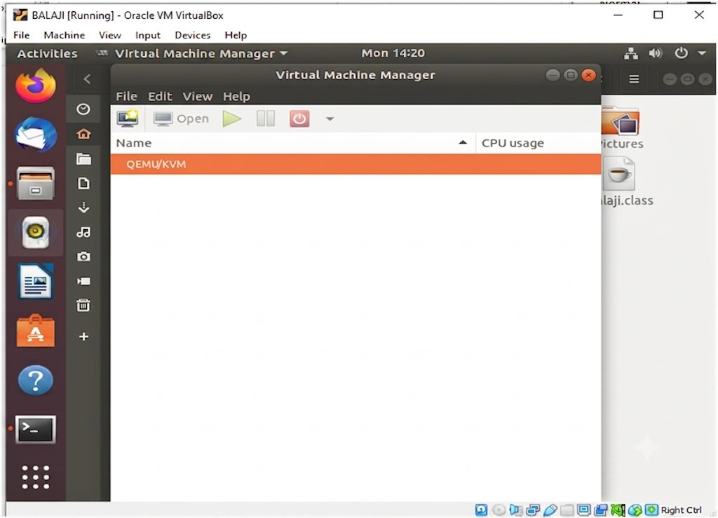

- Select Local install media (ISO image or CDOM).
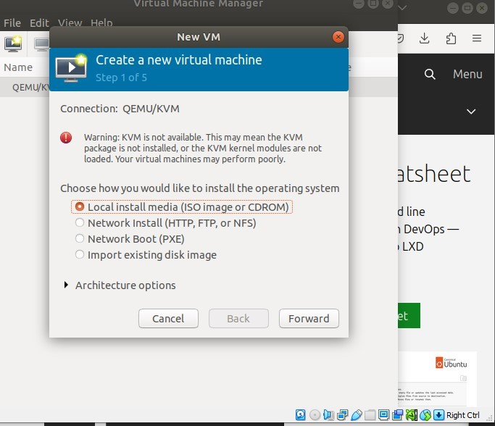

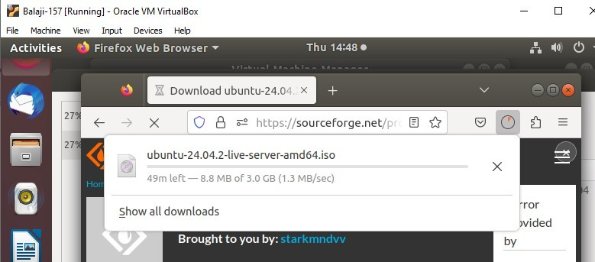

- Select the downloaded ubuntu server iso path and click Forward.
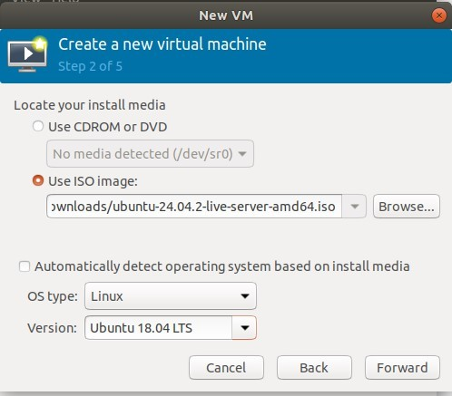

- Specify the memory and CPU required and click Forward.
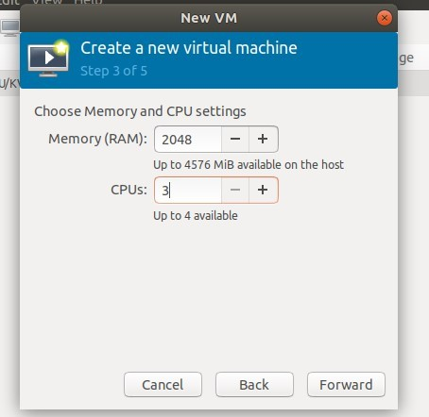

- Run the command : qemu-img create -f qcow2 ubuntu_vm.qcow2 10G
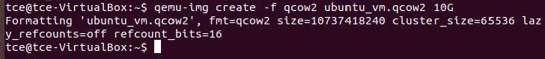

.

- Name the VM and click Finish.
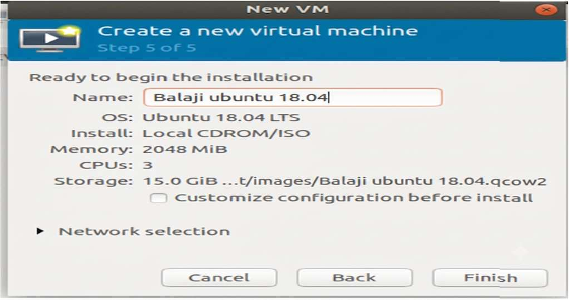

- Select Install Ubuntu Server and then the VM boots.
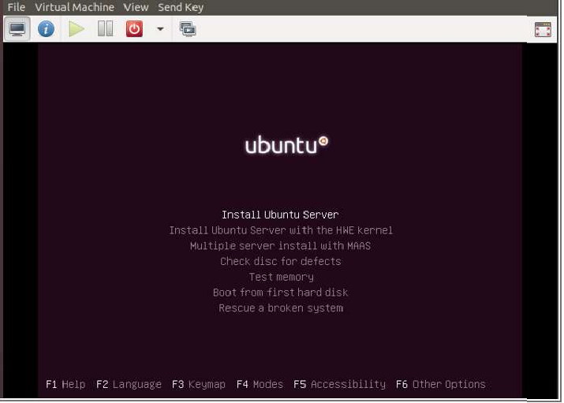

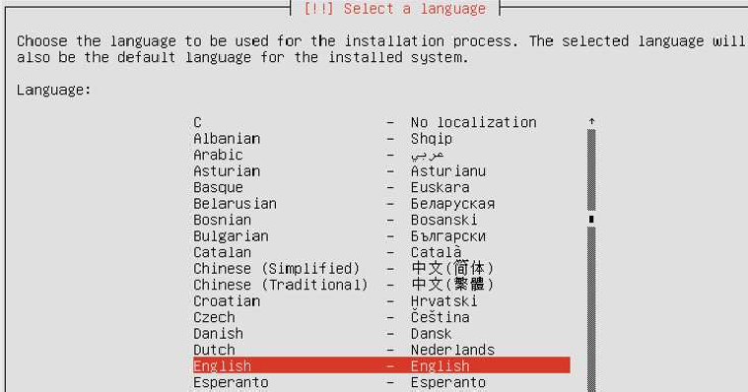
- Select the language and location.

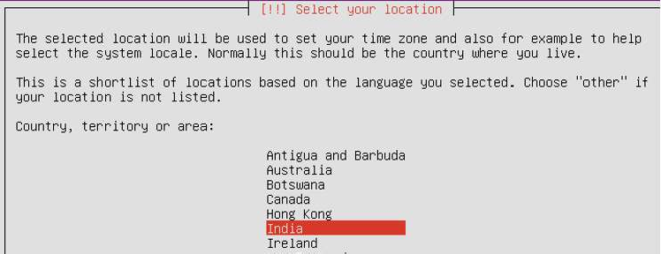

- Set the Keyboard configuration.
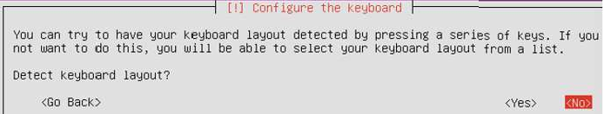

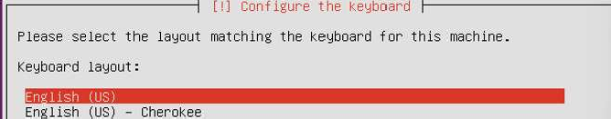

- Then it starts detecting, loading and scanning of needed things.

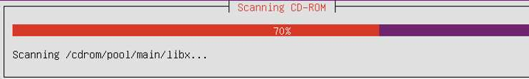

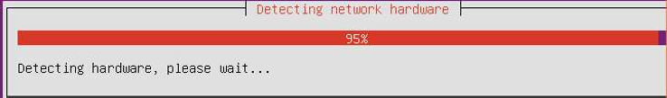

- Then set hostname, username, password and clock settings.
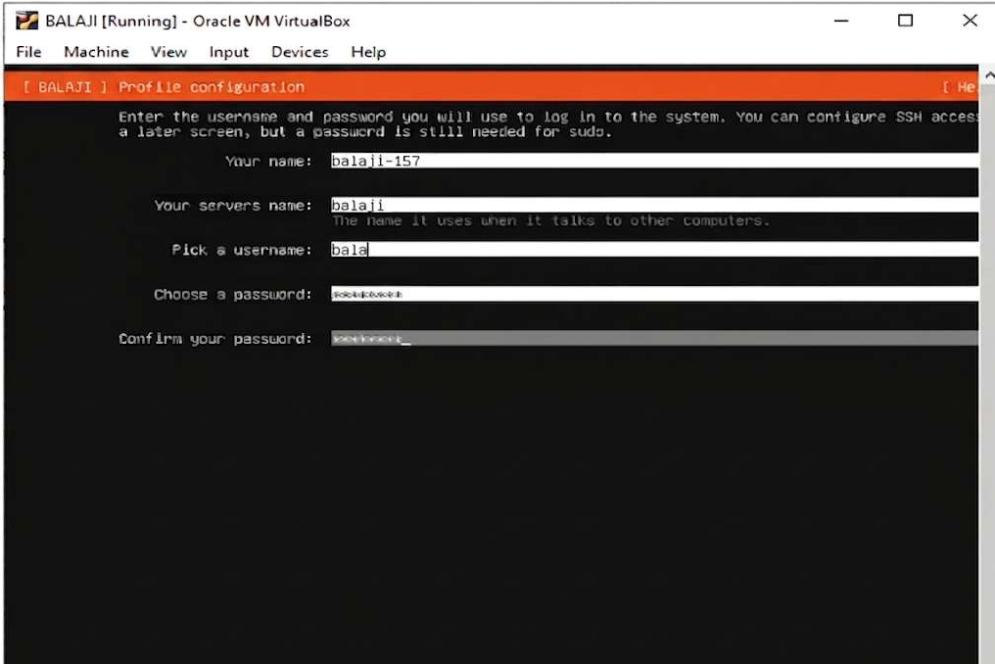

- Set the disk partition.
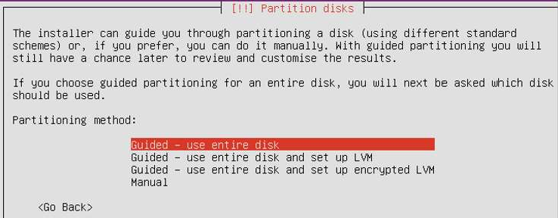

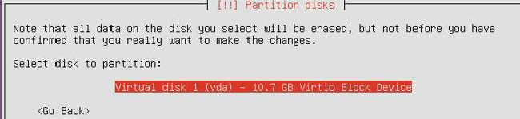

- Select Yes to write the changes to disks.
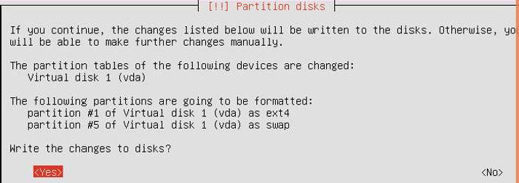

- Then, the system installation starts.
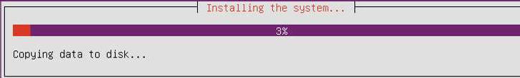
- For http proxy, just click Enter.
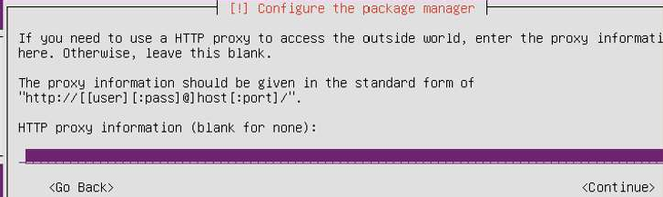

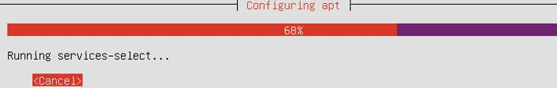

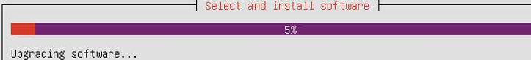

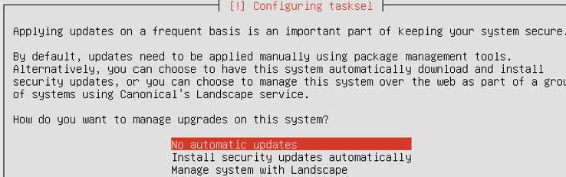
- Select No automatic updates option for configuring tasksel.

- In Software selection, select(use Spacebar) standard system utilities and OpenSSH server.
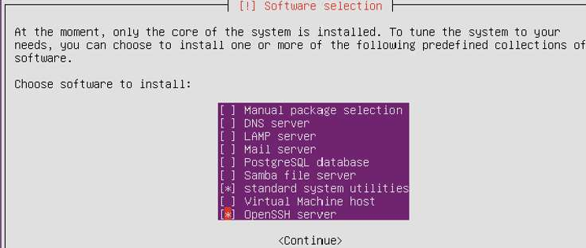

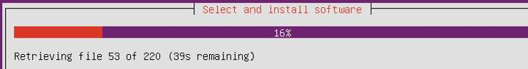

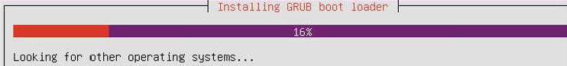

- Give Yes to install GRUB boot loader.
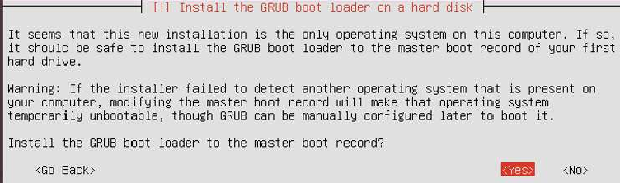
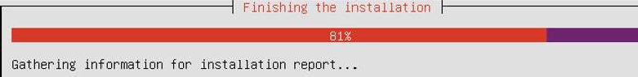

- Now, login to your VM.
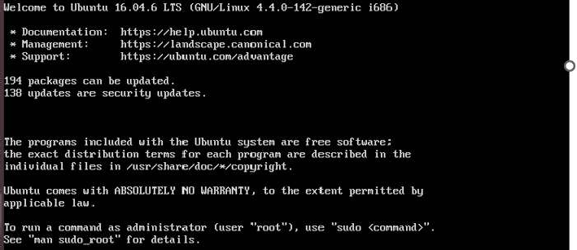
Image Resizing

  - Shut down the VM if it's running.
  - Resize the qcow2 image.
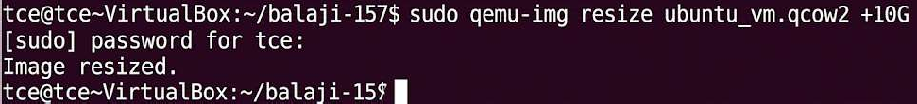
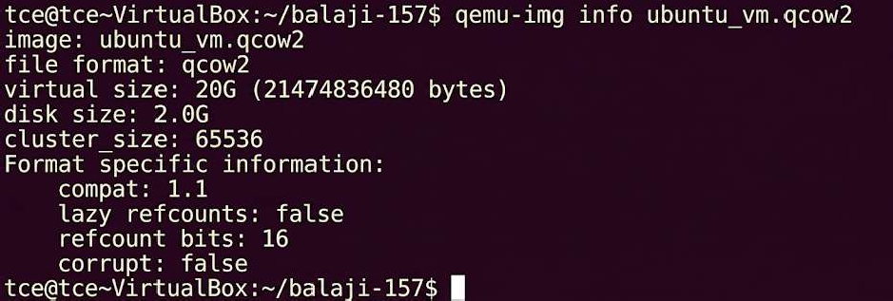

  - Resize partitions inside the VM.
Once you've resized the image, boot into the VM and resize the partition/filesystem:
sudo growpart /dev/sda 1 sudo resize2fs /dev/sda1

Image Conversion
- Conversion of qcow2 to vhd, vdi using qemu-img. qcow2 to vdi
qcow2 to vhd
qcow2 to img

