

**School of Computer Science and Engineering**

**Register Number: 18BCE0745**

**Name: Gourishetty Sreemanth**

**Assignment 1:**

**Planets and Chocolates**

**Code:**

**Index:**

<!DOCTYPE html>

<html lang="en">

<head>

    <meta charset="UTF-8">

    <meta name="viewport" content="width=device-width, initial-scale=1.0">

    <title>Document</title>

</head>

<body>

    <img src="PLANETS.jpg" width="620" height="372" usemap="#planetmap">

    <map name="planetmap">

        <area shape="rect" coords="11,3,154,179" title="sun" href="sun.html" alt="Sun">

        <area shape="rect" coords="140,3,327,184"  title="mer" href="mercury.html" alt="Sun">

        <area shape="rect" coords="317,3,485,175"  title="ven" href="venus.html" alt="Sun">

        <area shape="rect" coords="480,3,620,175"  title="earth" href="earth.html" alt="Sun">

    </map>

    <img src="choco.jpg" width="225" height="225" usemap="#chocomap">

    <map name="chocomap">

        <area shape="circle" coords="73,104,10" href="choco1.html" alt="Sun">

        <area shape="circle" coords="117,114,10"  href="choco2.html" alt="Sun">

        <area shape="circle" coords="153,123,10"  href="choco1.html" alt="Sun">

        <area shape="circle" coords="4=190,131,10"  href="choco2.html" alt="Sun">

    </map>

</body>

</html>

**Sun.html**

<!DOCTYPE html>

<html lang="en">

<head>

    <meta charset="UTF-8">

    <meta name="viewport" content="width=device-width, initial-scale=1.0">

    <title>Document</title>

</head>

<body>

    Hey Im sun

</body>

</html>

**Venus.html**

<!DOCTYPE html>

<html lang="en">

<head>

    <meta charset="UTF-8">

    <meta name="viewport" content="width=device-width, initial-scale=1.0">

    <title>Document</title>

</head>

<body>

    Hey Im venus

</body>

</html>

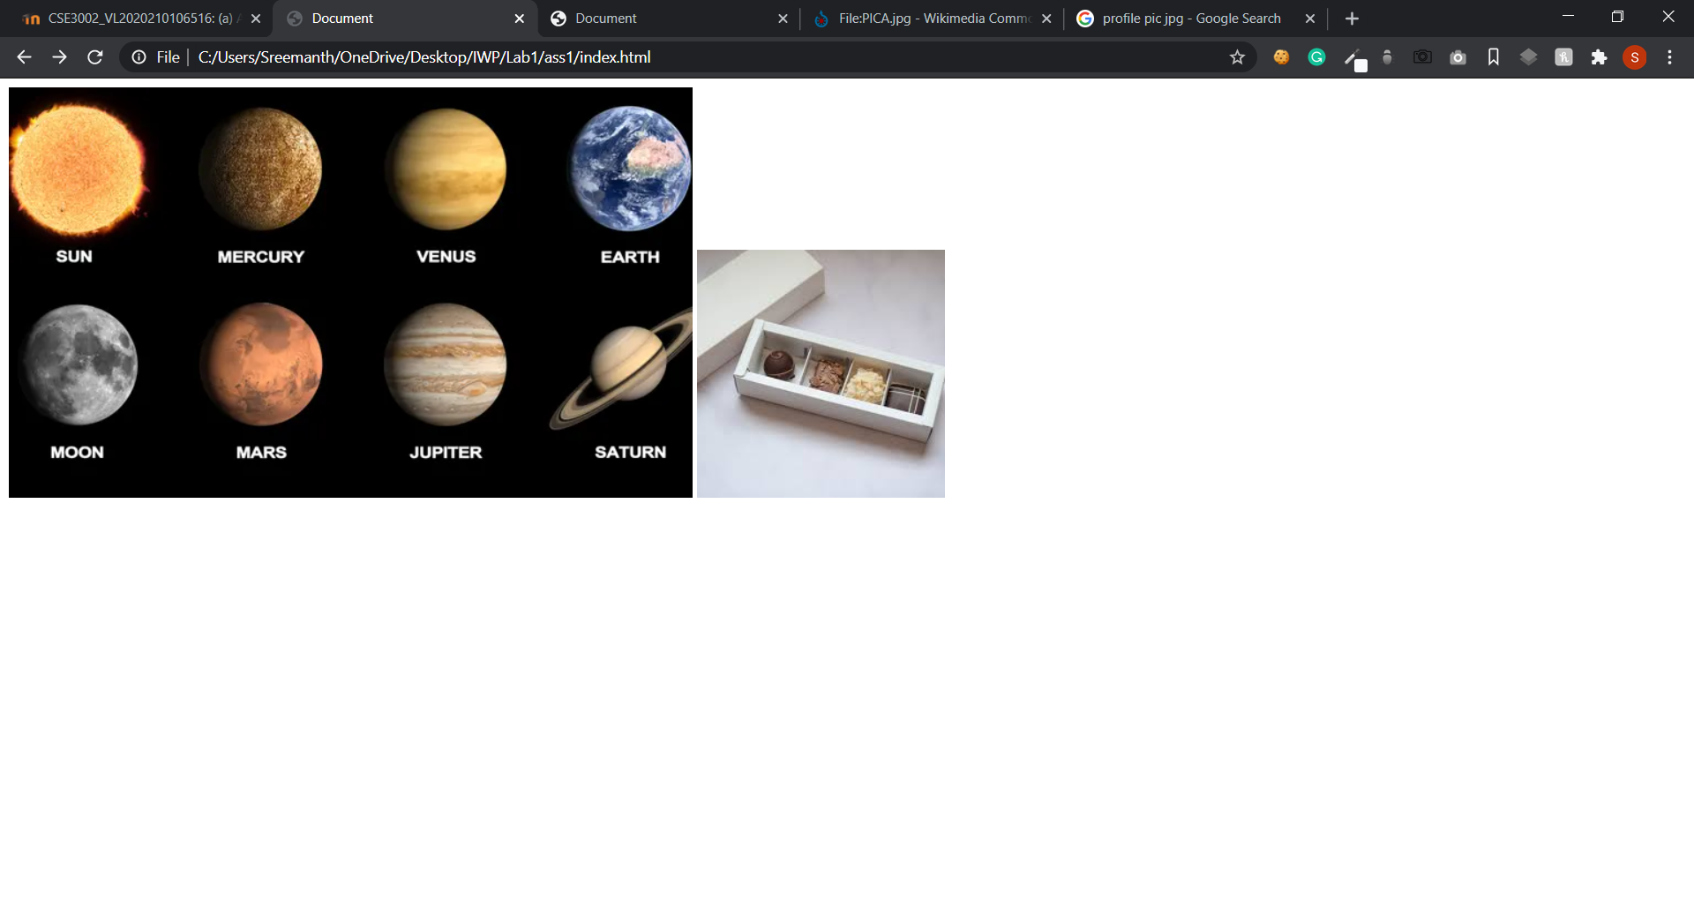

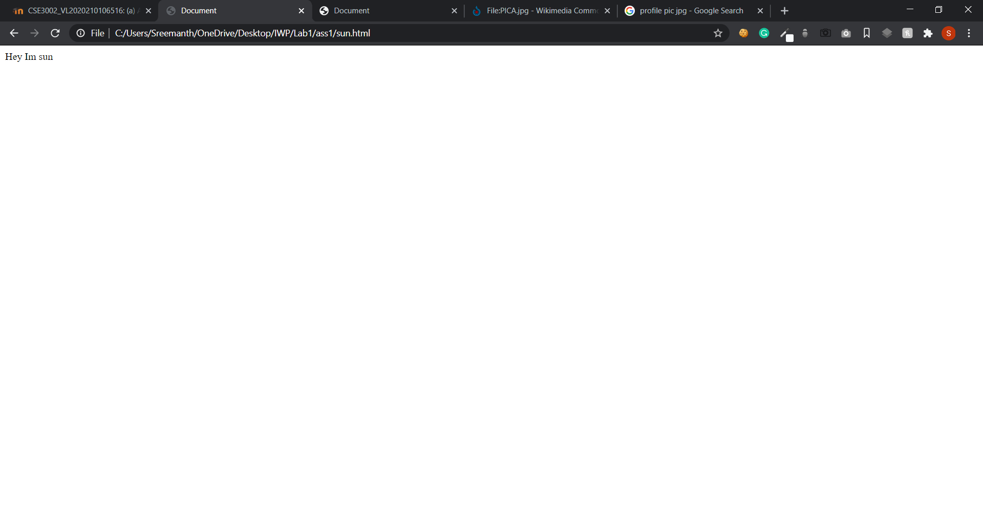

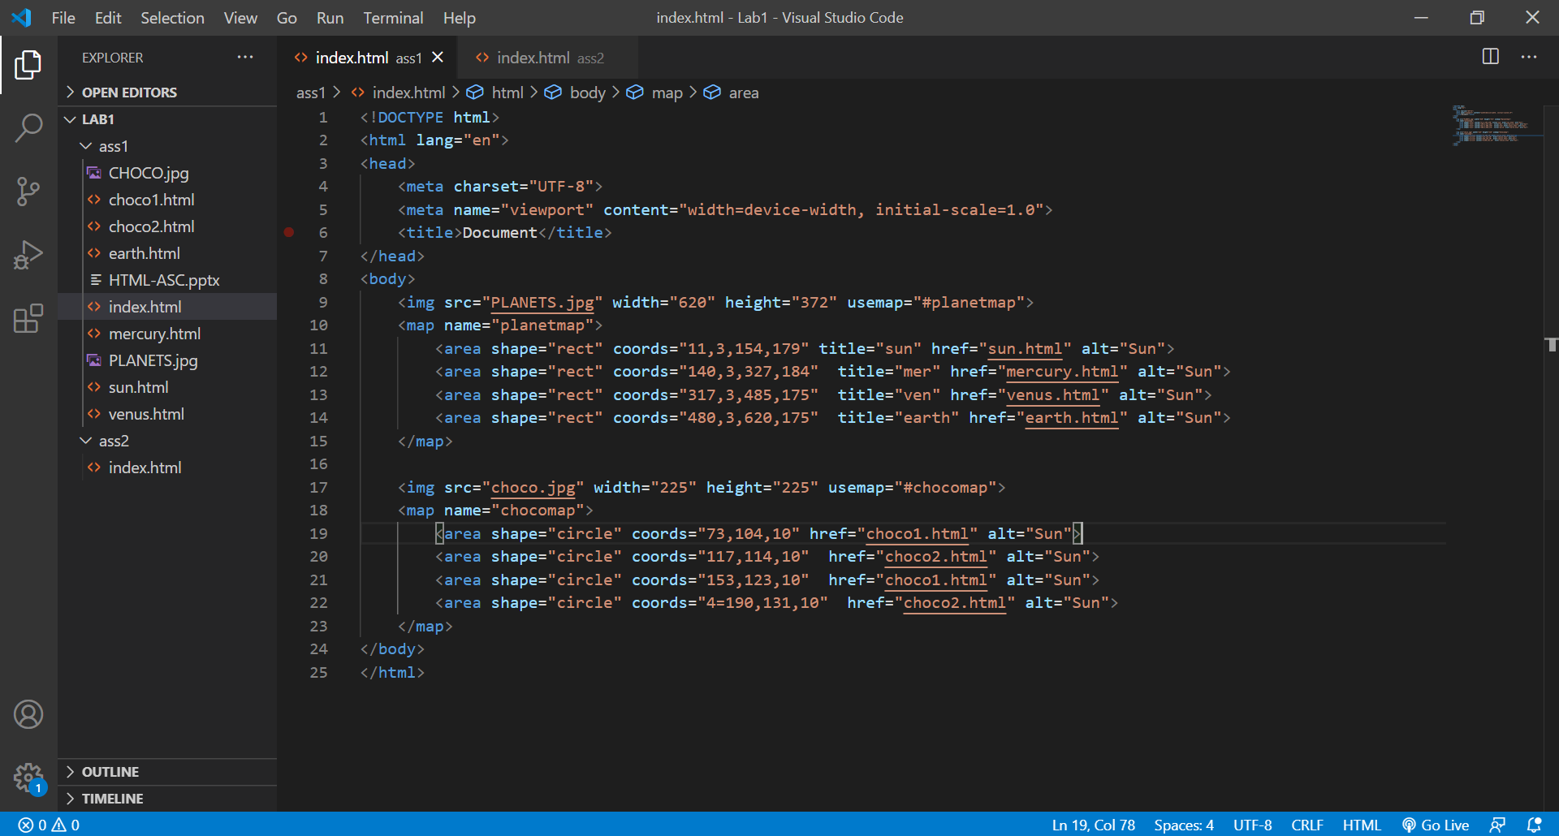

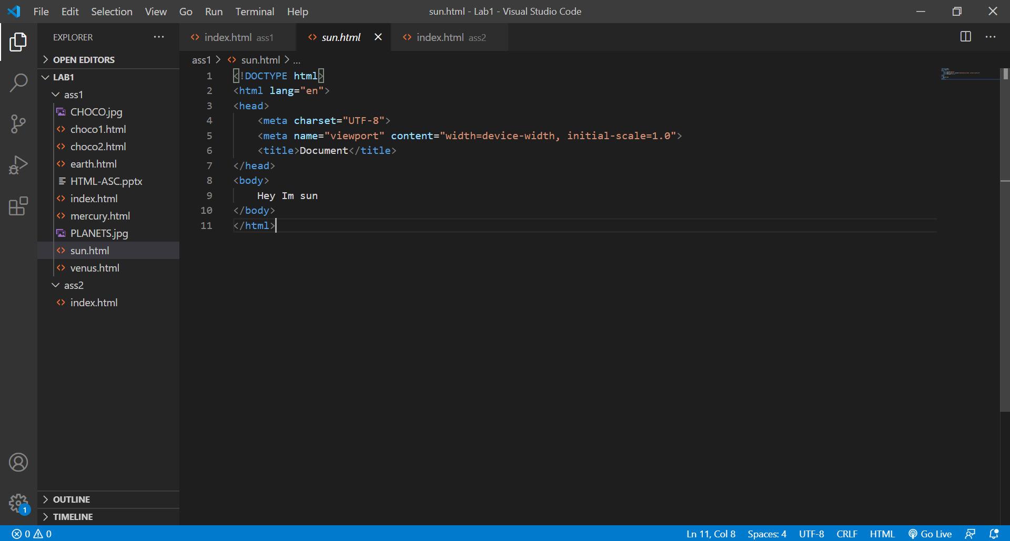

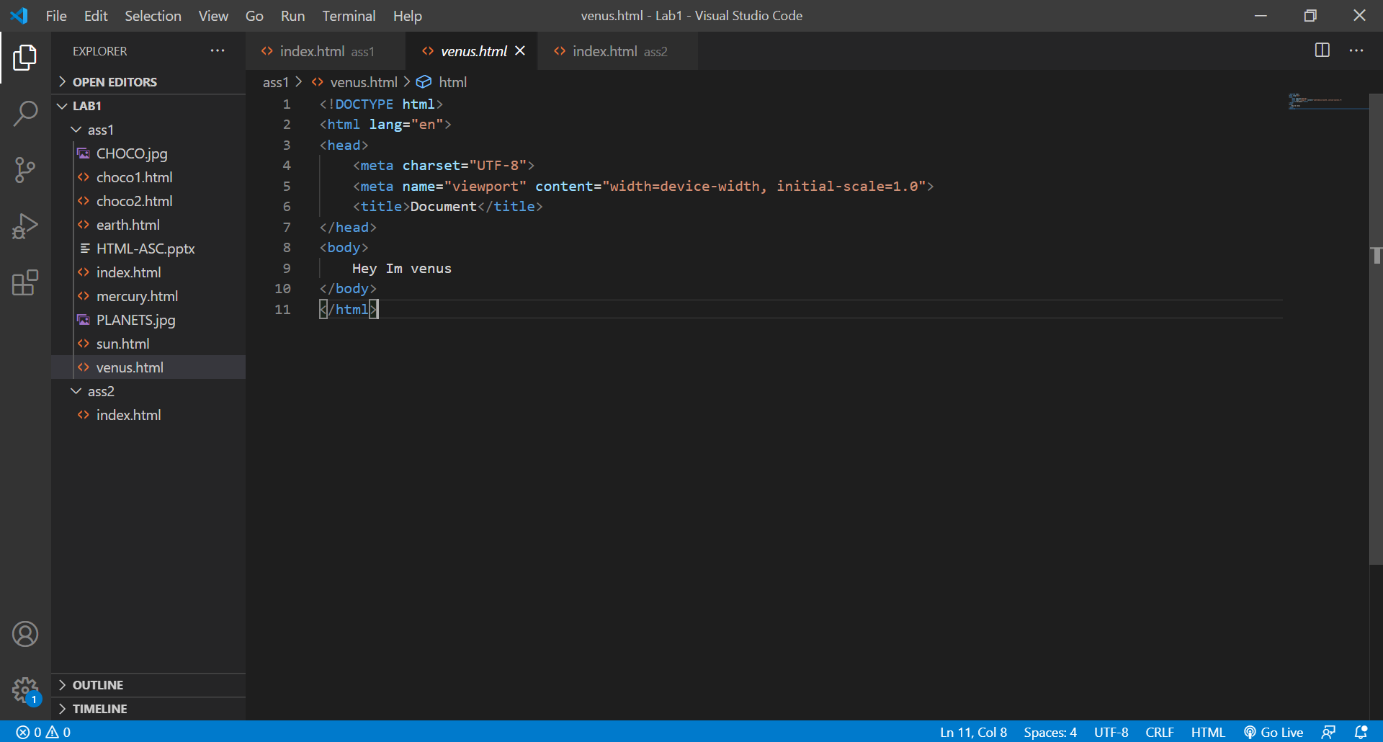

**Assignments 2:**

**Code:**

<!DOCTYPE html>

<html lang="en">

<head>

    <meta charset="UTF-8">

    <meta name="viewport" content="width=device-width, initial-scale=1.0">

    <title>Document</title>

</head>

<body>

    <center>

        <h1>

            Portfolio

        </h1>

    <hr>

        <img src="https://upload.wikimedia.org/wikipedia/commons/thumb/3/34/PICA.jpg/900px-PICA.jpg" width="255" height="255" alt="">

</center>

<h2>Sreemanth</h2>

<p>Lorem ipsum dolor sit amet consectetur adipisicing elit. Veniam odio itaque omnis error, voluptatum ducimus doloremque soluta nam, eum necessitatibus quaerat totam. Soluta provident nulla necessitatibus, animi excepturi sequi iure!</p>

<hr>

<h1>Hobbies</h1>

<ul>

    <li>Eat</li>

    <li>Sleep</li>

    <li>Code</li>

</ul>

<hr>

<h1>Skills</h1>

<table>

    <th>

    <tr>

        <td>Skills</td>

        <td>Ratings</td>

    </tr>

</th>

    <tbody>

        <tr> <td>Html</td><td>⭐⭐⭐⭐</td> </tr>

        <tr> <td>css</td><td>⭐⭐</td> </tr>

        <tr> <td>js</td><td>⭐</td> </tr>

        <tr> <td>nodejs</td><td>⭐⭐⭐⭐</td> </tr>

    </tbody>

</table>

<hr>

<h1>Feedback</h1>

<form action="mailto:sreemanth2001@gmail.com">

    <input type="submit" value="Contact Me">

</form>

</body>

</html>

**Output:**

