

**School of Computer Science and Engineering**

**Register Number: 18BCE0745**

**Name: Gourishetty Sreemanth**

**IWP- LAB Task -2**

**Task 1**

<!DOCTYPE html>

<html lang="en">

<head>

    <meta charset="UTF-8">

    <meta name="viewport" content="width=device-width, initial-scale=1.0">

    <title>Document</title>

</head>

<body style="background-color:bisque">

    <div class="">

        <h1>Dark1</h1>

        <iframe width="100%" height="400" src="https://en.wikipedia.org/wiki/Dark_(TV_series)" title="">

        </iframe>

    </div>

    <div class="">

        <h1>Dark2</h1>

        <iframe width="100%" height="400" src="https://en.wikipedia.org/wiki/Dark_(disambiguation)" title="">

        </iframe>

    </div>

    <div class="">

        <h1>Dark3</h1>

        <iframe width="100%" height="400" src="https://en.wikipedia.org/wiki/Dark_(TV_series)" title="">

        </iframe>

        </div>

</iframe>

</body>

</html>

**Output:**

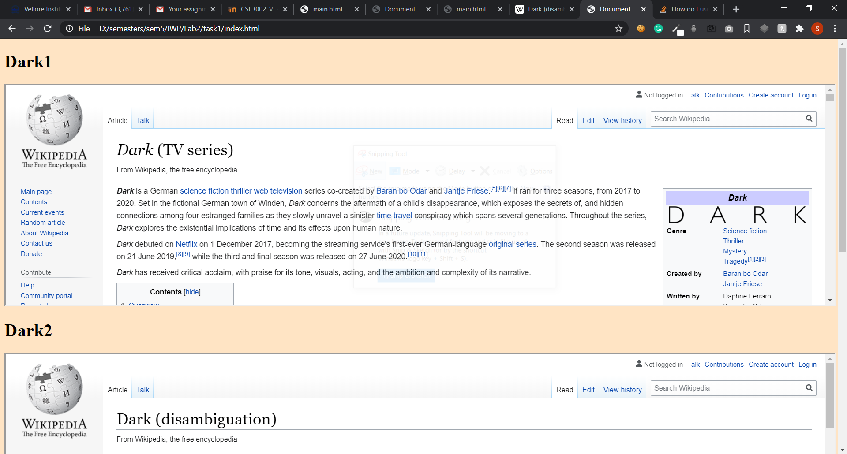

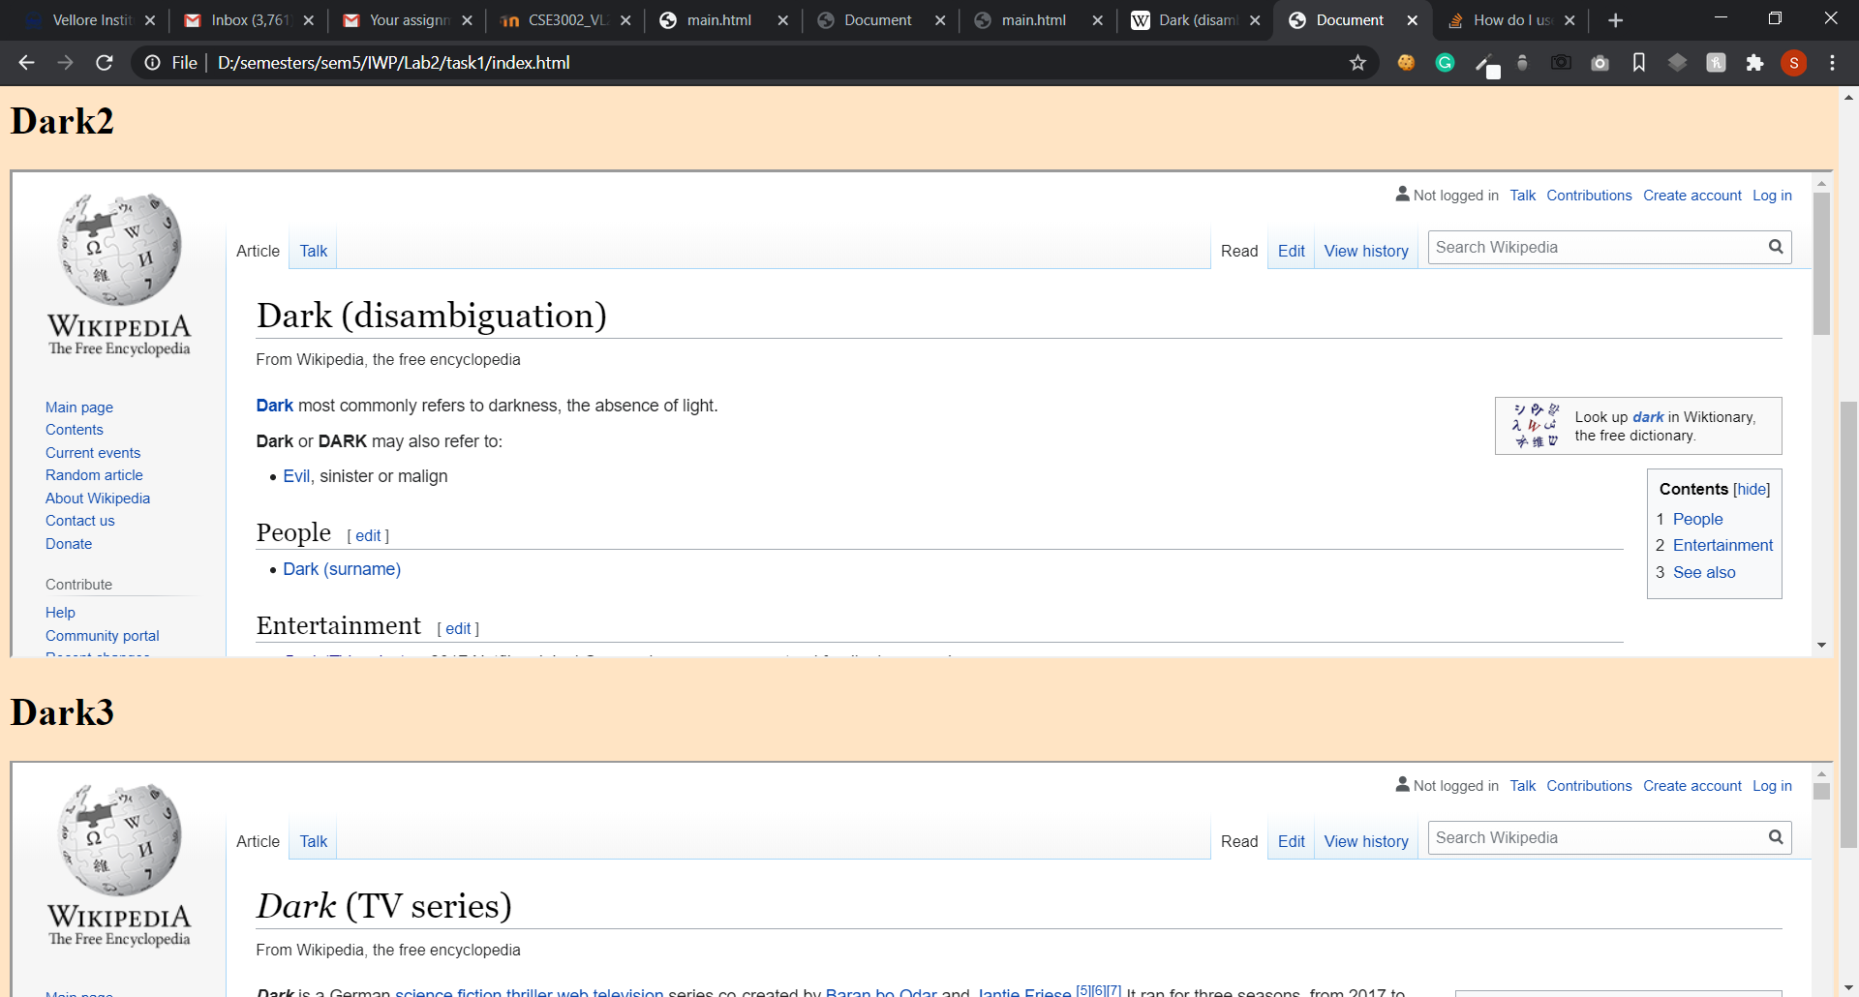

**Task 2)**

**Code:**

<!DOCTYPE html>

<html lang="en">

<head>

    <meta charset="UTF-8">

    <meta name="viewport" content="width=device-width, initial-scale=1.0">

    <title>Document</title>

</head>

<body>

    <table cellspacing="2" border="1" width="100%" cellpadding="3">

        <thead>

        <tr>

            <th>S.no</th>

            <th>Name</th>

            <th colspan="2">Location</th>

            <th colspan="2">From</th>

            <th colspan="2">To</th>

        </tr>

        <tr>

            <th></th>

            <th></th>

            <th>From</th>

            <th>To</th>

            <th>Arrival</th>

            <th>Dep</th>

            <th>Arrival</th>

            <th>Dep</th>

        </tr>

        </thead>

        <tbody>

            <tr>

                <td>1</td>

                <td>Express 1</td>

                <td>Vel</td>

                <td>Del</td>

                <td>9:30</td>

                <td>9:35</td>

                <td>10:30</td>

                <td>10:35</td>

            </tr>

            <tr>

                <td>1</td>

                <td>Express 1</td>

                <td>Vel</td>

                <td>Del</td>

                <td>9:30</td>

                <td>9:35</td>

                <td>10:30</td>

                <td>10:35</td>

            </tr>

            <tr>

                <td>1</td>

                <td>Express 1</td>

                <td>Vel</td>

                <td>Del</td>

                <td>9:30</td>

                <td>9:35</td>

                <td>10:30</td>

                <td>10:35</td>

            </tr>

            <tr>

                <td>1</td>

                <td>Express 1</td>

                <td>Vel</td>

                <td>Del</td>

                <td>9:30</td>

                <td>9:35</td>

                <td>10:30</td>

                <td>10:35</td>

            </tr>

        </tbody>

    </table>

</body>

</html>

**Ouputs:**

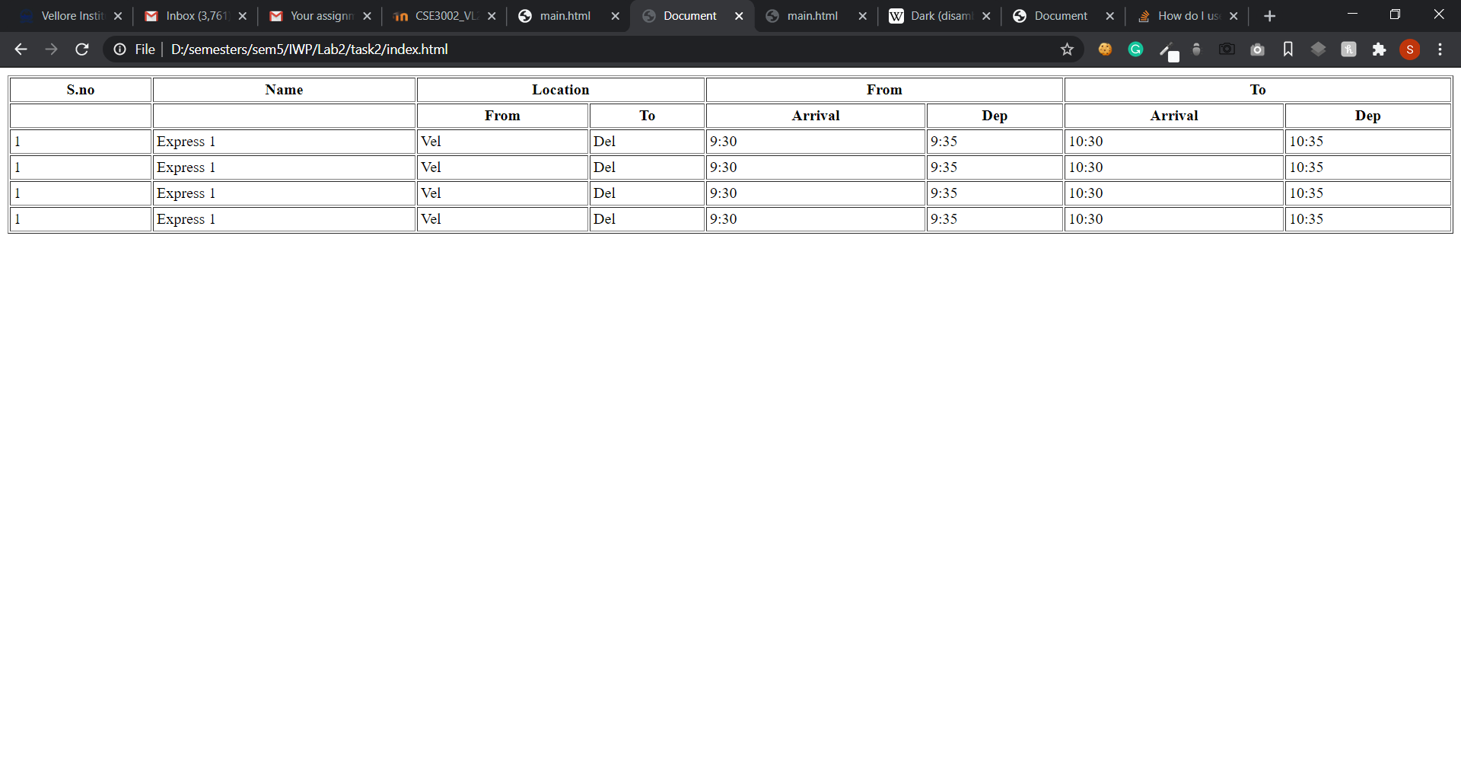

**Task 3)**

**Code:**

**Main.html**

<html>

    <frameset cols="20%,80%">

        <frame name=f1 src=nav.html>

        <frame name=f2 src=quote.html>

    </frameset>

</html>

**Nav.html**

<html lang="en">

<head>

    <title>Document</title>

</head>

<body>

   <ul><li><a href="quote1.html" target="f2">Home</a></li></ul>

   <ul><li><a href="quote2.html" target="f2">About Us</a></li></ul>

   <ul><li><a href="quote3.html" target="f2">Services</a></li></ul>

   <ul><li><a href="quote4.html" target="f2">Contacts</a></li></ul>

   <ul><li><a href="quote5.html" target="f2">Hello</a></li></ul>

   <ul><li><a href="quote6.html" target="f2">Hello</a></li></ul>

</body>

</html>

**Quote.html**

<!DOCTYPE html>

<html lang="en">

<head>

    <meta charset="UTF-8">

    <meta name="viewport" content="width=device-width, initial-scale=1.0">

    <title>Document</title>

</head>

<body>

 <Center>

 </Center>

</body>

</html>

**Quote1.html**

<!DOCTYPE html>

<html lang="en">

<head>

    <meta charset="UTF-8">

    <meta name="viewport" content="width=device-width, initial-scale=1.0">

    <title>Document</title>

</head>

<body>

    Hello1

</body>

</html>

**Quote2.html**

<!DOCTYPE html>

<html lang="en">

<head>

    <meta charset="UTF-8">

    <meta name="viewport" content="width=device-width, initial-scale=1.0">

    <title>Document</title>

</head>

<body>

    Hello2

</body>

</html>

**Quote3.html**

<!DOCTYPE html>

<html lang="en">

<head>

    <meta charset="UTF-8">

    <meta name="viewport" content="width=device-width, initial-scale=1.0">

    <title>Document</title>

</head>

<body>

    Hello3

</body>

</html>

**Quote4.html**

<!DOCTYPE html>

<html lang="en">

<head>

    <meta charset="UTF-8">

    <meta name="viewport" content="width=device-width, initial-scale=1.0">

    <title>Document</title>

</head>

<body>

    Hello4

</body>

</html>

**Quote5.html**

<!DOCTYPE html>

<html lang="en">

<head>

    <meta charset="UTF-8">

    <meta name="viewport" content="width=device-width, initial-scale=1.0">

    <title>Document</title>

</head>

<body>

    Hello5

</body>

</html>

**Output:**

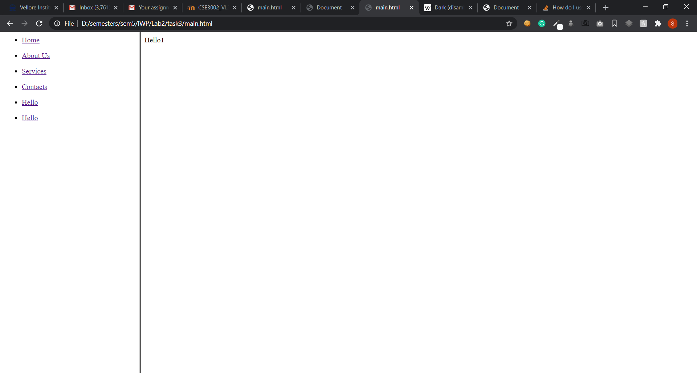

**After clicking about us**

