

**School of Computer Science and Engineering**

**Register Number: 18BCE0745**

**Name: Gourishetty Sreemanth**

• Animation: Rolling the ball and box from bottomleft to bottom-right [Hint: bezier curve is used to customize animation timings]

Index.html

<!DOCTYPE html>

<html lang="en">

<head>

    <meta charset="UTF-8">

    <meta name="viewport" content="width=device-width, initial-scale=1.0">

    <title>Document</title>

    <link rel="stylesheet" href="public\stylesheets\mian.css">

</head>

<body>

    <h1>Task1</h1>

    <div class="body">

        <div class="ball">

        </div>

        <div class="square">

        </div>

    </div>

</body>

</html>

Main.css

body,html{

    width: 100%;

    height: 100%;

}

.body{

    height: 80%;

    display: flex;

    flex-direction: column-reverse;

}

.ball{

    margin-top:50px;

    width: 100px;

    height: 100px;

    /* background-color: red; */

    background: rgb(2,0,36);

background: linear-gradient(90deg, rgba(2,0,36,1) 0%, rgba(9,9,121,1) 35%, rgba(0,212,255,1) 100%);

    border-radius: 50%;

    /* box-shadow: inset 3px 3px 3px #000; */

   animation-name: hello;

   animation-duration: 3s;

   animation-iteration-count: infinite;

   animation-timing-function: cubic-bezier(0.075, 0.82, 0.165, 1);

}

.square{

    width: 100px;

    height: 100px;

    background-color: red;

    /* box-shadow: inset 3px 3px 3px #000; */

   animation-name: hello;

   animation-duration: 3s;

   animation-iteration-count: infinite;

   animation-timing-function: cubic-bezier(0.075, 0.82, 0.165, 1);

   background: rgb(2,0,36);

   background: linear-gradient(90deg, rgba(2,0,36,1) 0%, rgba(9,9,121,1) 35%, rgba(0,212,255,1) 100%);

}

@keyframes hello{

    from{

       transform: translateX(0) rotatez(0);

    }

    to{

       transform: translateX(1200px) rotatez(900deg);

    }

}

**Output:**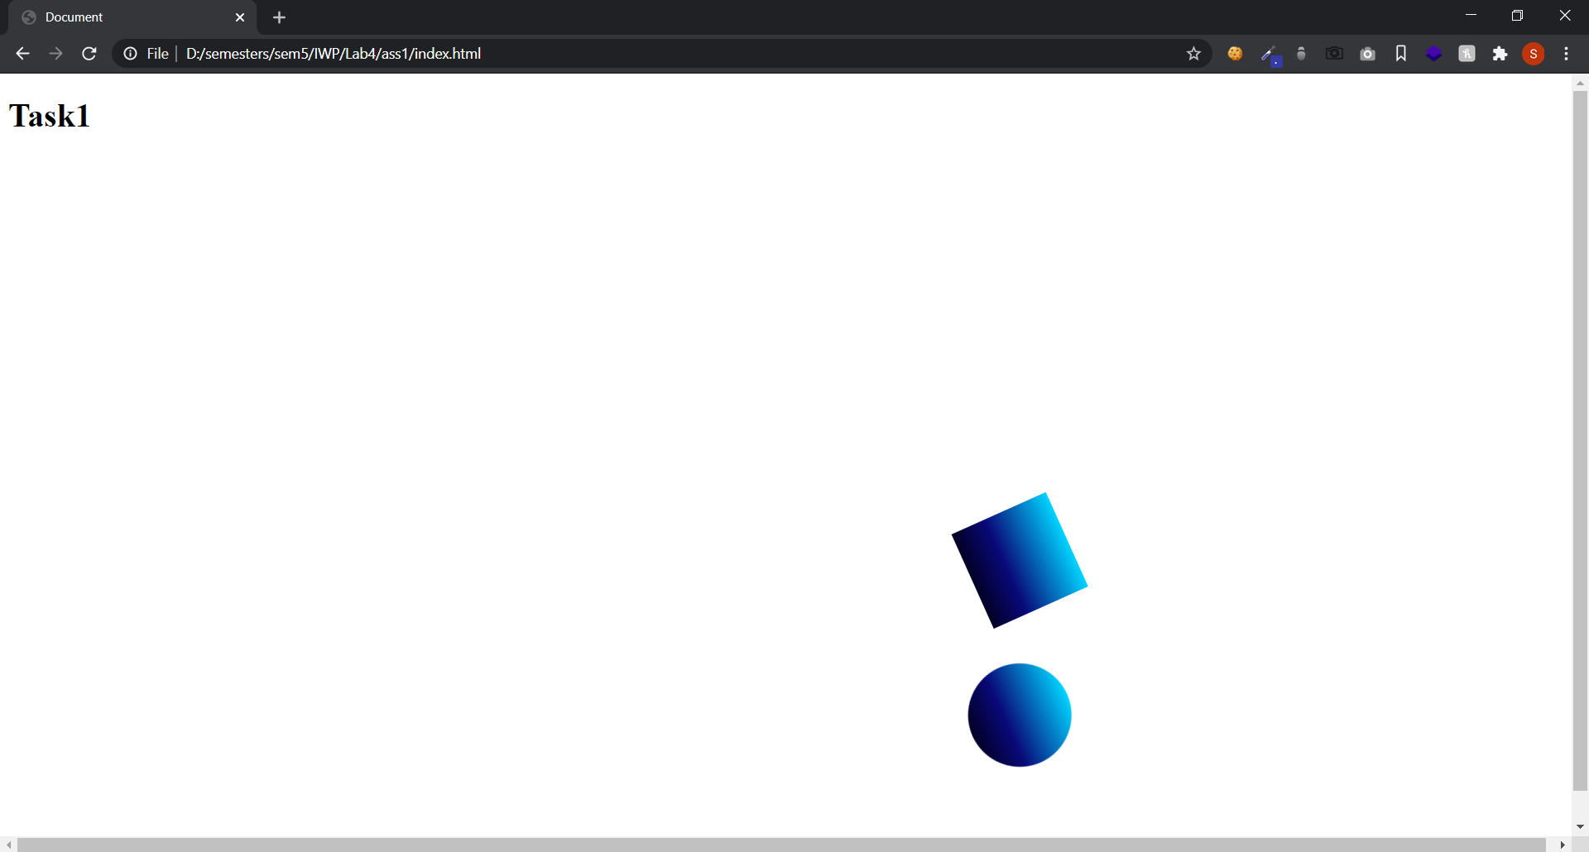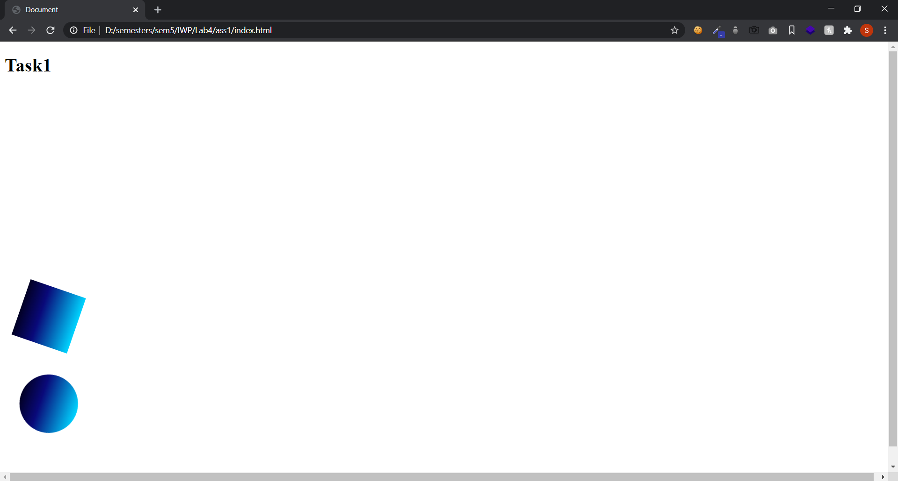

**Design below page. Apply CSS display and position properties.(relative,absolute,fixed,zindex,sticky,inline,block)**

**Index.html**

<!DOCTYPE html>

<html lang="en">

<head>

    <meta charset="UTF-8">

    <meta name="viewport" content="width=device-width, initial-scale=1.0">

    <title>Document</title>

    <link rel="stylesheet" href="public\stylesheets\mian.css">

</head>

<body>

    <h1>Task2</h1>

    <h2>Sticky :</h2>

    <div class="sticky">

        Im sticky

    </div>

    <h2>Position Static :</h2>

    <div class="static">

Im positioned static

    </div>

    <h2>Position : Relative</h2>

    <div class="relative">

        Im postioned relative to my original position\

        <div class="absolute1">

      <h2>Position : Absolute</h2>

            Im postioned absolute that means relative to body or nearest non-static position parent element(relative to nearest non static parent element)

        </div>

    </div>

    <div class="absolute2">

        <h2>Position : absolute</h2>

        Im postioned absolute that means relative to body or nearest non-static position parent element (relative to body)

    </div>

    <div class="fixed">

        Im placed fixed to the html page

    </div>

    <h1>Display Inline</h1>

    <div class="inline">

        Everything is In line in this are inline

    wefwefwefwefwef <div class="div">Div1 we frw</div> <div>Div2 we</div> we wef w e

    </div>

    <h1>Display Block</h1>

    <div class="block">

      wefwef  <span class="div">span1</span> wefwef<span>span2</span>wefw

    </div>

    <h1>Display Inline Block</h1>

    <div class="inlineblock">

        wefwefwefwefwef <div class="div">Div1 we frw</div> <div>Div2 we</div> we wef w e

    </div>

    </div>

</body>

</html>

**Main.css**

body,html{

    height: 120%;

}

div{

    padding:10px;

    background-color:lavender;

    margin: 30px 0;

    border: 2px solid black;

}

.inline div{

    padding:10px;

    background-color:red;

    margin: 10px 0;

    border: 2px solid black;

    display: inline;

}

div div{

    padding:10px;

    background-color:pink;

    margin: 10px 0;

    border: 2px solid black;

}

.block span{

    padding:10px;

    background-color:greenyellow;

    margin: 10px 0;

    border: 2px solid black;

    display: block;

}

.sticky{

    position: sticky;

    top: 0;

}

.static{

    position: static;

}

.relative{

    position: relative;

    top:10px;

    left:25px;

    right:25px;

    height: 200px;

}

.absolute1{

    position: absolute;

    top:70px;

    left: 50px;

}

.absolute2{

    position: absolute;

    top:10px;

}

h1{

    margin-top: 150px;

}

.fixed{

    position: fixed;

    bottom:10px;

    left:25px;

}

.inlineblock div{

    display: inline-block;

    width: 100px;

    height: 200px;

}

**Output:**

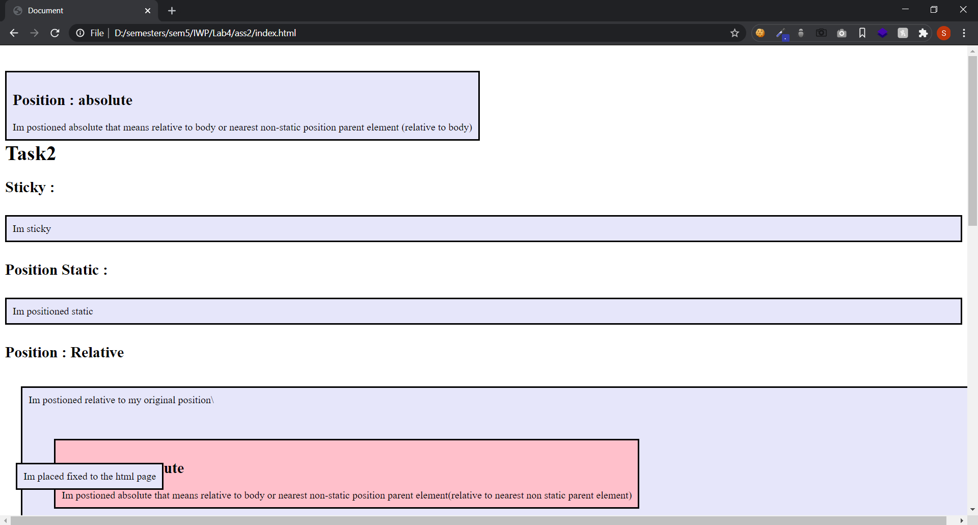

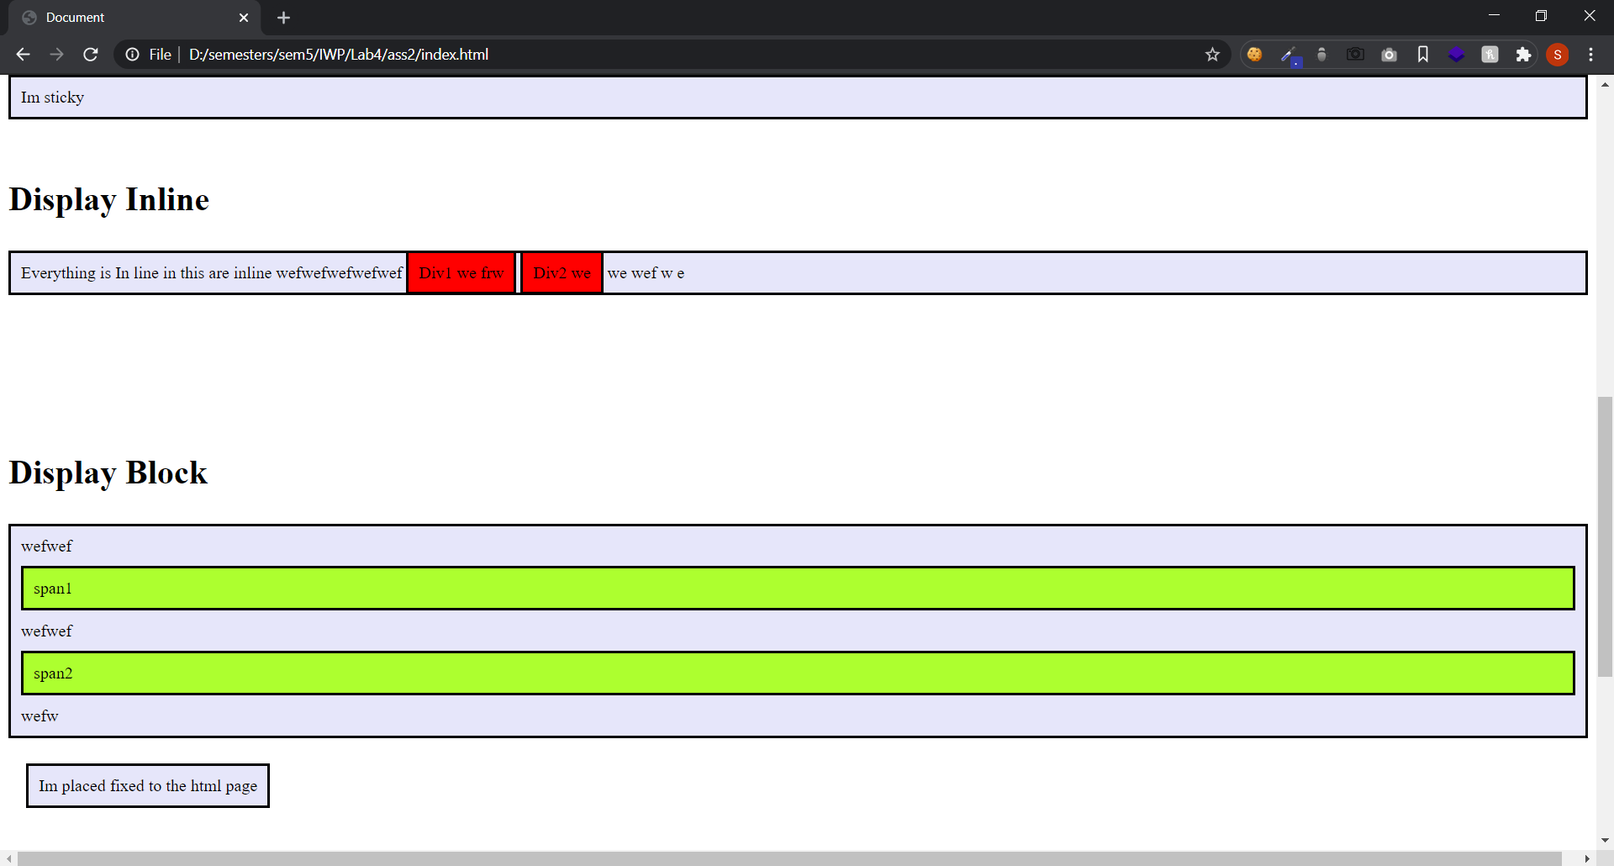

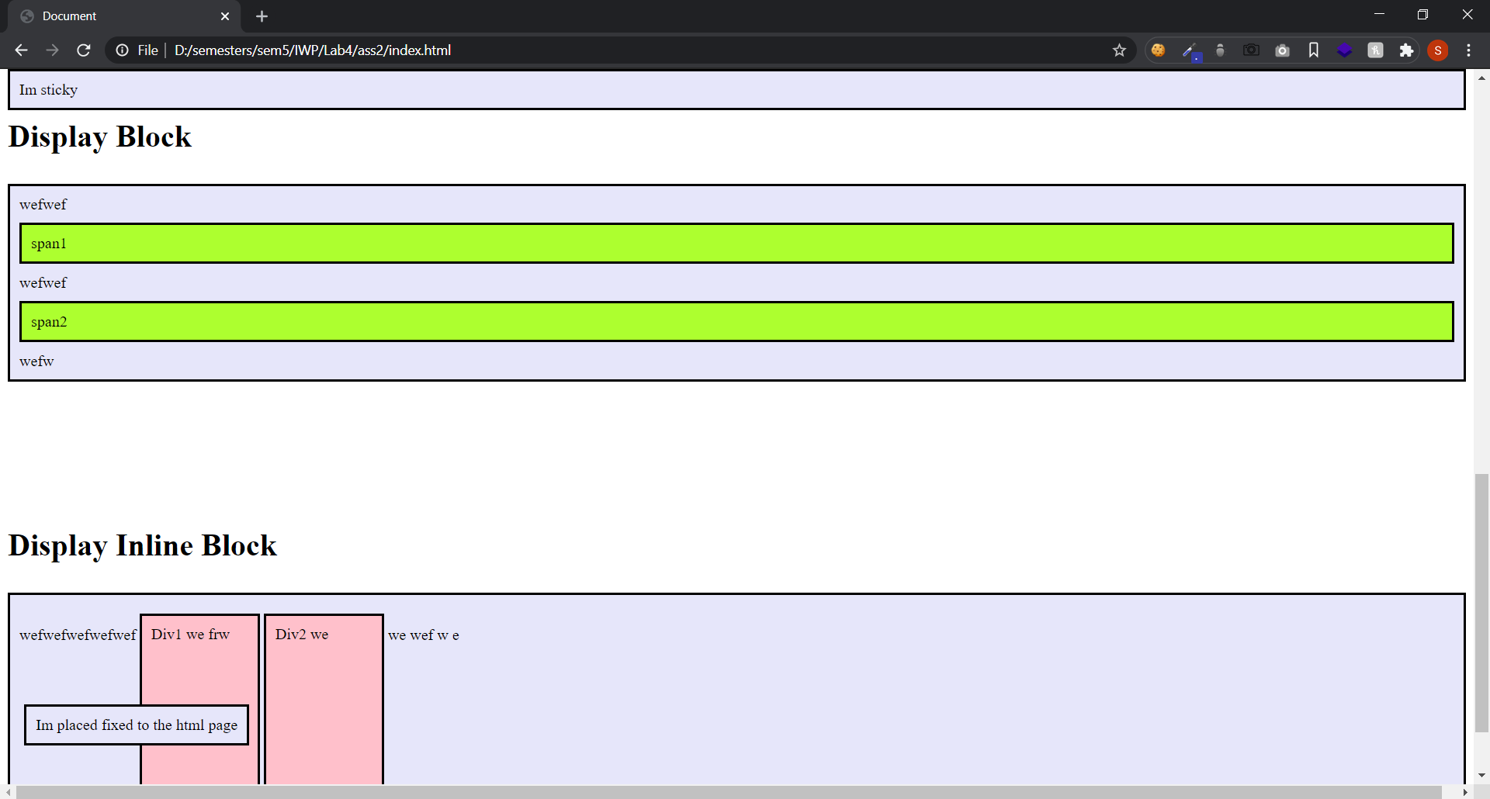

**A mail-order house sells five different products whose retail prices are as follows: product 1, $2.98; product 2, $4.50; product 3, $9.98; product 4, $4.49; and product 5, $6.87. Write a script that reads a series of pairs of numbers as follows: 1. Product number 2. Quantity sold for one day Your program should use a switch statement to determine each product's retail price and should calculate and output HTML that displays the total retail value of all the products sold last week. Use a prompt dialog to obtain the product number and quantity from the user. Use a counter-controlled loop(while..loop) to determine when the program should stop looping and display the final results. If the user inputs an invalid product number a proper alert window shall be displayed**

**Index.html**

<!DOCTYPE html>

<html lang="en">

<head>

    <meta charset="UTF-8">

    <meta name="viewport" content="width=device-width, initial-scale=1.0">

    <title>Document</title>

    <link rel="stylesheet" href="public\stylesheets\mian.css">

</head>

<body>

    <h1>Task3</h1>

   <table border="1" cellpadding=30>

       <thead>

           <th>Products</th>

           <th>Total Sales</th>

       </thead>

       <tbody>

           <tr>

               <td>Product 1</td>

               <td id="p1">$2.98</td>

           </tr>

           <tr>

               <td>Product 2</td>

               <td id="p2"> $4.50</td>

           </tr>

            <tr>

                <td>Product 3</td>

                <td id="p3">$9.98</td>

            </tr>

            <tr>

                <td>Product 4</td>

                <td id="p4">$4.49</td>

            </tr>

            <tr>

                <td>Product 5</td>

                <td id="p5">$6.87</td>

            </tr>

       </tbody>

   </table>

   <script src="public\js\main.js"></script>

</body>

</html>

**Main.js**

var p1 = document.getElementById("p1");

var p2 = document.getElementById("p2");

var p3 = document.getElementById("p3");

var p4 = document.getElementById("p4");

var p5 = document.getElementById("p5");

var pv1 = 2.98;

var pv2 = 4.50;

var pv3 = 9.98;

var pv4 = 4.49;

var pv5 = 6.87;

alert("Welcome to the page");

var c = parseInt(prompt("How many products you want to purchase"));

while(c>0){

    var inp = prompt("Enter the product Number");

    var val = parseInt(prompt("Quantity sold for one day"));

    var inpnumber = parseInt(inp);

    console.log(c);

    switch(inpnumber){

        case 1:

            pv1 = val*pv1;

            p1.innerHTML = "$"+pv1;

            c--;

            break;

        case 2:

            pv2 = val*pv2;

            p2.innerHTML = "$"+pv2;

            c--;

            break;

        case 3:

            pv3 = val*pv3;

            p3.innerHTML = "$"+pv3;

            c--;

            break;

        case 4:

            pv4 = val*pv4;

            p4.innerHTML = "$"+pv4;

            c--;

            break;

        case 5:

            pv5 = val*pv5;

            p5.innerHTML = "$"+pv5;

            c--;

            break;

        default:

            alert("Enter the right input");

            break;

    }

}

**Output:**

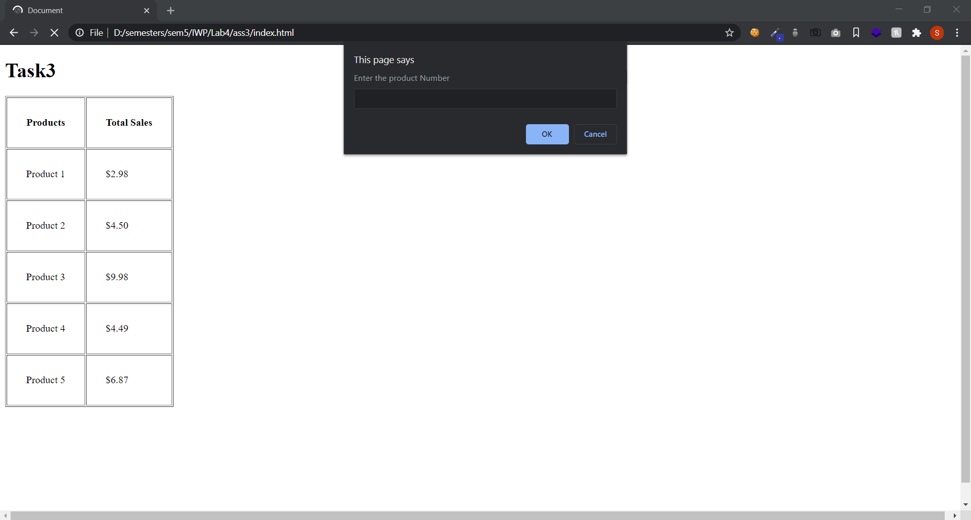

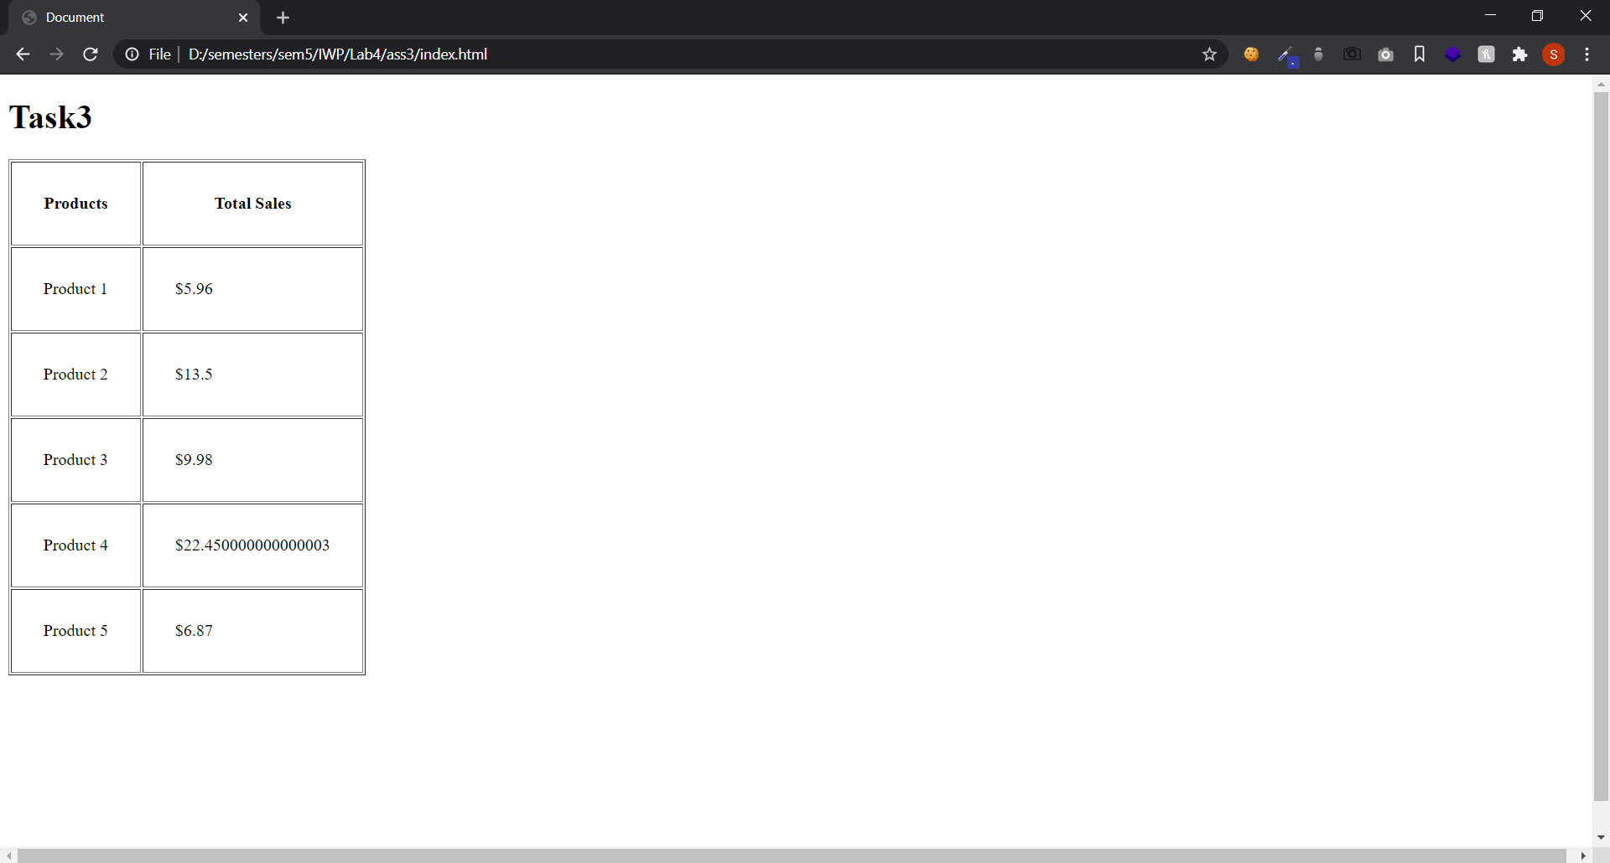

**Deployed Link:( Demo links)**

**Task1:** <https://sreemanthg.github.io/Internet-And-Web-Programming/Lab4/ass1/index.html>

**Task2:** <https://sreemanthg.github.io/Internet-And-Web-Programming/Lab4/ass2/index.html>

**Task3:** <https://sreemanthg.github.io/Internet-And-Web-Programming/Lab4/ass3/index.html>

**Source Code:**

<https://github.com/SreemanthG/Internet-And-Web-Programming/tree/master/Lab4>

**Main Repo:**

<https://github.com/SreemanthG/Internet-And-Web-Programming>