

**School of Computer Science and Engineering**

**Register Number: 18BCE0745**

**Name: Gourishetty Sreemanth**

1)

Develop an automated searching program using JavaScript to search text containing the word “red” and the phrase “pick-up truck” close to each other, followed by a “price”. Specifically, you should match the words “red” and the phrase “(pickup/pickup/pick up) truck” separated by at most two other words in between. The pick-up truck phrase could appear before or after the word red. After the words red and the phrase pick-up truck, the text should also contain a price as dollar, for example, $3.56 and $1,000,000 are valid amounts, whereas $5.321 and $-5, 29, 40 are not. [Hint: Use Regular expression for validation]

**Code:**

**Index.html:**

<!DOCTYPE html>

<html lang="en">

<head>

    <meta charset="UTF-8">

    <meta name="viewport" content="width=device-width, initial-scale=1.0">

    <title>Document</title>

    <link rel="stylesheet" href="main.css">

</head>

<body>

    <div class="flex">

        <input type="text" id="text">

        <input type="button" value="search" id="search">

        <div class="output" id="output">

        </div>

    </div>

    <script src="main.js"></script>

</body>

</html>

**Main.css:**

.flex{

    padding:10px 20px;

    display: flex;

    flex-direction: column;

    justify-content: center;

    align-items: center;

    border: 1px solid black;

    width:70%;

    margin-left:auto ;

    margin-right:auto ;

    margin-top: 30px;

}

input{

    width:100%;

    height: 30px;

    margin-top: 10px;

}

input[type=submit]{

padding:10px 20px;

width: 50% !important;

height: 50px ;

background-color: rgba(0, 60, 255, 0.952);

border:0px solid black;

color: white;

font-size: 1.5rem;

border-radius:7px;

margin-top: 10px;

}

**Main.js:**

    var mytext = document.getElementById("text");

var search = document.getElementById("search");

var output = document.getElementById("output");

var test1 =  "red toyota pick-up truck $500"

var validExpression=/(((red|Red)((\s)[a-z]+){0,2}\s(pickup|pick-up|pick up)\s(truck\s)|((pickup|pick-up|pick up)\s(truck)((\s)[a-z]+){0,2}\s(red)\s))((\s)[az]+(\s))*((\$)([0-9]{1,3})((\,)?([0-9]{3}))*(\.[0-9]{2})?)(\.)?)/;

search.addEventListener("click",function(){

// var h = validExpression.test(test1)

var s = mytext.value.match(validExpression);

output.innerHTML= "<div>Valid text is<div><div><div style='color:green'>"+s[0]+ "</div>"

})

**Output:**

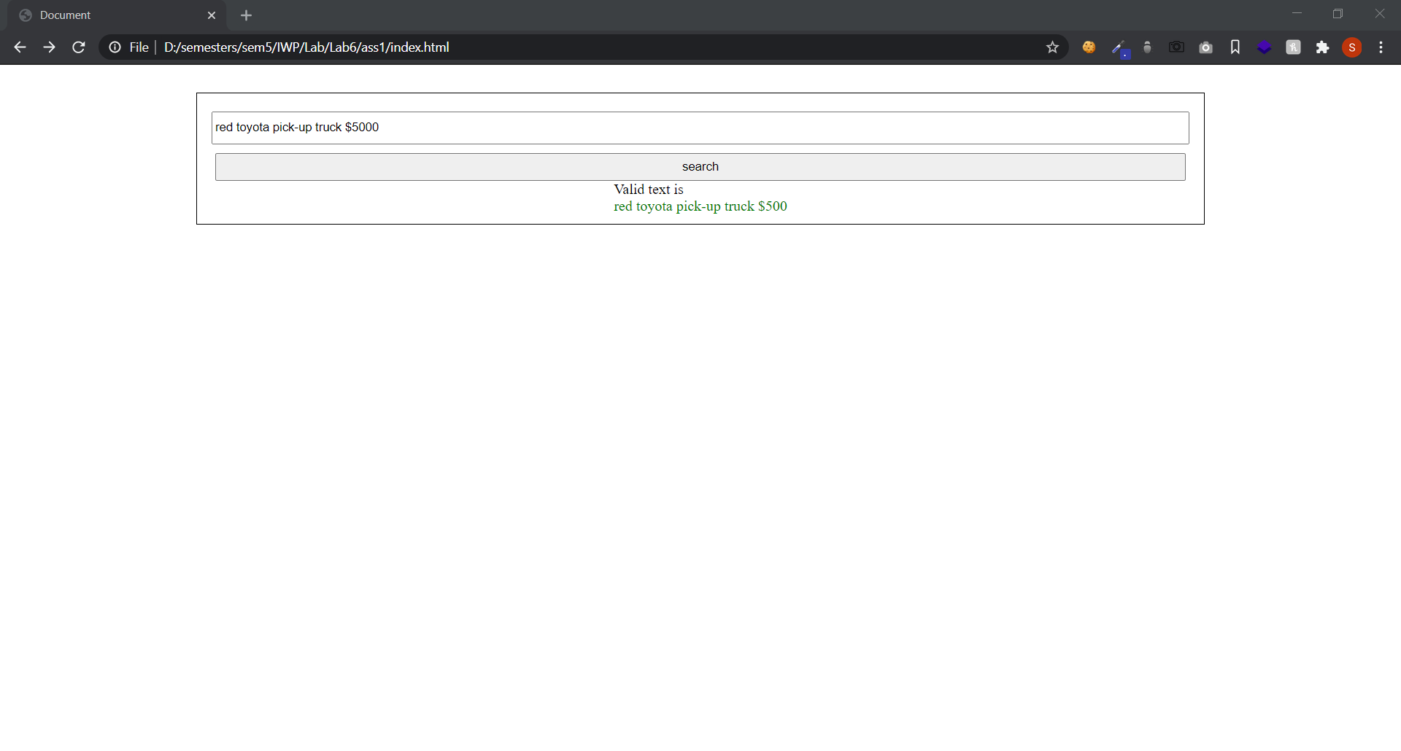

**2)**

Create a Doctor’s Appointment form with Patient name, Age, Gender, No of Visits,

Appointment Date, and Department (using text field).

Throw an exception if age and No. of Visits are not number and negative.

Throw an exception for doctor’s appointment during his vacation from 1/5/2020 to

31/5/2020.

Throw an exception for Department not specified as Paediatrician, Ophthalmology,

Cardiac, and Dental.

**CODE:**

**Index.html**

<!DOCTYPE html>

<html lang="en">

<head>

    <meta charset="UTF-8">

    <meta name="viewport" content="width=device-width, initial-scale=1.0">

    <title>Document</title>

    <link rel="stylesheet" href="main.css">

</head>

<body>

    <div class="flex">

        <form action="/" method="POST" id="form">

        <h3> Doctor’s Appointment form </h3>

            <div class="ss">

                <label for="name">

                    Name:

                </label>

                <input required type="text" id="name">

                <div id="nameerrors" class="e">

                </div>

            </div>

            <div class="ss">

                <label for="age">

                    Age:

                </label>

                <input required type="number" id="age">

                <div id="ageerrors" class="e">

                </div>

            </div>

            <div class="ss">

                <label for="gender">

                    Gender:

                </label>

                <input required type="text" id="gender">

                <div id="gerrors" class="e">

                </div>

            </div>

            <div class="ss">

                <label for="nov">

                    No. of Visits:

                </label>

                <input required type="number" id="nov">

                <div id="noverrors" class="e">

                </div>

            </div>

            <div class="ss">

                <label for="date">

                    Date:

                </label>

                <!--  -->

                <input required type="date" id="date">

                <div id="dateerrors" class="e">

                </div>

            </div>

            <div class="ss">

                <label for="dep">

                    Dep:

                </label>

                <input required type="text" id="dep">

                <div id="deperrors" class="e">

                </div>

            </div>

            <div class="ss">

                <input  type="submit" id="submit" value="Submit">

            </div>

        </form>

    </div>

    <script src="main.js"></script>

</body>

</html>

**Main.css:**

form{

    padding:10px 20px;

    display: flex;

    flex-direction: column;

    justify-content: center;

    align-items: left;

    border: 1px solid black;

    width:70%;

    margin-left:auto ;

    margin-right:auto ;

    margin-top: 30px;

}

.ss{

margin: 10px;

}

input{

    width:100%;

    height: 30px;

}

input[type=submit]{

padding:10px 20px;

width: 50% !important;

height: 50px ;

background-color: rgba(0, 60, 255, 0.952);

border:0px solid black;

color: white;

font-size: 1.5rem;

border-radius:7px;

}

.e{

    color:red;

}

**Main.js**

var form = document.getElementById("form");

// Name:

var name= document.getElementById("name");

// Age:

var age= document.getElementById("age");

// Gender:

var gender= document.getElementById("gender");

// No. of Visits:

var nov= document.getElementById("nov");

// Date:

var date= document.getElementById("date");

// Dep:

var dep= document.getElementById("dep");

form.addEventListener("submit",function(event){

    event.preventDefault();

    var flag = false;

    try{

        if(!age.checkValidity()){

            throw("Age must be a number");

        }

    }

    catch(e){

        // alert(e);

        document.getElementById("ageerrors").innerHTML = "<p>"+e+"</p>";

        flag=true;

    }

    try{

        if(age.value<0){

            throw("Enter Positive Age Value");

        }

    }

    catch(e){

        // alert(e);

        document.getElementById("ageerrors").innerHTML = "<p>"+e+"</p>";

        flag=true;

    }

    try{

        if(!nov.checkValidity()){

            throw("No. of visits must be a number");

        }

    }

    catch(e){

        // alert(e);

        document.getElementById("noverrors").innerHTML = "<p>"+e+"</p>";

        flag=true;

    }

    try{

        if(nov.value<0){

            throw("Enter Positive No. of Visits");

        }

    }

    catch(e){

        // alert(e);

        document.getElementById("noverrors").innerHTML = "<p>"+e+"</p>";

        flag=true;

    }

    try{

        if(Date.parse(date.value)<Date.parse("2020-05-01") || Date.parse(date.value)>Date.parse("2020-05-31")){

            throw("Enter Date Between from 1/5/2020 to 31/5/2020.");

        }

    }

    catch(e){

        // alert(e);

        document.getElementById("dateerrors").innerHTML = "<p>"+e+"</p>";

        flag=true;

    }

//         Throw an exception for Department not specified as Paediatrician,

// Ophthalmology, Cardiac, and Dental.

        try{

            if(dep.value!="Paediatrician" && dep.value!="Ophthalmology" && dep.value!="Cardiac" && dep.value!="Dental" ){

                throw("Enter the department from these Paediatrician, Ophthalmology, Cardiac, Dental");

            }

        }

        catch(e){

            // alert(e);

        document.getElementById("deperrors").innerHTML = "<p>"+e+"</p>";

        flag=true;

        }

        if(flag){

            return false;

        }

})

**Output:**

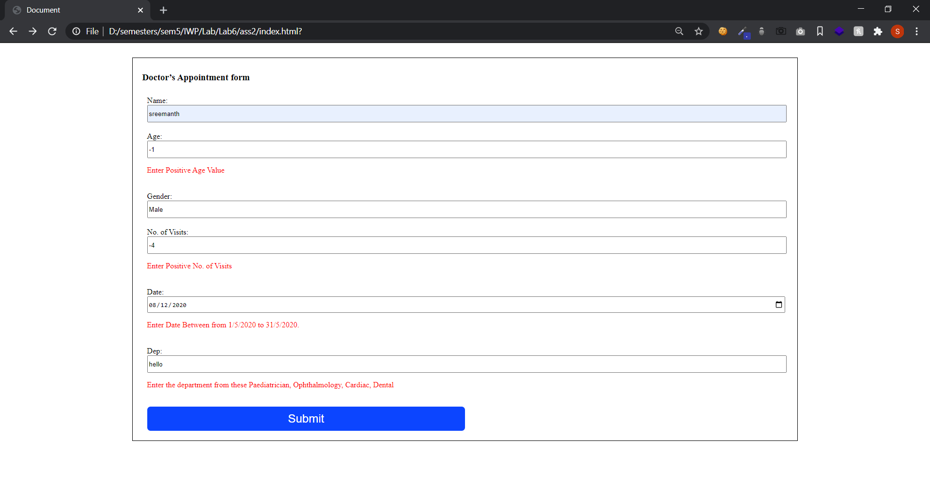

**Assignment 1 :** <https://sreemanthg.github.io/Internet-And-Web-Programming/Lab6/ass1/index.html>

**Assignment 2 :** <https://sreemanthg.github.io/Internet-And-Web-Programming/Lab6/ass2/index.html>

**Source Code:** <https://github.com/SreemanthG/Internet-And-Web-Programming/tree/master/Lab6>