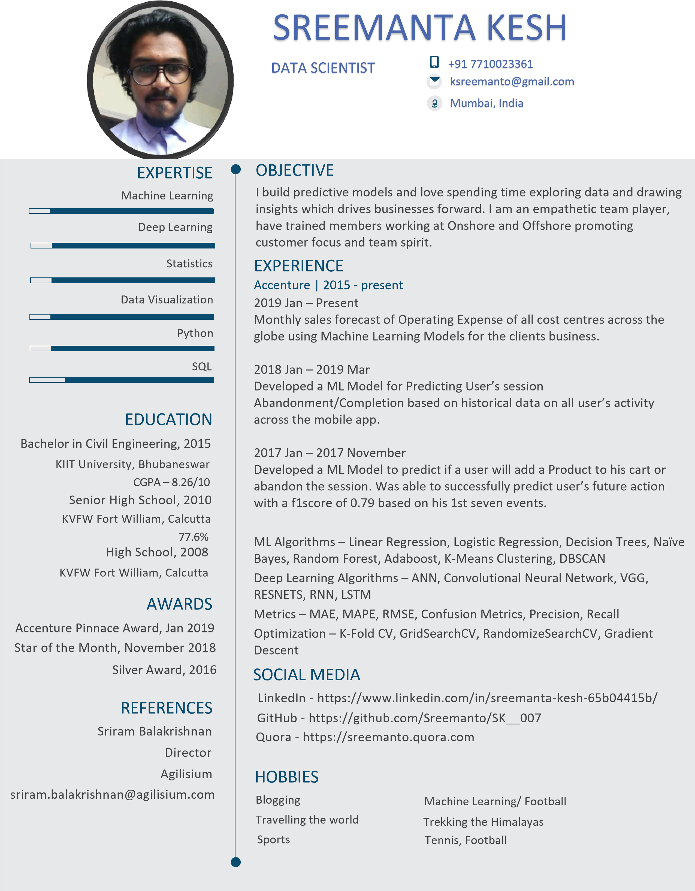

**SUMMARY -** Experienced Data Scientist/Engineer with 6+ years of WorkEx in. Adding value to organizations by data enabling AI and Data Ops at Scale. Productionizing Machine Learning models and building Data Pipelines and has a huge passion for data cleaning.

**SREEMANTA KESH**

**Email –** [**ksreemanto@outlook.com**](mailto:ksreemanto@outlook.com)

**Phone - +91 7710023361**

Machine Learning

**EXPERTISE**

**EXPERIENCE**

**Deloitte | Nov 2019 – Present**

Built an Explainable AI Tool assessing the fairness and transparency of all the ML models helping the business open the black-box and making them more interpretable.

**Impact** – Enabling trust in AI for Business CTO’s.

Developed a simulation forecast model using Python which predicted the delays of various activities and sub activities across different sites. This helped.

**Impact** – Enabled business take measures in advance and reduce cost for the respective sites

Built a Data Pipeline in Pyspark handling huge volumes of Data in MQDL Data Lake. Used Hive, NiFi and shell scripting to automate the flows.

**Impact** – Increase the throughput enabling the Data Science team to plan the schedules for testing of the drugs.

Built a Data Pipeline in Microsoft Azure setting up the SQL Database for daily inflows of the data for client’s business enabling seamless flow of data from source to the Analytics Team enabling ML and Analytics.

**Impact** – Setting up Data Pipeline on Cloud.

**Accenture | Nov 2015 – Nov 2019**

Automated the Service Request allotment tickets in the firm using Machine Learning.

**Impact** - Saved 95000 manhours annually

**Jan, 2018 - Mar 2019**

Deployed a ML Model whose objective predict if a user will continue or abandon session based on dynamic inputs captured during the run time. F1-score of 0.79 was achieved.

**Impact** – Decreased the abandonment failure rate by 19%

**Nov, 2015 - Dec 2017**

Worked as a Data Analyst where the task was to monitor ETL pipeline and prepare data for the BI team and application testing.

**Imarticus Learning | Jan 2019 – Present**

Worked as Data Science Trainer taking charge of Python and ML modules.

**DataFolkz | April 2020 – Present**

Helped setting up this ed-Tech startup for Data Analytics and Ai track and also take up the mentorship sessions where I help students and guide students build their profile and take mock-interviews thereby bridging the gap between coursework and Industry expertise.

**SOCIAL MEDIA**

**LinkedIn –** <https://www.linkedin.com/in/sreemanta/>

**GitHub –** <https://github.com/Sreemanto>

**Quora –** <http://sreemanto.quora.com/>

**Medium -** <https://medium.com/@ksreemanto>

**AWARDS**

Deloitte top performer of Q3, 2020.

Accenture Pinnacle Award, 2019.

Star of the month, 2018 Dec.

Silver Award, 2016.

Bachelor in Civil Engineering, 2015

KIIT University, Bhubaneshwar, CGPA – 8.26/10.

Senior High School, 2010, K. V. Fort William, Kolkata, 77%.

High School, 2008, K. V. Fort William, Kolkata, 84%.

**EDUCATION**

Apache NiFi

Mongo/Dynamo DB

Linux/Shell

Azure ML/ADF/Databricks

Power BI

Alteryx

SQL

PySpark

Python

Deep Learning