Automated Pipeline for Hospital Patient Admissions using Azure Synapse Analytics

1. Introduction
The growing demand for data-driven healthcare solutions necessitates efficient data processing pipelines that can transform raw clinical and operational data into actionable insights. This project implements an end-to-end automated data engineering pipeline for analysing hospital patient admissions between 2023-2024 across 6 hospitals. The dataset contains 300 records, representing admissions, diagnoses, costs, and hospital details.
The pipeline is designed using Azure Synapse Analytics and Azure Data Lake Storage (ADLS), following the Medallion architecture — Bronze, Silver, and Gold layers — to ensure data quality, reliability, and scalability. The final outputs are consumed in Power BI for visual analytics and business reporting.

2. Objectives
2.1 Technical Objective
To build a fully automated, scalable, and modular data pipeline that extracts, loads and transform (ELT) hospital admission data using Azure Synapse components and delivers ready-to-analyse datasets for visualization.
2.2 Business Objectives
The analysis aims to address the following key healthcare performance questions:
- Identify the most loyal or high-performing hospital in terms of total admissions and revenue.
- Perform time-series analysis on patient admissions and total costs.
- Determine which age group accounts for the most hospital admissions.
- Identify the department generating the highest revenue.
- Analyse departmental patient volume and average stay duration.
- Discover which age group contributes the most to total income.

3. Data Description
The dataset, Healthcare_PatientAdmissions.csv, contains 300 rows across 12 columns. It records patient admission data from six hospitals between 2023 and 2024.
Schema:
Column | Data Type | Description
AdmissionID | VARCHAR(10) | Unique admission identifier
PatientID | VARCHAR(10) | Patient identifier
PatientName | VARCHAR(50) | Patient’s full name
Gender | VARCHAR(10) | Gender of the patient
Age | INT | Patient’s age
Diagnosis | VARCHAR(30) | Diagnosis name
Department | VARCHAR(50) | Hospital department
Doctor | VARCHAR(50) | Treating doctor’s name
AdmissionDate | DATE | Admission date
DischargeDate | DATE | Discharge date
HospitalName | VARCHAR(50) | Name of the hospital
TotalCost | MONEY | Total cost of treatment

4. Architecture Overview
The pipeline follows the Medallion Architecture within Azure Synapse:
- Bronze Layer: Ingests raw data directly from the source (GitHub → ADLS).
- Silver Layer: Performs data cleansing, transformation, and enrichment using Synapse Spark Notebooks.
- Gold Layer: Builds star-schema dimensional models (fact and dimension tables) for analytical consumption.
The following Azure services were used:
- Azure Data Lake Storage (ADLS Gen2) for data storage.
- Azure Synapse Serverless SQL Pool for querying and creating external tables.
- Synapse Pipelines for orchestration.
- Synapse Notebooks (Spark) for transformation and writing data in Delta format.
- Power BI for visualization and business insights.

5. Pipeline Development Steps
5.1 Data Ingestion (Bronze Layer)
The pipeline begins with a Copy Activity that transfers the dataset from GitHub to ADLS in the /Data container.
A Script Activity (sql_init_hospital) initializes the environment:
- Creates Hospital_DW database.
- Sets collation to Latin1_General_100_BIN2_UTF8.
- Defines schemas: bronze, silver, and gold.
- Configures external data sources and credentials.
- Defines file formats (CSV, Parquet, Delta).
Create external table in bronze
if OBJECT_ID('bronze.hospital_all') is NOT NULL
DROP EXTERNAL TABLE bronze.hospital_all
create EXTERNAL TABLE bronze.hospital_all
(
- AdmissionID varchar(10),
- PatientID varchar(10),
- PatientName varchar(50),
- Gender varchar(10),
- Age INT,
- Diagnosis varchar(30),
- Department varchar(50),
- Doctor varchar(50),
- AdmissionDate DATE,
- DischargeDate DATE,
- HospitalName varchar(50),
- TotalCost MONEY
- )
- WITH(
- LOCATION ='Healthcare_PatientAdmissions.csv',
- DATA_SOURCE=hospital_src,
- FILE_FORMAT=csv_file_format_pv1,
- REJECT_VALUE=10,
- REJECTED_ROW_LOCATION='rejection/hospital'
- )

- select * from bronze.hospital_all

- ---Create view in bronze
- DROP VIEW IF EXISTS bronze.vw_hospital_all
- go
- CREATE VIEW bronze.vw_hospital_all
- AS SELECT * from bronze.hospital_all
- ---
- select top 10 * from bronze.vw_hospital_all

- select * from bronze.vw_hospital_all where AdmissionDate > '2025-11-08' -- should retrive none

- ALTER view bronze.vw_hospital_all
- AS
- select
- AdmissionID,
- PatientID,
- PatientName,
- Gender,
- Age,
- Diagnosis,
- Department,
- Doctor,
- AdmissionDate,
- DischargeDate,
- HospitalName,
- TotalCost,
- DATEDIFF(day,AdmissionDate,DischargeDate) as TotalDays
- FROM bronze.hospital_all;

- select top 10 * from bronze.vw_hospital_all

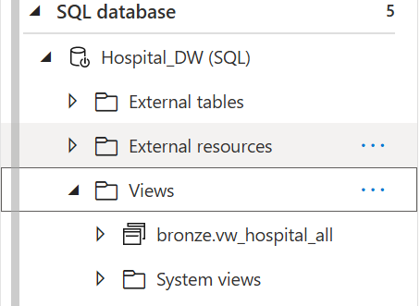
An external table bronze.hospital_all is then created on top of the CSV file, enabling SQL-based querying from the raw dataset.
A view (bronze.vw_hospital_all) is created to abstract the raw table and add a derived column TotalDays (difference between admission and discharge).

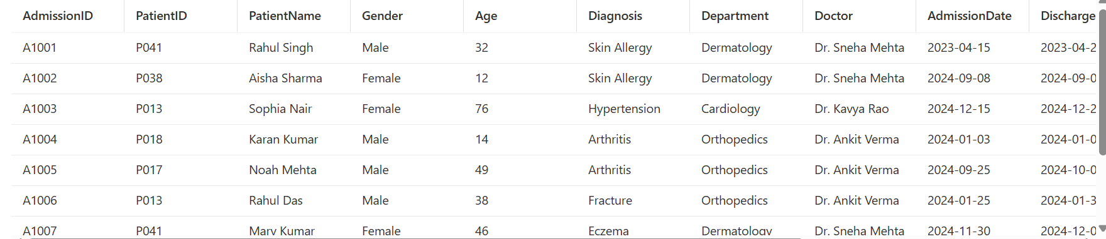

5.2 Data Transformation (Silver Layer)
Using a Synapse Spark Notebook, data is read from the Bronze layer and processed through multiple transformations:
- Trimmed and standardized all string fields to uppercase.
- Derived AdmissionYear and AdmissionMonth for time-based analytics.
- Calculated TotalDays using datediff(DischargeDate, AdmissionDate).
- Filtered invalid or inconsistent records (e.g., negative ages, negative costs, invalid date ranges).
- Added Latest column using window functions for row-level uniqueness.
The transformed data was then written in Delta format to the Silver layer path:
abfss://project6@sreesynapseproject5.dfs.core.windows.net/silver/hospital_clean1

windows_spec=Window.orderBy(col('AdmissionID').desc())

df_clean=df.withColumn('Gender',upper(trim(col('Gender'))))\
.withColumn('PatientName',upper(trim(col('PatientName'))))\
.withColumn('Diagnosis',upper(trim(col('Diagnosis'))))\
.withColumn('Department',upper(trim(col('Department'))))\
.withColumn('Doctor',upper(trim(col('Doctor'))))\
.withColumn('HospitalName',upper(trim(col('HospitalName'))))\
.withColumn('AdmissionYear',year(col('AdmissionDate')))\
.withColumn('AdmissionMonth',month(col('AdmissionDate')))\
.withColumn('Latest',row_number().over(windows_spec))\
.withColumn('TotalDays',datediff(col('DischargeDate'),col('AdmissionDate')))\
.filter((col('AdmissionDate')<=col('DischargeDate')) & ((col('Age')>0) & (col('TotalCost')>0)))

df_clean.write.format('delta').option("mergeSchema", "true").mode('overwrite').save('abfss://project6@sreesynapseproject5.dfs.core.windows.net/silver/hospital_clean1')

An external table silver.hospital_clean was created to expose this cleaned dataset for downstream processing.

5.3 Dimensional Modelling (Gold Layer)
A second Spark Notebook (gold_hospital) performed the dimensional modeling:
- Dimension Tables:
  - dim_patient: Created surrogate keys for unique patient combinations (PatientName, Age, Gender, ID).
  - dim_hospital: Mapped unique hospitals.
  - dim_department: Captured distinct departments.
  - dim_diagnosis: Linked diagnoses with their departments.
  - dim_doctor: Linked doctors with their respective departments.
- Fact Table:
  - fact_admissions: Contains foreign keys to all dimensions along with metrics such as TotalCost, TotalDays, and admission details.
dim_patient = silver_df.select("PatientID", "PatientName", "Gender", "Age")\
.distinct()\
.withColumn("PatientKey",row_number().over(Window.orderBy("PatientID", "PatientName", "Gender", "Age")))

dim_hospitals=silver_df.select('HospitalName')\
.distinct()\
.withColumn('HospitalKey',row_number().over(Window.orderBy(col('HospitalName'))))

dim_department=silver_df.select('Department')\
.distinct()\
.withColumn('DepartmentKey',row_number().over(Window.orderBy(col('Department'))))

dim_diagnosis=silver_df.select('Diagnosis','Department')\
.distinct()\
.withColumn('DiagnosisKey',row_number().over(Window.orderBy(col('Diagnosis'))))

dim_doctor = silver_df.select("Doctor", "Department").distinct() \
.withColumn("DoctorKey", row_number().over(Window.orderBy("Doctor")))

fact_admissions=silver_df.alias('s')\
.join(dim_patient.alias('p'),
[
col("s.PatientID") == col("p.PatientID"),
col("s.PatientName") == col("p.PatientName"),
col("s.Gender") == col("p.Gender"),
col("s.Age") == col("p.Age")
],'left'
)\
.join(dim_doctor.alias('d'),'Doctor','left')\
.join(dim_hospitals.alias('h'),'HospitalName','left')\
.join(dim_department.alias('dept'),'Department','left')\
.join(dim_diagnosis.alias('dig'),'Diagnosis','left')\
.select(
col('s.AdmissionID'),col('p.PatientKey'),col('dig.DiagnosisKey'),col('dept.DepartmentKey'),
col('d.DoctorKey'),col('s.AdmissionDate'),col('s.DischargeDate'),col('h.HospitalKey'),col('s.TotalCost'),
col('s.TotalDays'),col('s.AdmissionYear'),col('s.AdmissionMonth')
)

All these datasets were written in Delta format to the Gold container.
A Script Activity (gold_script) then created external tables for these Delta datasets using Serverless SQL Pool, making them queryable via Synapse SQL.

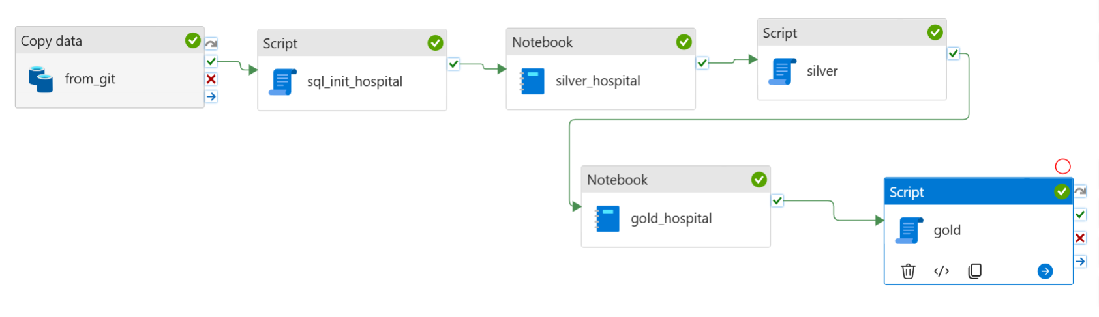

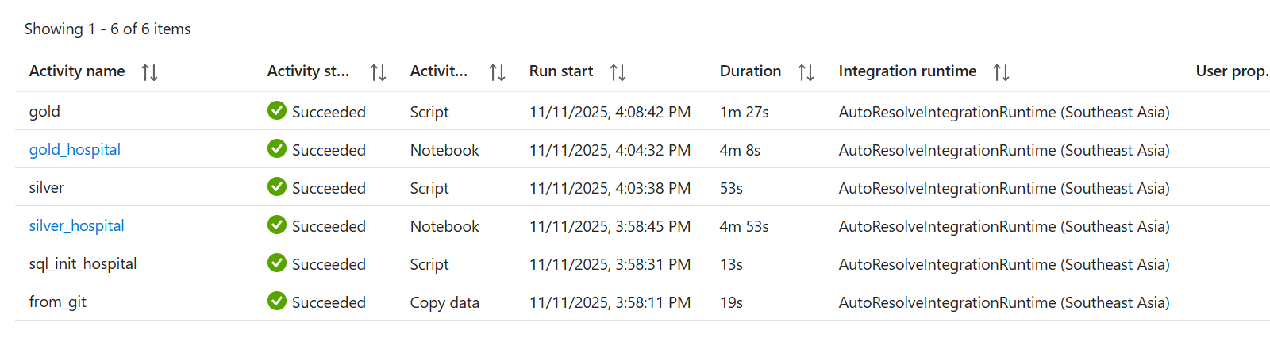

6. Analytical Consumption (Power BI)
Finally, Power BI was connected to the Gold Layer external tables for reporting and visualization.
The following insights were derived:
Business Question | Insight
1. Loyal Hospital | City Care Hospital ranked highest with 61 admissions and revenue exceeding 800,000.
2. Time-Series Trends | March recorded the highest admissions and generated maximum revenue.
3. Age Group with Most Admissions | Patients aged 58 years had the highest admission frequency.
4. Top Revenue-Generating Department | Endocrinology produced the highest revenue.
5. Department with Most Patients | General Medicine treated the most patients with the longest average stay.
6. Most Profitable Age Group | The 58-year age group contributed the most to overall income.

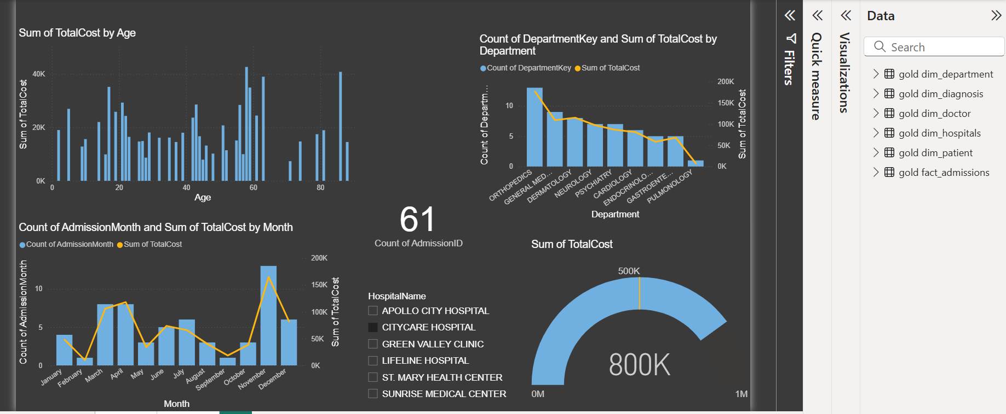

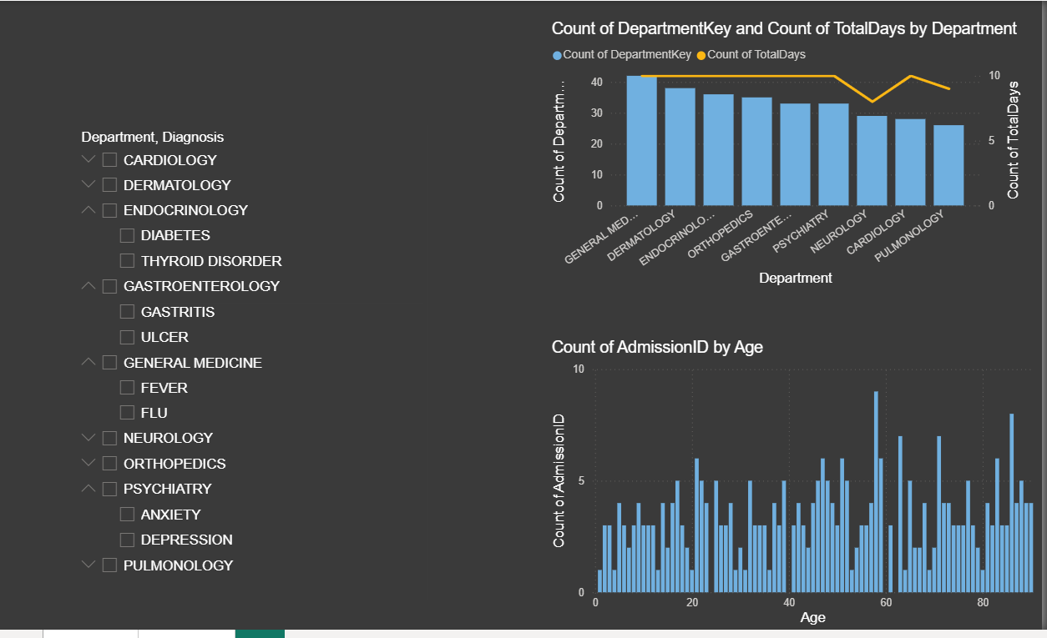

Summary:

Layer | Purpose | What Happened in Your Project | Output Format / Storage
Bronze (Raw Layer) | Ingest and store raw data exactly as received. | - Copied Healthcare_PatientAdmissions.csv from GitHub to ADLS.- Created external table bronze.hospital_all on top of the CSV.- Created view vw_hospital_all adding calculated TotalDays column. | CSV file in /bronze/ container
Silver (Cleaned Layer) | Clean, standardize, and enrich data for analytics. | - Read bronze data in Synapse Spark notebook.- Cleaned text fields (uppercase, trimmed).- Derived new columns: AdmissionYear, AdmissionMonth, and TotalDays.- Removed invalid or duplicate records.- Saved as Delta format and created external table silver.hospital_clean. | Delta format files in /silver/
Gold (Curated Layer) | Build star schema for analytics (facts and dimensions). | - Created dimension tables: dim_patient, dim_hospital, dim_department, dim_doctor, dim_diagnosis.- Created fact_admissions table linking all dimensions.- Wrote results in Delta format.- Created external tables in SQL for Power BI use. | Delta format files in /gold/
Power BI (Visualization Layer) | Business analytics and reporting. | - Connected to Gold layer external tables.- Built dashboards for key insights (hospital performance, revenue, age analysis). | Interactive dashboards

